UNIT II
SESSION I
Activity | Board Activity
Topic | Recap: Link Level flow control
 | Definition, concept
Activity | Presentation
Topic | Medium Access
 | Definition, addressing mechanism
Weblink | http://en.wikipedia.org/wiki/Media_Access_Control
Activity | Questions and Answers
Topic | Conclusion
- What is the primary function of medium access?
- Define medium access control.
- Define MAC address.
- Define channel access.
- Define multiple access.
- Define Ethernet.
- Functions performed in the MAC Sub layer.
- Define address resolution protocol.
- Define wireless interference.

SESSION II
Activity | Writing Board
Topic | Recap : Medium Access
 | Definition and concepts
Activity | Writing Board
Topic | CSMA
 | Definition, CSMA with collision detection and avoidance
WebLink | http://en.wikipedia.org/wiki/Carrier_sense_multiple_access
Activity | Show and tell activity
Topic | Conclusion
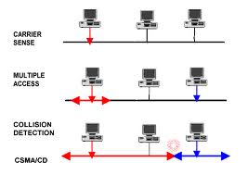
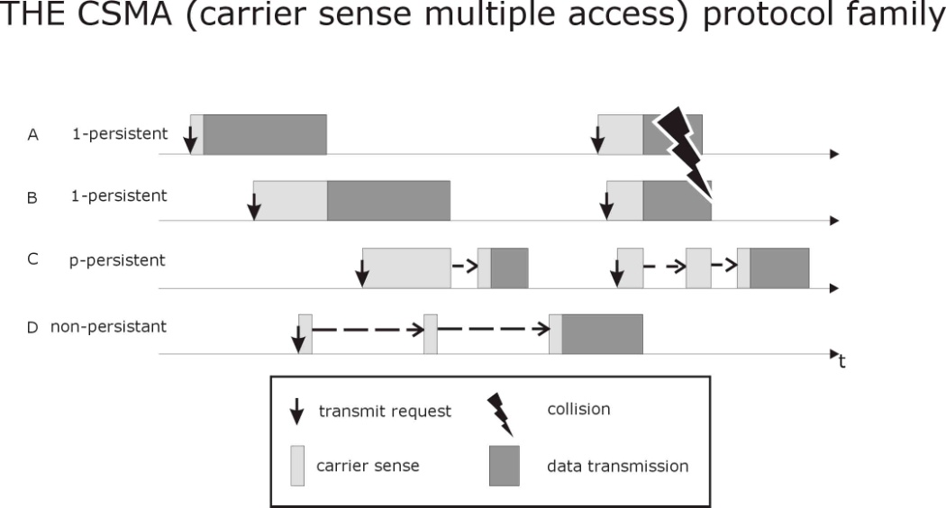

SESSION III
Activity | Board activity
Topic | Recap: CSMA
 | Definition and concepts
Activity | Board activity
Topic | Ethernet
 | Definition, Three generations of Ethernet.
WebLink | http://compnetworking.about.com/cs/ethernet1/g/bldef_ethernet.htm
Activity | Board activity
Topic | Physical properties
 | concepts
WebLink | https://facultystaff.richmond.edu/~dszajda/classes/cs150/Fall_2009/  www/lectures/networking_slides/EthernetSlides.pdf
Activity | Word scramble
Topic | Conclusion
atmrobcfee lret
olocnlisi
smca
srnehtte efat
aolah
Answer:
Robert Metcalfe
Collision
Csma
Fast Ethernet
aloha

SESSION IV
Activity | Writing Board
Topic | Access Control Algorithm
 | MAC, concepts
WebLink | http://www.erg.abdn.ac.uk/~gorry/eg3561/lan-pages/mac.html
Activity | Writing Board
Topic | Frame format
 | Ethernet frame format
WebLink | http://compnetworking.about.com/cs/ethernet1/g/bldef_ethernet.htm
Activity | Quiz
Topic | Conclusion
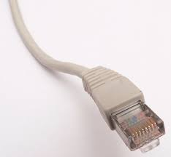
- Identify this above diagram.
- Define Ethernet.
- What is meant by fast Ethernet?
- Define collision.
- Define collision detection.
- What is meant by 10Base2?
- Define switched Ethernet.
- State the different Data rate for Ethernet.
- Define cabling.
- Define the frame format for Ethernet.

SESSION V
Activity | Board activity
Topic | Token Ring 802.5, Physical properties
Definition, Concepts
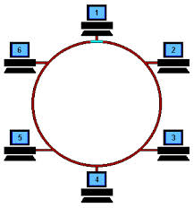
WebLink | http://pluto.ksi.edu/~cyh/cis370/ebook/ch03e.htm
Activity | Analogy
Topic | Token Ring Media Access Control
Relay game
In relay we are using stick, in similar manner in Token ring uses token to send one particular packet.
WebLink | http://www.webopedia.com/TERM/T/token_ring_network.html  http://www.textfiles.com/bitsavers/pdf/apollo/010005-00_ Apollo_Token_Ring_Media_Access_Control_  Layer_and_Physical_Layer_Protocols_Oct87.pdf
Activity | Board activity
Topic | Token ring maintenance, Frame Format
 | Concept, 802.5 token ring frame format
WebLink | http://homepages.uel.ac.uk/u0306091/TOKEN_RING.htm
Activity | Board activity
Topic | Ubiquitous Networking (content beyond the syllabus)
 | http://en.wikipedia.org/wiki/Ubiquitous_computing
WebLink
http://www.textfiles.com/bitsavers/pdf/apollo/010005-00_ Apollo_Token_Ring_Media_Access_Control_
Layer_and_Physical_Layer_Protocols_Oct87.pdf

SESSION VI
Activity | Board activity
Topic | Recap : Token Ring 802.5
 | Frame format, concepts
Activity | Board activity
Topic | FDDI Physical properties
 | Dual fiber ring a) normal operation b) Failure of the primary ring.
WebLink | http://en.wikipedia.org/wiki/Fiber_Distributed_Data_Interface
Activity | Board activity
Topic | Timed Token Algorithm, Token Maintenance, Frame Format
 | TRT- Token Rotation Time, TTRT- Target Token Rotation time, FDDI frame format
WebLink | https://www.google.co.in/search?sclient=psy-ab&q=Wi-Fi&oq=Wi-Fi&gs_l=hp.3...206370.206370.10.207249.1.1.0.0.0.0.0.0..0.0....0...1c.. 26.hp..58.5.24.wghNyrkVGJ0&bav=on.2,or.r_qf.&bvm=bv.52164340,  d.bmk&biw=1280&bih=696&dpr=1&emsg=NCSR&noj=1&ei=  zng1UveqDYOMrQei14H4BA

SESSION VII
Activity | Presentation, Board activity
Topic | Wireless LAN
 | Wireless 802.11 physical properties, example wireless network
WebLink | http://simple.wikipedia.org/wiki/Wireless_LAN
Activity | Analogy
Topic | Bluetooth Technologies
 | Data transfer using cell phones
WebLink | http://www.cisco.com/web/IN/solutions/en/wireless_lan/index.html
Activity | Presentation, Board activity
Topic | Wi-Fi
 | http://en.wikipedia.org/wiki/Wi-Fi
Activity | Recall by keywords
Topic | Conclusion
- Frequency hopping
- Infrared signals
- Wireless
- Bluetooth
- Wireless fidelity
- Direct sequence

SESSION VIII
Activity | Presentation
Topic | Bridges and Switches, Learning Bridges, Spanning Tree Algorithm
 | Definition and concepts
WebLink | http://jpkc.ncwu.edu.cn/jsjwl/net/kurose/ethernet/transparent_bridges.htm
Activity | Presentation
Topic | Broadcast and Multicast  Limitations of Bridges
 | Types of addressing schemes
WebLink | http://www.google.co.in/url?sa=t&rct=j&q=&esrc=s&source=web&cd=5&cad= rja&ved=0CEcQFjAE&url=http%3A%2F%2Fwww.comptechdoc.org%2 Findependent%2Fnetworking%2Fguide%2Fnetbroadcasting.html&ei= uXw1Up3lIMSGrgf8yoHwCQ&usg=AFQjCNGKsUz0F8IIaCuWjuDiuU1G8  fiexg&bvm=bv.52164340,d.bmk
Activity | Show and tell
Topic | Conclusion
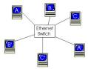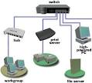

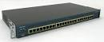

SESSION IX
Activity | Presentation
Topic | Recap: Bridges and Switches
 | concepts
Activity | Presentation
Topic | Cell Switching (ATM)
 | Cells, cell format, segmentation and reassembly
WebLink | http://en.wikipedia.org/wiki/Asynchronous_Transfer_Mode
Activity | Word scramble
Topic | Conclusion
nnasooucrhsy
rsftrane
omed
igdrbe
LAeNdd txnee
Answer Key:
nnasooucrhsy asynchronous
rsftrane transfer
omed mode
igdrbe bridge
LAeNdd txnee extended LAN

