Unit-V: System Level Security

Session -1 Intrusion detection Date: 18.09.2013 Period: 05
- Unspoken words (Intruder Introduction)
www.eecis.udel.edu/~mills/teaching/eleg867b/crypto_slides/ch18.ppt
- Masquerader
- Misfeasor
- Clandestine user
- Recall by keywords(Intrusion technique)
- One-way encryption
- Access control
- Recall by keywords (Intrusion Detection)
- Statistical anomaly detection
- Counter
- Gauge
- Interval timer
- resource utilization
- Rule based detection
- Rule based anomaly detection
- Rule based penetration identification
- Audit records
- Detection –specific audit records
- Native audit records

Session -2 Password management Date: 24.09.2013 Period: 03
Presentation (www.eecis.udel.edu/~mills/teaching/eleg867b/crypto_slides/ch18.ppt)

Activity: Crossword
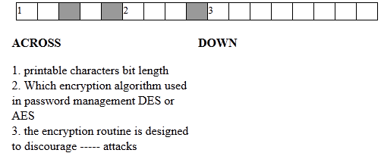

- Quiz
- List and briefly define three classes of intruders.
- What are two common techniques used to protect a password file?
- What are three benefits that can be provided by an intrusion detection system?
- What is the difference between statistical anomaly detection and rule-based intrusion detection?
- What metrics are useful for profile-based intrusion detection?
- What is the difference between rule-based anomaly detection and rule-based penetration identification?
- What is a honeypot?
- What is a salt in the context of UNIX password management?
- List and briefly define four techniques used to avoid guessable passwords.

Session -3 Viruses and Related threats Date: 08.10.13 Period: 06
- Video: http://www.youtube.com/watch?v=qy0-X7CTqss
http://www.youtube.com/watch?v=c34QwtYI40g

- Presentation: (www.eecis.udel.edu/~mills/teaching/eleg867b/crypto_slides/ch19.ppt)

- Quiz
- What is the role of compression in the operation of a virus?
- What is the role of encryption in the operation of a virus?
- What are typical phases of operation of a virus or worm?
- In general terms, how does a worm propagate?
- What is a digital immune system?
- How does behavior-blocking software work?

Session -4 Virus counter measures Date: 11.10.13 Period: 06

Video: http://www.youtube.com/watch?v=qy0-X7CTqss
- Presentation (www.eecis.udel.edu/~mills/teaching/eleg867b/crypto_slides/ch19.ppt)
- Recall by keyword
- Antivirus approach
- Detection
- Identification
- Removal

- Quiz
- How does a worm propagate?
- What is the role of encryption in the operation of a virus?
- What are the 4 generations of antivirus software?
- Briefly describe the recent worm attack.
- Why Morris worm is designed?

Session -5 Digital immune system (DIS) Date: 12.10.13 Period: 03
- Recall by keyword
- CPU emulator
- Virus signature scanner:
- Emulation control module
- Presentation (www.eecis.udel.edu/~mills/teaching/eleg867b/crypto_slides/ch19.ppt)
- Quiz
- What is a digital immune system?
- How does behavior-blocking software work?
- What is a DDoS?

Session -6 Firewall design principles Date: 12.10.13 Period: 07
- Show and tell
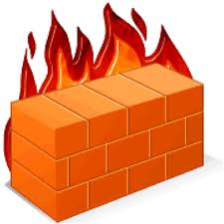

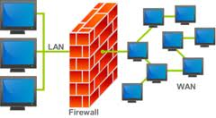

- Presentation (http://ece.uprm.edu/~noack/crypto/textslides/ch20.ppt)

- Remember by keyword
- Service control
- Direction control
- User control
- Behaviour control
- Quiz
- List three design goals for a firewall.
- List four techniques used by firewalls to control access and enforce a security policy.
- What information is used by a typical packet-filtering router?
- What are some weaknesses of a packet-filtering router?
- What is the difference between a packet-filtering router and a stateful inspection firewall?
- What is an application-level gateway?
- What is a circuit-level gateway?

Session -7 Firewall configuration Date: 17.10.13 Period: 05
Recall by words:
Screened host firewall system – single homed bastion host
Screened host firewall system –dual homed bastion host
Screened subnet firewall system
Presentation: (http://ece.uprm.edu/~noack/crypto/textslides/ch20.ppt)

Session -8 Trusted Systems Date: 22.10.2013 Period:08
Presentation (http://ece.uprm.edu/~noack/crypto/textslides/ch20.ppt)
Conclusion:
- Quiz
- In the context of access control, what is the difference between a subject and an object?
Subject: An entity capable of accessing objects, the concept of subject equates with that of process
Object: Anything to which access is controlled (e.g. files, programs)

- What is the difference between an access control list and a capability ticket?
  - An access control list lists users and their permitted access right
  - A capability ticket specifies authorized objects and operations for a user

- What are the two rules that a reference monitor enforces? N o read up, No write up

- What properties are required of a reference monitor?
Complete mediation, Isolation &Verifiability

