UNIT – V IMAGE COMPRESSION: SESSION INPUTS

SESSION – 1 input:

1. Fundamentals of Image Compression: Presentation:

www-ee.uta.edu/dip/courses/ee5356/631pub04_sec8compressBasic.ppt‎

cwww.ee.nctu.edu.tw/course/channel_coding/CC01.pdf‎

PPT slides are presented to learners to narrate the Fundamentals of Image Compression.

1. Image Compression models: Presentation:

ftp://biticrak.ae/syllabus/Old%20syllabus/BE/BE%20CSE/.../CS7107.pdf‎

With the help of PPT slides the concept of Image Compression is explained.

Elements of Information theory: Group discussion, Learners is grouped into

group A and Group B, Group A discusses about the fundamental of information

theory and Group B discusses about entropy. Facilitator consolidates the points

discussed by the groups.

1. Fundamentals of coding theorem & need for Compression: Presentation:

The facilitator explains the need for compression with the help of PPT slides.

www.kmitl.ac.th/~kwsomkia/DIP/Lecture.../Chapter08_handouts_2_fine.pd...

1. Conclusion: Questions and Answers

Define Entropy

Give the types of redundancy

What is meant by image compression?

Define data redundancy.

Session 2 input:

1. Recap:Quiz:Sample questions:

What is meant by coding redundancy?

Define interpixel redundancy?

Differentiate lossy and lossless coding.

Introduction to Huffman Coding: Writing board

The facilitator explains Introduction to Huffman Coding.

Huffman Codes

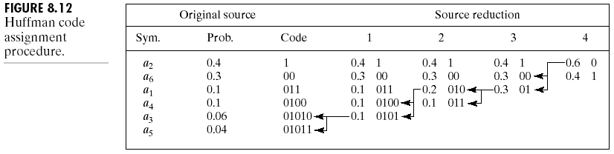



1. Steps to perform Huffman Coding: Writing board,Problem solving.

elderlab.yorku.ca/~vida/ppt/Huffman_Coding.ppt

Many Problems for Huffman coding are solved and results are discussed with the learner.

1. Conclusion:crossword.

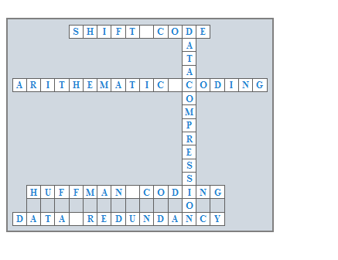

SESSION – 3 input:

1. Recap: tit for tat:

Learners are divided into two groups they are asked to prepare questions one group asks question to another and the other group answers the question and vice versa.

1. Sample Questions:

Give example for lossless coding.

Classify variable length coding.

List the types of shift code.

1. Introduction to Run length Encoding: Writing Board

www.csie.kuas.edu.tw/course/CS/old/english/ch-15.ppt‎

www-ee.uta.edu/dip/Courses/EE5351/Image_Compression.ppt

The facilitator explains the basic of Run length Coding.

Steps to Perform

1. Run length Encoding: Writing Board, problem solving

Many problems for Run length Encoding are solved and results are discussed with the learner.

1. Conclusion: Rapid fire: Sample Questions:

List the Types of run length coding.

Define compression ratio

Give the steps to perform run length coding.

SESSION – 4 input:

1. Recap: Quiz:
2. Introduction to Shift code: Writing Board

The facilitator explains the basic of Shift code

www.csie.ntnu.edu.tw/~violet/IP93/Chapter11.ppt‎

www.csie.kuas.edu.tw/course/CS/old/english/ch-15.ppt‎

Steps to Perform

1. Shift code: Writing Board, problem solving

Many problems for Shift code are solved and results are discussed with the

learner.

1. Conclusion: Learner and Presentation

Any one of the learner is asked to summarize the steps to perform shift code.

SESSION – 5 input:

1. Recap: Questions and Answers:
2. Introduction to Arithmetic coding: Writing board

The facilitator explains the procedure to perform Arithmetic coding

www.csie.kuas.edu.tw/course/CS/old/english/ch-15.ppt‎

Steps to Perform

1. Arithmetic coding: Writing Board, problem solving

|  |
| --- |
| Source symbol Probability Initial Subinterval |
| a10.2 [0.0, 0.2]  a20.2 [0.2, 0.4]  a30.4 [0.4, 0.8]  a40.2 [0.8, 1.0] |

1. Conclusion: Summarization

The facilitator summarizes the steps to perform shift code to the learners.

SESSION – 6 input:

1. Recap: Questions and Answers:

What is meant by quantization?

Does quantization results in loss of data?

Define shift code.

1. Introduction to Vector Quantization: Presentation

www.cs.rug.nl/~biehl/PPT/lvqdyn.ppt‎

Symbol encoder

Predictor

Predictor

Quantizer

Symbol encoder

Input Compressed

image image

Compressed Decompressed

image image

1. Block diagram of Vector Quantization: Writing board

The facilitator explains the basic concept of Vector Quantization

www-ee.uta.edu/dip/courses/ee5356/631pub04_sec8compressBasic.ppt‎

www-ee.uta.edu/dip/courses/ee5356/631pub04_sec8compressBasic.ppt‎

1. Conclusion: Rapid fire: Sample Questions:

What is meant by Vector Quantization?

Define predicator.

Whether Vector Quantization results in lossy compression?

SESSION – 7 input:

1. Recap: Brainstorming;

List the points contributed by the students on Transform Coding. Instruct them to specify the need for Transform coding. One member from each group narrates the principles of transform coding.

1. Introduction to Transform Coding: Presentation

The facilitator explains the basic concept of Transform Coding with the help of

PPT slides

www-ee.uta.edu/dip/courses/EE5355/631S09_lec10unitary.ppt‎

1. Encoder and Decoder of Transform Coding: Writing board

Construct

n x n

subimages

Forward transform

Quantizer

Symbol encoder

Symbol encoder

Inverse transform

Merge

n x n subimages

Input

(N x N)

Compressed Decompressed

image

image

1. Conclusion: Rapid fire: Sample Questions:

Transform codinglossy or lossless compression?

What is the role of quantiser in encoding process?

Define forward transform.

SESSION – 8 input:

1. Recap: Quiz: Sample questions:

What is the need for data compression?

Define inverse transform.

What is de-compression?

1. Introduction to JPEG Standard: Presentation:

The facilitator explains the basic concept ofJPEG Standard with the help of PPT slides.

seminarprojects.com/s/jpeg-ppt-gonzalez‎

www.csie.kuas.edu.tw/course/CS/old/english/ch-15.ppt‎

Techniques & Representation of JPEG Standard: Presentation

Quantize tables

Coding tables

Entropy Coding

DPCM

RLC

DCT

Quantization

Data

Heads

Tables

B x B

DC

Conclusion: Crossword:

J

P

E

G

2

0

0

C

M

D

E

P

J

SESSION – 9 input:

1. Recap: Quiz:

List the application of JPEG Standard.

What technique is used in encoding process of JPEG?

Which transform is used in JPEG Standard?

1. Introduction to MPEG Standard: Presentation:

www.csie.kuas.edu.tw/course/CS/old/english/ch-15.ppt‎

www.sdsc.edu/~gupta/mmclass5b.ppt‎

Evolution of MPEG

MPEG – 1

* Initial audio/video compression standard
* Used by VCD’s
* MP3 = MPEG – 1 audio layer 3
* Target of 1.5 Mb/2 bitrate at 352x240
* Only

1. Techniques & Representation of MPEG Standard: Presentation

The facilitator explains the basic concept ofMPEG Standard with the help of PPT slides.

www-ee.uta.edu/Dip/Courses/EE5359/MPEG%20AAC.ppt‎

1. Conclusion: learner led presentation. Any one of the learner is asked to summarize the steps to perform MPEG technique