Unit-I
Introduction
Session-1 Date: 10.07.13 , 1st hour, Time: 9.15 am-10.05 am
Recap: Control Systems
Suggested Activity: Quiz
- Classification of control systems: Open loop and closed loop system
- System: Effect or cause between two or more signals
- Difference between Open and closed loop system: Feedback signal
- Transfer function: L.T of Output/ L.T of input with zero initial conditions
- Basic elements of mechanical system: Mass, dashpot and spring
- Basic elements of electrical system: Resistance, inductance and capacitance
Content: Classification of Systems
- Continuous time system
- Discrete time system
Suggested Activity: Odd man out
Suggested Activity: Odd man out
- Which of the following is not a system?
i. Energy ii. Continuous iii. Discrete iv. Linear
b. Which one of the following is not a discrete time system?
i. Static ii. Dynamic iii. Causal iv. Power

- ECG gives information about the organ
i.Brain ii. Heart iii. Lungs iv. Kidney

- EEG gives information about the organ
i.Brain ii. Heart iii. Lungs iv. Kidney

Conclusion: Classification of Systems
Suggested Activity: Questions & Answers
- Define continuous time system.
Produces a continuous time output signal.
- Define discrete time system.
Produces a discrete time output signal.
- List the different types of signal.
a.One dimensional signal
b. Two dimensional signal
c. Multi dimensional signal
Ref : https://digitalsignalp.wordpress.com/2011/10/30/linear-and-non-linear-time-invariant-and-variant-systems-in-dsp/
Session-2 Date: 10.07.13 , 4th hour, Time: 12.00 pm-12.50 pm
Recap: Classification of Systems
Suggested Activity: Quiz
- Major classifications of systems: Continuous and discrete time systems
- Types of signals: One, two and multi dimensional signal
- System means: Effect or cause between two or more signals
Content: Classification of Discrete time Systems
Suggested Activity: Brainstorming
- Static systems: Output depends upon only present input
- Dynamic systems: Output depends upon past & future samples of input
- Time invariant: System characteristics does not change with time.
- Stable system: Bounded input produces bounded output sequence.
- Unstable system: Bounded input produces unbounded output sequence.
Conclusion: Classification of Discrete time Systems
Suggested Activity: Questions & Answers
- Define FIR system.
Impulse response of the system is of finite duration.
- What is meant by IIR system?
Impulse response of the system is of infinite duration.
- State the difference between Linear and non-Linear systems.
A system satisfies the superposition principle is said to be a linear system.
A system that does not satisfy the superposition principle is said to be non-linear system.
Ref : http://en.wikipedia.org/wiki/Continuous_signal
Session-3 Date: 11.07.13 , 1st hour, Time: 9.15 am-10.05 am
Recap: Classification of Discrete time Systems
Suggested Activity: Quiz
- Causal systems: Output depends upon only on past and present input.
- Difference between FIR & IIR systems: Response is of Finite and infinite duration.
- Time variant systems: System characteristics changes with time.
- Linear systems: System that satisfies the superposition principle.
Content: Classification of Signals
Suggested Activity: Group Activity
The entire class is divided into totally five groups. Each group is assigned a specific topic and asked to discuss about various points involved in that topic.
- Group-1: Continuous & Discrete time signal
The first group is asked to discuss about Continuous & Discrete time signal.
Unit step, unit ramp, impulse, sinusoidal, real and complex exponential signal.
- Group-2: Energy & Power signal
The second group is asked to discuss about Energy & Power signal.
Energy signal: Total energy of the signal is finite & Power is zero.
Power Signal: Average power of the signal is finite & energy is infinity.
- Group-3: Periodic & Aperiodic signal
The third group is asked to discuss about Periodic & Aperiodic signal.
Periodic signal: x(n+N) = x(n)
Aperiodic signal : x(n+N) ≠ x(n)
- Group-4: Symmetric & Antisymmetric signal
The fourth group is asked to discuss about Symmetric & Antisymmetric signal.
Symmetric signal: x(-n) = x(n)
Antisymmetric signal: x(-n) = -x(n)
- Group-5: Causal & Noncausal signal
The fifth group is asked to discuss about Causal & Noncausal signal.
Causal signal: x(n) = 0, for n< 0
Noncausal signal: x(n) ≠ 0, for n< 0
Ref :http://www.diet.unina.it/giacinto.gelli/DSPcourse/Lecture1.pdf -
Conclusion: Classification of signals
Suggested Activity: Pick & Answer
There are variety of questions based on the content of the session and any one of the learner is asked to pick the letter and the corresponding question to be answered.
- Energy signal
- Causal signal
- Symmetric signal
- Periodic signal
- Types of signals
- Example for signals
If the learner choose letter e then the question is types of signals and the answer is
a. One dimensional signal b. Two dimensional signal c. Multi dimensional signal
Ref : http://cnx.org/content/m10057/latest/
Session-4 Date: 13.07.13 , 6th hour, Time: 2.20 pm-3.10 pm
Recap: Classification of signals
Suggested Activity: Remembering
- Symmetric signals are also called as Even signals
- Antisymmetric signals are also called as Odd signals
- Unit step signal: u(t) = 1 for t ≥ 0, u(t) = 0 for t < 0
- Unit ramp signal: r(t) = t for t ≥ 0, r(t) = 0 for t < 0
Content: Mathematical representation of signals

Suggested Activity: Match the following
Column-A Column-B
1. Graphical Representation a. Sequence 4
2. Functional Representation b. Table 3
3. Tabular Representation c. Function 2
4. Sequence Representatio n d. Graph 1
Ref: http://www.youtube.com/watch?v=He_Zokhmj8M
Conclusion: Mathematical representation of signals
Suggested Activity: Recall by Keywords
- Unit step sequence: u(n) = 1 for n ≥ 0, u(n) = 0 for n < 0
- Unit ramp sequence: r(n) = n for n ≥ 0, r(n) = 0 for n < 0
- Unit impulse response: δ(n) = 1 for n = 0, δ(n) = 0 for n ≠ 0
Ref:http://static.flipora.com/websearch.html?ref_type=ihome&src_type=tg&tv=7.304&t=7.304&u=8309201
Session-5 Date: 17.07.13 , 3rd hour, Time: 11.10 am-12.00 pm
Recap: Mathematical representation of signals
Suggested Activity: Brain Storming

- Functional Representation:

X(n) = { 1 for n = -1
2 for n = 0,1
0.5 for n = 2
1.5 for n = 3
0 otherwise }

- Tabular Representation:

n | -1 | 0 | 1 | 2 | 3
X(n) | 1 | 2 | 2 | 0.5 | 1.5

Ref: http://www.ipredict.it/Methods/DigitalSignalProcessing.aspx
Content: Spectral density & Operation on signals

Suggested Activity: Match the following
Column-A Column-B
1. Shifting a. Sampling 3
2. Time Reversal b. Multiplication 4
3. Time Scaling c. Adder 5
4. Signal Multiplier d. Delay or advance 1
5. Signal Addition e. folding the sequence 2
Ref: http://cnx.org/content/m10125/latest/
Conclusion: Spectral density & Operation on signals

Suggested Activity: One word answer
- Shifting means y(n) = x(n-k)
- Time Reversal is denoted as x(-n)
- Time Scaling y(n) = x(2n)
- Signal multiplier y(n) = x₁(n)* x₂(n)
Ref:http://www.csee.wvu.edu/classes/ee327/resources/ct_signal_operations.pdf
Session-6 Date: 17.07.13 , 4th hour, Time: 12.00 pm-12.50 pm
Recap: Spectral density & Operation on signals
Suggested Activity: Group Discussion
The entire class is divided into totally six groups. Each group is assigned a specific topic and asked to discuss about various points involved in that topic.
- Group-1: Shifting
It takes the input sequence and shift the values by an integer increment.
- Group-2: Time Reversal
It is obtained by folding the sequence about n = 0.
- Group-3: Time Scaling
It is accomplished by replacing n by λn in the sequence x(n)
- Group-4: Scalar multiplication
X(n) is multiplied by a scale factor a.
- Group-5: Signal Multiplier
Multiplication of two signal sequences to form another sequence.
- Group-6: Signal Addition
Two signals can be added by using an adder.
Content: Sampling techniques

Suggested Activity: Brainstorming
- Sampling period: Time interval between successive samples.
- Sampling rate : Reciprocal of sampling period.
- Sampling or Decimation: Process of reducing sampling rate.
Ref: http://wiki.answers.com/Q/Sampling_techniques_in_signal_processing
Conclusion: Sampling techniques
Suggested Activity: Question & Answers

- Give the function of sampling period.
X(nT) = x(n), -∞ < n < ∞
- Give the expression for sinusoidal signal.
X(t) = SinΩt
Ref:"http://en.wikibooks.org/w/index.php?title=Digital_Signal_Processing/Sampling_and_Reconstruction&oldid=2498653"

Session-7 Date: 18.07.13 , 1st hour, Time: 9.00 am-10.05 am
Recap: Sampling techniques
Suggested Activity: Group Discussion
The entire class is divided into totally three groups. Each group is assigned a specific topic and asked to discuss about various points involved in that topic.
- Group-1: Sampling period
Time interval between successive samples.
- Group-2: Sampling rate
Reciprocal of sampling period.
- Group-3: Sampling or Decimation
Process of reducing sampling rate.
Ref: http://wiki.answers.com/Q/Sampling_techniques_in_signal_processing
Content: Quantization & Quantization error

Suggested Activity: Group Activity
The entire class is divided into totally two groups. Each group is assigned a specific topic and asked to discuss about various points involved in that topic.
- Group-1: Quantization
Quantization is the process of representing the analog voltage from the sample-and-hold circuit by a fixed number of bits. The input analog voltage (or current) is compared to a set of pre-defined voltage (or current) levels.
- Group-2: Quantization error
The process rounds the analog voltage to the nearest level, which means that the digital representation is an approximation to the analog voltage. There are a few methods for quantizing samples.
Conclusion: Quantization & Quantization error

Suggested Activity: Quiz

- Quantization means the process of representing the analog voltage.
- Quantization error- approximation to the analog voltage.
- Quantization noise: Difference between the quantized value and actual sample.
Ref: http://en.wikibooks.org/wiki/Digital_Signal_Processing/Sampling_and_Reconstruction

Session-8 Date: 19.07.13 , 2nd hour, Time: 10.05 am-10.50 am
Recap: Quantization & Quantization error
Suggested Activity: Quiz

- Converting discrete time continuous signal to discrete time discrete signal- Quantization
- x_{q}(n)-x(n) = e(n): Quantization noise
- Quantization noise- Difference between the quantized value and actual sample.

Content: Nyquist rate, aliasing effect

Suggested Activity: Board Activity

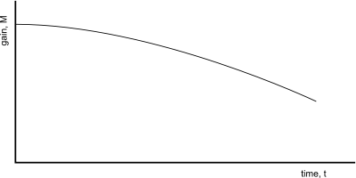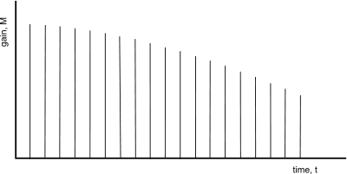
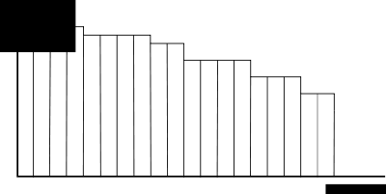

- Aliasing is a common problem in digital media processing applications
- The Nyquist Sampling Rate is the lowest sampling rate that can be used without having aliasing.
- Anti- Aliasing The sampling rate for an analog signal must be at least two times as high as the highest frequency in the analog signal in order to avoid aliasing.
Conclusion: Nyquist rate, aliasing effect

Suggested Activity: Tit for Tat
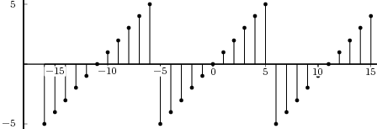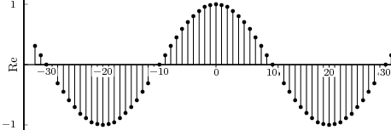

Ref: http://en.wikibooks.org/wiki/Digital_Signal_Processing/Sampling_and_Reconstruction
Session-9 Date: 20.07.13 , 6th hour, Time: 2.20 pm-3.20 pm
Recap: Nyquist rate, aliasing effect

Suggested Activity: Unspoken word

- Reconstruction: Process of creating an analog voltage (or current) from samples.\
- Aliasing is a common problem in digital media processing applications.
- Nyquist Sampling Rate is the lowest sampling rate that can be used without having aliasing.

Content: Digital signal representation

Suggested Activity: Board Activity
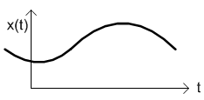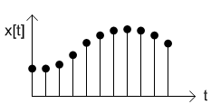
Continuous time signal Discrete time signal

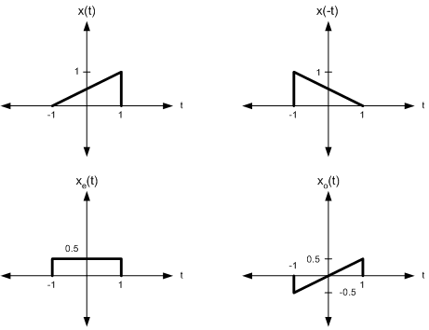
Energy and Power Signals

Conclusion: Digital signal representation

Suggested Activity: Show & Tell Activity

Energy signals representation
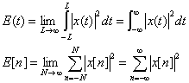

Ref: http://www.youtube.com/watch?v=G-J4FG2L_yc
Ref: http://www.songho.ca/dsp/signal/signals.html
Session-10, 11, 12
Content: Tutorial based on classification of signals

Suggested Activity: Board Activity- Problem Solving
Ref: https://digitalsignalp.wordpress.com/2011/10/30/linear-and-non-linear-time-invariant-and-variant-systems-in-dsp/
Ref: http://www.dspguide.com/ch6.htm
Ref: http://www.youtube.com/watch?v=G-J4FG2L_yc

