Unit-III
Discrete Fourier Transform & Computation
Session-1 Date: 29.08.13 , 1st hour, Time: 9.15 am-10.05 am
Recap: Fourier transform of discrete sequence

Suggested Activity: Quiz
- A discrete-time signal of fundamental period consists of 2π / N radians.\
- The frequency range for continuous-time signals extends from -∞ to ∞.
- Continuous-time periodic signals are called power signals.
Content: Introduction to DFT properties
Suggested Activity: Board Activity
- Linearity:
If x₁(n) ↔ X₁(ω) and
x₂(n) ↔ X₂(ω)
then, a₁x₁(n) + a₂x₂(n) ↔ a₁ X₁(ω) + a₂ X₂(ω)

- Time Shifting:
If x(n) ↔ X(ω)
then, x(n-k) ↔ e^{-jωk} X(ω)

- Time Reversal:
If x(n) ↔ X(ω)
then, x(-n) ↔ X(-ω)
Ref:http://eeweb.poly.edu/iselesni/EL713/zoom/dftprop.pdf
Conclusion: Introduction to DFT properties
Suggested Activity: Rapid fire
- The signal x(t) has a finite number of finite discontinuities.
- The signal x(t) has a finite number of maxima and minima.
- The signal x(t) is absolutely integrable.
Ref: http://en.wikipedia.org/wiki/Discrete_Fourier_transform

Session-2 Date: 30.08.13 , 2nd hour, Time: 10.05 am-10.55 am
Recap: Introduction to DFT properties

Suggested Activity: Show & Tell Activity

- a₁x₁(n) + a₂x₂(n) ↔ a₁ X₁(ω) + a₂ X₂(ω) ----→ Linearity
- x(n-k) ↔ e^{-jωk} X(ω) ----→ Time Shifting
- x(-n) ↔ X(-ω) ----→ Time Reversal

Content: DFT properties

Suggested Activity: Brain Storming
- Real signals:
X_{R}(ω) = $\sum_{n=-∞}^{∞}{x\left(n\right)cos}$ ωn

X_{I}(ω) = $-\sum_{n=-∞}^{∞}{x\left(n\right)sin}$ ωn

- Real and even signals:
x(n) = 1/π$\int_{0}^{π}{XR(ω)}$cos $ωn dω$

- Real and odd signals:
x(n) = -1/π$\int_{0}^{π}{XI(ω)}$sin $ωn dω$
Conclusion: DFT properties
Suggested Activity: Pick & Answer
There is variety of questions based on the content of the session and any one of the learner is asked to pick the letter and the corresponding question to be answered.
- Real signals
- Real and even signals
- Real and odd signals
- Purely imaginary signals
If the learner choose letter d then the question is Purely imaginary signals and the answer is
x(n) = 1/π$\int_{0}^{π}{[XR(ω)}$cos $ωn+XI\left(ω\right)sin ωn] dω$
Ref : http://licos.epfl.ch/courses/dsp0607/dsp_n02_chapter2.pdf

Session-3 Date: 30.08.13 , 4th hour, Time: 12.00 pm-12.50 pm
Recap: DFT properties
Suggested Activity: Quiz
- Convolution theorem:
x(n)= x₁(n)*x₂(n)↔X(ω) = X₁(ω)X₂(ω)
- Correlation theorem:
r_{x1x2}(m) ↔ S_{x1x2}(ω) = X₁(ω)X₂(-ω)
Content: Magnitude representation
Suggested Activity: Group Activity
The entire class is divided into totally three groups. Each group is assigned a specific topic and asked to discuss about various points involved in that topic.
- Group-1:
The first group is asked to discuss about the Circular shift of a sequence and the students involved with more interest and also the steps involved is discussed.
.
- Group-2:
The second group is asked to discuss about the Circular convolution and the students involved with more interest and also the steps involved is discussed.

- Group-3:
The third group is asked to discuss about the Circular correlation and the students involved with more interest and also the steps involved is discussed.
Conclusion: Magnitude representation
Suggested Activity: Unspoken word
- Equalizer: In digital communications, a corrective system.
- System identification: A set of measurements performed on the system.
- Invertible: One-to-one correspondence between its input and output signals.
Ref : http://cacr.uwaterloo.ca/techreports/2012/cacr2012-21.pdf
Session-4 Date: 30.08.13 , 5th hour, Time: 1.30 pm-2.20 pm
Recap: Magnitude representation
Suggested Activity: Board Activity

Content: Phase representation
Suggested Activity: Group Activity
The entire class is divided into totally two groups. Each group is assigned a specific topic and asked to discuss about various points involved in that topic.
- Group-1:
The first group is asked to discuss about the concentric circle method and the students involved with more interest and also the steps involved is discussed.
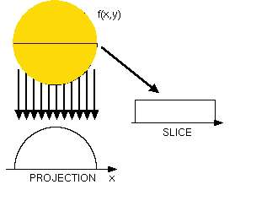.
- Group-2:
The second group is asked to discuss about the matrix multiplication method and the students involved with more interest and also the steps involved is discussed.
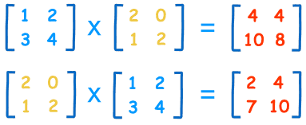
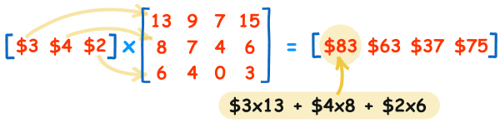
Ref:http://en.wikipedia.org/wiki/Matrix_multiplication
Conclusion: Phase representation
Suggested Activity: Questions & Answers
- Convolution concept
Y(n)$=\sum_{k=-∞}^{∞}{h\left(k\right)x(n-k)}$
- Impulse Fourier transform
H(F) = $\int_{-∞}^{∞}{h(t)}$ e-^{j2πFt} dt
Ref: http://www.sciencedirect.com/science/article/pii/0010448592900359
Session-5 Date: 31.08.13, 6th hour, Time: 2.20 pm-3.10 pm
Recap: Phase representation
Suggested Activity: Brain Storming

- H_{R}(ω) = $\sum_{k=-∞}^{∞}{h\left(k\right)cos }ωk$ ------→ Real component of H(ω)
- H_{I}(ω) = $\sum_{k=-∞}^{∞}{h\left(k\right)sin}ωk$ ------→ Imaginary component of H(ω)
- │H(ω)│= $\sqrt{{HR(ω)}^{2}+{HI(ω)}^{2}}$
- Angle of H(ω) = tan⁻¹[H_{I}(ω) / H_{R}(ω)]

Content: Computation of DFT using FFT algorithm

Suggested Activity: Board activity
Two different approaches are used to find the DFT of the sequence. The important computational algorithm called Fast Fourier Transform (FFT) algorithms, for computing the DFT when the size N is a power of 2 and when it is a power of 4.
Computation of DFT using FFT Algorithms
FFT : Fast Fourier Transform Algorithms
- X(k) = $\sum_{n=0}^{N-1}{x\left(n\right)}$ W_{N}^{nk}
- Direct Computation of DFT
- To compute one DFT point
- N complex multiplications are required
- N-1 complex additions are required
- To compute N DFT points (k = 0,1, …,N-1)
- N² complex multiplications (N x N)
- N²-N complex additions. ( (N -1) x N )
Conclusion: Computation of DFT using FFT algorithm
Suggested Activity: Recall by Keywords
- DFT : Discrete Fourier Transform
- FFT : Fast Fourier Transform
- Separability:
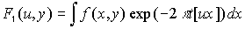
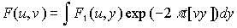
- Periodicity and Conjugate Symmetry
Ref: http://www.viit.ac.in/FFT_Algorithm.pdf
Session-6 Date: 02.09.13 , 6th hour, Time: 2.20 pm-3.10 pm
Recap: Computation of DFT using FFT algorithm
Suggested Activity: Remembering
- Rotation: Simply stated: if a function is rotated, then its Fourier transform rotates an equal amount.
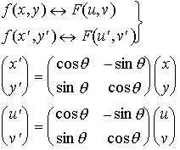

- Distributivity : The Fourier transform and its inverse are distributive over addition but not over multiplication.
Content: Decimation-in-time algorithm
Suggested Activity: Group Discussion
A decimation-in-time radix-2 FFT breaks a length-N DFT into two length-N/2 DFTs followed by a combining stage consisting of many butterfly operations. A decimation-in-time FFT algorithm on n = 2 ^{p} inputs with respect to a primitive n-th root of unity ω = exp(2πi / n) relies on O(n log n) butterflies of the form:
Conclusion: Decimation-in-time algorithm
Suggested Activity: Show & Tell Activity

Radix-2 butterfly diagram

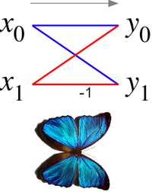
Inversion of butterflies:
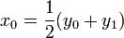
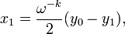
Ref: http://en.wikipedia.org/wiki/Butterfly_diagram
Session-7 Date: 03.09.13 , 6th hour, Time: 2.20 pm-3.10 pm
Recap: Decimation-in-time algorithm
Suggested Activity: Quiz
- Symmetry Property: W_{N}^{k+N/2} = -W_{N}^{k}
- Periodicity Property: W_{N}^{k+N} = W_{N}^{k}
- Direct computation requires
- 2N² evaluations of trigonometric functions
- 4N² real multiplications
- 4N(N-1) real additions
- A number of indexing and addressing operations
Content: Decimation-in-frequency algorithm

Suggested Activity: Group Discussion
The entire class is divided into totally two groups. Each group is assigned a specific topic and asked to discuss about various points involved in that topic.
- Group-1:
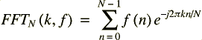
- Group-2:
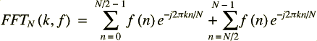
- Group-3:
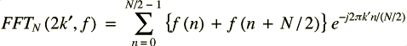

Conclusion: Decimation-in-frequency algorithm
Suggested Activity: Questions & Answers

- Define DIF algorithm.
The process of dividing the frequency components into even and odd parts is what gives this algorithm its name 'Decimation In Frequency'.
- What is meant by 'twiddle factors'?
The factors T_{N} are conventionally referred to as 'twiddle factors'.

Ref: http://www.systems.caltech.edu/EE/Courses/EE32b/handouts/FFT.pdf
Session-8 Date: 04.09.13 , 3rd hour, Time: 11.10 am-12.00 pm
Recap: Decimation-in-frequency algorithm
Suggested Activity: Brainstorming
- Twiddle factors:
- Pass Loop: An N (=2^{p} ) point transform will perform p 'passes', indexed by P=0..p-1.
- Block Loop: Pass will P operate on B_{P} (=2^{P} ) sub-blocks, each of size N_{P} (=N/B_{P}=2^{p-P}), indexed by b=0..B_{P}-1
- Butterfly Loop: Each sub-block operation will perform N'_{P} (=N_{P}/2=2^{p-P-1}) butterflies, indexed by n=0..N'_{P}-1.
Content: FFT using radix 2

Suggested Activity: Group Activity

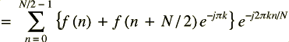
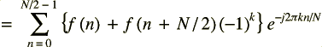
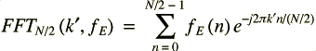
Conclusion: FFT using radix 2

Suggested Activity: Pick & Answer
There are variety of questions based on the content of the session and any one of the learner is asked to pick the letter and the corresponding question to be answered.
- Radix-2 FFT algorithms
- Radix-4 FFT algorithms
- Symmetry property
- Periodicity property
If the learner choose letter d then the question is Periodicity property and the answer is W_{N}^{k+N} = W_{N}^{k}.
Ref: http://www.engineeringproductivitytools.com/stuff/T0001/PT03.HTM
Session-9 Date: 04.09.13 , 4th hour, Time: 12.00 pm-12.50 pm
Recap: FFT using radix 2
Suggested Activity: Quiz
- X_{R}(k) = $\sum_{n=0}^{N-1}{[cos(\frac{2πkn}{N})}$x_{R}(n) + sin($\frac{2πkn}{N}$)x_{I}(n)]
- X_{I}(k) = $-\sum_{n=0}^{N-1}{[sin(\frac{2πkn}{N})}$x_{R}(n) - x_{I}(n)$cos(\frac{2πkn}{N})$]
Content: Construction of 8 point DFT

Suggested Activity: Board Activity
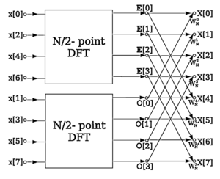
The butterfly can also be used to improve the randomness of large arrays of partially random numbers, by bringing every 32 or 64 bit word into causal contact with every other word through a desired hashing algorithm, so that a change in any one bit has the possibility of changing all the bits in the large array.
Conclusion: Construction of 8 point DFT
Suggested Activity: Questions & Answers

- 1st Algorithm for computation of DFT:
- Store the signal column-wise
- Compute the M-point DFT of each row
- Multiply the resulting array by the phase factors W_{N}^{lq}
- Compute the L-point DFT of each column.
- Read the resulting array row-wise.
- 2nd Algorithm for computation of DFT:
- Store the signal column-wise
- Compute the L-point DFT at each column
- Multiply the resulting array by the phase factors W_{N}^{pm}
- Compute the M-point DFT of each row.
- Read the resulting array column-wise.
Ref: http://sist.sysu.edu.cn/uploaded/file/Chpt04%281%29.pdf

Session-10 Date: 05.09.13 , 1st hour, Time: 9.15 am-10.05 am
Content: Tutorial: Computation of DFT using FFT algorithm

Suggested Activity: Board Activity- Problem Solving
Ref: http://www.sciencedirect.com/science/article/pii/0010448592900359
Session-11 Date: 06.09.13 , 2nd hour, Time: 10.05 am-10.55 am
Content: Tutorial: Decimation-in-time algorithm (DIT)

Suggested Activity: Board Activity- Problem Solving
Ref: http://www.mathworks.in/help/matlab/math/fast-fourier-transform-fft.html
Session-12 Date: 13.09.13 , 2nd hour, Time: 10.05 am-10.55 am
Content: Tutorial: Decimation-in-time algorithm (DIF)
Suggested Activity: Board Activity- Problem Solving
Ref: http://www.numerix-dsp.com/tutorials/DSP/FrequencyDomainProcessing.pdf

