Unit-II
Session Name | : | Frequency Transformation
Course Title | : | CS2403 -Digital Signal Processing
Semester | : | VII Semester
Programme Name | : | B.E
Author Name | : | Mrs.V.GANDHIMATHI
Department | : | ECE
Institution Name | : | VRS College of Engg. & Tech
Mobile Number | : | 9245582632
E-mail | : | adhihema02@gmail.com

Session -1
1. Introduction: Discrete Fourier Transform
Since the learners have some basic understanding about Fourier transform, it would be a good idea to ask some basic questions to help the learners recall the concepts DFT.
http://en.wikipedia.org/wiki/Discrete_Fourier_transform
Introduction to DFT
In mathematics, the discrete Fourier transform (DFT) converts a finite list of equally spaced samples of a function into the list of coefficients of a finite combination of complex sinusoids, ordered by their frequencies, that has those same sample values. It can be said to convert the sampled function from its original domain (often time or position along a line) to the frequency domain.
The input samples are complex numbers (in practice, usually real numbers), and the output coefficients are complex too. The frequencies of the output sinusoids are integer multiples of a fundamental frequency, whose corresponding period is the length of the sampling interval. The combination of sinusoids obtained through the DFT is therefore periodic with that same period. The DFT differs from the discrete-time Fourier transform (DTFT) in that its input and output sequences are both finite; it is therefore said to be the Fourier analysis of finite-domain (or periodic) discrete-time functions.
The DFT is the most important discrete transform, used to perform Fourier analysis in many practical applications. In digital signal processing, the function is any quantity or signal that varies over time, such as the pressure of a sound wave, a radio signal, or daily temperature readings, sampled over a finite time interval (often defined by a window function). In image processing, the samples can be the values of pixels along a row or column of a raster image. The DFT is also used to efficiently solve partial differential equations, and to perform other operations such as convolutions or multiplying large integers.
Since it deals with a finite amount of data, it can be implemented in computers by numerical algorithms or even dedicated hardware. These implementations usually employ efficient fast Fourier transform (FFT) algorithms;^{[1]} so much so that the terms "FFT" and "DFT" are often used interchangeably. The terminology is further blurred by the (now rare) synonym finite Fourier transform for the DFT, which apparently predates the term "fast Fourier transform" but has the same initialism.
Suggested Activity: Introduces & Questions
Questions
- Define Fourier.
- Write the formula for Fourier transform.
- Define IFT.
- Differentiate FT for CT and DT signals.

- DFT and IDFT
http://www.dspguide.com/ch8/2.htm
Suggested Activity: Explains and Problems
The DFT and IDFT can be explained on the board .Write the formula for DFT and IDFT and solve problems using formulas.
3. Conclusion –Mind map
a. Define DFT and IDFT.
b. Give the formulas for DFT and IDFT
c. Determine DFT for x (n) = {1,1,0,0}

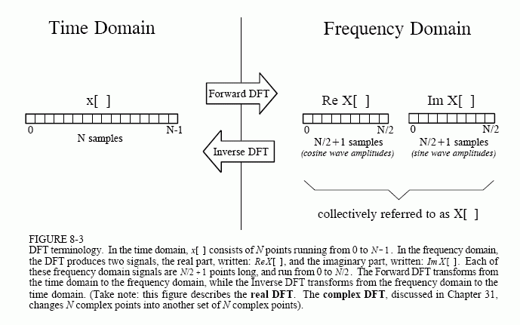
The frequency domain contains exactly the same information as the time domain, just in a different form. If you know one domain, you can calculate the other. Given the time domain signal, the process of calculating the frequency domain is called decomposition, analysis, the forward DFT, or simply, the DFT. If you know the frequency domain, calculation of the time domain is called synthesis, or the inverse DFT. Both synthesis and analysis can be represented in equation form and computer algorithm.The number of samples in the time domain is usually represented by the variable N. While N can be any positive integer, a power of two is usually chosen, i.e., 128, 256, 512, 1024, etc. There are two reasons for this. First, digital data storage uses binary addressing, making powers of two a natural signal length. Second, the most efficient algorithm for calculating the DFT, the Fast Fourier Transform (FFT), usually operates with N that is a power of two. Typically, N is selected between 32 and 4096. In most cases, the samples run from 0 to N-1, rather than 1 to N.

Session -2
- Recap: DFT
Suggested Activity: Quiz
We can conduct a quiz to check the learners what things they learned in previous session.

Properties of DFT
http://en.wikipedia.org/wiki/Discrete_Fourier_transform

Suggested Activity: Chalk and talk, PPT
    - Periodicity, Linearity
    - Time & frequency shifting
    - Time reversal of a sequence

Periodicity
If the expression that defines the DFT is evaluated for all integers k instead of just for , then the resulting infinite sequence is a periodic extension of the DFT, periodic with period N.
The periodicity can be shown directly from the definition:
Similarly, it DF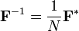T
Another way of looking at the DFT is to note that in the above discussion, the DFT can be expressed as a Vandermonde matrix:
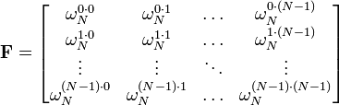
where
is a primitive Nth root of unity. The inverse transform is then given by the inverse of the above matrix:
With unitary normalization constants , the DFT becomes a unitary transformation, defined by a unitary matrix:
- Conclusion :
Suggested Activity: Chart
Session-3
- Recap: DFT
Suggested Activity: Recall
DFT concepts can be recall by using DFT and IDFT formulas
- Properties of DFT
Suggested Activity: Presentation, chalk and talk
- Conclusion and summary:
Suggested Activity: Word Puzzles
Words:
- DFT
- IDFT
- Periodicity
- Linear
- Time shift
- Frequency shift

Session-4

Filtering methods based on DFT
Suggested Activity: Introduces
https://engineering.purdue.edu/~ee538/DFTbasedLinearFiltering.pdf
- Overlap save and add method

Suggested Activity: chalk and talk

We can explain overlap and save method on the board

- Conclusion and summary:

Suggested Activity: Problems solved
Example:
x(n)={ 1,-1,2,-2,3,-3,4,-4} and h(n) ={-1,1}

Session-5
1. Introduction – FFT Algorithms
Suggested Activity: Introduces

2. Radix-2 and Radix-4 algorithms
Suggested Activity: Writing board
3. Conclusion:

Suggested Activity: Rapid fire

- Define FFT.
- Compare DFT and FFT
- Advantages of FFT.

Session -6

- Decimation in time Algorithms:
Suggested Activity: Introduces
FFT Algorithm Decimation-in-time-Algorithm

Decimation-in- Time FFT Algorithms To achieve the dramatic ...

2. DIT-Procedure
Suggested Activity: Writing board
3. Conclusion:
Suggested Activity: Formulas

Session -7

- Decimation in frequency Algorithms:
Suggested Activity: Introduces
The radix-2 decimation-in-frequency algorithm rearranges the discrete Fourier transform (DFT) equation into two parts: computation of the even-numbered discrete-frequency indices X(k) for k=[0,2,4,…,N−2] (or X(2r) and computation of the odd-numbered indices k=[1,3,5,…,N−1] (or X(2r+1) )
X(2r)=∑n=0N−1x(n)W2rnN∑n=0N2−1x(n)W2rnN+∑n=0N2−1x(n+N2)W2r(n+N2)N∑n=0N2−1x(n)W2rnN+∑n=0N2−1x(n+N2)W2rnN1∑n=0N2−1(x(n)+x(n+N2))WrnN2DFTN2[x(n)+x(n+N2)]

X(2r+1)=∑n=0N−1x(n)W(2r+1)nN∑n=0N2−1(x(n)+WN2Nx(n+N2))W(2r+1)nN∑n=0N2−1((x(n)−x(n+N2))WnN)WrnN2DFTN2[(x(n)−x(n+N2))WnN]

The mathematical simplifications reveal that both the even-indexed and odd-indexed frequency outputs X(k) can each be computed by a length-N2 DFT. The inputs to these DFTs are sums or differences of the first and second halves of the input signal, respectively, where the input to the short DFT producing the odd-indexed frequencies is multiplied by a so-called twiddle factor term WkN=e−(i2πkN). This is called decimation in frequency because the frequency samples are computed separately in alternating groups and a radix-2 algorithm because there are two groups. . This conversion of the full DFT into a series of shorter DFTs with a simple preprocessing step gives the decimation-in-frequency FFT its computational savings.

2. DIT-Procedure
Suggested Activity: chalk and talk
3. Conclusion:
Suggested Activity: Learner led presentation

We can asked to any one of the learner to summarize the DIT and the procedure of DIF
Session -8

- Introduction-Linear filtering:

Suggested Activity: Introduces

Use of FFT algorithm in linear filtering

Use of FFT in Linear Filtering

A Linear Filtering Approach to the Computation of Discrete Fourier ...

Suggested Activity: presentation
3. Conclusion:
Suggested Activity: Rapid fire
Questions:
- What is linear filtering?
- What are the convolution sectioned methods?
- Differentiate overlap add and save method.
- Give the procedure for convolution method.

Session -9

- Introduction-DCT :
Suggested Activity: Introduces and questions
http://www.cs.cf.ac.uk/Dave/Multimedia/node231.html

2. DCT- Formulas and definitions
Suggested Activity: Chalk and talk
3. Conclusion:
Suggested Activity: Formulas

The Discrete Cosine Transform (DCT)
The discrete cosine transform (DCT) helps separate the image into parts (or spectral sub-bands) of differing importance (with respect to the image's visual quality). The DCT is similar to the discrete Fourier transform: it transforms a signal or image from the spatial domain to the frequency domain (Fig 7.8).
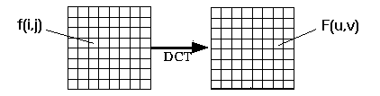
DCT Encoding
The general equation for a 1D (N data items) DCT is defined by the following equation:
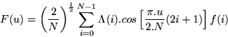
and the corresponding inverse 1D DCT transform is simple F⁻¹(u), i.e.:
where
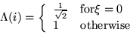
The general equation for a 2D (N by M image) DCT is defined by the following equation:
and the corresponding inverse 2D DCT transform is simple F⁻¹(u,v),
