Unit-III
Session Name | : | IIR Filter Design
Course Title | : | CS2403 -Digital Signal Processing
Semester | : | VII Semester
Programme Name | : | B.E
Author Name | : | Mrs.V.GANDHIMATHI
Department | : | ECE
Institution Name | : | VRS College of Engg. & Tech
Mobile Number | : | 9245582632
E-mail | : | adhihema02@gmail.com

Session -1

- Introduction: Structures of IIR
Suggested Activity: Introduces
Basic IIR Digital Filter Structures

- The causal IIR digital filters we are concerned with in this course are characterized by a real rational transfer function of or, equivalently by a constant coefficient difference equation
- From the difference equation representation, it can be seen that the realization of the causal IIR digital filters requires some form of feedback

- Direct form I &II
Suggested Activity: chalk and talk
- A cascade of the two structures realizing and leads to the realization of shown below and is known as the direct form I structure

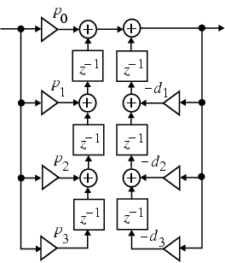

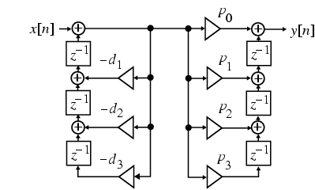
- Conclusion-Mind map
Suggested Activity: chalk and talk

Session -2
- Recap : Structures of IIR
Suggested Activity: Questions

- Cascade and parallel form
Suggested Activity: Board

- By expressing the numerator and the denominator polynomials of the transfer function as a product of polynomials of lower degree, a digital filter can be realized as a cascade of low-order filter sections
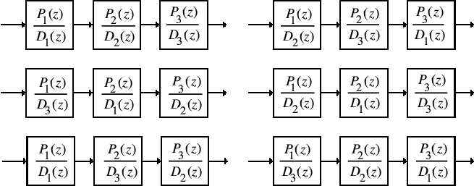

- A partial-fraction expansion of the transfer function in leads to the parallel form I structure

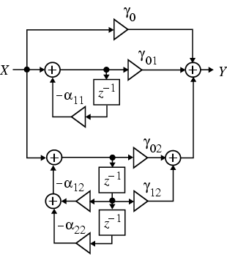
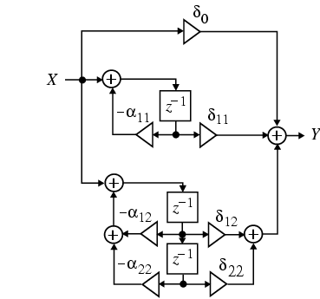
- Conclusion-Problems solved

Session -3
1. Introduction: Analog filter design
Suggested Activity: Introduces

Analogue Filter Design
- Frequency response of ideal LPF
To determine poles and order of filter ‘N’ and cutoff frequency
Suggested Activity: Chalk and talk

Digital filter - Wikipedia, the free encyclopedia
Designing of an IIR Filter from an Analog Filter

In electronics, computer science and mathematics, a digital filter is a system that performs mathematical operations on a sampled, discrete-time signal to reduce or enhance certain aspects of that signal. This is in contrast to the other major type of electronic filter, the analog filter, which is an electronic circuit operating oncontinuous-time analog signals. An analog signal may be processed by a digital filter by first being digitized and represented as a sequence of numbers, then manipulated mathematically, and then reconstructed as a new analog signal (see digital signal processing). In an analog filter, the input signal is "directly" manipulated by the circuit.
A digital filter system usually consists of an analog-to-digital converter to sample the input signal, followed by a microprocessor and some peripheral components such as memory to store data and filter coefficients etc. Finally a digital-to-analog converter to complete the output stage. Program Instructions (software) running on the microprocessor implement the digital filter by performing the necessary mathematical operations on the numbers received from the ADC. In some high performance applications, an FPGA or ASIC is used instead of a general purpose microprocessor, or a specialized DSP with specific paralleled architecture for expediting operations such as filtering.
Digital filters may be more expensive than an equivalent analog filter due to their increased complexity, but they make practical many designs that are impractical or impossible as analog filters. When used in the context of real-time analog systems, digital filters sometimes have problematic latency (the difference in time between the input and the response) due to the associated analog-to-digital and digital-to-analog conversions and anti-aliasing filters, or due to other delays in their implementation.
- Conclusion
Suggested Activity: Rapid fire
Questions:
- Draw the frequency of ideal LPF filter.
- Give the formula for poles of the filter.
- Write the formula for order of the filter.
- Give the cut off frequency of the filter.

Designing of an IIR Filter from an Analog Filter
http://en.wikipedia.org/wiki/Butterworth_filter

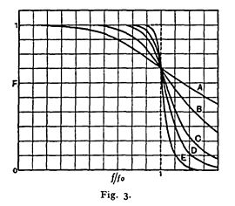

Session- 4
- Transfer function of the filters
Design of filters
Procedure
Suggested Activity: Writing board
A simple example of a Butterworth filter is the third-order low-pass design shown in the figure on the right, with C₂ = 4/3 F, R₄ = 1 Ω, L₁ = 3/2 H, and L₃ = 1/2 H.^{[3]} Taking the impedance of the capacitors C to be 1/Cs and the impedance of the inductors L to be Ls, where s = σ + jω is the complex frequency, the circuit equations yield the transfer function for this device:
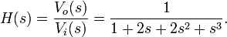
The magnitude of the frequency response (gain) G(ω) is given by
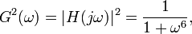
and the phase is given by
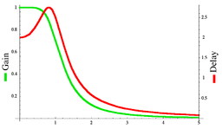
Gain and group delay of the third-order Butterworth filter with ω_{c}=1
The group delay is defined as the derivative of the phase with respect to angular frequency and is a measure of the distortion in the signal introduced by phase differences for different frequencies. The gain and the delay for this filter are plotted in the graph on the left. It can be seen that there are no ripples in the gain curve in either the passband or the stop band.
The log of the absolute value of the transfer function H(s) is plotted in complex frequency space in the second graph on the right. The function is defined by the three poles in the left half of the complex frequency plane.
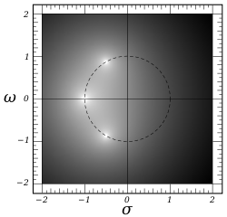
Log density plot of the transfer function H(s) incomplex frequency space for the third-order Butterworth filter with ω_{c}=1. The three poles lie on a circle of unit radius in the left half-plane.
These are arranged on a circle of radius unity, symmetrical about the real s axis. The gain function will have three more poles on the right half plane to complete the circle.
By replacing each inductor with a capacitor and each capacitor with an inductor, a high-pass Butterworth filter is obtained.
A band-pass Butterworth filter is obtained by placing a capacitor in series with each inductor and an inductor in parallel with each capacitor to form resonant circuits. The value of each new component must be selected to resonate with the old component at the frequency of interest.
A band-stop Butterworth filter is obtained by placing a capacitor in parallel with each inductor and an inductor in series with each capacitor to form resonant circuits. The value of each new component must be selected to resonate with the old component at the frequency to be rejected.

Transfer function[edit source | editbeta]
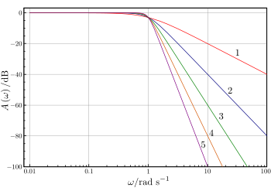
Plot of the gain of Butterworth low-pass filters of orders 1 through 5, with cutoff frequency . Note that the slope is 20ndB/decade where n is the filter order.
Like all filters, the typical prototype is the low-pass filter, which can be modified into a high-pass filter, or placed in series with others to form band-pass andband-stop filters, and higher order versions of these.
The gain of an n-order Butterworth low pass filter is given in terms of the transfer function H(s) as
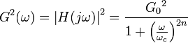
where
- n = order of filter
- ω_{c} = cutoff frequency (approximately the -3dB frequency)
- is the DC gain (gain at zero frequency)
It can be seen that as n approaches infinity, the gain becomes a rectangle function and frequencies below ω_{c} will be passed with gain , while frequencies above ω_{c} will be suppressed. For smaller values of n, the cutoff will be less sharp.
We wish to determine the transfer function H(s) where (from Laplace transform). Since H(s)H(-s) evaluated at s = jω is simply equal to |H(jω)|², it follows that
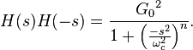
The poles of this expression occur on a circle of radius ω_{c} at equally spaced points. The transfer function itself will be specified by just the poles in the negative real half-plane of s. The k-th pole is specified by
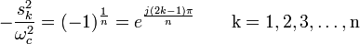
and hence;
The transfer function may be written in terms of these poles as
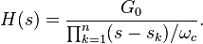
The denominator is a Butterworth polynomial in s.
- Conclusion :
Suggested Activity: Problem solving

Session -5

Introduction-Chebyshev filter approximation
Suggested Activity: Introduces
http://www.ece.uah.edu/courses/ee426/Chebyshev.pdf
- Type I and II filters
Suggested Activity: Writing board

- Conclusion : Questions and Answers

- Tell about chebyshev polynomial.
- What is type-I and II chebyshev filter
- Draw the frequency response curve.
- Write polynomial equation.

Session -6

Recap: Chebychev filter approximation
Suggested Activity: Brain storming

- Transfer function of the Chebychev filters
Suggested Activity: chalk and talk
http://www.matheonics.com/Tutorials/Chebyshev.html
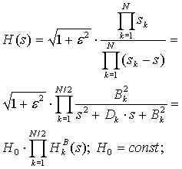
- Conclusion : Problem solving
Find transfer function for normalized chebyshev filter for N=2.

Session -7

Discrete time IIR filter from analog filter

Suggested Activity: Brain storming

Designing of an IIR Filter from an Analog Filter
Butter worth and chebychev filters

- From the specification find the order of the filter N.
- Round off it to the next higher integer.
- Find the Transfer function H(s) for Ω_{c} = 1 rad/sec for the value of N.
- Calculate the cut off frequency Ω_{c}
- Find the transfer function H_{a}(s) for the above value by substituting s/Ω_{c} in H(s)

Suggested Activity: Writing board
- Calculate the poles of chebyshev filter using,
- Sk = a cosøk +jb sinøk ; k = 1,2,……N
- Find the denominator polynomial of the transfer function using these poles.
- Numerator of the transfer function depends on the value of N
  - For odd N substitute s=0 in the denominator polynomial and find the value. This value is equal to the numerator
  - For even N substitute s=0 in the denominator polynomial and divide the result by √1+ε² This value is the numerator.
- Conclusion : Questions and answers

Session -8
- Introduction: IIR filter design
Suggested Activity: Introduces

Impulse invariance - Wikipedia, the free encyclopedia
Impulse invariance is a technique for designing discrete-time infinite-impulse-response (IIR) filters from continuous-time filters in which the impulse response of the continuous-time system is sampled to produce the impulse response of the discrete-time system. The frequency response of the discrete-time system will be a sum of shifted copies of the frequency response of the continuous-time system; if the continuous-time system is approximately band-limited to a frequency less than the Nyquist frequency of the sampling, then the frequency response of the discrete-time system will be approximately equal to it for frequencies below the Nyquist frequency
- Impulse invariant method
Suggested Activity: chalk and talk
(IIR) Filters by Using the Bilinear Transformation Method
- Bilinear transformation method
Suggested Activity: Board activity
- Conclusion: Formulas

Session -9
- Introduction : Approximation derivatives
Suggested Activity: Introduces

IIR Filter Design By Approximation Of Derivatives: (P) for DSP_class ...

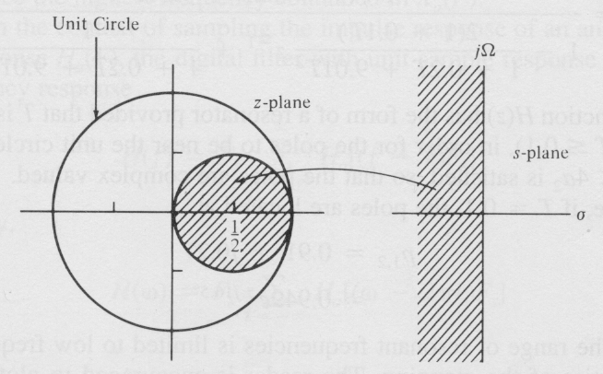
- Procedure
Suggested Activity: Presentation
- Frequency translation
http://www.mathworks.in/help/dsp/ug/digital-frequency-transformations.html

Frequency Transformation
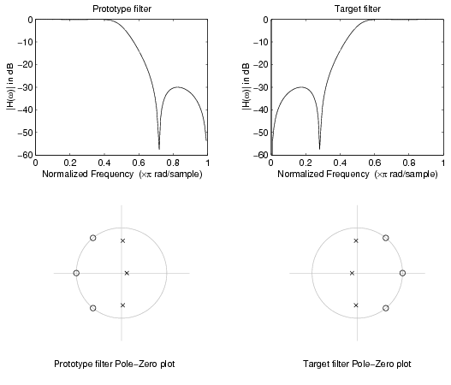
Suggested Activity: chalk and talk

Real Lowpass to Real Bandpass
Real lowpass filter to real bandpass filter transformation uses a second-order allpass mapping filter. It performs an exact mapping of two features of the frequency response into their new location additionally moving a DC feature and keeping the Nyquist feature fixed. As a real transformation, it works in a similar way for positive and negative frequencies.
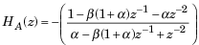
with α and β given by
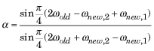
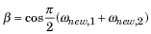
- Conclusion : Problem solving

