**Unit-IV**

|  |  |  |
| --- | --- | --- |
| **Session Name** | **:** | F IR Filter Design |
| **Course Title** | **:** | CS2403 -Digital Signal Processing |
| **Semester** | **:** | VII Semester |
| **Programme Name** | **:** | B.E |
|  | | |
| **Author Name** | **:** | Mrs.V.GANDHIMATHI |
| **Department** | **:** | ECE |
| **Institution Name** | **:** | VRS College of Engg. & Tech |
| **Mobile Number** | **:** | 9245582632 |
| **E-mail** | **:** | [adhihema02@gmail.com](mailto:adhihema02@gmail.com) |

**Session -1**

1. **Introduction: Structures of FIR**

[Filter **Structures** for **FIR filters** - the Signal Processing and Speech **...**](http://www.google.co.in/url?sa=t&rct=j&q=structures%20of%20fir%20filter&source=web&cd=2&cad=rja&ved=0CC8QFjAB&url=http%3A%2F%2Foldwww.spsc.tugraz.at%2Fcourses%2Fvwa%2Fpapergr3&ei=C80DUqXvLIaLrQeWwoDYDw&usg=AFQjCNGKukyZYT1y9I18fSirs_KD4P54oA&bvm=bv.50500085,d.bmk)

**Suggested Activity: Introduces**

1. **Direct form, cascade and linear phase realization**

**Suggested Activity: problem solving**

1. **Conclusion: Rapid fire**

The transfer function of an FIR filter is defined as follows:

http://zone.ni.com/images/reference/en-XX/help/371325F-01/equ_fir_transfer_function.gif

where z is a complex variable, M is the filter order, and h is the set of filter coefficients.

## <http://zone.ni.com/reference/en-XX/help/371325F-01/lvdfdtconcepts/fir_filter_specs/>

## FIR Direct Form

For FIR filters, the FIR Direct Form structure is the most straightforward structure from a filter transfer function perspective. The following figure represents the FIR Direct Form structure. The number of delays equals the filter order. Refer to the [Understanding Filter Structure Graphs](http://zone.ni.com/reference/en-XX/help/371325F-01/lvdfdtconcepts/dfd_structure_graph/) topic for information that helps you read and understand a filter structure graph.

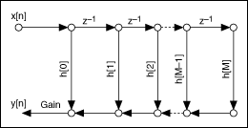

## FIR Direct Form Transposed

The FIR Direct Form Transposed structure is the alternate direct form implementation for FIR filters. The following figure represents the FIR Direct Form Transposed structure.

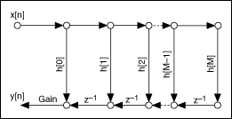

Both direct form structures contain the same number of delays. However, in the FIR Direct Form structure, the word length of the delays equals that of the input signal x[n]. In the FIR Direct Form Transposed structure, the word length of the delays equals that of the [accumulator](http://zone.ni.com/reference/en-XX/help/371325F-01/lvdfdtconcepts/dfd_structure_graph/). In most cases, the word length of the input signal is less than the word length of the accumulator. Therefore, the FIR Direct Form structure requires less memory for saving internal states than the transposed structure.

Both direct form structures also contain the same number of multipliers, which equals M+1. However, if you perform the multiplications in parallel and then perform summations on the multiplication products for both structures, the FIR Direct Form Transposed structure has better timing performance because the delays following the adders in this structure can store the summation results temporarily for performing the summations in parallel. However, the FIR Direct Form structure does not contain delays for the adders so the summations in this structure take more time. If you perform the multiplications and additions serially using a loop structure, the FIR Direct Form structure is more efficient because this structure requires less memory.

**Session -2**

1. **Introduction: Linear phase filters**

**Suggested Activity: Introduces**

### [Linear phase - Wikipedia, the free encyclopedia](http://www.google.co.in/url?sa=t&rct=j&q=linear%20phase%20fir%20filter&source=web&cd=1&cad=rja&ved=0CCkQFjAA&url=http%3A%2F%2Fen.wikipedia.org%2Fwiki%2FLinear_phase&ei=I80DUuG2H8-mrAe1poDAAQ&usg=AFQjCNEG06htwjCp7uQXSOybA4kT0kyDYg&bvm=bv.50500085,d.bmk)

<http://www.astro.rug.nl/~vdhulst/SignalProcessing/Hoorcolleges/college08.pdf>

**Linear phase** is a property of a [filter](http://en.wikipedia.org/wiki/Filter_(signal_processing)), where the [phase response](http://en.wikipedia.org/wiki/Phase_response) of the filter is a [linear function](http://en.wikipedia.org/wiki/Linear_function) of [frequency](http://en.wikipedia.org/wiki/Frequency), excluding the possibility of wraps at \pm\pi. In a [causal system](http://en.wikipedia.org/wiki/Causal_system), perfect linear phase can be achieved with a [discrete-time](http://en.wikipedia.org/wiki/Discrete-time) [FIR](http://en.wikipedia.org/wiki/Finite_Impulse_Response) filter.

Since a linear phase (or [generalized linear phase](http://en.wikipedia.org/wiki/Linear_phase#Generalized_linear_phase)) filter has constant [group delay](http://en.wikipedia.org/wiki/Group_delay), all frequency components have equal delay times. That is, there is no distortion due to the time delay of frequencies relative to one another; in many applications, this constant group delay is advantageous. By contrast, a filter with *non-linear phase* has a group delay that varies with frequency, resulting in [phase distortion](http://en.wikipedia.org/wiki/Phase_distortion).

A filter with linear phase may be achieved by an FIR filter which is either symmetric or anti-symmetric. A necessary but not sufficient condition is \sum_{n =-\infty}^\infty h[n] \cdot \sin(\omega \cdot (n - \alpha) + \beta)=0 for some \alpha, \beta

1. **Symmetric and anti symmetric FIR filters**

<http://zone.ni.com/reference/en-XX/help/371325F-01/lvdfdtconcepts/fir_filter_specs/>

## FIR Symmetric

Use the FIR Symmetric structures for symmetric linear phase FIR filters, which use the symmetry of the filter coefficients to reduce the number of multipliers from M+1 to M/2+1, when M is an even number, or (M+1)/2, when M is an odd number. The following figure represents the FIR Symmetric structure when the filter order is an even number.

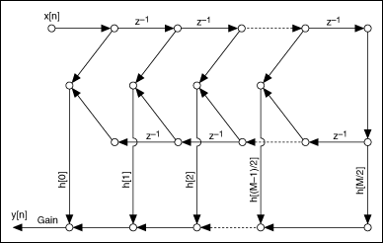

The following figure represents the FIR Symmetric structure when the filter order is an odd number.

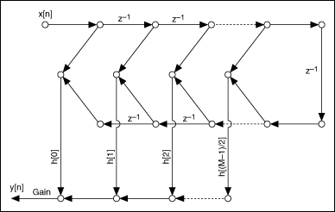

## FIR Anti symmetric

Use the FIR Anti symmetric structure for anti symmetric linear phase FIR filters, which use the anti symmetry of the filter coefficients to reduce the number of multipliers from M+1 to M/2, when M is an even number, or (M+1)/2, when M is an odd number. The following figure represents the FIR Anti symmetric structure when the filter order is an even number.

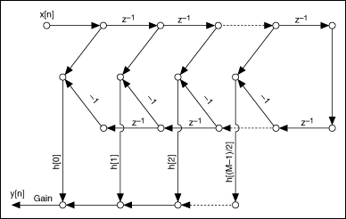

The following figure represents the FIR Anti symmetric structure when the filter order is an odd number.

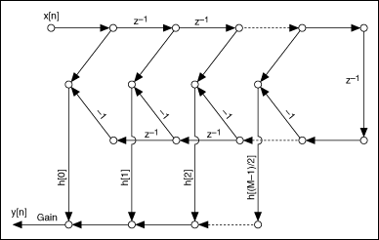

**Suggested Activity: problem solving**

1. **Symmetric and N –odd & even**

**Suggested Activity: writing board**

1. **Conclusion: Brain storming**

Questions:

1. Define FIR.
2. Advantages of FIR
3. Disadvantages of FIR.

**Session -3**

1. **Recap: Linear phase filters**

**Suggested Activity: Questions**

1. **Anti symmetric and N is even & odd**

**Suggested Activity: chalk and talk**

1. **Conclusion: Questions and answers**

Questions:

1. What are linear filters?
2. Write the expression for frequency response for h(n) is symmetric and Nis even & odd.
3. Define phase delay
4. What is group delay?

**Session -4**

1. **FIR filter using window techniques:**

<http://www.ece.uvic.ca/~andreas/ISCASTutorial/Part%201-FIR%20Filters-Window%20Method.pdf>

<http://www.youtube.com/watch?v=1N94cQYPZmU>

**Suggested Activity: Quizzing and formulas**

1. **Characteristics and frequency response of the window function**

**Suggested Activity: PPT**

1. **Conclusion: Brain storming**

**Session -5**

1. **Recap: window function**

**Suggested Activity: mind map**

1. **Rectangular and hamming window**

<http://www.ijarcsse.com/docs/papers/June2012/Volume_2_issue_6/V2I600260.pdf>

**Suggested Activity: presentation and formulas**

1. **Conclusion: board activity**

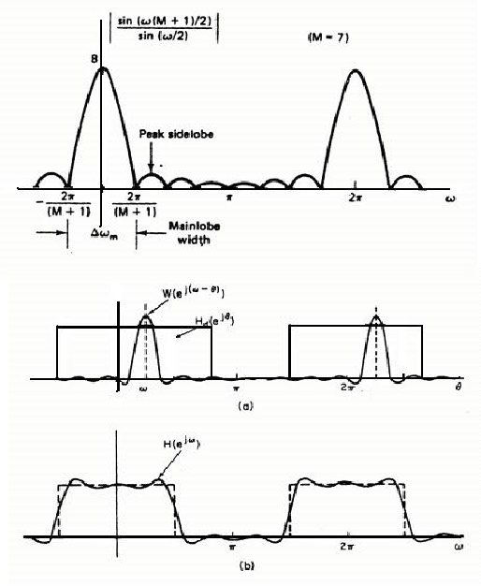

**Session -6**

1. **Recap: Rectangular window**

**Suggested Activity: formulas**

* **How to reduce the Gibbs phenomenon?**

**(1 )Narrow main lobe width**

**(2)Side lobe energy decrease to zero when w reaches**

****

1. **Hanning and blackmann window**

**Suggested Activity: chalk and talk**

****

****

1. **Conclusion: board activity**

**Session -7**

1. **Recap: hamming window**

****

**Suggested Activity: mind map**

1. **Kaiser and Barlett window**

**Suggested Activity: board**

<http://my.safaribooksonline.com/book/electrical-engineering/communications-engineering/9780132598804/fir-filter-design/ch36>

Perform the following steps to approximate the ideal lowpass filter response.

1. Based on the intended application, determine the following:
   * the normalized passband edge frequency, *λP*
   * the normalized stopband edge frequency, *λS*
   * the maximum tolerable passband ripple, δ*P*
   * the maximum tolerable stopband ripple, δ*S*
2. Determine the transition width, Δλ, as

Δλ = λ*s* – λ*p*

1. Set δ equal to the smaller of δ*P* or δ*S*, and compute *A* as

*A* = –20log10δ

1. Use the value of *A* computed in step 3 to determine the value for β[**[\*]**](javascript:moveTo('ch36fn01');) as
2. Determine the required number of taps, *N*, as
3. Compute the window coefficients as
4. For , compute *h*[*n*] and *h*[*N* – 1 – *n*] as

where *m* = *n* –(*N* – 1)/2.

1. If *N* is odd, compute *h*[(*N* – 1)/2] as
2. Check the filter response against the conditions specified in step 1. If the filter meets the specified conditions, the design is complete. If the filter response does not meet the specifications, increase *N* by 1, and return to step 6.
3. **Conclusion: problem solving**

**Session -8**

1. **Introduction: Frequency sampling techniques**

### [De sign FIR Filter*by the*Frequency Sampling Method*Introduction ...*](http://www.google.co.in/url?sa=t&rct=j&q=fir%20filter%20design%20using%20frequency%20sampling%20technique&source=web&cd=2&cad=rja&ved=0CC4QFjAB&url=http%3A%2F%2Fwljx.hdu.edu.cn%2Feol%2Fcommon%2Ffckeditor%2Fopenfile.jsp%3Fid%3DDBCPDCDADCDBDECPEDGIGBHAGBDFCAEGEJFCCAEGGJGMHEGFHCCAEBHAHAHCGPHIGJGNGBHEGJGPGOHDCOHAHAHE&ei=hc0DUsrzIYm0rAfOs4DoDQ&usg=AFQjCNETpYR_6PzupkWQ13LhQ1tJg2fy7Q&bvm=bv.50500085,d.bmk)

The Frequency Sampling Technique In this method, [Park87], [Rab75], [Proakis00] the desired frequency response is provided as in the previous method. Now the given frequency response is sampled at a set of equally spaced frequencies to obtain N samples. Thus, sampling the continuous frequency response Hd(w) at N points essentially gives us the N-point DFT of Hd(2pnk/N). Thus by using the IDFT formula, the

filter co-efficient can be calculated using the following formula h(n)=Now using the above N-point filter response, the continuous frequency response is calculated as an interpolation of the sampled frequency response. The approximation error would then be exactly zero at the sampling frequencies and would be finite in frequencies between them. The smoother the frequency response being approximated, the smaller will be the error of interpolation between the sample points. One way to reduce the error is to increase the number of frequency samples [Rab75]. The other way to improve the quality of approximation is to make a number of frequency samples specified as unconstrained variables. The values of these unconstrained variables are generally optimized by computer to minimize some simple function of the approximation error e.g. one might choose as unconstrained variables the frequency samples that lie in a transition band between two frequency bands in which the frequency response is specified e.g. in the band between the pass band and the stop band of a low pass filter.

**Suggested Activity: Introduces**

<http://www.ee.iitb.ac.in/~esgroup/es_mtech02_sem/es02_sem_rep_arojit.pdf>

1. **Procedure and problems**

**Suggested Activity: problem solving**

1. **Conclusion: Tit for tat**

**Session -9**

1. **Introduction: finite word length effects**

**Suggested Activity: Introduces**

### Finite Word length Effects*-*

### Finite register lengths and A/D converters cause errors in:-

### (i) Input quantisation.

### (ii) Coefficient (or multiplier) quantisation

### (iii) Products of multiplication truncated or rounded due to machine length

1. **Rounding and truncation**

**Suggested Activity: board activity**

**With finite precision the response does not converge to the origin but assumes cyclically a set of values –the Limit Cycle**

* **For rounding operations *q*(*n*) is uniform distributed where *Q* is the quantisation step (i.e. in a word length of bits with sign magnitude representation or mod 2**
* **A discrete-time system with quantisation at the output of each multiplier may be considered as a multi-input linear system**

**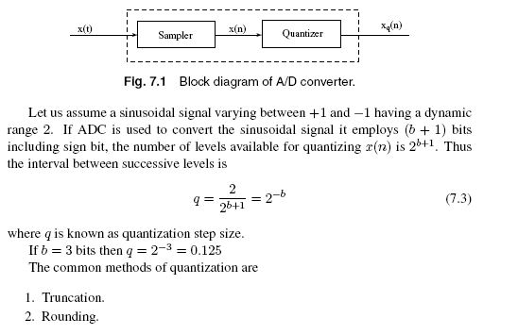**

1. **Conclusion: brain storming**

**Questions:**

* + 1. What is quantization?
    2. Define rounding
    3. Define truncation
    4. What do you meant by quantization noise?