**Session Input**

**Unit-V**

|  |  |  |
| --- | --- | --- |
| **Session Name** | **:** | Applications |
| **Course Title** | **:** | CS2403 -Digital Signal Processing |
| **Semester** | **:** | VII Semester |
| **Programme Name** | **:** | B.E |
|  | | |
| **Author Name** | **:** | Mrs.V.GANDHIMATHI |
| **Department** | **:** | ECE |
| **Institution Name** | **:** | VRS College of Engg. & Tech |
| **Mobile Number** | **:** | 9245582632 |
| **E-mail** | **:** | [adhihema02@gmail.com](mailto:adhihema02@gmail.com) |

**Session -1**

1. **Introduction: Multirate signal processing**

**Suggested Activity: Introduces**

<https://www.google.co.in/?gws_rd=cr&ei=DExFUubNN4WHrgeDkICwBg#q=multirate+signal+processing>

1. **Decimation and interpolation**

**Suggested Activity: chalk and talk**

<http://users.abo.fi/htoivone/courses/sbappl/asp_chapter2.pdf>

1. **Conclusion: Recall by keywords**
2. **D**
3. **I**
4. **Up sampling**
5. **Down sampling**











**Session -2**

1. **Introduction: phase shifters**

**Suggested Activity: Discussion**

<http://www.qsl.net/va3iul/Phase_Shifters/Phase_Shifters.pdf>

1. **Design of phase shifters**

**Suggested Activity: PPT**

<http://en.wikipedia.org/w/index.php?search=phaseshifters&button=&title=Special%3ASearch>

**3. Conclusion: Rapid fire**

a. What are phase shifters?

b. Give applications of phase shifters?

c. Purpose of poly phase structure.



**Session -3**

1. **Introduction: digital filters**

**Suggested Activity: Introduces**

1. **Implementation of digital filter banks**

**Suggested Activity: writing board**

1. **Sub band coding of speech signals and quadrature mirror filters**

<http://www.compandent.com/>

**Suggested Activity: PPT**



1. **Conclusion: Questions and answers**
2. **Define sub band coding**
3. **What is digital filter bank?**
4. **Explain quadrature mirror filter.**

**Session -4**

1. **Introduction: ADC**

**Suggested Activity: Recall by words**

**Words:**

1. **Sampling.**
2. **Sampling theorem**
3. **Quantization**
4. **Continuous time signal**

<http://www.mds.com/products/s042?gclid=CIGf-I-htLoCFWFS4godrDQAJQ>

1. **Transmultiplexers and AD/DA conversions**

**Suggested Activity: PPT**





1. **Speech compression**

**Suggested Activity: PPT**

1. **Conclusion: Questions**
2. **Define ADC.**
3. **State sampling theorem.**
4. **Give the purpose of transmultiplexers.**
5. **What is speech compression?**

**Session -5**

1. **Introduction: Adaptive filters**

**Suggested Activity: PPT**

<http://www.eas.asu.edu/~dsp/grad/anand/java/AdaptiveFilter/Zero.html>

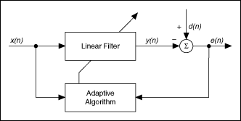

**Applications**

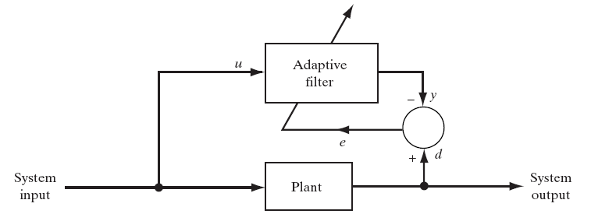

* **Parameters**
  + **u=input of adaptive filter=output to plant**
  + **y=output of adaptive filter**
  + **d=desired response=delayed system input**
  + **e=d-y=estimation error**

1. **Wiener filters , LMS and RLS algorithm**

**Suggested Activity: PPT and board**

* **The LMS Algorithm consists of two basic processes**
  + **Filtering process**
    - **Calculate the output of FIR filter by convolving input and taps**
    - **Calculate estimation error by comparing the output to desired signal**
  + **Adaptation process**
    - **Adjust tap weights based on the estimation error**

<http://www.eas.asu.edu/~dsp/grad/anand/java/ANC/ANC.html>

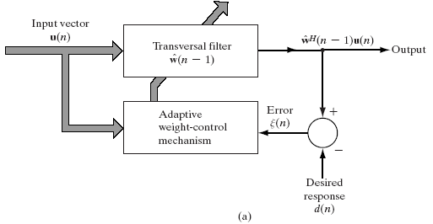

1. **Conclusion: Recall and list by key words**

**Words:**

1. **Adaptive filter.**
2. **LMS**
3. **RLS**
4. **FIR**
5. **IIR**

**Session -6**

1. **Introduction: Musical sound processing**

[www.eetindia.co.in/](https://maps.google.co.in/aclk?sa=l&ai=C_rbydZFrUvzaGuuqiQf554G4DYWzh_cDv8P4tgWthd7aRxABIMBUULTxpoP5_____wFg5ZLog9gOoAHb7MD6A8gBAakCO1qSqI4Phj6qBChP0KvPluVwEtJu7aX1N_-VHTOofQLMv_TmCu4E4FcHaVAjKcRM7wBwgAeNk78FkAcD&num=3&sig=AOD64_2mHkkQvv4SHELeMJ8qxf2r3F4a6g&adurl=http://www.eetindia.co.in/CAT_1800002_signals.HTM%3Frefer%3Dgoogle_cpc)

**Suggested Activity: Analogy**

1. **Audio processing**

**Suggested Activity: Presentation**

1. **Conclusion: Recall by writing**

**Sound production**

**Echoes**

**Audio sound**

**Session -7**

1. **Introduction: Image enhancement**

<http://www.r-s-c-c.org/node/225>

**Suggested Activity: Discussion & questionnaires**

1. **What is image?**
2. **What are the features of image?**
3. **Histogram equalization**

**The histogram of a digital image with gray levels in the range [0, L-1] is a discrete**

**function *h(rk)=nk* , where *rk* is the kth gray level and nk is the number of pixels in the**

**image having gray level *rk*. It is common practice to normalize a histogram by dividing each of its values by the total number of pixels in the image, denoted by the product MN.**

**Thus, a normalized histogram is given by h(rk)=nk/MN**

**Suggested Activity: Presentation**

* **Let rk, k∈[0..L-1] be intensity levels and let p(rk) be its normalized histogram function.**
* **The intensity transformation function for histogram equalization is**



**3. Conclusion: Brain storming**

**a. What is image enhancement?**

**b. Define histogram processing.**

**c. What do you mean by equalization?**

**Session -8**

1. **Introduction: Median**

**Suggested Activity: Introduces and questions**

1. **Geometric, Harmonic and Contra median:**

<http://www.maxvalue.com/tip104.htm>

**Suggested Activity: Chalk and talk**

**Consecutive terms of a geometric sequence are proportional**

**Consider the geometric sequence with a common factor 10.**





1. **Conclusion: Rapid fire**
2. **Define median.**
3. **What is geometric median?**
4. **Define Harmonic median.**
5. **What do you by contra median?**

**Session -9**

1. **Recap: filtering**

**Suggested Activity: Brain storming**

<http://cilab.knu.ac.kr/seminar/Seminar/2010/20101009%20Colour%20Image%20Enhancement%20by%20Virtual%20Histogram%20Approach.pdf>

1. **Color Image enhancement**



**Suggested Activity: PPT**

1. **DSP processor**

**Suggested –Activity: Demonstration**

**4. Conclusion: Tit for tat**

