**UNIT II**

**SESSION 1**

**Topic:**

* Need for security
* Business needs

**Date:** 20.7.13

**Period:** 3

**Web links:**

<http://jwfiles.net/99avpz4zmhyn/IS_notes-ppt_s.rar.html>

**Suggested Activity: Puzzle**



**Conclusion :**

By the above activity the students got an idea about the Need for security and the business needs and functions.

**SESSION 2**

**Topic:**

* Threats
* Categories
* Deliberate act of information exortion
* Deliberate act of sabotage or vandalism
* Deliberate act of theft
* Deliberate software attacks
* Deviations in QoS

**Date:** 20.7.13

**Period:** 3

**Web links:**

[http://www.cse.hcmut.edu.vn/~tqchi/ISS/Presentations/Threats_and_Attacks_to_Information_Security.ppt](http://www.cse.hcmut.edu.vn/%7Etqchi/ISS/Presentations/Threats_and_Attacks_to_Information_Security.ppt).

**Suggested Activity: Recall by keywords**

* Infosec functions

-protection

- collection safeguard

* Issues
  + management
  + People

**Suggested Activity: pick ‘n’ answer**

|  |  |
| --- | --- |
| **A** | **B** |
| **C** | **D** |

1. Threat

Threat is an object, person, or other entity that represents a constant danger to an asset

1. How management protects information?

Through policy, education and training, and technology controls

1. How many categories of threats?

12 categories

1. Acts of Human Error or Failure is caused by?
   1. Inexperience
   2. Improper training
   3. Incorrect assumptions
   4. Other circumstances

**Conclusion :**

By the above activities the students got an idea about Threats and its Categories

**SESSION 3**

**Topic:**

* Threats
* Categories
* Technical hardware failure or errors
* Technical software failure or errors
* Technological obsolescence
* Compromises to Intellectual property

**Date:** 23.7.13

**Period:** 5

**Web links:**

[http://www.cse.hcmut.edu.vn/~tqchi/ISS/Presentations/Threats_and_Attacks_to_Information_Security.ppt](http://www.cse.hcmut.edu.vn/%7Etqchi/ISS/Presentations/Threats_and_Attacks_to_Information_Security.ppt).

**Suggested activity: Recall by keywords**

1.Infosec functions

* + protection
  + collection
  + safeguard

2. Issues

* + management
  + People

**Suggested activity: pick ‘n’ answer**

|  |  |
| --- | --- |
| **10** | **20** |
| **30** | **40** |

10. What are the Communications and Other Services?

* + - telephone
    - water & wastewater
    - trash pickup
    - cable television

20.Threat of loss of services can lead to?

Inability to function properly

30.Voltage levels?

* + - * spike – momentary increase
      * surge – prolonged increase
      * sag – momentary low voltage
      * brownout – prolonged drop
      * fault – momentary loss of power
      * blackout – prolonged loss

1. Hackers use what?

skill, guile, or fraud to steal the property of someone else

**Conclusion :**

By the above activities the students got an idea about Threats and its Categories

**SESSION 4**

**Topic:**

* Attacks
* Malicious code & hoaxes
* Backdoors & password crack
* Brute force
* Spoofing
* Man-in-the middle

**Date:** 24.7.13

**Period:** 1

**Web links:**

[http://www.cse.hcmut.edu.vn/~tqchi/ISS/Presentations/Threats_and_Attacks_to_Information_Security.ppt](http://www.cse.hcmut.edu.vn/%7Etqchi/ISS/Presentations/Threats_and_Attacks_to_Information_Security.ppt).

<https://www.youtube.com/watch?v=dAEb_-YBDiM>

<https://www.youtube.com/watch?v=aCMtX17CiKw>

**Suggested activity: pick ‘n’ answer/ show and tell**

* An attack is the deliberate act that exploits vulnerability

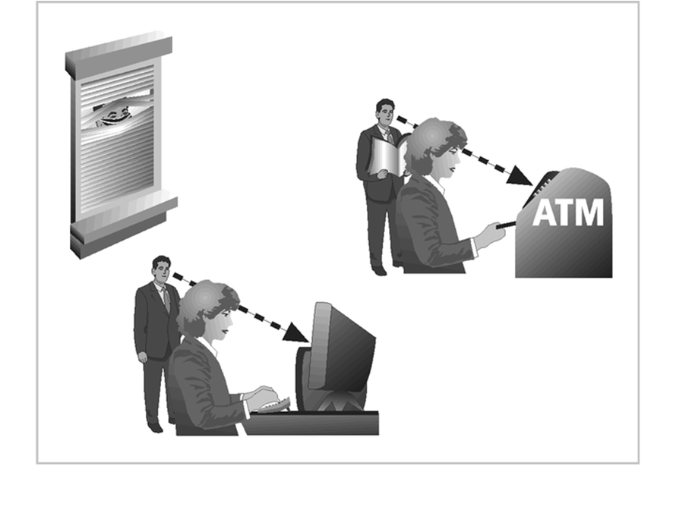

**Answer: Shoulder surfing attack**

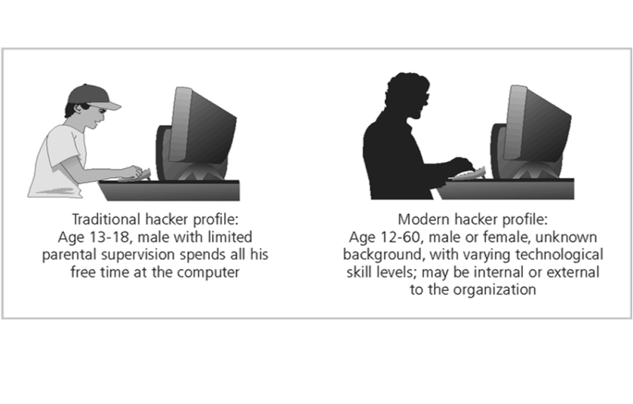

**Answer: hacker profile**

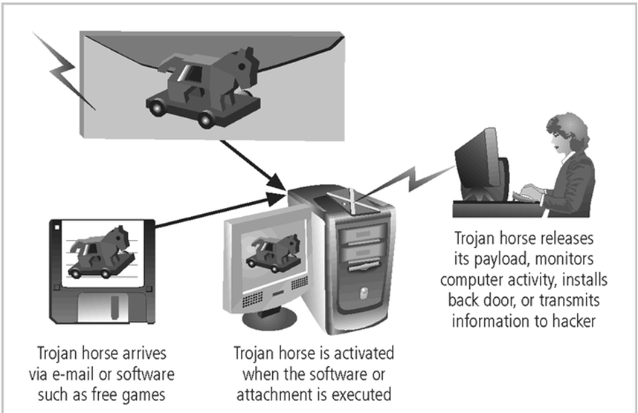

**Answer: Trojan horse attack**

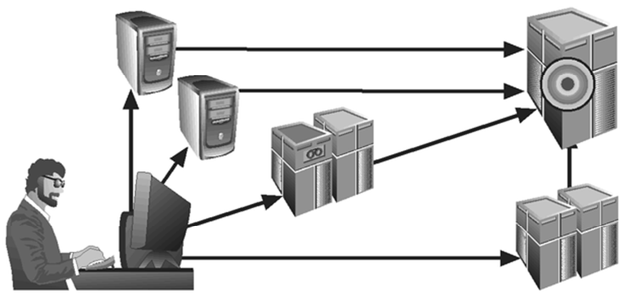

**Answer: DOS attack**

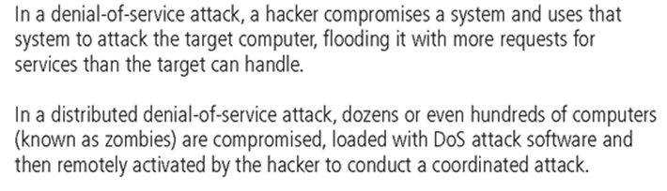

**Conclusion :**

By the above activities the students got an idea about attacks.

**SESSION 5**

**Topic:**

* Attacks
* Mail-bombing
* Sniffers
* Buffer Overflow
* Timing Attack

**Date:** 26.7.13

**Period:** 6

**Web links:**

<http://u.cs.biu.ac.il/~doronp/security.ppt>

**Suggested activity: crossword**



**Suggested activity: Questioning**

1. What is Mail-bombing?

- another form of e-mail attack that is also a DoS, in which an attacker routes large quantities of e-mail to the target

1. Define Sniffers

- a program and/or device that can monitor data traveling over a network.

1. What is Buffer Overflow ?
   * application error occurs when more data is sent to a buffer than it can handle
   * when the buffer overflows, the attacker can make the target system execute instructions, or the attacker can take advantage of some other unintended consequence of the failure
2. What is Timing Attack?
   * works by exploring the contents of a web browser’s cache
   * can allow collection of information on access to password-protected sites

**Conclusion :**

By the above activities the students got an idea about attacks.

**SESSION 6**

**Topic:**

* Legal, ethical & professional issues

**Date:** 27.7.13

**Period:** 3

**Web links:**

<http://www.cse.hcmut.edu.vn/~tqchi/ISS/Presentations/Threats_and_Attacks_to_Information_Security.ppt>

**Suggested activity: rabik cube**

|  |  |  |
| --- | --- | --- |
| A | B | E |
| C | D | F |

1. Define attack.

An attack is the deliberate act that exploits vulnerability

1. What is Malicious Code?

This kind of attack includes the execution of viruses, worms, Trojan horses, and active web scripts with the intent to destroy or steal information

1. What is Unprotected Shares

Using file shares to copy viral component to all reachable locations

1. Denial-of-service (DoS)?

Attacker sends a large number of connection or information requests to a target

1. Spam ?

Unsolicited commercial e-mail - while many consider spam a nuisance rather than an attack

1. Social Engineering ?

The process of using social skills to convince people to reveal access credentials or other valuable information to the attacker

**Suggested activity: puzzle**



**Conclusion :**

By the above activities the students got an idea about Legal, ethical & professional issues

**SESSION 7**

**Topic:**

Legal, ethical & professional issues

**Date: 27**.7.13

**Period:** 8

**Web links:**

<http://jwfiles.net/99avpz4zmhyn/IS_notes-ppt_s.rar.html>

<http://www.csudh.edu/Eyadat/classes/CIS378/handouts/Legal,%20Ethical,%20and%20Professional%20Issues%20In.ppt>

<http://www.kuroski.net/DA107/spring-2012/9781111138219_PPT_ch03.ppt>

**Suggested activity: pick ‘n’ Answer**

|  |  |
| --- | --- |
| **AA** | **BB** |
| **CC** | **DD** |

AA. Civil law?

Civil law seeks to resolve non-criminal disputes such as disagreements over the meaning of contracts, property ownership, divorce, child custody, and damages for personal and property damage.

BB. Criminal law?

A body of rules and statutes that defines conduct prohibited by the government because it threatens and harms public safety and welfare and that establishes punishment to be imposed for the commission of such acts.

CC. Public law?

Body of [law](http://www.businessdictionary.com/definition/law.html) governing relations between a state and its [citizens](http://www.businessdictionary.com/definition/citizen.html), and [dealing](http://www.businessdictionary.com/definition/dealer.html) with the [structure](http://www.businessdictionary.com/definition/structure.html) and [operation](http://www.businessdictionary.com/definition/operation.html) of the [government](http://www.businessdictionary.com/definition/government.html).

DD. Tort law?

A body of rights, obligations, and remedies that is applied by courts in civil proceedings to provide relief for persons who have suffered harm from the wrongful acts of others.

**Suggested activity: puzzle**



**Conclusion :**

By the above activities the students got an idea about Legal, ethical & professional issues

**SESSION 8**

**Topic:**

Legal, ethical & professional issues

**Date:** 30.7.13

**Period:** 5

**Web links:**

<http://jwfiles.net/99avpz4zmhyn/IS_notes-ppt_s.rar.html>

<http://jwfiles.net/99avpz4zmhyn/IS_notes-ppt_s.rar.html>

<http://www.csudh.edu/Eyadat/classes/CIS378/handouts/Legal,%20Ethical,%20and%20Professional%20Issues%20In.ppt>

<http://www.kuroski.net/DA107/spring-2012/9781111138219_PPT_ch03.ppt>

**Suggested activity: Tit for tat**

1. List relevant US laws

* Computer Fraud and Abuse Act of 1986
* National Information Infrastructure Protection Act of 1996
* USA Patriot Act of 2001
* Telecommunications Deregulation and Competition Act of 1996
* Communications Decency Act (CDA)
* Computer Security Act of 1987
* The Health Insurance Portability & Accountability Act Of 1996 (HIPAA) also known as the Kennedy-Kassebaum Act
* The Financial Services Modernization Act or Gramm-Leach-Bliley Act of 1999

2.Export and Espionage Laws

* Freedom of Information Act of 1966 (FOIA)
* Economic Espionage Act (EEA) of 1996
* Security and Freedom Through Encryption Act of 1997 (SAFE)

**Suggested activity: Quiz**

1. List any 4 commandments of Ethical Concepts in Information Security

* Thou shalt not snoop around in other people's computer files.
* Thou shalt not use a computer to steal.
* Thou shalt not use a computer to bear false witness.
* Thou shalt not copy or use proprietary software for which you have not paid.

1. What is Cultural Differences in Ethical Concepts?

Differences in cultures cause problems in determining what is ethical and what is not ethical

1. Whys ethical & legal training is important?

Proper ethical and legal training is vital to creating an informed, well prepared, and low-risk system user

1. Define Deterrence

Preventing an illegal or unethical activity

1. List 3 conditions for Laws and policies

Laws and policies only deter if three conditions are present:

* Fear of penalty
* Probability of being caught
* Probability of penalty being administered

**Conclusion :**

By the above activities the students got an idea about Legal, ethical & professional issues

**SESSION 9**

**Topic:**

Legal, ethical & professional issues

**Date:** 1.8.13

**Period:** 2

**Web links:**

<http://jwfiles.net/99avpz4zmhyn/IS_notes-ppt_s.rar.html>

<http://jwfiles.net/99avpz4zmhyn/IS_notes-ppt_s.rar.html>

<http://www.csudh.edu/Eyadat/classes/CIS378/handouts/Legal,%20Ethical,%20and%20Professional%20Issues%20In.ppt>

<http://www.kuroski.net/DA107/spring-2012/9781111138219_PPT_ch03.ppt>

**Suggested activity: rapid fire quiz**

1. Deterrents examples?

Laws, policies, and technical controls are all examples of deterrents

2. What does ethical sensitivity reveal?

Studies of ethical sensitivity to computer use reveal different nationalities have different perspectives

3. Define policies

Policies function in an organization like laws

**Suggested activity:puzzle**



**Conclusion :**

By the above activities the students got an idea about Legal, ethical & professional issues