UNIT – I
INTRODUCTION
Session 1

1.Introduction to Optical communication system : Video presentation
http://www.youtube .com/ watch?v=2P3nKJHO2j0
http://www.youtube .com/ watch?v=B156Cc1.kzzc
http://www.youtube .com/ watch?v=PrEF9UN98cE
video demonstrating the optical fiber communication
2. Three windows of operation : PPT slides.
http://www.authorstream.com/Presentation/ssasikalaraja-1569497-optical-fibers-devices/
First generation –850 nm ,
Second generation-1300 nm
Third generation -1550nm
Explanation for each window of operation and the reason for shifting to third window
3. Elements of Optical communication: Show and Tell , PPT slides
Explanation for sources, detectors ,connectors ,splices, couplers
Pictures of the (sources) -LED ,LASER (detectors)- PIN ,Avalanche photo diode , Connectors were displayed and the learners identifies and remembers
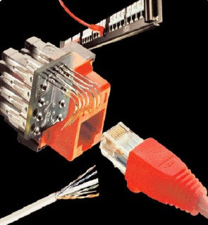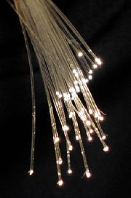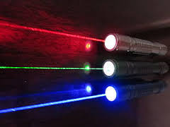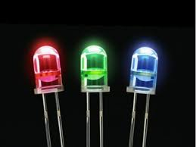
Connector Optical fiber Laser LED
4. Advantages& Disadvantages of OFC : Board activity
Advantages :
i. low cost
ii. light weight
iii. larger bandwidth
iv. Immunity to EMI
v. High security
Disadvantages : High installation cost
5. Conclusion : Question & Answer
The following questions can be asked to ensure that the learners have gained a good understanding of the concepts discussed so far
Sample questions : Answers:

- List the advantages of OFC. 1.Low cost, light weight , Higher BW etc.,
- The third window operates at ----- 2. 1550 nm
- Tell the basic components of OFC 3. Sources, detectors ,connectors ,splices, couplers
- List the sources and detectors. 4. LED , LASER -Optical source
Avalanche and PIN photo diode – Optical detectors
Session 2
- Recap: Recall by keywords
Students were divided into 4 groups. SM(Single Mode ),MM(Multi Mode) ,SI(Step Index ) , GI ( Graded Index). The facilitator lists the important keywords of last session. . Each group is given a chance to discuss about the keyword listed .one mark allotted for each correct answer .facilitator records the score
Sample keywords :
Connectors – temporary joint , under human control
Splices- permanent joint , fusion joints where human cannot intervene
Couplers- used to divide or to combine optical power

- Total Internal Reflection: PPT slides, Video
Video demonstrating the TIR Phenomenon. http://course.ee.ust.hk/elec342/notes/lecture2_ray%20theory%20transmission.pdf
http://www.youtube.com/watch?v=axwDkA9PrgI
http://hyperphysics.phy-astr.gsu.edu/hbase/phyopt/totint.html

Explanation for TIR is presented .when θ _{i} > θ c TIR occurs .
θ _{i} ⁼ θ c refracted ray is 90⁰
θ _{i} < θ c Refraction
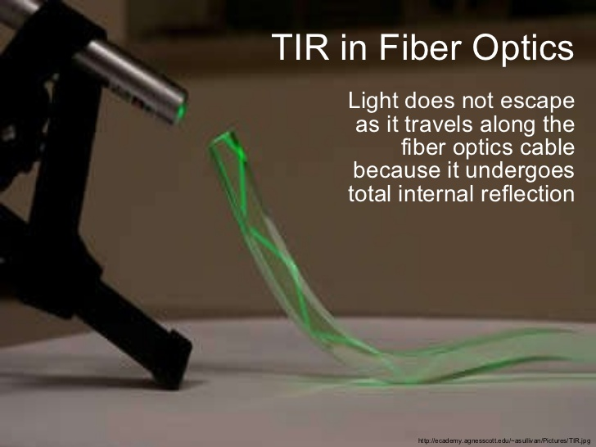
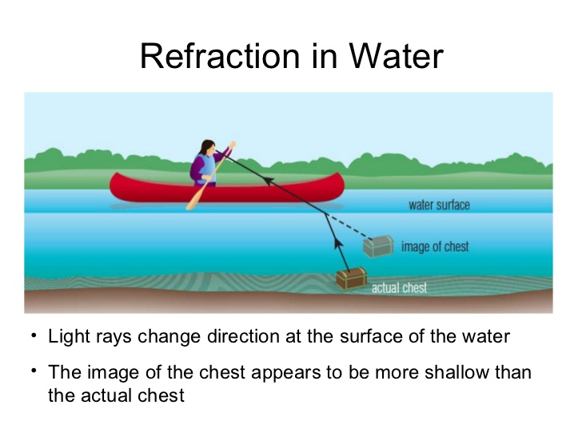

- Acceptance angle & Numerical Aperture : PPT slides / Board activityy
Slides depicting the acceptance cone
http://etd.lib.fsu.edu/theses/available/etd-11202003-060632/unrestricted/09_psm_Chapter2.pdf
http://whww.youtube.com/watch?v=axwDkA9PrgI

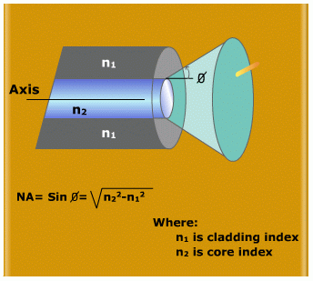
- Conclusion: Problem solving

Learners are divided in to 3 per group and problem given for each group & instructed to solve the problem. Review the answers for all given problems
Sample problem: A silica optical fiber with a core diameter large enough to be considered by ray theory analysis has a core refractive index of 1.50 and a cladding refractive index of 1.47.
Determine: a) The critical angle at the core-cladding interface.
b) The NA for the fiber.
c) The acceptance angle in air for the fiber.
Solution : a)The critical angle φc at the core- cladding interface is given by
Eq. sinφc = n2 / n1
φc = sin⁻¹⁽n2 / n1) = sin⁻¹ 1.47/1.50 = 78.50
b) NA = (n1² - n2²) ½ = (1.50² - 1.47²) ½ =(2.25 - 2.16) ½ =0.30
c) θa=sin-1 NA = sin-1 0.30 =17.4⁰

Session 3
- Recap: Word puzzle
Choose a letter from the knowledge circle and Find the answer from the given letters in the circle

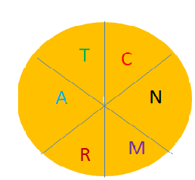

For example N -Numerical Aperture
- Gives the relationship between acceptance angle , refractive indices n₁,n₂
- Light collecting ability of the fiber
- NA= Sin θa = (n₁² - n₂² ) ^{½}
- NA = n₁ (2∆ ) ^{1/2}

- Types of fibers:- PPT slides
Step index , Graded index -Single mode fiber, Multimode fiber
www.orientaluniversity.in/wp-content/uploads/14.ppt‎

- Single mode and Multimode structures: Story telling , PPT slides
http://www.photond.com/products/fimmwave/fimmwave_applications_02.htm
www.ece.msstate.edu/~winton/classes/.../fibers/OpticalFiberModes.pp
In a village there lived an old man named Joel .He had three sons Sim ,Sam, Sil. One day he called his sons to build their own houses .He gave equally sized land and told them to make use of the entire area available to each of them The .three of them built houses but each one was different from the other
Sim’s house had very thick walls and narrow place for living .only one person can be accommodated in the house at a time .but it was less expensive
Sam’s house had thin walls and larger area for living. Many people can be accommodated in the house at a time .It was also less expensive
Sil ‘s house was the most different .His house was similar to that of Sam’s house in terms of thickness of the wall, but the living area is curved curved deeper at the center and bulged at the edges .It was too expensive .He was very much surprised and happy. Here Joel represents the Optical fiber and his three sons represent the types of fiber.
SM fiber-SIM , Step index Multimode Fiber –SAM , Graded index Multimode Fiber- SIL

4.Conclusion: Cross examine

The 4 groups were given 3 minutes to prepare 3 questions .Group A can pose
the question to Group B 1mark awarded for each correct answer .If wrong
Group A has to give the correct answer .this can be done in a cyclic manner
Facilitator records the score

Session 4

- Recap: Recall by keywords
List of keywords
Step index –multimode propagation , intermodal dispersion
Graded index- multimode propagation, smoothing effect ,no intermodal dispersion
Single mode – only one mode ,LASER Source, long distance
Multi mode – many hundreds of modes , LED, short distance

- Meridional rays , Skew rays :PPT slides/ Board activity
www.ece.utexas.edu/~friedric/inclas7.ppt‎
etweb.ju.edu.jo/staff/ee/.../OC%208%20SI%20Fiber%20Modes.ppt‎
Derivation for the acceptance angle of skew rays

- Single mode & multimode structure –skew & meridional ray:-PPT slides
http://www.youtube.com/watch?v=gNOVwOthKZI
http://www.youtube.com/watch?v=Hx10fwjVV90
http://www.youtube.com/watch?v=yKrwKxYzTzY&list=PL3585AC23FCCEBAAD
Structures showing the discussion and the propagator of light within the structure
- Conclusion: Learner led presentation
Facilitator instructs a volunteer of anyone from the four groups to give a short summary of the concepts discussed. 2marks awarded for the respective group
Session 5
- Recap: Fill in the blanks
The following questions can be asked to ensure that the learners have gained a good understanding of the concepts discussed so far .Two minutes of time is given for each group. The group first gives all the correct answers is awarded 2 marks
Sample questions
- The acceptance angle for Skew rays is ----------.
- The ray that do not pass through the core axis --------
- Launching of optical power into the fiber is easier in ----------
- ------------ pass through the core axis
- ---------------occurs in step index multimode fiber
Answers :
- Sin θas Cos γ =(n₁² - n₂² ) ^{½}
- Skew rays
- Multi mode fiber
- Meridional ray
- Intermodal dispersion
- Difference between step and graded index fiber: Board activity
The difference between step index and graded index is listed
- Refractive index profile of step and graded index fiber : PPT Slides
www.srmuniv.ac.in/openware_d_loads/u3LECT%20-%207.ppt‎
http://www.youtube.com/watch?v=yKrwKxYzTzY&list=PL3585AC23FCCEBAAD

- Conclusion: Problem solving
Normalized frequency and guided modes: Problem solving
Learners are divided in to 3 per group and problem given for each group & instructed to
solve the problem. Facilitator review the answers for all given problems
Sample problem:
A multimode SI fiber with a core diameter of 80 μm and refractive index difference of
1.5% is operating at a wavelength of 0.85 μm. If the core RI is 1.48, estimate the
normalized frequency for the fiber and number of guided modes.
Answer:
V = (2П / λ) an (2∆) = 75.8
M = V²/2 = 2873

Session 6
- Recap: Question & Answer
The following Questions will help the learners recall the step index and graded index fibers
Sample Questions:
- Refractive index profile of graded index fiber
- Tell any two differences between step and graded index fiber
- What is meant by intermodal dispersion ? How it is reduced in GI fibers?
- Mode theory of optical waveguide:- PPT slides
http://www.colorado.edu/physics/2000/waves_particles/

- Electromagnetic mode theory:- PPT slides
PPT slides depicting the Electromagnetic waves , Maxwell’s equation
http://www.scribd.com/doc/68040893/12/Electromagnetic-mode-theory-for-optical-propagation

4. Conclusion : Summarization
Faculty summarizes the session by highlighting the important key concepts of mode theory – Maxwell’s equations

Session 7
- Recap: Question & Answer
- Tell the Maxwell’s wave equation
- What are called leaky modes ?
- Velocity of light in free space is given by V = 1 / √με

- Evanescent field and Goose Henchman shift: PPT slides / chalk & talk
www.powershow.com/.../Evanescent_fields_powerpoint_ppt_presentation

- Linearly polarized modes, Mode coupling: chalk & talk / PPT slides
http://www.photond.com/products/fimmwave/fimmwave_applications_02.htm
http://www.youtube.com/watch?v=DbTUfo9B7gk
Intensity profile of exact mode and LP mode is shown.
The individual modes do not propagate through out the length of the fiber without large energy transfer to the adjacent modes. This mode conversion is known as mode coupling.

- Conclusion: Learner led presentation
Facilitator instructs a volunteer of anyone from the four groups to give short summary of the concepts discussed. 2marks awarded for the respective group

Session 8
- Recap: Question & Answer
Overview of modes
The following questions can be asked to ensure that the learners have gained a
good understanding of the concepts discussed so far
- What are LP modes? - LP modes are not exact modes and obtained as an approximation
- What are HE & EH modes? –Hybrid modes (both Hz and Ez are non zero
- What is meant by mode coupling ? – transferring of energy from one mode to another
- Modes in a planar guide: PPT slides.
Description given for Guided modes, radiated modes and leaky modes
http://www.scribd.com/doc/68040893/14/Modes-in-a-planar-guide

- Phase velocity & group velocity, Normalised frequency: PPT slides
Animations for phase and group velocity shown
`http://galileoandeinstein.physics.virginia.edu/more_stuff/Applets/sines/GroupVelocity.html

- Conclusion : Problem solving
Learners are divided in to 3 per group and problems given for each group & instructed to solve the problems. Facilitator review the answers for all given problems.
A multimode SI fiber has RI difference of 1% and a core of 1.5. The number of modes propagation at a wavelength of 1.3μm is 1100. Estimate the diameter of the fiber
Answer: V = 2Пa /λ NA
NA = 46 μm
Diameter = 92 μm
Session 9
- Recap: Match the key word (Animated)
Matching the keyword is presented in PPT slides.
1.Spot size cutoff normalised freq of SMfiber
2.Cut off wavelength Phase velocity
3.2.405 Vg
4.β /k 1/ Vg
5.MFD above which operates as single mode
6.ω / β transfer of energy to adjacent modes
7.Wave packet velocity 2ω₀
8. Group delay mode field radius
9. Mode coupling n _{eff}

- Single mode fiber: PPT slides
http://www.renka.com/products/SmartLITE%20Cable/DEC00%20SM%20OFC%20RENKA.pdf

Effective cutoff wavelength -derivation
- Mode field diameter and spot size, Effective Refractive index: PPT slides
www.psut.edu.jo/sites/yazan/classes/Fall_2008/.../EE_5551_8.ppt‎
http://www.youtube.com/watch?v=enpxAjm2jAI
Group delay and phase delay derivation

- Conclusion: Problem solving
Learners are divided in to 3 per group and problem given for each group & instructed to solve the problem. Facilitator review the answers for all given problems
Sample problem:
Determine the cutoff wavelength for a SI fiber to exhibit single mode operation when the core RI and radius are 1.46 and 4.5μm respectively with the RI difference being 0.25%.
λ_{C} = 2Пan₁ (2∆)^{1/2} / 2.405 = 1.214 μm

