UNIT – II
Session:1
- Introduction to Degradation mechanism: PPT slides / chalk and talk
http://www.youtube.com/watch?v=yzHhgdRw2Gk

- See animation at link Ch 2e 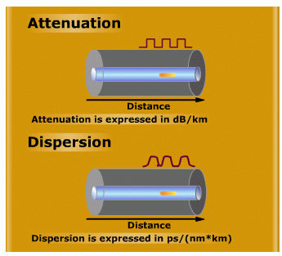

- Types of degradation mechanism: PPT slides
www.youtube.com/watch?v=AyCrJ2uhams
Attenuation, Absorption, scattering and dispersion

- Types of absorption process: PPT slides
Extrinsic absorption and intrinsic absorption losses
www.youtube.com/watch?v=AyCrJ2uhams

- Problems: Group activity
Problems were given to the groups and instructed to cross check the answer among the groups and finally the facilitator verified it.

Session 2
- Recap: Tit for Tat
Each group is given 5 min to prepare Question s. one group asks the other and vice versa facilitator records the score.
- Define attenuation
- What is absorption?.
- Attenuation / unit length is.
- What is intrinsic and extrinsic absorption?

- Scattering in optical fiber: PPT slides
www.ess.uci.edu/~cmclinden/link/xx/node18.html‎
Linear and nonlinear scattering losses and its types.
Example: Scattering of light by Atmosphere

The colours of the sky are caused by the scattering of light

- Types of scattering process: PPT slides
Rayleigh, Mie, SBS, SRS scattering
http://www.youtube.com/watch?v=jDyM3fyWUPo
http://www.youtube.com/watch?v=PNBnfqUycto
http://www.youtube.com/watch?v=Xp66iXyXg5k
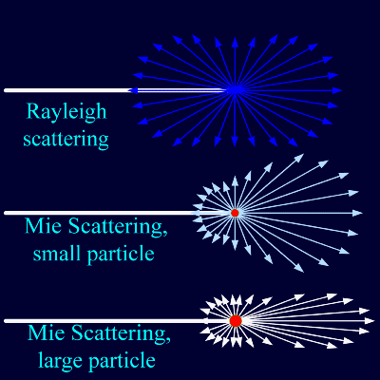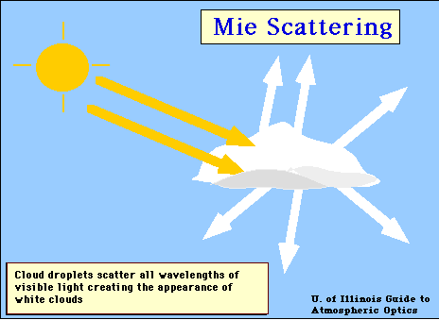
Large particles in the atmosphere are able to scatter all wavelengths of white light equally when all wavelengths of white light are scattered equally, then Mie scattering is occurring. It occurs when the particles causing the scattering are larger than the wavelengths of radiation in contact with them. Mie scattering is responsible for the white appearance of the clouds, as seen.

- Bending loss and its types: PPT slides
Micro bending and macro bending loss
http://www.youtube.com/watch?v=wGaJMVQt7qc&list=PL3585AC23FCCEBAAD

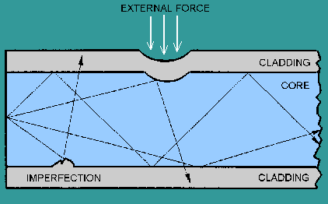

Session: 3
- Recap: Learner led presentation
A learner is randomly called to give a presentation on last session.

- Types of Dispersion: PPT slides
http://www.youtube.com/watch?v=PWaNMjimtP0
Intra modal and inter modal dispersion

- Material dispersion: PPT slides
http://www.youtube.com/watch?v=kLDQLkiPfZQ&list=PL3585AC23FCCEBAAD
www.youtube.com/watch?v=SAEQND4NyoM
Pulse broadening and derivation for material dispersion
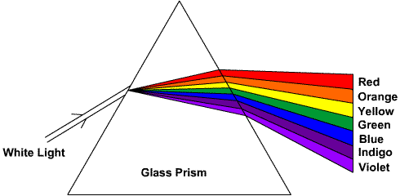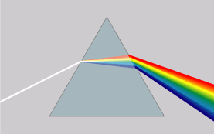

- Conclusion: Match the keyword
Animated keyword is listed and the learners are instructed to find the correct match from the display

Session:4
- Recap: Question & Answer

- What is meant by dispersion?
- List the types of dispersion
- What is ISI?

- Wave guide dispersion: PPT slides
Derivation for waveguide dispersion

http://www.slideshare.net/samruddhaparkar1/losses-in-optical-fiber
http://www.slideshare.net/bheemsain/fiber-signal-degradation-final

- Effect of dispersion on optical system: Role play
Two girls and one boy representing 101 .to begin with this activity, let us call upon 5 learners. To be very specific, let us call 4 girls , where in 2 of them are slim and the rest are fat and 1 boy to volunteer the role play. Let us consider girls as logic 1 and boy as logic0 .We can draw two lines on the floor which will act as optical fiber. Now at one side of the line, we can ask the role play volunteers to line up, 2 slim girls, and a boy making a pattern1, 0,1. Then 2 slim girls and 1 boy is replaced by 2 fat girls .It could be seen that no space for a boy and 0 is lost.
- Conclusion:- Rapid fire
Facilitator asks normally the learners. The learner has to respond within 1 min.
  - Chromatic dispersion
  - Waveguide dispersion
  - Intermodal dispersion
  - Intramodal dispersion

Session:5
- Recap: Question & Answer
The following questions can be asked to ensure that the learners have gained a good understanding of the concepts discussed so far

- What types of dispersion takes place in multimode fiber.?
- Define waveguide dispersion
- What is intramodal dispersion and where it takes place?
- Intermodal dispersion : chalk and talk
ece.uwaterloo.ca/~ece477/Lectures/ece477_3.ppt‎
Multimode step index fiber & Multimode graded index dispersion
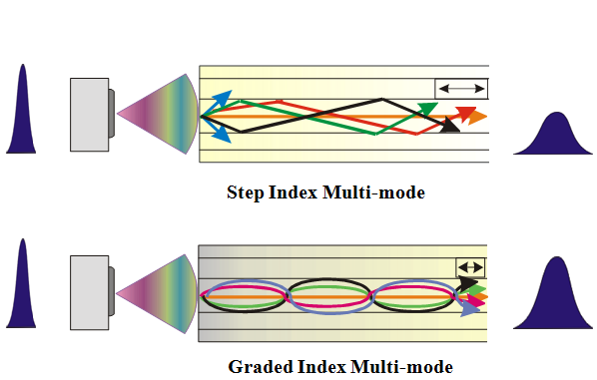
- Modal noise: chalk and talk

- Conclusion: Problem solving.
Estimate the rms pulse broadening per km for the fiber when the optical source used is an ILD with relative spatial width σλ = 0.0012λ = 1.02nm
σ _{M} = σ λLM = 0.1nS/KM

Session:6
- Recap: Word find
Learners are instructed to identify the keywords discussed in last session and explain it .The sample word is spectral width - band of wavelength over which source emits light
Answer:
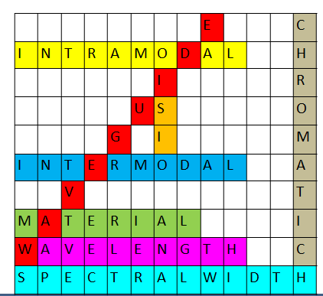
- Polarisation mode dispersion- PMD: PPT slides
http://www.youtube.com/watch?v=DKCHYUxXYXo&list=PL3585AC23FCCEBAAD
The 2 orthogonal modes propagate slightly at different speed causing fiber birefringence.

- Overall fiber dispersion: PPT slide/chalk and talk
Overall dispersion for single mode and multimode fibers.
http://www.slideshare.net/samruddhaparkar1/losses-in-optical-fiber
http://www.slideshare.net/bheemsain/fiber-signal-degradation-final
http://www.powershow.com/view/2166bf-Yzc4Y/Fiber_Optics_powerpoint_ppt_presentation

- Nonlinear phenomenon: Board activity
Introduction to kerr effect, SBS,SRS
Session:7
- Recap: Fill ups

- Electric field orientation of light signal is --------
- PMD occurs due to ----------
- --------- are fastest modes
- ----------dispersion is more in multimode fiber
- Fiber alignment and losses: PPT slides /chalk and talk
http://www.youtube.com/watch?v=-4laWjdjjpA
Fiber alignment and joint loss.
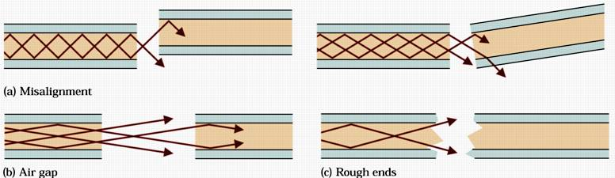
- Optical splices& Types of splices: PPT slides
http://www.youtube.com/watch?v=sRDbvtszsVI
Fiber splices – Permanent joint between two fibers where human cannot intervene frequently
http://www.slideserve.com/tariana/fiber-optic-connectors-splices-and-tools
Fusion splice,V Groove splice- Mechanical splice

- Conclusion : Question & Answers
- What is fresnel reflection?
- What is longitudinal, lateral, angular misalignment?
- Which alignment give greater loss per unit displacement.?
- What are splices?

Session :8
- Recap: Recall by Questions
- What are intrinsic coupling losses at fiber joints?
- What is the effect of core diameter mismatch?
- What is RI profile mismatch?
2. Optical convectors: PPT slides
http://www.youtube.com/watch?v=9rdPDnxfVm0
http://www.youtube.com/watch?v=4Ovqe3XjRqM
http://images.yourdictionary.com/fiber-optic-connectors
Single mode fiber joint
Multimode fiber joint
3. Types of connectors :PPTslides
Ferrule and expanded beam connector
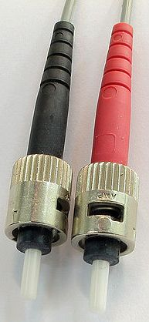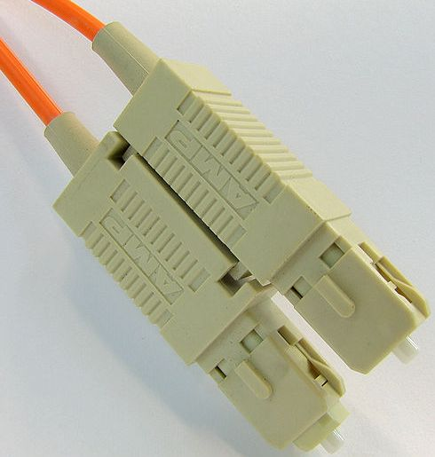
ST Connector SC Connector

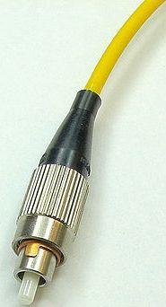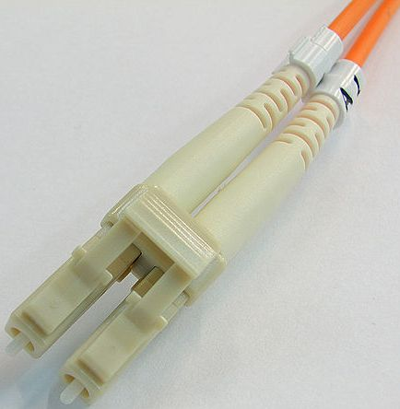

FC connector LC connector

4. Conclusion: Tit for tat
Each group is given 5 min to prepare Question s. one group asks the other and vice versa. Facilitator records the score.
What is a Splice ?
Tell the the types of connectors
List the splicing techniques
Drawbacks of fusion splicing.

Session :9
- Recap: Question & Answer
- Principle of expanded beam connector
- List the connector types
- What is a connector?

- Fiber couplers: chalk & talk / PPT slides
soe.northumbria.ac.uk/ocr/teaching/fibre/pp/Components-L2.ppt‎
Classification of couplers - Core interaction type and surface interaction type

- Types of coupler: chalk & talk
Three port and four port coupler parallel and slant type
http://www.nyelubricants.com/_pdf/literature/optpdfs/nyelightwave.pdf
http://www.youtube.com/watch?v=ZorJs7fzRHs

- Conclusion: Summarize
Facilitator gives a quick summary about splices, connectors and couplers.
Splices – Permanent connection, Types
Connectors – demountable connector .Types
Coupler –distribute the power from main fiber to one or more branch fibers

