UNIT – III
SOURCES AND DETECTORS
Session:1
1. Introduction to optical sources: Chalk and talk/PPT
http://www.ee.ui.ac.id/wasp/wp-content/uploads/2011/09/5.-Optical-Sources.pdf
Sources – LED Incoherent light – LASER – coherent light ,homo junction LED
2.Indirect & direct band gap materials: Brain storming
Animation for direct & indirect band gap.
The following questions are asked
Where does that energy go?
What is the mechanism behind photon emission in LEDs?
3. Double hetero structure – PPT slides/ Board activity
Hetero structure & double hetero structure and its advantages.
http://www.scribd.com/doc/7314300/fibre-optical-sources-detectors
http://www.aps.org/publications/apsnews/200603/forefronts.cfm
http://www.ee.sc.edu/personal/faculty/simin/ELCT566/10%20Real%20LED%20and%20Heterostructure%20LEDs.pdf
http://www.tf.uni-kiel.de/matwis/amat/semi_en/kap_7/backbone/r7_1_4.html
4. Conclusion: Fast review
A Fast Review about LED & LASER is given by the facilitator
Advantages of LED For single mode operation – LED
For multi mode operation – Laser
A comparison of LED & LASER, Double hetero structure and its advantages
Session: 2
- Recap: Recall by keywords
Optical sources are recalled by list of keywords
Radiance , Coherent source
Confinement
Homo junction
Hetero junction , Double hetero junction
- Surface emitter LED & Edge emitter LED – PPT slides
http://www.orafol.com/tl_files/EnergyUSA/papers/LED-Source-Modeling-for-Optical-Design-workbook_Davis_2004.pdf
Explanation given for working principle & structure
Edge emitter LED
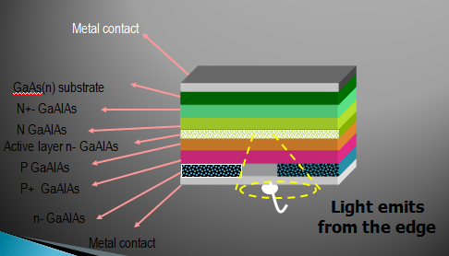

- Quantum efficiency – chalk and talk /PPT slides
Quantum efficiency derivation
- Conclusion: cross word puzzle

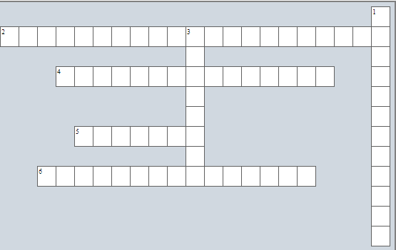
Across Down

2. both carrier & optical confinement can be 1. Time delay between the application
obtained using this structure of current pulse & the onset of
optical emission
4. LED’s are best choice for 3. Optical power radiated into a unit
solid angle /unit area.
- An indirect band gap material
- The plane of the emitting region is oriented
perpendicular to the fiber axis.

Session: 3
- Recap: Tit for Tat
The class is divided into 4 groups & each group has to prepare 1 question. Group 1 will ask group 2 & vice versa, group 3 will ask group 4 & vice versa.
Advantages of LED
Compare SLED and ELED
Define Quantum efficiency.
- LASER –principle of operation ,structure – Animation , PPT slides.
Absorption, Spontaneous and Stimulated emission explained using animation
Fabry parot resonator, Distributed Feedback structures
- Laser diodes & Laser modes – PPT slides.
https://www.google.co.in/url?sa=t&rct=j&q=&esrc=s&source=web&cd=1&cad=rja&sqi=2&ved=0CCsQFjAA&url=http%3A%2F%2Fece.uwaterloo.ca%2F~ece477%2FLectures%2Fece477_4_0.ppt&ei=WmrUUfKfJszNrQfitoGYAw&usg=AFQjCNGlCnSRSVZ9K8kpmaKIK-1AeRrdHQ&sig2=DVKXx92f_Vn4CWx369J1bA

ILD – gain guided, index guided
- Conclusion: Pick and answer
A grid is prepared with 4 questions and the questions are hidden . Facilitator instructs each group to pick an alphabet from the grid. Each alphabet is connected to the question via hyperlink. 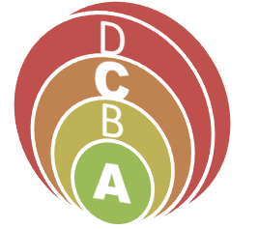
Session:4
- Recap: Questions & Answer
Facilitator randomly pick the learners and ask the following sample questions:
  - What are laser modes?
  - What is the principle of Fabry parot resonator?
  - Give the dimension of longitudinal, transverse, lateral modes.
  - Threshold condition for oscillations

- Laser diodes structures: - PPT slides
Gain induced, positive & negative index Guide

http://www.globalspec.com/reference/13683/160210/chapter-9-5-1-gain-and-index-
guided-lasers
http://www.matthiaspospiech.de/files/studium/praktikum/diodelasers.pdf
- Quantum well laser: Chalk & talk
A brief explanation is given

- Conclusion: Rapid fire
Facilitator asks questions to each group. The group which responds within 1 sec is awarded with marls
1. What are the Structures of LASER?
2. List the Advantages of laser diode .
3. What is meant by Positive index and Negative index?

Session 5

- Recap: Learner led presentation
A learner has to summarize the last class topic –Laser structures and its modes

- Optical detectors– PPT slides
http://www.slideshare.net/RajanKumar1/optical-fibre-detector
http://www.fiber-optics.info/articles/fiber_optic_detectors
Types of photodiode-PIN and Avalanche photo detector

- PIN photodiode ,Speed response of photodiodes – PPT slides / Board activity
Quantum efficiency – derivation
http://www.fiberoptics4sale.com/wordpress/pin-photodetector-characteristics-for-optical-fiber- communication/

- Conclusion: Match the following (Animated form)
- Responsivity
- Quantum efficiency
- Upper cut off wavelength
- Types of photo detector
- Photo current

Session:6
- Recap: Recall by keywords
We can divide the learners into 4 groups. One group can be asked to list the key words that are discussed in the last session and the other groups can be asked to give a brief description for the same.
The sample list of keyword that can be expected from the group are:
PIN
Transit time
Photo current
Diffusion length
Upper cut off wavelength .
- Avalanche photodiode – PPT slides
Working principle
https://www.google.co.in/url?sa=t&rct=j&q=&esrc=s&source=web&cd=1&ved=0CDAQFjAA&url=http%3A%2F%2Fece.uwaterloo.ca%2F~ece477%2FLectures%2Fece477_6.ppt&ei=pmrUUcCPFYm0rAen-IGIBA&usg=AFQjCNE5C0MWxB9eF-brZOzgerq0nBnXRw&sig2=uI8gjmTyyq0HaFgtO_OIjA
- Benefits & draw backs of Avalanche photodiode – chalk & talk

- Conclusion: Problem solving
The quantum efficiency of a particular Si RAPD is 80% for the detector of radiation at a wavelength of 0.9μm when the incident optical power is 0.5μW. The output current from the device is 11μA. Determine the multiplication factor of the photodiode under these conditions.
I_{p} =P_{O}R =P_{O} ηq/hc = 0.2898μA
M = I_{m}/I_{p} = 37.96 = 35

Session: 7
- Recap: Tit for Tat
The groups are instructed to prepare 2 questions on APD. One team will ask the other and in turn the other team will ask them.
What is meant by reach through?
List the advantages of APD.
How internal gain is achieved?
What is meant by impact ionization

- Photo detector noise – PPT slides
http://www.ee.ryerson.ca/~fernando
- Effects of noise: Chalk & talk

- Conclusion: Recall by question

- What is transit time?
- What is detector response time?
- Give the Mean square value of shot noise
- What is S/N?

Session: 8
1, Recap: Tit for Tat
The class is divided into 4 group & each group has to prepare 1 question group 1 will ask group 2 & vice versa, group 3 will ask group 4 & vice versa.
Define ionization rate
Define multiplication fctor.
Avalanche gain
2.Noise sources – PPT slides
Leakage current noise
Shot noise
Dark current noise
3.Equivalent circuit of photo detector receiver and receiver bandwidth – PPT slides / Board activity
Photo detector parameters and amplifier resistance and its effect on receiver bandwidth
4.Conclusion :Cross word puzzle
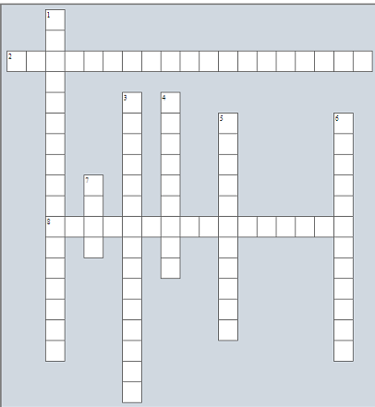

Across  - device that has internal gain mechanism  - carrier multiplication process |  | Down  - ratio no. of e-h pairs to no. of incident photons  - that causes further impact ionization  - noise that follows poisson process  - the time it takes photogenerated carriers to travel across the depletion region  - the photocurrent generated per unit optical power  - Reach -trough Avalanche photodiode

Session: 9
- Recap: Quiz
Prior preparation of quiz question by the groups. Question numbers and the group were put in the lot. students from one of the group picks the question and ask the group mentioned.
Quantum noise
Leakage current noise
Diffusion length
- Problems from noise sources: Board activity.

- Signal to noise ratio – Equations for all noise sources, Detector response time – Board activity – PPT slides
Transit time, Diffusion time, RC time constant.

- Conclusion: Cross examine
Facilitator examine the learners understanding of the topic by asking questions randomly.
What is meant by diffusion time?
Define S/N of optical receiver
Define sensitivity

