UNIT – V
OPTICAL NETWORKS
Session: 1
- Recap: Brain storming
Learners are asked to review the network terminology. Students from each group tell about it . They listed the types of networks and the terminologies related to that

- Introduction to optical networks – PPTSlides
Network concepts: node, router, station, topology
www.ece.iupui.edu/~dskim/Classes/ICE3025/ch01.ppt‎

- Optical network concepts: PPT Slides
Star, bus & Ring topology LAN, WAN & MAN
Faculty.uscupstate.edu/atzacheva/SIMS201/LAN_MAN_WAN.ppt‎
home.iitk.ac.in/~navi/sidbinetworkcourse/lecture1.ppt‎

- Conclusion : Summarisation
Facilitator summarized the session by high lighting the LAN , WAN ,MAN and topology

Session: 2
- Recap: Question & Answer
A set of questions can help the learners to recall about optical networks we can call the learners randomly to answer the questions.
1. Name 3 topologies used in optical networks
2. Use of passive & active network coupler.
3. What is a Router?
4. Enumerate the OSI Layer

- SONET / SDH networks:- Power point presentation
http://www.youtube.com/watch?v=WToiJS8x1CQ
http://www.youtube.com/watch?v=h8_zU1koOcM
Slides depicting SONET / SDH
Digital Interface for connecting optical fiber.

https://www.google.co.in/url?sa=t&rct=j&q=&esrc=s&source=web&cd=1&ved=0CCsQFjAA&url=http%3A%2F%2Fnetwk.hannam.ac.kr%2Fdata%2Fdata_communication4%2Fdata_communication4thchap17.ppt&ei=YXLUUdXkE4mTrgeJzIDYDw&usg=AFQjCNEbuPF6vLSw-GqeTI5pHz_PqE_-dg&sig2=g9boGuauTVMWP_EpuORZmA

- SONET / SDH frame structure: PPT

STS – 1, STS – N frame structure
STM – 1 SDH frame structure
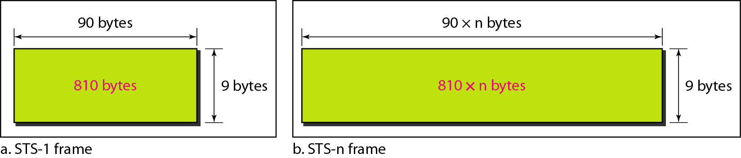
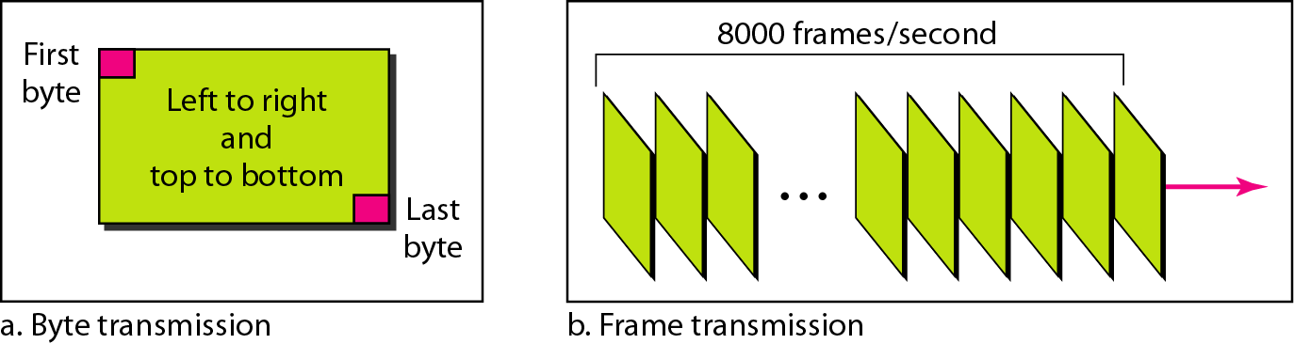

- Comparisons between SONET and SDH: brain storming
Students identify & list the comparisons STM – 1 is equivalent to STS – 3 signal.
SONET –standard in North America , ANSI Standard , OC N equivalent to STS-N
SDH - Standard in rest of the world , ITU-T Standard , no such equivalent
Session: 3
- Recap: Identify the Acronym
Learners recollect the last session by identifying the acronym and have to discuss about it .Each group is given an opportunity and the facilitator records the score.
Synchronous Digital Hierarchy - SDH
Synchronous Transport Signal-1 - STS-1
Synchronous Optical Network - SONET
Synchronous Transport Module-1- STM-1
Passive Optical Network - PON

- SONET Architecture and Networks-PPT Slides
Ring architecture , UPSR and BLSR
ADM and WDM networks
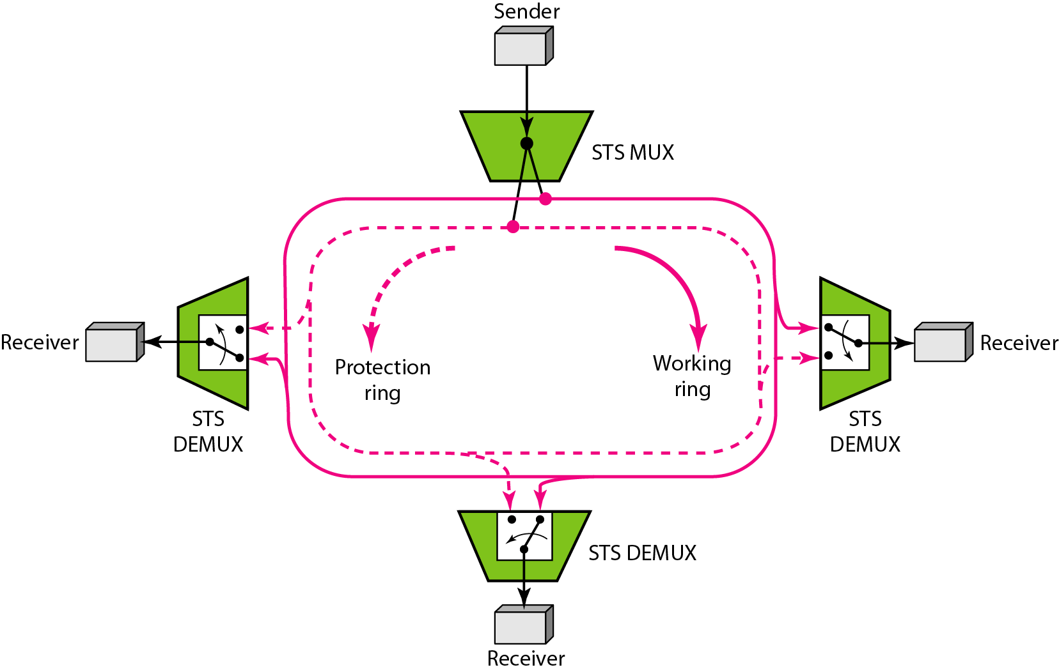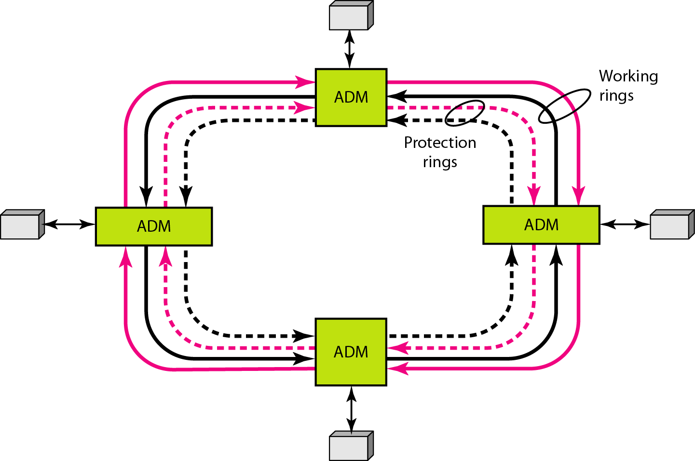

- Broad cast & select networks – PPT slides.
Slides depicting single hop, multi hop networks.
http://www.retitlc.polito.it/mellia/corsi/07-08/reti_ottiche_master/2-ON-Poli-b&S.pdf

- Conclusion: Re call by question
Facilitator conclude the session by asking the following questions.
- Limitation of single hop networks
- What is meant by single hop?
- Drawbacks of broadcast & select networks
- Define UPSR and BLSR

Session: 4
- Recap: Group Quiz
The class is divided into 4 groups A,B,C & D each groups prepare a set of 4 questions. Group A pose question to Group B & in turn Group B asks question Group A. Facilitator records the score.
Sample questions:
1.What is meant by single & multihop?
2. ADM facility means --------
3. What is meant by path and line switching?
- Wavelength routed networks – PPT slides / chalk talk
To over come the limitations of broad cast & select network wavelength reuse, conversion, optical switching.
http://www4.ncsu.edu/~hp/Chapter9.pdf
http://www-users.aston.ac.uk/~blowkj/photonicnetworks/lecture6/lecture6.ppt
- Wavelength conversion & OXC – PPT slides.

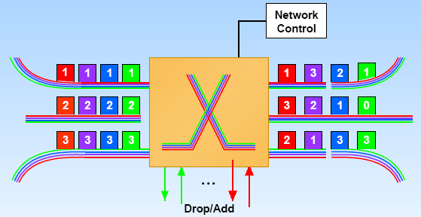
- Conclusion:- Question & Answer
Randomly pick the learners and ask the following sample questions:
- Limitation of broadcast & select network
- Methods to over come the limitations.
- What is wavelength reuse?
- What is wavelength conversion?

Session: 5
- Recap: Recall by keywords
Facilitator lists some keywords each group is asked to recollect from the keywords
OXC.- Optical X connect- to switch to required output port
ADM- Add / Drop Multiplexer- Facility in SONET networks to add or drop the sub channels.
DWDM – Dense Wavelength Division Multiplexing- High capacity , data rate 10 Gbps , close spacing of wavelengths
Hop- No of intermediate nodes
Shuffle net- Topology used in multihop broadcast & select network
- Nonlinear effects: PPT slides
http://www.imedea.uib.es/~salvador/coms_optiques/addicional/agrawal/NLOF.pdf
SBS
SRS
Optical signal injected into the fiber is the source of interacting photons and is called pump wave since it supplies power for the generated wave.
SRS-Severely limit the performance of multi channel OC system by transferring energy from short wavelength channels to neighboring long wavelength channels.
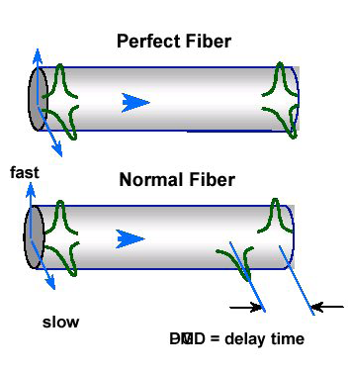

- Self phase modulation, Cross phase modulation & Four wave mixing: PPT slides.
http://www.imedea.uib.es/~salvador/coms_optiques/addicional/agrawal/NLOF.pdf
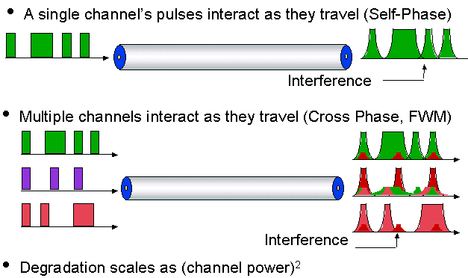
Four wave mixing

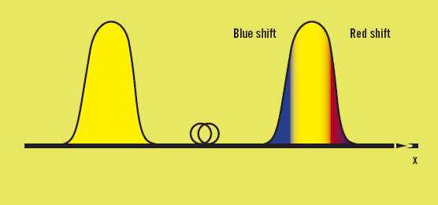
- Conclusion: Recall by questions
A set of questions can help the learners to recall about nonlinear effects.
- What are the nonlinear effects that experience gain or loss to the channel?
- Stokes photon.
- What is Kerr effect?
- What is meant by power penalty?
- SBS Threshold.

Session: 6
- Recap: Rapid fire
The class is divided into 3 groups Facilitator pose questions to the groups. The group that answers within 2 secs is awarded. If they don’t it passes to the next group.
Sample questions
GVD means?
What is SPM?
Challenges faced in designing optical networks
Effective length & area.

- Performance of WDM/& EDFA – chalk & talk
http://www.ijarcsse.com/docs/papers/June2012/Volume_2_issue_6/V2I600125.pdf

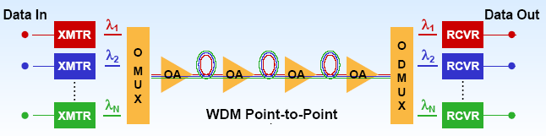
- Conclusion: Recall by questions
Link bandwidth
Standard Wavelength spacing
Inter channel cross talk
Inter channel cross talk
Session: 7
- Recap: Quiz
Students are divided into 5 groups & question were asked to a group in round robin form.
Sample questions:
FWM
SRS
CPM
Pump wave

- Introduction to soliton pulses: Animated slide presentation
Single pulse, 2 pulses, Multiple pulses

- Soliton parameter – Animated PPT slides
http://www.jpier.org/PIER/pier74/11.07050401.Gangwar.SS.pdf
Application of soliton – chalk & talk
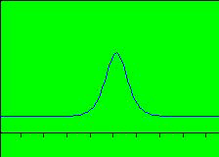

- Conclusion: Learner Led Presentation
Facilitator instructs one of the learner to summmarise the session.

Session: 8
- Recap: Questions & answer
What do you mean by the term soliton?
Define fundamental soliton
What are called higher order solitons?
Define FWHM
Dispersion length

- Introduction to CDMA: PPT slides
http://www.ee.buffalo.edu/faculty/paololiu/566/op_cdma.ppt

- Concept of optical CDMA: Chalk & Talk

- Conclusion: Pick and answer
A grid is prepared with 4 questions and the questions are hidden . Facilitator instructs each group to pick a number from the grid. Each alphabet is connected to the question via hyperlink.
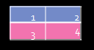

Session: 9
- Recap: Tit for Tat
Students are divided into 3 groups and 5 minutes given for preparation of 3 questions one group will ask the other & vice versa Facilitator records the score.
Principle of optical cdma
TDM
Spread spectrum
Chips

- Ultra high capacity networks: Chalk & talk / PPT slides
www.slideworld.com/pptslides.../Ultra-High-Capacity-Optical--Communi...‎
www.mtitc.government.bg/upload/docs/3.7_kalbe.ppt‎
Ultra high capacity WDM networks -Block diagram and explanation
- Bit interleaved and time slotted :Chalk & Talk
Types of Ultra high capacity WDM networks
- Conclusion :Crossword puzzle

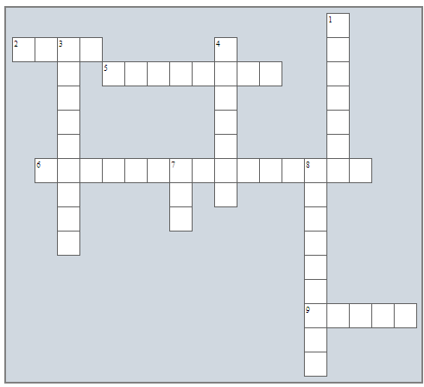

Across Down

2. One of the SONET architecture 1. Connects the adjacent pieces of
Equipment
5. Logical manner is which nodes are 3. Information transmitted in the
linked together form of light pulses only
6. SONET/SDH architecture is called as 4. Access to an optical data bus is
achieved by
9. standard signal format in North America 7. An important SONET/SDH network
element
8. Loss due to coupler itself.

Books Referred: “ Optical Fiber Communication “ , John M Senior
“ Optical Fiber Communication” , Gerd Keiser
“ Optical Networks, A practical Perspective,” Morgan Kaufmann.
Rajiv Ramaswami and Kumar N. Sivarjan,

