**UNIT-II**

**Transmission Characteristics of optical fibers**

**Session input 1**

**SubTopic:** **Recap: single mode fiber**

**Suggested Activity: Tit for tat**

The students were asked to form two groups. Five questions from each side is asked .The answer given by the opposite side is assigned with 1 mark. if they are not answered the turn goes to opposite side. The questions asked were

1.What is the meant by cutoff Wavelength?.

2.Give the expression for group delay.

3.What is mode field diameter?

4.What is called effective Refractive Index?.

**Subtopic: Attenuation**

**Suggested Activity: Slide Representation**

The concept of attenuation is explained with the formulas.

**Subtopic: Types of losses**

**Suggested Activity: Slide Representation**

The causes of attenuation is explained with its types such that absorption, Scattering losses, Bending losses and core cladding losses.

**Sub Topic: Conclusion**

**Suggested Activity: Problem solving**

Thus attenuation is measured under various condition and attenuation is measured in terms of dBm,dB/km and in watts.

[**http://fp.optics.arizona.edu/kkieu/Propagation%20loss%20in%20optical%20fibers-01-25-13.pdf**](http://fp.optics.arizona.edu/kkieu/Propagation%20loss%20in%20optical%20fibers-01-25-13.pdf)

<http://www.scribd.com/doc/27163745/Loss-Characteristics-of-Optical-Fiber>



**Session input 2**

**SubTopic: Recap: Attenuation**

**Suggested Activity: Problem solving**

Problems are given from attenuation such that to find the

**Sub Topic: Absorption**

**Suggested Activity: Slide representation.**

The absorption of light rays due to atomic defects, intrinsic absorption and extrinsic absorption. Loss is explained with graphs.

**Subtopic: bending loss.**

**Suggested Activity: Slide representation**

The types of bending losses are explained with diagrams.

**Sub Topic: Conclusion**

**Suggested Activity: Summarize**

Thus the section is concluded with the summarizing the losses due to bending and absorption.

[**http://fp.optics.arizona.edu/kkieu/Propagation%20loss%20in%20optical%20fibers-01-25-13.pdf**](http://fp.optics.arizona.edu/kkieu/Propagation%20loss%20in%20optical%20fibers-01-25-13.pdf)

<http://www.scribd.com/doc/27163745/Loss-Characteristics-of-Optical-Fiber>

<http://www.fiberoptics4sale.com/wordpress/optical-fiber-attenuation/>

<http://www.learn-about-electronics.com/absorption.html>

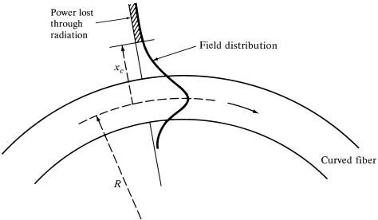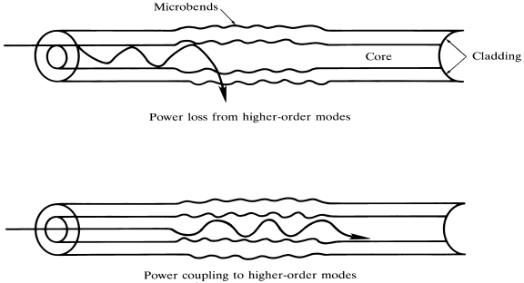

**Session input 3**

**Subtopic: Recap: absorption**

**Suggested Activity: Question and answering**

Questions are arised from absorption such that

* When will absorption due to atomic defects increased?
* What are the remedies for microbending loss?
* What are the causes of absorption?

**Sub Topic: Linear Scattering losses**

**Suggested Activity: Show and tell**

The concept of linear scattering loss is explained with its classification. They are Rayleigh and mie scattering. The scattering formation is shown by figures . The dispersion by prism is given for example

**Subtopic:N on linear scattering losses.**

**Suggested Activity: Slide representation**

The concept of non linear scattering loss is explained and its classification Stimulated brillouin and stimulated raman scattering is explained with its remedies.

**Sub Topic: Conclusion**

**Suggested Activity: Summarize**

Thus the section is concluded with the summarizing the losses due to linear and non linear scattering .

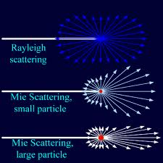

<http://expha.com/sean/UF/July2010%20Backup/Academic/Loser%20Biased%20Diagnostics/Rayleigh%20and%20Mie%20Light%20Scattering.pdf>

<http://topdefinitions.com/2013/07/07/mie-scattering-is/>

<http://www.slideshare.net/samruddhaparkar1/losses-in-optical-fiber>

<http://www.slideshare.net/bheemsain/fiber-signal-degradation-final>

<http://www.scribd.com/doc/68040893/40/Nonlinear-scattering-losses>

**Session input 4**

**Subtopic: Recap: Scattering losses**

**Suggested Activity: Question and answering**

Questions are arised from scattering losses such that

* What are the causes of scattering losses?
* What is the difference between linear and non linear scattering?
* How can we reduce linear scattering losses?

**Sub Topic: Introduction to dispersion**

**Suggested Activity: Brainstorming**

The dispersion is explained with the diagram from which the students can able to understand the dispersion of wavelength by different colours. They are material and Waveguide dispersion and intermodal dispersion.

**Subtopic:Intramodal dispersion**

**Suggested Activity: Anology**

The concept of intramodal dispersion is explained with two cars with different speed and the derivation for intramodal dispersion is derived.

**Sub Topic: Conclusion**

**Suggested Activity: Summarize**

Thus the section is concluded with the summarizing the causes of intramodal dispersion.

<http://www.slideshare.net/samruddhaparkar1/losses-in-optical-fiber>

<http://www.slideshare.net/bheemsain/fiber-signal-degradation-final>

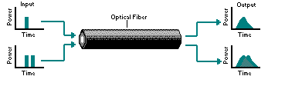

Pulse degradation from dispersion

**Session input 5**

**Subtopic: Recap: Intermodal dispersion**

**Suggested Activity: Question and answering**

Questions are arised from intramodal dispersion such that

* What are the causes of intramodal dispersion?
* What are the types of dispersion comes under intramodal dispersion?
* How can we avoid intramodal dispersion?

**Sub Topic: Intermodal dispersion**

**Suggested Activity: chalk and talk**

The dispersion is explained with the expression derived for intermodal dispersion.

**Subtopic:Midband and infrared transmission**

**Suggested Activity: Chalk and Talk**

The concept of transmission in midband and infrared is explained.

**Sub Topic: Conclusion**

**Suggested Activity: Summarize**

Thus the section is concluded with the summarizing the causes of intramodal dispersion.

<http://www.slideshare.net/samruddhaparkar1/losses-in-optical-fiber>

<http://www.slideshare.net/bheemsain/fiber-signal-degradation-final>

<http://www.powershow.com/view/2166bf-Yzc4Y/Fiber_Optics_powerpoint_ppt_presentation>

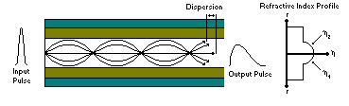

**Session input 6**

**Subtopic: Recap: Intermodal dispersion**

**Suggested Activity: Question and answering**

Questions are arised from intramodal dispersion such that

* What is meant by intermodal dispersion?
* What are the remedies to be followed for intermodal dispersion?

**Sub Topic: Polarisation mode dispersion**

**Suggested Activity:Slide presentation**

The PMD dispersion is explained with the diagrams and the expression is explained.

**Subtopic:Linear and Non linear phenomenon**

**Suggested Activity: Slide representation**

The overall dispersion measurement is explained.

**Sub Topic: Conclusion**

**Suggested Activity: Summarize**

Thus the section is concluded with the summarizing the PMD and overall dispersion.

<http://www.olson-technology.com/mr_fiber/PMD.htm>

<http://www.scribd.com/doc/64328412/Polarization-Mode-Dispersion-PMD-its-limits-compensation-and-effect-on-optical-fiber-networks>

<http://www.tuhh.de/okt/Forschung/Pmd/>

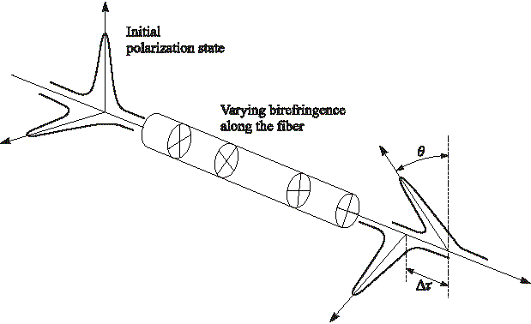

**Session input 7**

**Subtopic: Recap: Polarisation mode dispersion**

**Suggested Activity: Question and answering**

Questions are arised from intramodal dispersion such that

* What is meant by polarization mode dispersion?
* How can we measure overall dispersion?

**Sub Topic: Optical splices**

**Suggested Activity: Demonstration**

The different types of optical splices are explained with neat diagrams and it was explained practically with fibers.

**Subtopic: optical couplers**

**Suggested Activity: slide representation**

The difference between optical splices and optical connectors are explained. The types are explained in detail. The connectors are explained with real connectors with the sample.

**Sub Topic: Conclusion**

**Suggested Activity: question and answer**

Thus the section is concluded with the discussion of question and answer .

<http://www.nyelubricants.com/_pdf/literature/optpdfs/nyelightwave.pdf>

<http://www.youtube.com/watch?v=ZorJs7fzRHs>

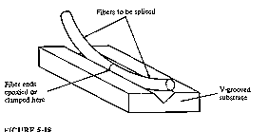optical splices

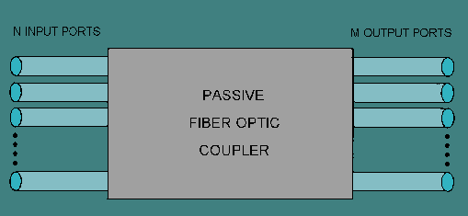optical coupler

**Session input 8**

**Subtopic: Recap: optical splices and optical couplers**

**Suggested Activity: Question and answering**

Questions are arised from intramodal dispersion such that

* What is meant by optical splices?
* What is the use of optical couplers?
* What are the types of splices available?

**Sub Topic: Optical connectors**

**Suggested Activity: Slide representation**

The different types of optical connectors are explained with neat diagrams

**Subtopic:Expanded beam connectors**

**Suggested Activity:Chalk and Talk**

The expanded beam connectors are explained with neat diagrams.

**Sub Topic: Conclusion**

**Suggested Activity: Summarize**

Thus the section is concluded with the summarizing the connectors.

<http://www.youtube.com/watch?v=4Ovqe3XjRqM>

<http://en.wikipedia.org/wiki/Optical_fiber_connector>

<http://images.yourdictionary.com/fiber-optic-connectors>



Expanded beam connector

**Session input 9**

**Subtopic: Recap: optical connectors**

**Suggested Activity: Question and answering**

Questions are arised from intramodal dispersion such that

* What are the requirements of optical connectors?
* What are the advantages of expanded beam connectors?

**Sub Topic: Optical misalignment**

**Suggested Activity: Slide representation**

The different types of optical extrinsic losses are explained with its types.

**Subtopic:Fiber joint losses**

**Suggested Activity:Slide representation**

The intrinsic losses such as variation in NA,Core diameter and refractive index profile are explained.

**Sub Topic: Conclusion**

**Suggested Activity: Summarize**

Thus the section is concluded with the problem solving for various losses due to intrinsic and extrinsic losses.

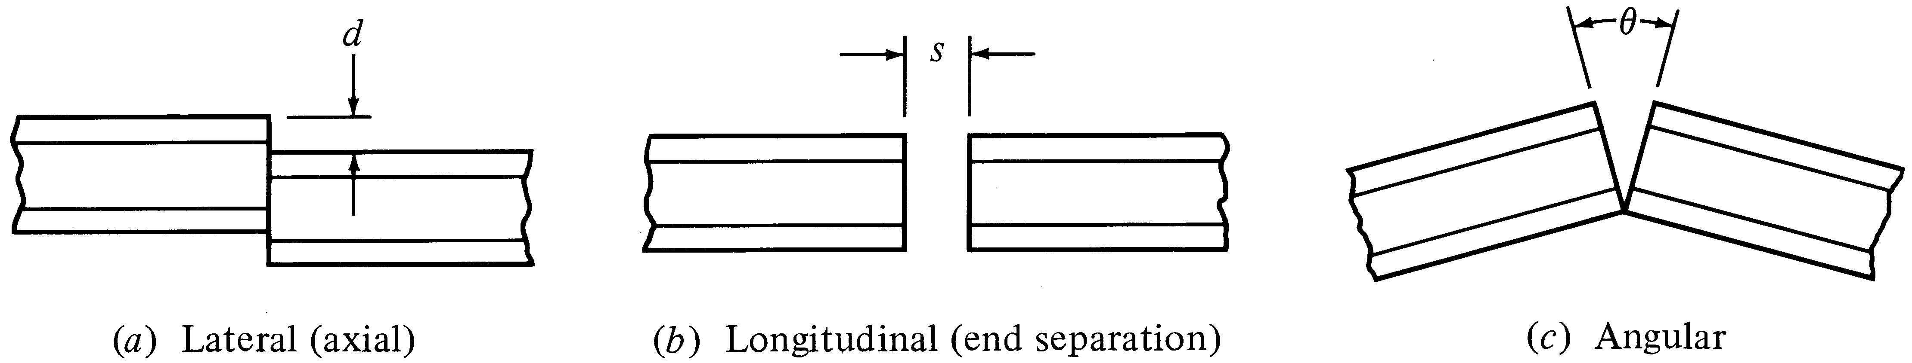

<http://www.youtube.com/watch?v=4Ovqe3XjRqM>

<http://global-sei.com/fttx/basic_e/index02.html>

<http://www1.delta-search.com/?q=fiber+joint+losses&babsrc=HP_ss&s=web&rlz=0&as=0&ac=46>

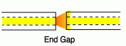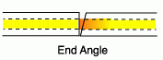dirt