UNIT-III
Sources and Detectors
Session Input -1
SubTopic:Recap:Fiber optic joints and losses
Suggested Activity: Questioning
The students are formed into two groups (One team is full of girls and another team is full of boys) and the questions are set and asked by the staff. The marks were entered in the black board for each team.Upto 5 questions were asked for each team. The questions asked were as follows
- What is the use of fiber couplers?
- What are the extrinsic losses occur in the fiber?
- What are the intrinsic loss occur in the fiber?
- In what ways fibers are joined together?.
Finally the highest mark scorer team is announced as the winning team. The learners can able to remember and get an overview of optical joints and losses.
SubTopic:Direct and Indirect Bandgap materials
Suggested Activity: Slide Representation
The sources used for optical transmitters are explained .Then the direct and Indirect bandgap material used for sources are explained.
SubTopic:: Double heterojunction
Suggested Activity: Brainstorming
The need for a source is explained and the confinement of optical and carrier in LED is explained with double hetero junction The refractive index difference is explained and the cause for this configuration is asked.
SubTopic::Conclusion
Suggested Activity: Summarize
The basic configuration of is summarized.
http://www.scribd.com/doc/7314300/fibre-optical-sources-detectors
http://www.aps.org/publications/apsnews/200603/forefronts.cfm
http://www.ee.sc.edu/personal/faculty/simin/ELCT566/10%20Real%20LED%20and%20Heterostructure%20LEDs.pdf
http://www.tf.uni-kiel.de/matwis/amat/semi_en/kap_7/backbone/r7_1_4.html

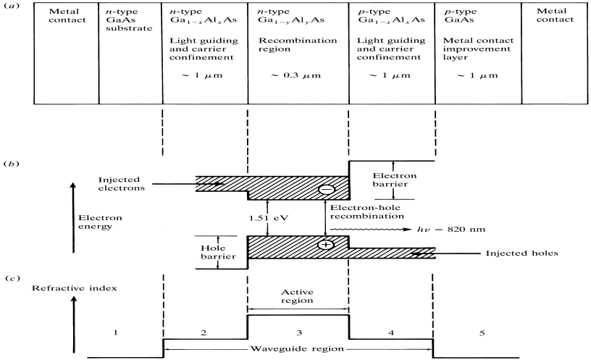
Session input 2
SubTopic:Recap:Double heterojunction.
Suggested Activity: Tit for Tat
The students are formed into two groups (One team is full of girls and another team is full of boys) and a team leader is represented by each item and the questions are asked from each team alternatively. The marks were entered in the black board for each team.Upto 5 questions were asked by each team. The questions asked were as follows
- What is the difference between direct and Indirect bandgap material?
- Whatare the confinements occur in double hetero structure?
- What is meant by heterojunction?
- Name the direct bandgap materials
- How optical confinements achieved in heterojunction?
- What are the requirements of a light source?

SubTopic: Surface emitter LED.
Suggested Activity: Slide Representation
The types of LED are given and surface emitter LED is explained with slides.
SubTopic: Edge Emitter LED.
Suggested Activity: Slide Representation
The edge emitter LED is explained and the their output beam type also explained.
Sub Topic: Quantum efficiency
Suggested Activity: Chalk and talk.
The quantum efficiency is derived from its input and output signals.
SubTopic: Conclusion
Suggested Activity: Summarize
The operation of LED is summarized and explained once again and conclude the section.
http://www.scribd.com/doc/7314300/fibre-optical-sources-detectors
http://www.doriclenses.com/administrer/upload/pdf/NOT_FCL_ENG_070212_doricl97_doricle_ZmKKtZ.pdf
http://www.scribd.com/doc/56617793/6/Edge-Emitter-LEDs-ELEDs
http://www.authorstream.com/Presentation/PRERIT_KAKA-573696-optical-source
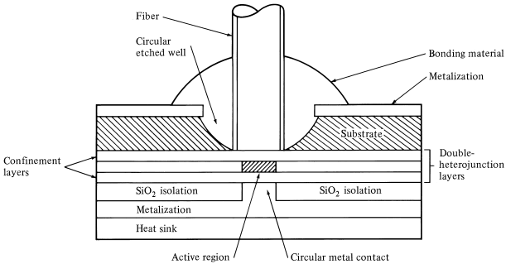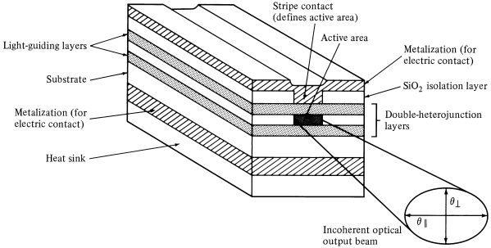

Session input 3
SubTopic:Recap: Types of LED.
Suggested Activity: questioning and answer
The students are asked questions randomly.Upto 5 questions were asked to them. The questions asked were as follows
- What are the two types of LED?
- What are the drawbacks in LED?
- What is the quantum efficiency of LED?
- What is meant by half power bandwidth?
- What are the advantages of edge emitter LED?
SubTopic: Laser diode structures
Suggested Activity: Slide representation
The advantages of laser is compared with LED is explained.Then the way in which laser can be produced is explained with three key process.
SubTopic: Gain guided laser structure
Suggested Activity: Slide Representation
The construction of laser diode in three sides are explained with the modes
SubTopic: Conclusion
Suggested Activity: Summarize
The operation of LASER is summarized and explained once again and conclude the section.
http://www.globalspec.com/reference/13683/160210/chapter-9-5-1-gain-and-index-guided-lasers
http://www.matthiaspospiech.de/files/studium/praktikum/diodelasers.pdf

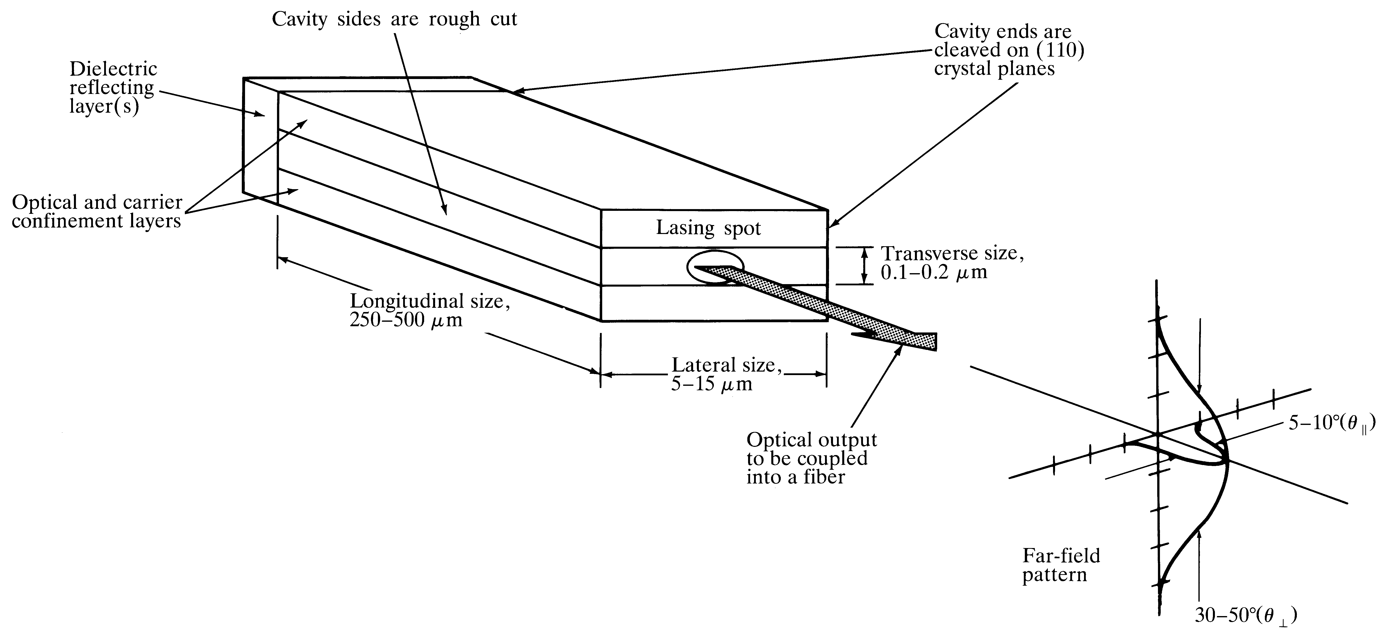

Session input 4
SubTopic:Recap: Laser diode structures
Suggested Activity: Questioning
The students are asked questions randomly.Upto 5 questions were asked to them. The questions asked were as follows
- What are the three key process of laser?
- What is the difference between laser and LED?
- What are the types of laser structures used for optical communication?
SubTopic: Quantum efficiency of Laser
Suggested Activity: Brainstorming
The internal quantum efficiency is explained and the external quantum efficiency is external quantum efficiency is explained is derived by asking the input and output for LED from the students.
SubTopic: Comparison between LED and ILD.
Suggested Activity: Chalk and talk
The performance of LED and laser is discussed and compared.
.
SubTopic: Conclusion
Suggested Activity: Problem solving
Problems are given for quantum efficiency calculation.

http://www.matthiaspospiech.de/files/studium/praktikum/diodelasers.pdf
http://www.google.co.in/url?sa=t&rct=j&q=&esrc=s&source=web&cd=2&cad=rja&ved=0CC0QFjAB&url=http%3A%2F%2Fece.uwaterloo.ca%2F~ece477%2FLectures%2Fece477_4_0.ppt&ei=Hp36UfG5Bs7irAfCiICQCw&usg=AFQjCNGlCnSRSVZ9K8kpmaKIK-1AeRrdHQ&sig2=wsMzVg1HqXE0chv87UAmdg&bvm=bv.50165853,d.bmk

http://www.semiconductor-today.com/features/SemiconductorToday_MayJun_Stepping%20up%20EBL.pdf

Session input 5

SubTopic:Recap: optical sources
Suggested Activity: Quiz
The students are asked divided into four groups .Upto 3 questions were asked to them. The questions asked were as follows
- What are the types of laser structures?
- Define quantum efficiency of Laser
- What are the advantages of LASER over LED?
- What are the confinements occur in hetero junction?
- What are the requirements of optical sources?
- What are the difference between direct and indirect bandgap materials?
SubTopic:Requirements of a photodetector
Suggested Activity: Chalk and Talk
The basic requirements of a photodetector is discussed then the photo diode concept is explained
SubTopic: PIN photodiode.
Suggested Activity: Slide Representation
The basic principle of PIN photodiode is explained and its working principle is explained.
Sub Topic: Quantum efficiency of photodiode
Suggested Activity:Brainstorming.
The quantum efficiency of PIN diode is derived by asking questions to the students to form the equation of quantum efficiency of photodetector.
SubTopic: Conclusion
Suggested Activity: Summarize
The structure of PIN Photodiode is summarized and explained once again and conclude the section.
http://www.osioptoelectronics.com/technology-corner/frequently-asked-questions/basic-pin-photodiode-characteristics.aspxhttp://www.radio-electronics.com/info/data/semicond/photo_diode/photo_diode.phphttp://stanwir.seecs.nust.edu.pk/Lectures/FOCS/LightDetectors.pdf
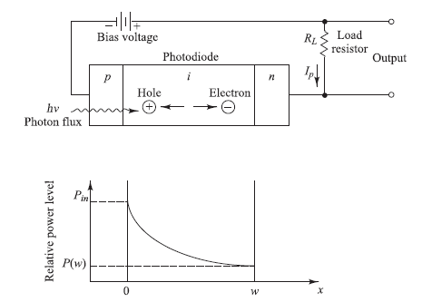
Session input 6

Subtopic: Recap: PIN photo diode
Suggested Activity: question and answer
The students are asked questions randomly.Upto 5 questions were asked to them. The questions
asked were as follows
- What are the requirement of photodetector in optical communication?
- Define quantum efficiency of PIN Diode.
- What is the basic principle of PIN Photodiode?
- What is meant by responsivity of photodiode?

Subtopic: Avalanche Photodiode
Suggested Activity: Slide representation
The working principle of avalanche photodiode is explained. The responsivity and quantum efficiency also explained.

SubTopic: quantum efficiency of APD.
Suggested Activity: Chalk and Talk
The responsivity and quantum efficiency also explained.

SubTopic: Conclusion
Suggested Activity: Problem solving
Thus the section is concluded with the problem solving for calculating quantum efficiency of PIN and Avalanche photodiode.

http://ftp.utcluj.ro/pub/users/cemil/dwdm/dwdm_Intro/7_5311726.pdf

http://www.radio-electronics.com/info/data/semicond/photo_diode/photo_diode.php
http://neutron.physics.ucsb.edu/docs/Avalanche_photodiodes_info.pdf

Session input 7

Subtopic: Recap: Avalanche photo diode
Suggested Activity: question and answer
The students are asked questions randomly.Upto 5 questions were asked to them. The questions asked were as follows
- What are the advantages of avalanche photodiode?
- What is meant by impact ionization?
- What is meant by avalanche effect?
- Give the expression for responsivity of APD
- What is meant of reach through avalanche photodiode?,

Subtopic: Comparison between PIN and Avalanche photodiode.
Suggested Activity: Chalk and Talk
The PIN diode and Avalanche photodiode is compared with its performance.

Subtopic: Photo detector noise
Suggested Activity: Chalk and Talk
The introduction to various photo detector noises were introduced.

SubTopic: Conclusion
Suggested Activity:summarize
Thus the section is concluded with summarizing the photo detector noises.

http://www.imagineeringezine.com/ttaoc/r-circuits.html
http://nptel.iitm.ac.in/courses/Webcourse-contents/IIT%20Bombay/Optical%20Communication/seen/FOC-Noise-BER.doc

Session input 8

Subtopic: Recap: Photo diode
Suggested Activity: question and answer
The students are asked questions randomly.Upto 5 questions were asked to them. The questions asked were as follows
- What are the difference between PIN and APD photo diode?
- Define quantum efficiency of PIN photodiode
- What are the advantages of APD?
- Why photodiode is used for optical receiver?

Subtopic: Noise sources.
Suggested Activity: slide representation
The Various noise sources were discussed with its sources like thermal noise, quantum noise etc.

Subtopic: Signal to noise ratio
Suggested Activity: Chalk and Talk
The signal to noise ratio of a photo detector is derived.
SubTopic: Conclusion
Suggested Activity:summarize
Thus the section is concluded with summarizing the photo detector noises with the sources.

http://nptel.iitm.ac.in/courses/Webcourse-contents/IIT%20Bombay/Optical%20Communication/seen/FOC-Noise-BER.doc
http://agamemnon.cord.org/cm/leot/Module4/module4.htm
http://optical-technologies.info/noise-in-photodetectors/

Session input 9

Subtopic: Recap:Photo detectors and sources
Suggested Activity:Tit for tat
The students are formed into two groups (One team is full of girls and another team is full of boys) and a team leader is represented by each item and the questions are asked from each team alternatively. The marks were entered in the black board for each team.Upto 5 questions were asked by each team. The questions asked were as follows
- What are the difference between PIN and APD photo diode?
- Define quantum efficiency of PIN photodiode
- Define internal quantum efficiency of LED?
- What are the three key process of laser action?
- What is the condition for lasing?
- What is meant by population inversion?

Subtopic:Detector Response time.
Suggested Activity: slide representation
The various terms such as transit time, response time and junction capacitance are discussed.

Subtopic: calculation of photo detector noise
Suggested Activity: Problem solving
The formulas used for photodetector noises are used familiarized by solving problems.

SubTopic: Conclusion
Suggested Activity:summarize
Thus the section is concluded with summarizing the detector response time.

http://nptel.iitm.ac.in/courses/Webcourse-contents/IIT%20Bombay/Optical%20Communication/seen/FOC-Noise-BER.doc

http://www.scribd.com/doc/16603895/Photo-Detector

