Unit 1 Introduction to power plants and boilers

Session Plan 1

Recap: Power plants – Introduction

1. Name the different types of power plant?

Thermal, nuclear, Hydel, gas turbine, geothermal power plant

1. Give any two types of power plant layout?

Steam power plant layout, Hydel power plant lay out, Diesel power plant layout.

Layout of steam power plant: PPT

<http://www.powerelectricalblog.com/2007/03/thermal-power-plant-layout-and.html>

Steam power plant converts the energy stored in fossil fuel to mechanical work

The four main circuits one would come across in any thermal power plant layout are

1. Coal and Ash Circuit
2. Air and Gas Circuit
3. Feed Water and Steam Circuit
4. Cooling Water Circuit

Conclusion: question and answer

1. Give the principle of working of steam power plant?

Steam energy is converted to mechanical energy which in turn is converted to      electrical energy.

1. Give the major circuit of steam power plant?

Coal and Ash Circuit,-Air and Gas Circuit,- Feed Water and Steam Circuit, Cooling  Water Circuit

Session Plan 2

Recap: Steam power plant

Quiz: 1. Give the characteristics of steam power plant?

High efficiency, higher reliability and availability

2. Give the cost comparison of steam with hydro power plant?

Steam power plant cost low compared to hydro power plant.

Reheating of steam is done to increase the temperature of steam by which the efficiency of the plant is increased (<http://en.wikipedia.org/wiki/Rankine_cycle>**)**

Advantages of steam power plant : PPT Presentation

1. Initial investment is low
2. Power plant can be located near load center, so transmission cost and losses are considerably reduced.
3. Commissioning of thermal power plant requires less period of time
4. Feed water heaters are provided to heat the feed water supplied to boiler by which overall efficiency of plant can be increased.

(http://en.wikipedia.org/wiki/Feedwater_heater)

Disadvantages of steam power plant:

1. Life and efficiency of steam power plant is less when compared to Hydel power plant
2. Transportation of fuel is major problem
3. Cost of power generation is more than hydro power
4. Air pollution is major problem
5. Coal may be exhausted by gradual use.

Conclusion: question and answer

1. Life span of steam power plant is lower than Hydel power plant
2. Major problem in steam power plant is Pollution
3. Coal may be exhausted by gradual use.

Session Plan: 3

Recap: Advantages, Disadvantages of steam power plant

Questioning:

1. List any two advantages of steam power plant?

* Low initial investment, Less time to commission plant
* Cost of Steam power plant is lower than Hydel power plant
* Major problem in steam power plant is fuel transportation.

Layout and principle of working of Hydel power plant PPT (<http://en.wikipedia.org/wiki/Hydroelectricity>)

Various components in Hydel power plant are water reservoir, dam, spill way, pressure tunnel, penstock, fore bay, surge tank, water turbine, draft tube, tail race, transformer

Working: Potential energy of water is used to run turbine to which the electric generator is coupled.

Advantages: Water is cheaper, No transportation of fuel, Free from pollution and ash disposal

Hydel power plant can meet rapid variation of load.

Conclusion: The session is concluded by summarizing the topics on components of Hydel power plant and advantages.

Session Plan: 4

Recap: Working of Hydel power plant (quiz)

1. Give the principle of power production in hydro power plant?

Hydraulic energy is converted into electrical energy.

1. What is the purpose of surge tank?

To ensure uniform discharge in penstock for various load conditions

Layout of Diesel power plant: PPT (<http://mechanicalengineeringnotebook.blogspot.com/2012/09/general-layout-of-diesel-engine-power.html>**)**

The major components of the plant are

Engine , air supply system , exhaust system, fuel system , cooling system , lubricating system, starting system, governing system.

[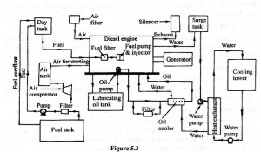](http://www.mechlook.com/wp-content/uploads/2010/04/figure-53.jpg)

Conclusion: The session is concluded by summarizing the various components and working of diesel power plant.

Session Plan: 5

Recap: Working principle of Diesel power plant

Quiz: 1. Give the components of diesel power plant

Engines, air supply system, exhaust system, fuel system, and cooling system

2. What is the purpose of lubricating system?

To reduce friction between mating parts, and to remove heat

**Layout of MHD power plant: PPT presentation**

http://en.wikipedia.org/wiki/MHD_generator#Power_generation.

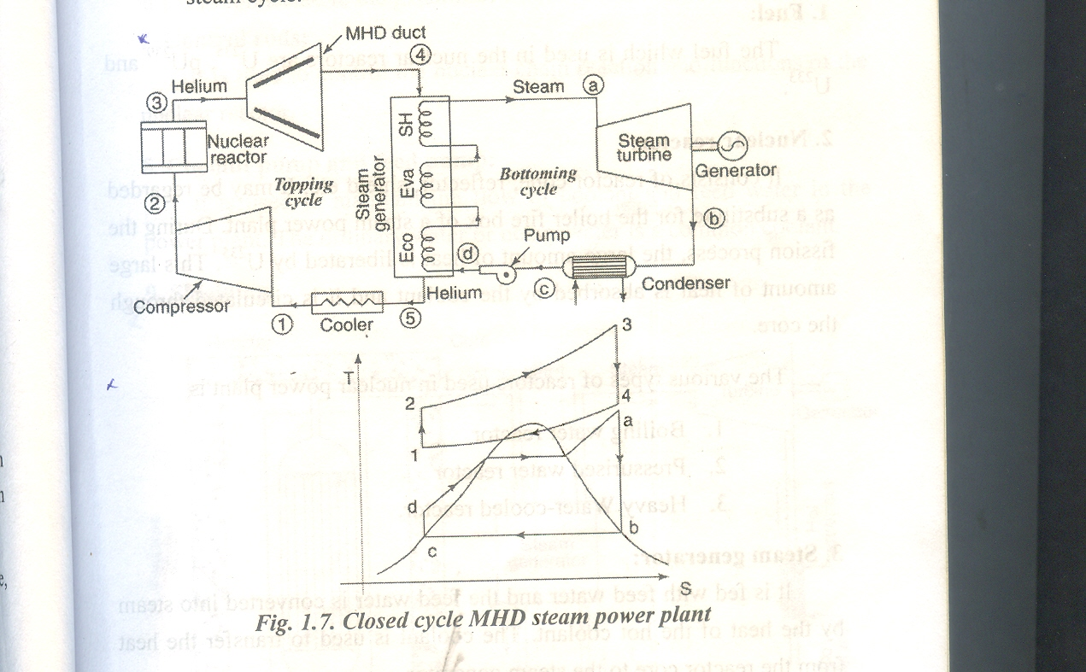

M.H.D generator is highly efficient heat engine which directly convert thermal energy into electricity

**Principle:**

The principle of a MHD generator is based on “Faradays law of electro magnetic induction” its states that a changing magnetic induces an electric field in any conductor located in it.

**Advantages:**

1. High efficiency when compared to other power plants
2. Fuel economy
3. Combined power and steam can be produced

Conclusion & Summary:

The session is concluded by summarizing the topics on principle and working of the MHD power plant

Session Plan 6

Recap: Working **of MHD power plant**

**Quiz:** 1. MHD works on the principle of Faraday’s law of electromagnetic induction

2. In MHD power plant combined power and steam is produced

**Layout of Nuclear power plant - PPT**

http://en.wikipedia.org/wiki/Nuclear_plant

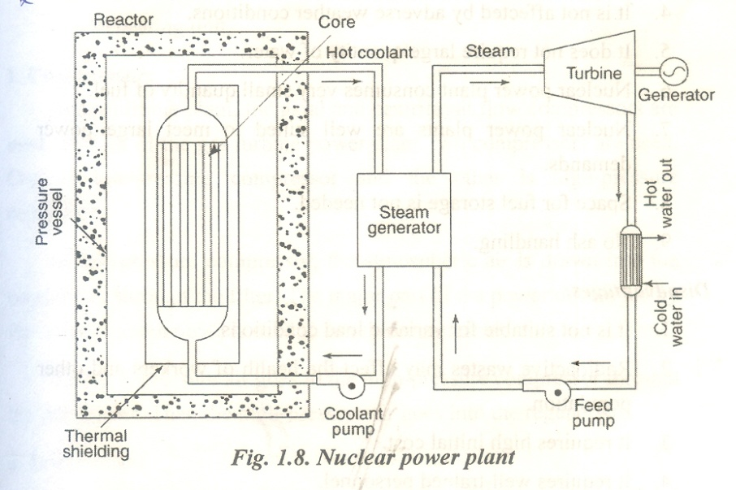

Working principle

* The heat generated in the reactor due to the fission of the fuel is taken up by the coolant.
* The hot coolant then leaves the reactor and flows through the steam generator.
* In the steam generator the hot coolant transfers its heat to the feed water which gets converted into steam.
* The steam produced is passed through the turbine, which is coupled with generator.
* Hence the power is produced during the running of turbine.
* The exhaust steam from the turbine is condensed in the condenser.
* The condensate then flows to the steam generator through the feed pump.
* The cycle is thus repeated.

**Conclusion:**

The session is concluded by summarising the working principle, advantages and disadvantages of nuclear power plant.

Session Plan 7

**Recap**: Working of Nuclear power plant

Quiz: 1. In nuclear reactor heat is produced by fission reaction

2. Control rods used in fission reaction is boron

3. Moderators reduce the reaction rate of neutron

**Gas turbine power plant layout**

http://en.wikipedia.org/wiki/Gas_turbine_power_plant#Industrial_gas_turbines_for_power_generation

Combustion and generation of electricity:

* Gas turbine draws clean air into through air filter from atmosphere, with the help of a compressor.
* During the compression pressure of the air is increased.
* Compressed air is passed through to a combustion chamber along with fuel (Natural gas).
* The air fuel mixture is ignited at high pressure in the combustion chamber.
* Combustion takes place.
* The generated hot gas of compression is passed through the gas turbine.
* Hot gases expand, and the turbines blades are connected to the turbine shaft are rotated.
* The turbine shaft which is coupled to the shaft of the electrical generator at the other end also rotates and drives the electrical generator.
* A portion of the energy developed by the hot gases through the gas turbine is used to run the compressor.

MERITS:

Natural gas is readily available.

* Setting up cost can be reduced if the plant is installed near the source of natural gas.
* Less gas storage cost
* Less space occupation.
* Compared to steam power plant, smaller in size.
* Low operating cost.
* Low maintenance cost.
* No standby losses.
* Cheaper fuels like natural gas.

Conclusion:

The session is concluded by summarizing the working principle and advantages of gas turbine power plant.

Session Plan 8

**Recap:** Working of Gas turbine power plant

Quiz: 1. Gas turbine uses cheap fuel like natural gas

2. Operating cost of gas turbine is low

**Combined power cycles layout PPT**

http://www.stonecrushingmachine.com/solution/mining-equipment/siemens-combined-cycle-power-plant-layout/

**COMBINED POWER CYCLE:**

The maximum steam temperature in a power cycle exceeds 6000c but the pulverized coal furnace temperature is about 13000c. So there is a lot of energy wasted in the power plant. To increase the efficiency and reduce the fuel the combined power cycles are induced combined power cycle.

1. Gas turbine – steam turbine plant
2. Thermionic – steam plant
3. Thermo electric – steam plant
4. M.H.D- steam plant

In [electric power generation](http://en.wikipedia.org/wiki/Electric_power_generation) a combined cycle is an assembly of [heat engines](http://en.wikipedia.org/wiki/Heat_engine) that work in tandem off the same source of heat, converting it into mechanical energy, which in turn usually drives [electrical generators](http://en.wikipedia.org/wiki/Electrical_generator). The principle is that the exhaust of one heat engine is used as the heat source for another, thus extracting more useful energy from the heat, increasing the system's overall efficiency. This works because heat engines are only able to use a portion of the energy their fuel generates (usually less than 50%).

The remaining heat (e.g., hot exhaust fumes) from combustion is generally wasted. Combining two or more thermodynamic cycles results in improved overall efficiency, reducing fuel costs. In stationary power plants, a successful, common combination is the [Brayton cycle](http://en.wikipedia.org/wiki/Brayton_cycle) (in the form of a turbine burning [natural gas](http://en.wikipedia.org/wiki/Natural_gas) or [synthesis gas](http://en.wikipedia.org/wiki/Synthesis_gas) from [coal](http://en.wikipedia.org/wiki/Coal)) and the [Rankine cycle](http://en.wikipedia.org/wiki/Rankine_cycle) (in the form of a steam power plant). Multiple stage turbine or steam cylinders are also common.

Conclusion:

The session is concluded by summarizing the working principle and advantages of combined power cycle.

**Session Plan 9**

Recap : **Working of Combined power cycles**

**Quiz:** 1. In combined power cycles both heat and steam is produced

2. state any two combined cycle – gas turbine – steam power plant, MHD – steam plant

**Steam boilers and cycles**

<http://en.wikipedia.org/wiki/Steam_cycle>, <http://en.wikipedia.org/wiki/Steam_engine>

A boiler which generates steam at pressure greater that 80 bar, a temperature of steam about 500 c, producing more than 250 tons of steam per hour called high pressure boilers.



**Lamont boiler:**



1. Steam separator
2. Water circulating pump
3. Distributing header
4. Evaporator
5. Convection super heater
6. Economiser
7. Combustion chamber

**Advantages :**

1. It is forced circulation boiler

2. High working pressure

**Disadvantages:**

1. The salt and sediment are deposited on the inner surface of water.

2. Danger of over heating of tubes

High pressure and super critical boilers

<http://en.wikipedia.org/wiki/Boiler>

**Supercritical boiler:**

The most of the large number of steam generating plants are designed between working ranges of 125 atm and 5100c to 300 atm and 6600c. These types of boiler are basically classified into sub-critical and super-critical boilers

1. Economiser
2. Evaporator
3. Super heater

**Advantages:**

1. High thermal efficiency
2. Heat transfer rate is high
3. The erosion and corrosion are minimised
4. Easy operation
5. More adaptable load fluctuations

Conclusion:

The session is concluded by summarizing the working principle and advantages of boile.