Unit 4 Diesel and Gas Turbine Power Plants
Session Plan 1
Recap: Comparison of turbines
- High efficiency is obtained in reaction turbines
- Impulse turbine requires less space than reaction turbine for same power
Diesel power plant working
http://www.scribd.com/doc/53729252/Diesel-Electric-power-plant
The air and fuel mixture are working medium in diesel engine are plant. The atmospheric air is coming inside the combustion chamber during the suction stroke and fuel is injected through the injection pump The air fuel mixed inside inside the engine and the charge is ignited due to the high compression inside the engine cylinder The basic principle in diesel engine is thermal energy is converted to mechanical energy and this mechanical energy to produced power using generator.
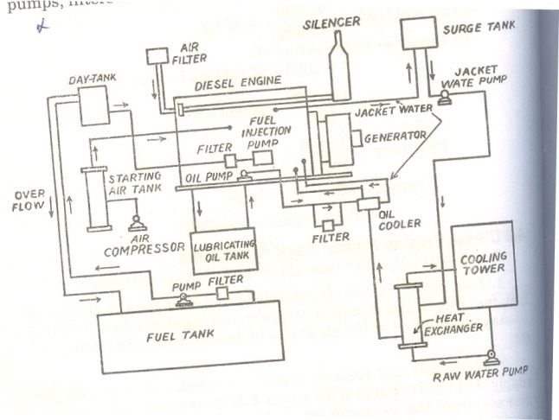
Application of Diesel power plant
http://en.wikipedia.org/wiki/Diesel_generator
Peak load plant, mobile plant, standby units, Emergency plant, Nursery station, starting station, central station
Conclusion & Summary:
- Diesel power plant can located to load centre
- In diesel power plant stand by losses are less
Session Plan 2
Recap: Application of Diesel power
- Diesel power plant can be used as mobile plant
- Life of diesel power plant is quite small

Advantages of Diesel engine power plant
http://en.wikipedia.org/wiki/Diesel_engine
- Design and installation are very simple
- Occupy very less space
- Can be started and put on load quickly
- Overall capital cost of diesel power plant is less than that of steam power plant
- Requires less quantity of water for cooling process
- No problem of ash handling

Disadvantages of Diesel engine power plant
http://en.wikipedia.org/wiki/Diesel_engine
- High operating cost
- High maintenance and lubrication cost
- Diesel unit capacity is limited
- Diesel power plant noise is a serious problem
- Life of diesel power plant is less
Conclusion & Summary:
- In diesel power plant operating cost is high
- Capacity of diesel power plant is limited

Session Plan 3
Recap: Advantages of Diesel engine power plant
- Diesel power plant occupy very less space
- Diesel power plant can be started and put on load quickly
General lay out of Diesel plant
http://www.scribd.com/doc/23430482/Basic-Mechanical-Engineering-Power-Plant-Engineerin

Classification of Diesel plants
http://www.beneficiationplantfor.com/crusher-mill/types-of-diesel-engine-power-plants-ppt.html
Peak load plant, mobile plant, standby units, Emergency plant, Nursery station, starting station, central station
Two stroke and four stroke engine

Conclusion & summary:
- Diesel engine are used in marine application
- Diesel engine are classified into two stroke and four stroke

Session Plan 4
Recap: Classification of Diesel plants
- Diesel engine can be used as a peak load plant
- Mostly diesel engine power plant are used as emergency plant

Diesel engine components
http://en.wikipedia.org/wiki/Diesel_engine
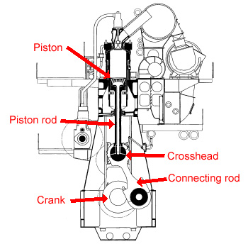

Selection of engine type
http://en.wikipedia.org/wiki/Diesel_generator
- According to fuel burned per minute
- Brake mean effective pressure
- Fuel injection system
- Combustion process
- Fuel air ratio
- Cooling method employed
- Size of cylinder
- volumetric efficiency

Conclusion & summary:
- Diesel engine can be classified according to size of cylinder
- Based on volumetric efficiency diesel engine can be classified

Session Plan 5
Recap: Diesel engine components
- Main components of diesel engine are piston, cylinder, head etc
- The reciprocating motion of the piston is converted to rotary motion

Performance characteristics of diesel engine
http://en.wikipedia.org/wiki/Diesel_engine
Diesel engines can operate on a variety of different fuels, depending on configuration, though the eponymous diesel fuel derived from crude oil is most common. The engines can work with the full spectrum of crude oil distillates, from natural gas, alcohols, petrol, wood gas to the fuel oils from diesel oil to residual fuels.
The type of fuel used is a combination of service requirements, and fuel costs. Good-quality diesel fuel can be synthesized from vegetable oil and alcohol. Diesel fuel can be made from coal or other carbon base using the Fischer-Tropsch process. Biodiesel is growing in popularity since it can frequently be used in unmodified engines, though production remains limited. Recently, biodiesel from coconut, which can produce a very promising coco methyl ester (CME), has characteristics which enhance lubricity and combustion giving a regular diesel engine without any modification more power, less particulate matter or black smoke, and smoother engine performance. The Philippines pioneers in the research on Coconut based CME with the help of German and American scientists. Petroleum-derived diesel is often called petrodiesel if there is need to distinguish the source of the fuel.
Pure plant oils are increasingly being used as a fuel for cars, trucks and remote combined heat and power generation especially in Germany where hundreds of decentralized small- and medium-sized oil presses cold press oilseed, mainly rapeseed, for fuel. There is a Deutsches Institut für Normung fuel standard for rapeseed oil fuel.
Residual fuels are the "dregs" of the distillation process and are a thicker, heavier oil, or oil with higher viscosity, which are so thick that they are not readily pumpable unless heated. Residual fuel oils are cheaper than clean, refined diesel oil, although they are dirtier. Their main considerations are for use in ships and very large generation sets, due to the cost of the large volume of fuel consumed, frequently amounting to many tonnes per hour. The poorly refined biofuels straight vegetable oil (SVO) and waste vegetable oil (WVO) can fall into this category, but can be viable fuels on non-common rail or TDI PD diesels with the simple conversion of fuel heating to 80 to 100 degrees Celsius to reduce viscosity, and adequate filtration to OEM standards. Engines using these heavy oils have to start and shut down on standard diesel fuel, as these fuels will not flow through fuel lines at low temperatures. Moving beyond that, use of low-grade fuels can lead to serious maintenance problems because of their high sulphur and lower lubrication properties. Most diesel engines that power ships like supertankers are built so that the engine can safely use low-grade fuels due to their separate cylinder and crankcase lubrication.
Normal diesel fuel is more difficult to ignite and slower in developing fire than petrol because of its higher flash point, but once burning, a diesel fire can be fierce. Fuel contaminants such as dirt and water are often more problematic in diesel engines than in petrol engines. Water can cause serious damage, due to corrosion, to the injection pump and injectors; and dirt, even very fine particulate matter, can damage the injection pumps due to the close tolerances that the pumps are machined to. All diesel engines will have a fuel filter (usually much finer than a filter on a petrol engine), and a water trap. The water trap (which is sometimes part of the fuel filter) often has a float connected to a warning light, which warns when there is too much water in the trap, and must be drained before damage to the engine can result. The fuel filter must be replaced much more often on a diesel engine than on a petrol engine, changing the fuel filter every 2-4 oil changes is not uncommon for some vehicles.
Supercharging of Diesel engine
http://en.wikipedia.org/wiki/Supercharger
A supercharger is an air compressor used for increasing the pressure, temperature, and density of air supplied to an internal combustion engine. This compressed air supplies a greater mass of oxygen per cycle of the engine to support combustion than available to a naturally aspirated engine, enabling for more fuel to be burned and more work to be done per cycle, thus allowing to increase the power produced by the engine. Power for the supercharger can be provided mechanically by means of a belt, gear, shaft, or chain connected to the engine's crankshaft. When power is provided by a turbine powered by exhaust gas, a supercharger is known as a turbo supercharger typically referred to simply as a turbocharger or just turbo. Common usage restricts the term supercharger to mechanically driven units.
Conclusion & Summary
- Diesel fuel have higher flash point
- Diesel have higher calorific value

Session Plan 6
Recap: Super charging of Diesel engine
- A supercharger is an air compressor used for increasing the pressure, temperature, and density of air supplied to an internal combustion engine.
- When power is provided by a turbine powered by exhaust gas, a supercharger is known as a turbo supercharger

Gas turbine power plant – layout
http://en.wikipedia.org/wiki/Gas_turbine_power_plant
A gas turbine, also called a combustion turbine, is a type of internal combustion engine. It has an upstream rotating compressor coupled to a downstream turbine, and a combustion chamber in-between.
The basic operation of the gas turbine is similar to that of the steam power plant except that air is used instead of water. Fresh atmospheric air flows through a compressor that brings it to higher pressure. Energy is then added by spraying fuel into the air and igniting it so the combustion generates a high-temperature flow. This high-temperature high-pressure gas enters a turbine, where it expands down to the exhaust pressure, producing a shaft work output in the process. The turbine shaft work is used to drive the compressor and other devices such as an electric generator that may be coupled to the shaft. The energy that is not used for shaft work comes out in the exhaust gases, so these have either a high temperature or a high velocity. The purpose of the gas turbine determines the design so that the most desirable energy form is maximized. Gas turbines are used to power aircraft, trains, ships, electrical generators, or even tanks
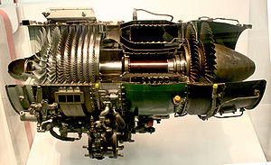

Types of gas turbines

Jet engines, Turboprop engines, Aero derivative gas turbines
Industrial gas turbines differ from aeronautical designs in that the frames, bearings, and blading are of heavier construction. They are also much more closely integrated with the devices they power electric generator and the secondary-energy equipment that is used to recover residual energy (largely heat).
They range in size from man-portable mobile plants to enormous, complex systems weighing more than a hundred tonnes housed in block-sized buildings. When the turbine is used solely for shaft power, its thermal efficiency is around the 30% mark. This may cause a problem in which it is cheaper to buy electricity than to burn fuel. Therefore many engines are used in CHP (Combined Heat and Power) configurations that can be small enough to be integrated into portable container configurations.
Gas turbines can be particularly efficient—up to at least 60%—when waste heat from the turbine is recovered by a heat recovery steam generator to power a conventional steam turbine in a combined cycle configuration.^{[14][15]} They can also be run in a cogeneration configuration: the exhaust is used for space or water heating, or drives an absorption chiller for cooling or refrigeration.
Another significant advantage is their ability to be turned on and off within minutes, supplying power during peak, or unscheduled, demand. Since single cycle (gas turbine only) power plants are less efficient than combined cycle plants, they are usually used as peaking power plants, which operate anywhere from several hours per day to a few dozen hours per year—depending on the electricity demand and the generating capacity of the region. In areas with a shortage of base-load and load following power plant capacity or with low fuel costs, a gas turbine power plant may regularly operate most hours of the day. A large single-cycle gas turbine typically produces 100 to 400 megawatts of electric power and has 35–40% thermal efficiency
Conclusion & Summary
- A large single-cycle gas turbine typically produces 100 to 400 megawatts
- Thermal efficiency of gas turbine power plant is 35-40%

Session Plan 7
Recap: Components and working of gas turbine power plant
- Gas turbine power plant works on the Brayton cycle
- Gas turbine power plant can be used in combination of steam power plant

Gas turbine fuels
http://en.wikipedia.org/wiki/Gas_turbine
- Ultra/Low LHV gaseous fuels
- Blast furnace gas (BFG)
- Air blown IGCC
- Biomass gasification
- High hydrogen gaseous fuels
- Refinery gas
- Petrochemical gas
- Hydrogen power
- Medium LHV gaseous fuels
- Weak natural gas
- Landfill gas
- Coke oven gas
- Corex gas
- Natural gas
- Natural gas
- Liquefied natural gas (LNG)
- High LHV gaseous fuels
- CH4 and higher hydrocarbons
- Liquid petroleum gas (butane, propane)
- Refinery off-gas
- Liquid fuels
- Diesel oil
- Naphtha
- Crude oils
- Residual oils
- Bio-liquids

Advantages of gas turbine engines
- Very high power-to-weight ratio, compared to reciprocating engines;
- Smaller than most reciprocating engines of the same power rating.
- Moves in one direction only, with far less vibration than a reciprocating engine.
- Fewer moving parts than reciprocating engines.
- Greater reliability, particularly in applications where sustained high power output is required
- Waste heat is dissipated almost entirely in the exhaust. This results in a high temperature exhaust stream that is very usable for boiling water in a combined cycle, or for cogeneration.
- Low operating pressures.
- High operation speeds.
- Low lubricating oil cost and consumption.
- Can run on a wide variety of fuels.
- Very low toxic emissions of CO and HC due to excess air, complete combustion and no "quench" of the flame on cold surfaces

Disadvantages of gas turbine engines
- Cost is very high
- Less efficient than reciprocating engines at idle speed
- Longer startup than reciprocating engines
- Less responsive to changes in power demand compared with reciprocating engines
- Characteristic whine can be hard to suppress
Conclusion & Summary
- Cost of gas turbine engine is very high
- Gas turbine can be operated in low pressure
Session Plan 8
Recap: Advantages and Disadvantages of gas turbine power plant
  - Gas turbine can run on a wide variety of fuels
  - Gas turbine produces very low toxic emissions of CO and HC due to excess air
Gas turbine materials
http://en.wikipedia.org/wiki/Turbine_blade
The development of super alloys in the 1940s and new processing methods such as vacuum induction melting in the 1950s greatly increased the temperature capability of turbine blades. Further processing methods like hot isostatic pressing improved the alloys used for turbine blades and increased turbine blade performance. Modern turbine blades often use nickel-based super alloys that incorporate chromium, cobalt, and rhenium.
Aside from alloy improvements, a major breakthrough was the development of directional solidification (DS) and single crystal (SC) production methods. These methods help greatly increase strength against fatigue and creep by aligning grain boundaries in one direction (DS) or by eliminating grain boundaries all together (SC)
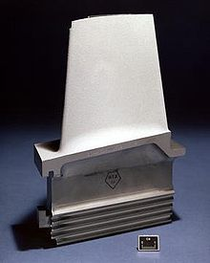
A turbine blade with thermal barrier coating.
Another major improvement to turbine blade material technology was the development of thermal barrier coatings (TBC). Where DS and SC developments improved creep and fatigue resistance, TBCs improved corrosion and oxidation resistance, both of which become greater concerns as temperatures increased. The first TBCs, applied in the 1970s, were aluminide coatings. Improved ceramic coatings became available in the 1980s. These coatings increased turbine blade capability by about 200°F (90°C). The coatings also improve blade life, almost doubling the life of turbine blades in some cases.^{[9]}Most turbine blades are manufactured by investment casting (or lost-wax processing). This process involves making a precise negative die of the blade shape that is filled with wax to form the blade shape. If the blade is hollow (i.e., it has internal cooling passages), a ceramic core in the shape of the passage is inserted into the middle. The wax blade is coated with a heat resistant material to make a shell, and then that shell is filled with the blade alloy. This step can be more complicated for DS or SC materials, but the process is similar. If there is a ceramic core in the middle of the blade, it is dissolved in a solution that leaves the blade hollow. The blades are coated with the TBC they will have, and then cooling holes are machined as needed, creating a complete turbine blade.
Conclusion & Summary
- Mostly turbine blades are made by investment casting
- Modern turbine blades often use nickel-based super alloys

Session Plan 9
Recap: Advantages and disadvantages of various turbine materials
- Nickel based alloy for turbine blade can with stand high temperature
- Turbine blades made of investment casting are cheaper
Open and closed cycles in gas turbine
http://en.wikipedia.org/wiki/Closed-cycle_gas_turbine
A closed-cycle gas turbine is a turbine that uses a gas (e.g. air, nitrogen, helium, argon,^{[1]} etc.) for the working fluid as part of a closed thermodynamic system. Heat is supplied from an external source. Such re circulating turbines follow the Brayton cycle.
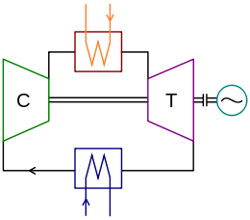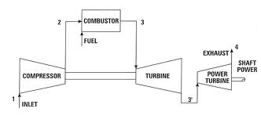
reheating, regeneration in gas turbine plant
http://www.scribd.com/doc/51435453/The-Brayton-Cycle-with-Regeneration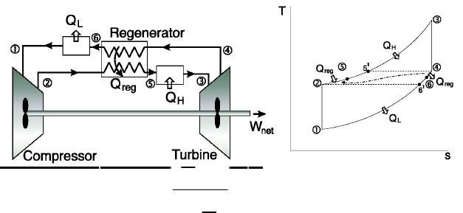
Conclusion & Summary
- Reheating in gas turbine increases the efficiency of the plant
- Regenerative heating utilize the waste exhausted from the turbine

