Unit 5 Other power plants and Economics of Power plants

Session Plan 1
Recap: Reheating, regeneration in gas turbine plant
- Reheating in gas turbine plant increases the thermal efficiency
- Overall plant efficiency is increased by regenerative heating

Geo thermal energy – working principle

http://en.wikipedia.org/wiki/Geothermal_electricity
Geothermal electricity is electricity generated from geothermal energy. Technologies in use include dry steam power plants, flash steam power plants and binary cycle power plants. Geothermal electricity generation is currently used in 24 countries, while geothermal heating is in use in 70 countries.
Estimates of the electricity generating potential of geothermal energy vary from 35 to 2,000 GW. Current worldwide installed capacity is 10,715 megawatts (MW), with the largest capacity in the United States (3,086 MW), Philippines, and Indonesia. India has announced a plan to develop the country's first geothermal power facility in Chhattisgarh.
Geothermal power is considered to be sustainable because the heat extraction is small compared with the Earth's heat content. The emission intensity of existing geothermal electric plants is on average 122 kg of CO₂ per megawatt-hour (MW·h) of electricity, about one-eighth of a conventional coal-fired plant.

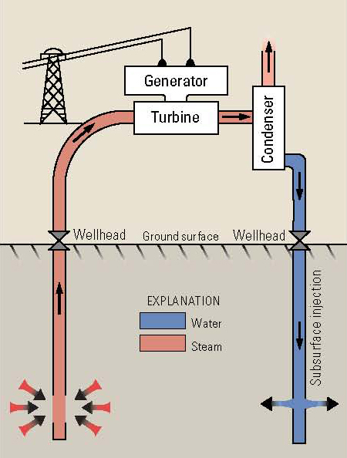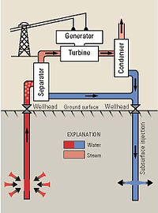
Advantages of geo thermal energy

http://www.greenlivinganswers.com/archives/178

The Advantages of Geothermal Energy
When a power station harnesses geothermal power in the correct manner, there are no by products, which are harmful to the environment. Environmentalists should be happy about that!
There is also no consumption of any type of fossil fuels. In addition, geothermal energy does not output any type of greenhouse effect. After the construction of a geothermal power plant, there is little maintenance to contend with. In terms of energy consumption, a geothermal power plant is self-sufficient.
Another advantage to geothermal energy is that the power plants do not have to be huge which is great for protecting the natural environment.
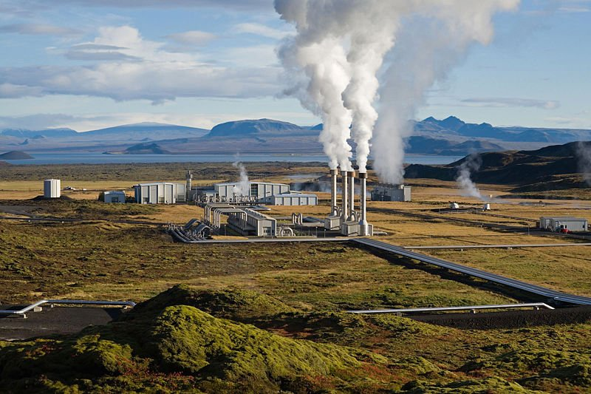

Conclusion & Summary
- In geothermal power plant there is also no consumption of any type of fossil fuels
- Green houses gas is not emitted in geothermal plant

Session Plan 2

Recap: Advantages of geo thermal energy
- Geothermal power plant has little maintenance
- Geothermal power plant does not require huge space

Ocean thermal energy conversion – working
http://en.wikipedia.org/wiki/Ocean_thermal_energy_conversion
Ocean thermal energy conversion (OTEC) uses the temperature difference between cooler deep and warmer shallow or surface ocean waters to run a heat engine and produce useful work, usually in the form of electricity. OTEC is a base load technology that allows for production of electricity on a constant basis. However, the temperature differential is small and this impacts the economic feasibility of ocean thermal energy for electricity generation.
The most commonly used heat cycle for OTEC is the Rankine cycle using a low-pressure turbine. Systems may be either closed-cycle or open-cycle. Closed-cycle engines use working fluids that are typically thought of as refrigerants such as ammonia or R-134a. These fluids have low boiling points, and are therefore suitable for powering the system’s generator to generate electricity. Open-cycle engines use vapour from the seawater itself as the working fluid.
OTEC can also supply quantities of cold water as a by-product. This can be used for air conditioning and refrigeration and the nutrient-rich deep ocean water can feed biological technologies. Another by-product is fresh water distilled from the sea
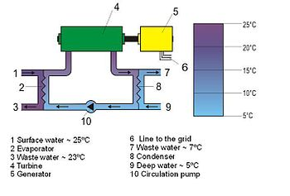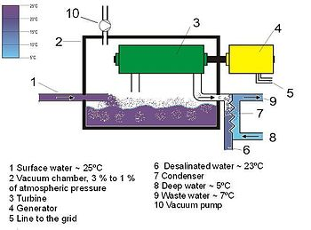

Advantages of Ocean thermal energy
http://www.azhealthtips.info/2013/05/ocean-thermal-energy-conversion-advantages-and-disadvantages.html

Advantages
- OTEC uses clean, renewable, natural resources. Warm surface seawater and Cold water from the ocean depths replace fossil fuels to produce electricity.
- Suitably designed OTEC plants will produce little or no carbon dioxide or other polluting chemicals.
- OTEC systems can produce fresh water as well as electricity. This is a significant advantage in island areas where fresh water is limited.
- There is enough solar energy received and stored in the warm tropical ocean surface layer to provide most, if not all, of present human energy needs.
- The use of OTEC as a source of electricity will help reduce the state's almost complete dependence on imported fossil fuels.

Disadvantages
- OTEC-produced electricity at present would cost more than electricity generated from fossil fuels at their current costs.
- OTEC plants must be located where a difference of about 20º C occurs year round. Ocean depths must be available fairly close to shore-based facilities for economic operation. Floating plant ships could provide more flexibility.
- No energy company will put money in this project because it only had been tested in a very small scale.
- Construction of OTEC plants and lying of pipes in coastal waters may cause localized damage to reefs and near-shore marine ecosystems.

Conclusion & Summary
- OTEC uses clean, renewable, natural resources
- Suitably designed OTEC plants will produce little carbon dioxide

Session Plan 3

Recap: Advantages of Ocean thermal energy
- OTEC systems can produce fresh water as well as electricity
- The use of OTEC as a source of electricity will help to reduce the use of fossil fuel

Pumped storage power generation

http://en.wikipedia.org/wiki/Pumped-storage_hydroelectricity
Pumped-storage hydroelectricity (PSH) is a type of hydroelectric power generation used by some power plants for load balancing. The method stores energy in the form of potential energy of water, pumped from a lower elevation reservoir to a higher elevation. Low-cost off-peak electric power is used to run the pumps. During periods of high electrical demand, the stored water is released through turbines to produce electric power. Although the losses of the pumping process makes the plant a net consumer of energy overall, the system increases revenue by selling more electricity during periods of peak demand, when electricity prices are highest.

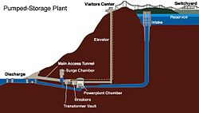

Advantages of Pumped storage power generation

http://en.wikipedia.org/wiki/Hydroelectricity
A pumped-storage hydroelectric power plant is a net consumer of energy but can be used to smooth peaks and troughs in overall electricity demand. Pumped storage plants typically use "spare" electricity during off peak periods to pump water from a lower reservoir or dam to an upper reservoir. Because the electricity is consumed "off peak" it is typically cheaper than power at peak times. This is because the "base load" power stations, which are typically coal fired, cannot be switched on and off quickly so remain in service even when demand is low. During hours of peak demand, when the electricity price is high, the water pumped to the high reservoir is allowed to flow back to the lower reservoir through a water turbine connected to an electricity generator. Unlike coal power stations, which can take more than 12 hours to start up from cold, the hydroelectric plant can be brought into service in a few minutes, ideal to meet a peak load demand
Conclusion & summary
- Hydroelectric plant can be brought into service in a few minutes
- Pumped storage plants typically use "spare" electricity during off peak periods to pump water from a lower reservoir

Session Plan 4

Recap: Advantages of Pumped storage power generation
- Pumped storage plant can be use to smooth, peak and trough in overall electricity demand
- Pumped storage plant ideal to meet a peak load demand

Solar central receiver system – power generation
http://en.wikipedia.org/wiki/Solar_power_tower
The solar power tower, also known as 'central tower' power plants or 'heliostat' power plants or power towers, is a type of solar furnace using a tower to receive the focused sunlight. It uses an array of flat, movable mirrors (called heliostats) to focus the sun's rays upon a collector tower (the target). Concentrated solar thermal is seen as one viable solution for renewable, pollution-free energy.
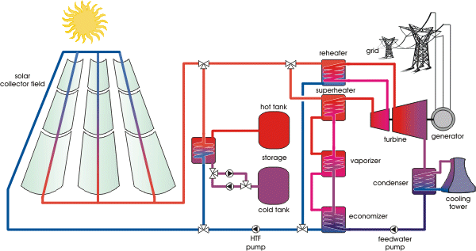
Application of Solar central receiver system
http://www.docstoc.com/docs/3547443/CENTRAL-RECEIVER-SYSTEM-CRS-SOLAR-POWER-PLANT-USING-MOLTEN-SALT
- Mostly for power production in remote areas
- Production of steam for cleaning surgical equipments in hospitals
- Hot water for cleaning and washing purposes

Conclusion & summary
- Central tower system can produce steam to a temperature of 400⁰C
- Central tower system mostly used for power production

Session Plan 5
Recap: Application of Solar central receiver system
- Central power plant uses solar energy for power production
- Central power plants are capable of producing power in MW
Cost analysis of electric energy
http://en.wikipedia.org/wiki/Cost_of_electricity_by_source
The cost of electricity (typically cents/kWh, Euro/kWh, Euro or $/MWh) generated by different sources is a calculation of the cost of generating electricity at the point of connection to a load or electricity grid. It includes the initial capital, discount rate, as well as the costs of continuous operation, fuel, and maintenance. This type of calculation assists policy makers, researchers and others to guide discussions and decision making.
Fixed cost or capital cost – Land , building and equipment cost, interest, Depreciation cost
Depreciation cost is calculated by straight line method, sinking fund method, diminishing value method, insurance, management cost
Operating cost – Cost of fuel, lubricating oil, grease and water costs, cost of maintenance and repairs, cost of operating labour, cost of supervision, taxes
Advantages of cost analysis
http://www.nrel.gov/analysis/analysis_tools_benefits.html
Pay back calculation, minimum saving required, rate of return of investment
Conclusion & summary
- Depreciation cost is calculated by straight line method
- Fixed cost is the cost associated with buildings

Session Plan 6
Recap: Advantages of cost analysis
- Cost analysis is used to know the pay back period
- Rate of return of investment can found out using cost analysis
Fixed and operating costs
http://www.fas.org/sgp/crs/misc/RL34746.pdf
Fixed cost is the cost associated with cost of land, building, equipment cost, interest and depreciation cost of the equipment, Insurance and management cost
Operating cost includes cost of fuel, lubricating oil, grease and water cost, cost of maintenance and repairs, cost of operating labour, cost of supervision, taxes.

Energy rates in power plants
http://en.wikipedia.org/wiki/Cost_of_electricity_by_source
Energy source | Costs of electricity production in euros per megawatt hour
Nuclear Energy | 107.0 – 124.0
Brown Coal | 88.0 – 97.0
Black Coal | 104.0 – 107.0
Domestic Gas | 106.0 – 118.0
Wind Energy Onshore | 49.7 – 96.1
Wind Energy Offshore | 35.0 – 150.0
Hydropower | 34.7 – 126.7
Biomass | 77.1 – 115.5
Solar Electricity | 284.3 – 391.4
Conclusion & summary:
- operating cost includes cost of fuel and lubricating oil
- Fixed cost includes cost of equipment

Session Plan 7

Recap: Energy rates in power plants
- Cost of energy in hydro power plant is more
- Energy cost is low in coal power plant

Tariffs types

http://en.wikipedia.org/wiki/Electricity_tariff
- Flat demand rate
- Straight meter rate
- Block meter rate
- Hopkinson demand rate (two part tariff )
- Doherty demand rate
- Wright demand rate

Economics of load sharing in power plant
http://www.ignou.ac.in/upload/Unit-7-58.pdf
The economics of power plant operation is greatly influenced by load factor, demand factor, utilization factor

Conclusion & summary
- Mention any two factor which influence economics of power plant – load factor and demand factor
- Hopkinson demand rate is a two part tariff method

Session Plan 8

Recap: Tariffs types
- Give any two tariff types – flat demand rate, straight meter rate
- The objective of tariff is to recover the cost of operation

Comparison of various power plants

http://en.wikipedia.org/wiki/Cost_of_electricity_by_source

Operating cost of various power plants

http://en.wikipedia.org/wiki/Cost_of_electricity_by_source

Energy source | Costs of electricity production in euros per megawatt hour
Nuclear Energy | 107.0 – 124.0
Brown Coal | 88.0 – 97.0
Black Coal | 104.0 – 107.0
Domestic Gas | 106.0 – 118.0
Wind Energy Onshore | 49.7 – 96.1
Wind Energy Offshore | 35.0 – 150.0
Hydropower | 34.7 – 126.7
Biomass | 77.1 – 115.5
Solar Electricity | 284.3 – 391.4

Conclusion & summary
- The main advantages of combined power generation is flexibility of operation
- Security of power supply is available in cogeneration power plant

Session Plan 9

Recap: Operating cost of various power plants
- Operating cost of solar energy is more
- Operating cost of wind energy is low

Load duration curves of various power plants
http://en.wikipedia.org/wiki/Load_duration_curve

http://www.nct-tech.edu.lk/Download/Technology%20Zone/Variable%20Load%20on%20Power%20Station..pdf
- The various types of load curve are
- Residential load
- Commercial load
- Industrial load
- Municipal load
- Traction load
- Irrigation load

Advantages of load curve in power plants

http://en.wikipedia.org/wiki/Base_load_power_plant

Load curves give full information about the incoming load and help to decide the installed capacity of the power station and to decide the economical sizes of various generating units

These curves also help to estimate the generating cost and to decide the operating schedule of the power station

A load duration curve represents rearrangements of all the load elements of chronological load curve in order of descending magnitude.

Conclusion & summary
- The various load curve are residential load and commercial load
- Load curve helps to decide the installed capacity of power plant

