**UNIT-III**

**MICROWAVE PASSIVE COMPONENTS**

**Session – I Date: 22.7.13 period:1**

Questionnaires and brainstorming on microwave components:

* What is microwave?

High frequency signal with small wavelength

* Need for microwave components?

Electrical length = 0.33 λ, Phase delay = 118.8° !!!

* How resistor, capacitor, inductor, wire differ in microwave?

Differ in size & freq. of operation

* Where it is applicable?

In microwave engineering applications

Presentation & brainstorming in microwave range & its significances:

* Frequency band range
* Uses of each range in communication

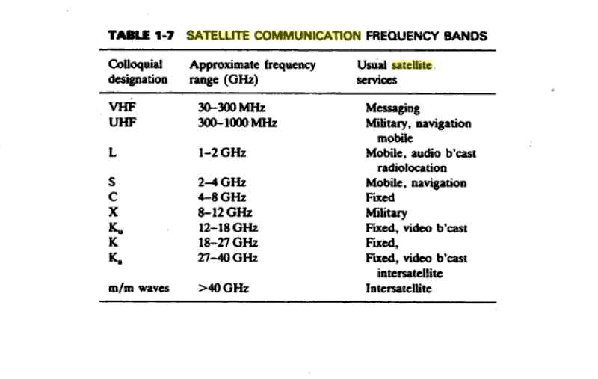

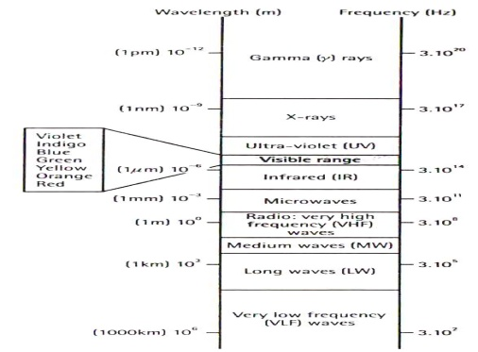

HF – 0.003 – 0.03 (Freq in GHZ),VHF – 0.03 - 0.3, UHF – 0.3 – 1.00, L BAND – 1.00 – 2.00, S BAND – 2.00 – 4.00, C BAND – 4.00 – 8.00, X BAND – 8.00 – 12.00,

KU BAND – 12.00 – 18.00, K BAND – 18.00 – 27.00, Ka BAND – 27.00 – 40.00

MILLIMETER – 40.00 – 300.0, SUB MILLIMETER – ABOVE 300.00

Presentation on application of microwaves:

* Different level of application

Conclusion & Summary: recall by key words

* Impedance & admittance
* S parameter
* S band range
* Ku band range
* K band range
* X band range

**Session – II Date:22.7.13 `period:6**

Brainstorming in scattering matrix:

* What are low frequency parameters?

Z, Y, h, ABCD

* What are high frequency parameters?

S parameter

* Impact on wavelength

Electrical length = 0.33 λ, Phase delay = 118.8° !!!

* What is S parameter?

Scattering matrix for high freq.

* What is need for S parameter?

Low freq. parameter are not stable in high freq.

* Advantage of S parameter.

VSWR, phase measurement, power balance

* Limitation of low freq. parameter.

Unstable, no equipment available

Presentation & derivation:

* Concept of N port scattering matrix representation

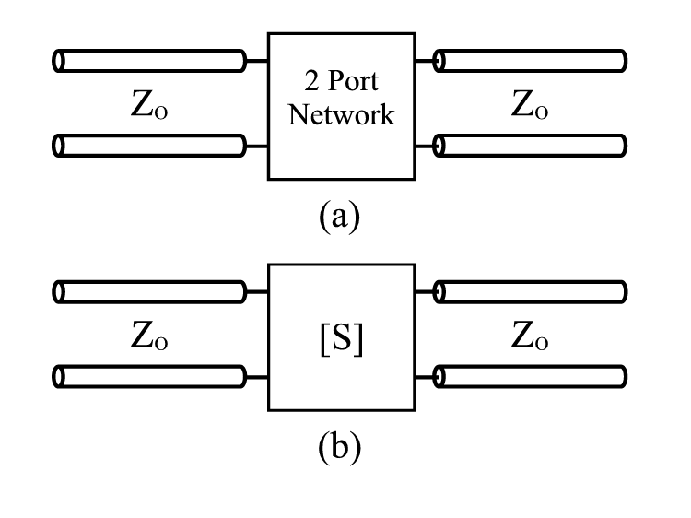



Conclusion & summary: recall by key words

* Reflection coefficient
* Transmission coefficient
* Reciprocal networks - condition
* Lossless networks - condition

**Session – III Date:23.7.13 `period:2**

Brainstorming & discussion on S parameter:

* What is S parameter?

Scattering Matrix

* What is need for S parameter?

For high freq.

* Advantage of S parameter.

Power balance, VSWR measurement

* Why S parameter cannot be used in low frequency analysis?

No equipment available

* Why low frequency parameter cannot be used in high frequency analysis?

Unstable, no o/p. s/c possible

Brainstorming &discussion:Properties of S Matrix

* Zero diagonal property

Sii = 0, if matched

* Reciprocal property – condition



* Lossless property – condition







* Phase shift property

Brainstorming & discussion:

* Formulation of Scattering matrix (S) parameter:



* Formation of scattering matrix presentation- two port network



Conclusion & summary: List by key words & quiz

* S11 or S22
* S21 or S12
* Reflection coefficient
* Standing wave ratio
* Transmission coefficient

**Session – IV Date:23.7.13 `period:8**

Introduction: microwave Tee junction

* Need for microwave junction : Independent ports
* Uses: branching
* Factor representing it: S parameters

Demonstration & Derivation:

* Show & tell - E plane junction

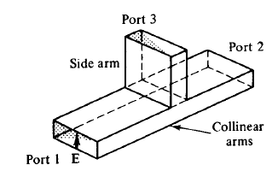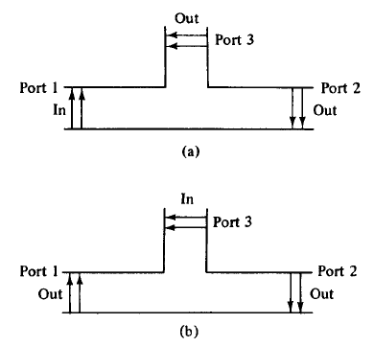

**S13 = -S23**

* Show & tell - H plane junction

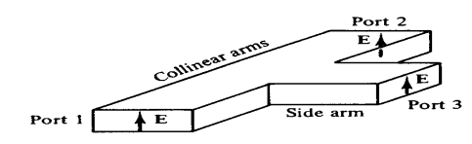

**S13 = S23**

* Its S matrix derivation

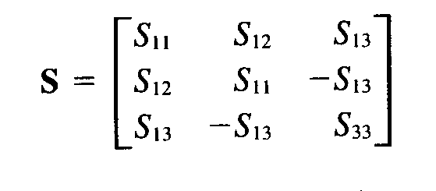

Demonstration & Derivation:

* Show & tell – Magic Teejunction

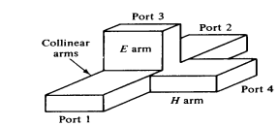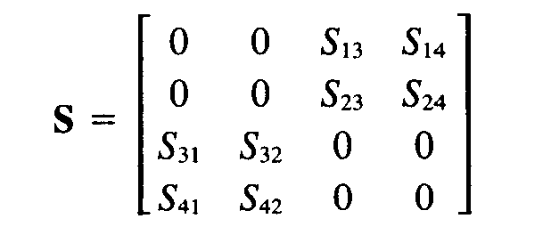

S34 = S43 =0

S12 = S21 = 0

* Presentation - Rat race junction
* Its S matrix derivation

Conclusion & summary: List by key words: Quiz

* Reciprocal condition of E & H plane
* Reciprocal condition of Magic Tee
* S13=? In E plane & H plane
* S23=? In E plane & H plane
* S11 & S22=?
* What is hybrid ring?
* S13=? In magic Tee & rat race junction
* S23=? In magic Tee & rat race junction

**Session –V**

Brainstorming & Discussion on couplers:

* How power is divided in microwave?

E plane, H plane, magicTee junctions

* Need for it

branching

* Factor representing it

S- matrix, electric & magnetic fields

Demonstration & presentation:

* Show & tell - Directional coupler

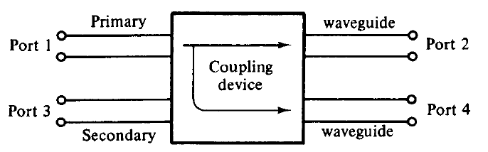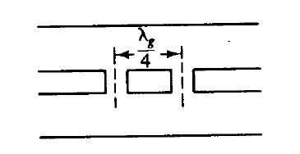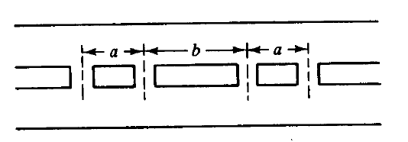

* Show & tell - Two hole coupler– ports- termination

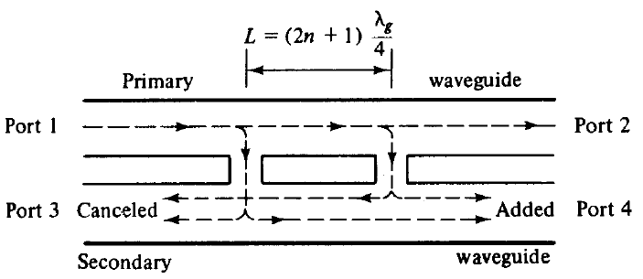

* L=(2n+1) λg/4
* **types :**

two-hole directional coupler

four-hole directional coupler

reverse-coupling directional coup.

Bethe-hole directional coupler

**Coupling factor** is a measure of power levels in primary and secondary line

**Directivity** is a measure of how well the forward travelling wave in the primary waveguide couples only to a specific port of the secondary waveguide

Derivation:

* S matrix derivation for directional coupler
* **S13=S31=0, S24=S42=0**
* **S21=S12  S41= S14 S32= S23 S43 = S34**

Conclusion & summary: recall by key words:

* S13=? 0
* S24=? 0
* S11 & S22=? 0
* Diagonal element S11 & S22
* Phase shifter : phase changer
* Primary & secondary waveguide : Directional coupler

**Session –VI**

Presentation: Ferrites

* Microwave properties : high resistance magnetic material

consist of mainly ferrite oxide & one or more other metals

it is made by inserting metallic atoms into iron oxide in place of some iron atoms

addition of zinc atom in iron oxide forms zinc ferrite(ZnFe2O3)

* EM waves passing through ferrite undergoes phase shift and attenuation, which is influenced by applied dc magnetic field
* Need : phase changing
* Principle of operation : faraday rotational law

If a circular polarized wave is made to pass through a ferrite rod which has been influenced by an axial magnetic field B ,then the axis of polarization gets tilted in clockwise direction and amount of tilt depends upon the strength of magnetic field and geometry of the ferrite.

nonreciprocal precession of unpaired electrons in ferrite causes their relative permeabilities(μr+, μr-) to be unequal and the wave in the ferrite is then circularly polarized

Demonstration &presentation:

* Show & tell – Termination
* **Terminations:** matching the load, For VSWR measurements
* Types

(i) matched load

(ii) standard mismatches

(iii) adjustable shorts

Demonstration &Presentation:

* Show & tell – isolator

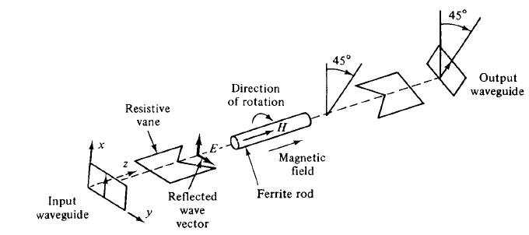

* Its S matrix derivation

Conclusion & summary: list by key words:

* Faraday rotation law
* Reciprocal network
* Applications
* Reflection coefficient
* S12=? In isolator
* S21=? In isolator

**Session –VII**

Presentation: Gyrator

* Microwave properties : Faraday Rotational law

If a circular polarized wave is made to pass through a ferrite rod which has been influenced by an axial magnetic field B ,then the axis of polarization gets tilted in clockwise direction and amount of tilt depends upon the strength of magnetic field and geometry of the ferrite.

* Principle of operation: phase shift with two end rectangular waveguide with centered circular waveguide

Phase change with each twist

* Application : 180 phase changer

Demonstration &Presentation:

* Show & tell – circulator

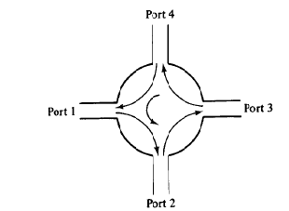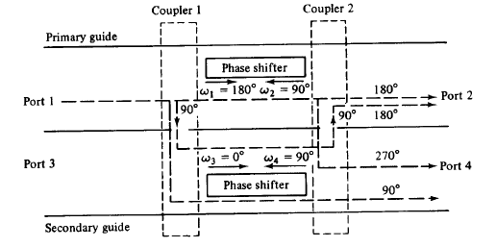

* Its S matrix derivation
* **S13=S31=0, S24=S42=0**
* **S21, S12  =0, S41=0, S14, S32, S23=0, S43, S34=0, S11S22 S33 S44  =0**

Conclusion & summary: recall by key words:

* Faraday rotation law
* Reciprocal network
* Applications
* Reflection coefficient
* S12=? In circulator : not possible
* S21=? In circulator : possible
* S13=? In circulator : not possible
* S31=? In circulator : not possible

**Session –VIII**

Demonstration &Presentation:

* Microwave corners
* 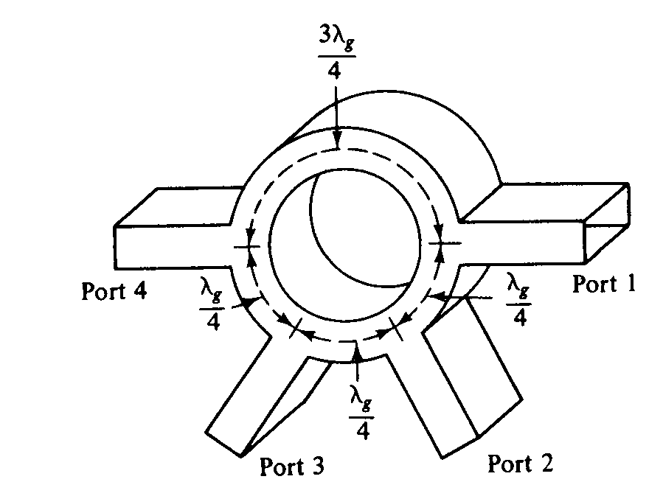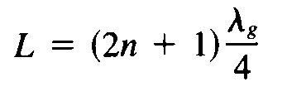
* Types

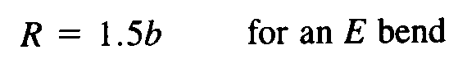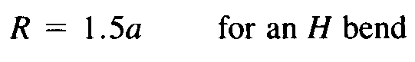

Demonstration &Presentation:

* Microwave bends

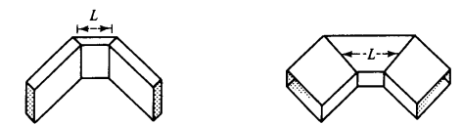



* types

Demonstration &Presentation:

* Microwave twist

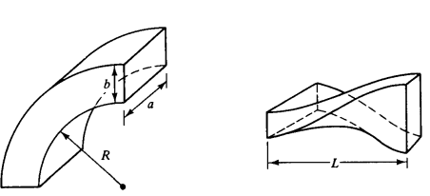

Conclusion & summary: list by key words:

* Need for corners : for waveguide sharp bends
* Need for twist : change of waveguide plane
* Need for bends : for waveguide bends
* Defined length of corners, bends & twist

**Session – IX**

Demonstration & presentation:

* Show & tell – Attenuator

passive devices used to control power levels

partially absorbs the power

two types (i) fixed attenuator

(ii) variable attenuator

fixed: thin dielectric strip coated with resistive film placed at centre of wave parallel to E-field

* induced current in resistive film results in power dissipation
* tapered at edge to reduce reflections
* Variable: micrometer screw from one side to centre

Presentation & Discussion:

* Phase changer
* Two port passives that produce a variable change in phase when transmitted through it.
* Placing lossless dielectric slab within a waveguide parallel to and at the position of maximum E-field
* Differential phase change is produced due to change of wave velocity through the dielectric slab
* Its need in microwave system – circulator
* 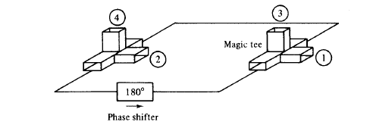

Case study:

* Rectangular cavity resonator – its components – resonant frequency
* Cylindrical cavity resonator – its components – resonant frequency
* Application

|  |  |
| --- | --- |
|  |  |
|  |  |

Conclusion & summary: list by key words:

* Faraday rotation
* Ferrites
* Reciprocal network
* Precise attenuator