UNIT-IV
MICROWAVE SEMICONDUCTOR DEVICES
Session - I
Introduction and brainstorming on semiconductor devices:
- What is semiconductor device?
Has property in b/w insulator & metal by doping with Silicon or Germanium
- Difference b/w low and high frequency semiconductor device
Three main requirements which are reverse
Dimensions
Heat sinking
Packaging
- Frequency consideration : bands
Presentation & discussion:
- Semiconductor devices
Solid state devices becoming increasingly important at microwave frequencies
- Microwave solid state devices are preferred as its electrical proprties lie intermediate b/w metals and insulators
- Conductivity varied by change in temperature, optical excitation, impurity content
- 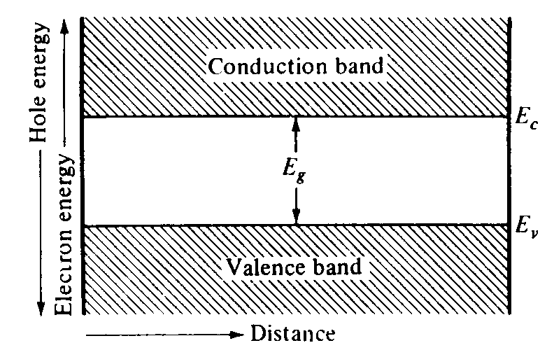

- Types
- Classified into four groups
(i) microwave transistor - BJT, HBT, Tunnel diode
(ii) field effect transistor - FET, MESFET,HEMT, NMOS, PMOS, CCD
(iii) transferred electron devices – GUNN DIODE
(iv) avalanche transit time devices – IMPATT, TRAPPAT, BARRIT
- Presentation & discussion: Principle & operation of microwave semiconductor device
- Microwave transistor generate power upto 5GHz
- Gunn diode generate 1W at X-band
- LSA –highest peak power- 250 W in C-band, 100W in X-band 50W in Ku-band
- TRAPATT diode also produce power but- opearting freq. is determined by thickness of active layer in diode
Ex: 10GHz requires 10μm
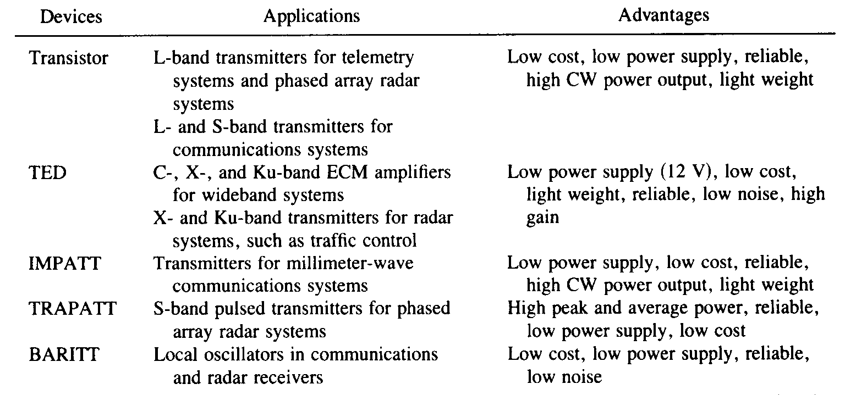
Conclusion & Summary: recall by key words
- HEMT - High electron mobility transistor
- TED – Transferred Electron diode
- IMPATT - Impact ionization avalanche transit time diode
- TRAPATT - trapped plasma avalanche triggered transit time diode
- GUNN – TED semiconductor diode

Session – II
Introduction & discussion:
- Bipolar junction transistor – BJT:
- Si n-p-n type – 5 GHZ oper. Freq.
- At high temp. & high radiation field GaAs used
- Three types of configuration:
- (i) common – base, (ii) common – emitter, (iii) common - collector
- 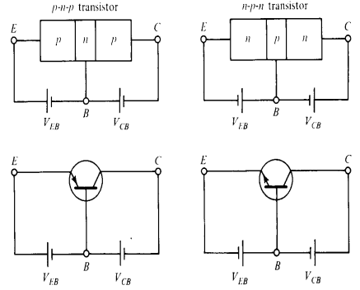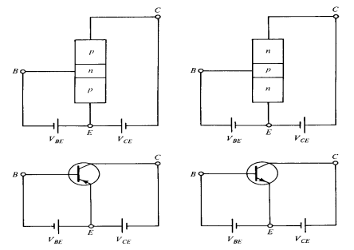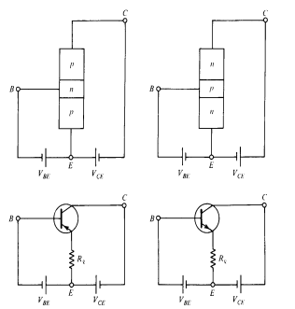
- Mode of operation:
- (i) normal mode, (ii) saturation mode, (iii) cut-off mode, (iv) inverse mode
- 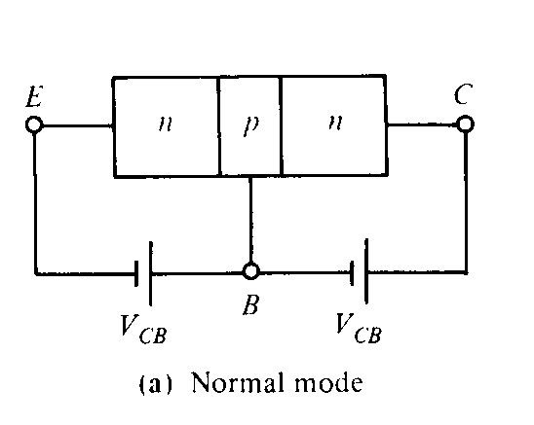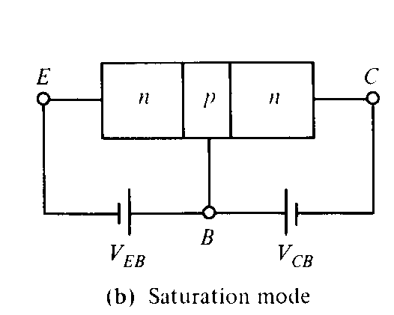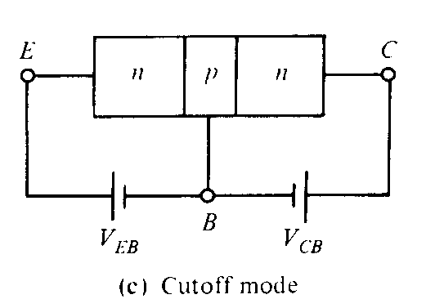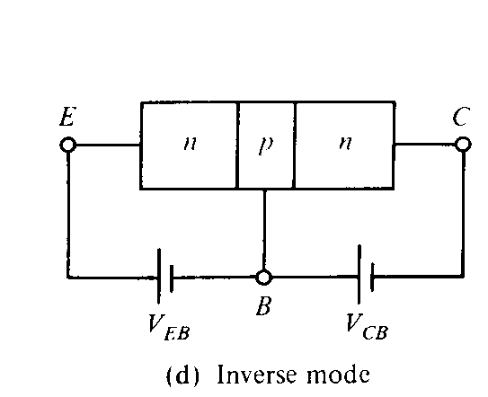
- Field effect transistor – FET
Presentation & discussion:
- Operation of BJT & FET
- Three regions of I-V charcteristics:
- (i) active region- Ic depends on Vc, Ie
- (ii) saturation- Ic increases sharply
- (iii) cut-off – non active
- High frequency Limitation:
- At high frequencies, reactance due to junction capacitance limits the gain.
- Capacitance depletion layer width
- depends on & bias voltage
- provides

- feedback path
- Transit time reduced by narrow p & n region
- Also reduced by reducing depletion layer width but
- it need higher collector voltage without avalanche breakdown
- but increases power dissipation, damage the device
- power frequency limitation of BJT: Four equations
- 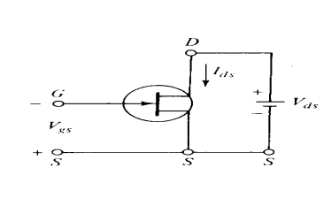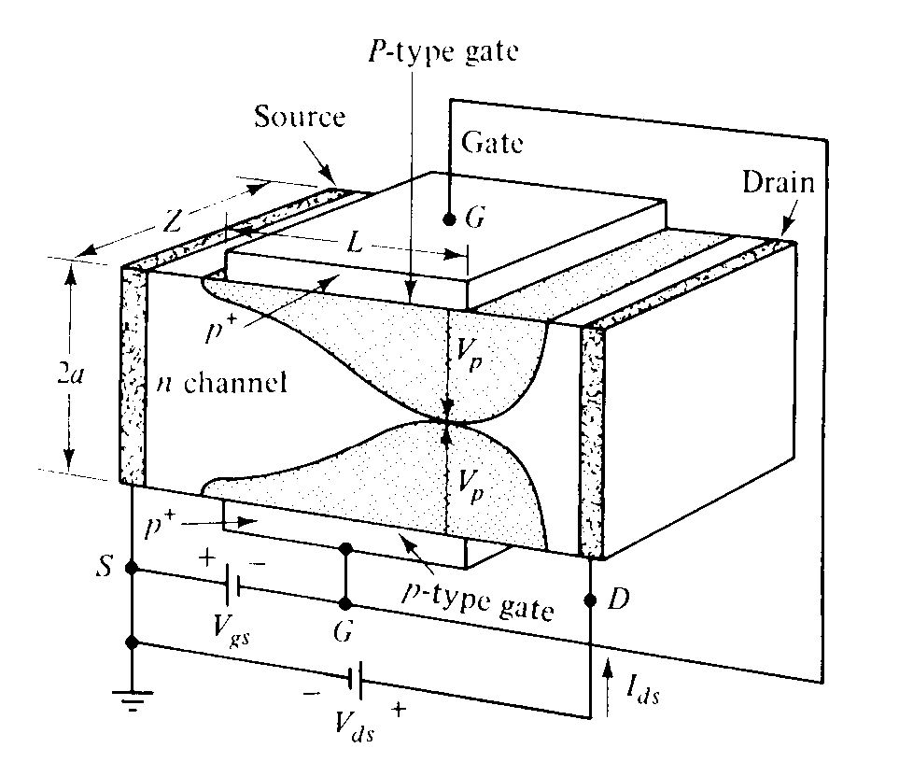
- Vg is 0, no drain current Id
- For small Vd b/w is applied, n-type act as simple resistor, hence current Id increases linearly with Vd
- If Reverse gate voltage Vg is applied, majority of electrons depleted from the channel & charge region extends
- Characteristic & application of BJT & FET
- 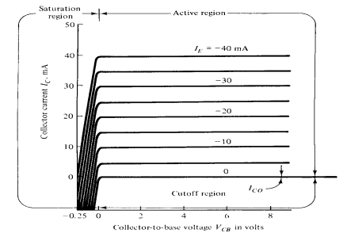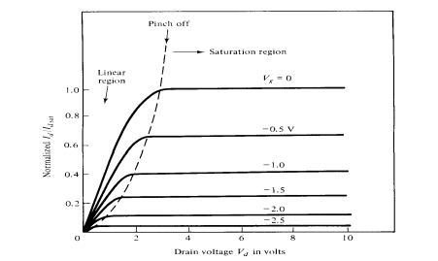

Conclusion & summary: recall by key words
- Negative resistance
- Energy band
- Forbidden band
- Valence and conduction band
- Tunneling
- Comparison b/w PN diode & tunnel diode

Session – III
Presentation & Video:
- Operation of Tunnel diode
- Negative resistance semiconductor p-n junction diode
- Negative resistance is created by tunnel effect of electrons in p-n junc.
- Both have high impurity concentration of 10¹⁹ to 10²⁰
- Useful in amplification, oscillation and binary memory
Principle of operation:
- Depletion layer barrier at junction is very thin such that particle will tunnel through the barrier even though no kinetic energy
- Filled energy state in one side and allowed empty state on other for tunneling
- 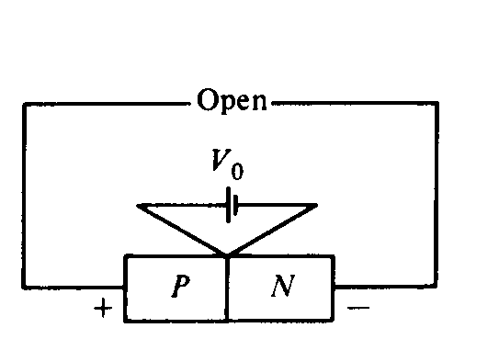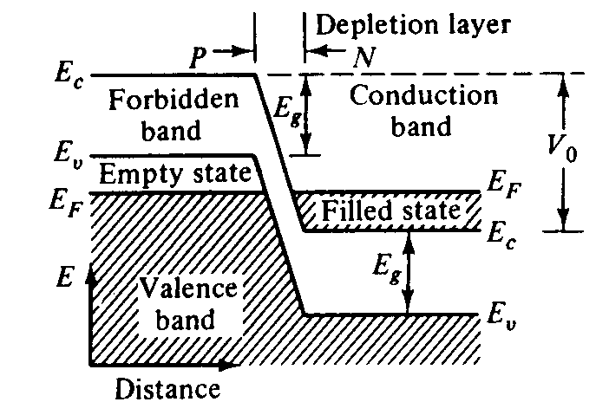
- 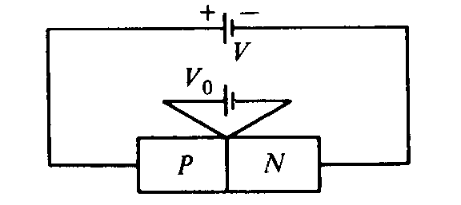
- 0 < V <Vp:
- 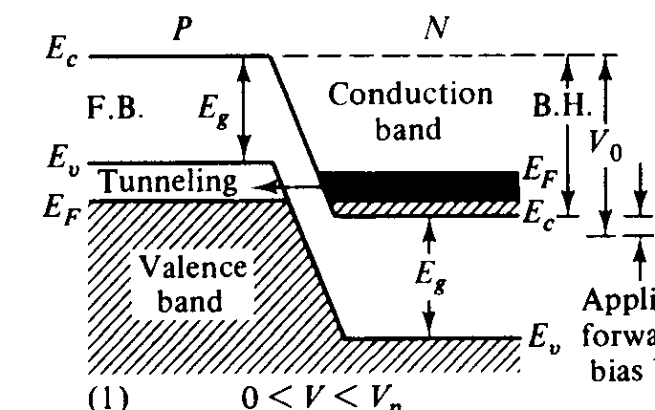
- V=Vp: Vp< V <Vv: Vv< V <α :
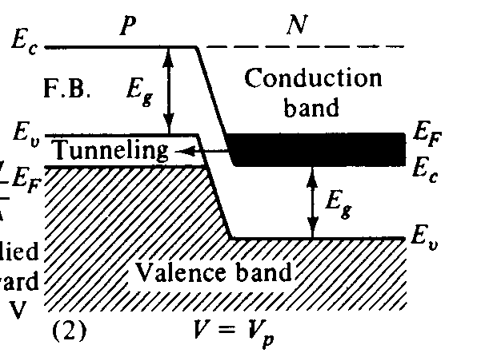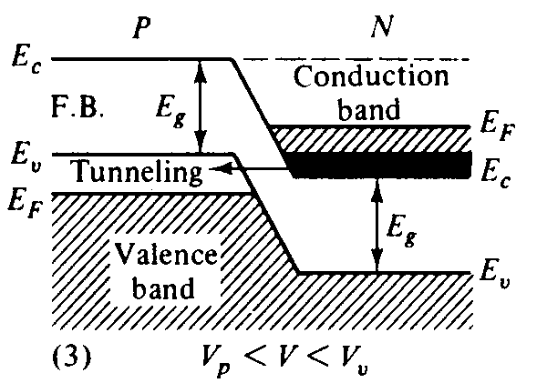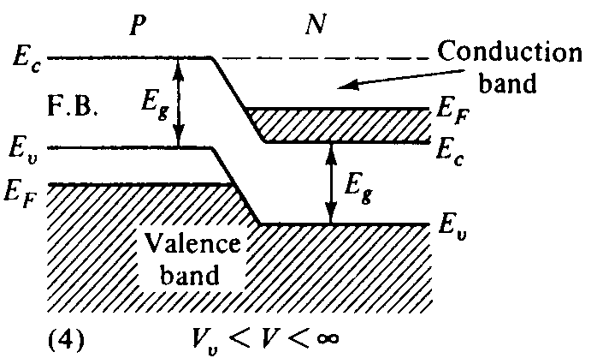

- Characteristic & application of Tunnel diode
- 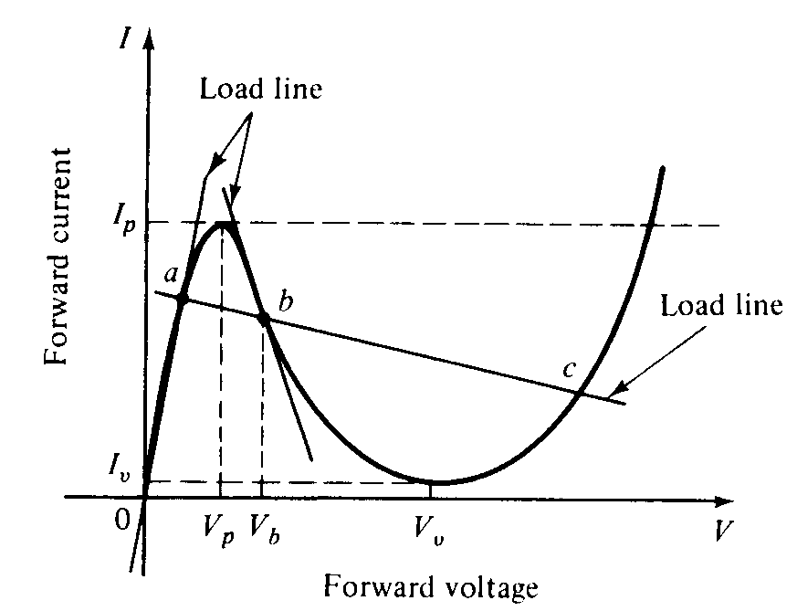
- www.youtube-tunneldiode.flv

Presentation:
- Principle of Varactor diode
- Operation of Varactor diode
Video Presentation:
www.youtube.com/watch?v=dTEOVD0eBsM
http://www.learnerstv.com/video/Free-video-Lecture-5089-engineering.htm#
Presentation:
- Principle of Step recovery diode
- Operation of Step recovery diode

Conclusion & summary: List by key words
- Voltage variable junction capacitance
- Varactor frequency multiplier
- Comparison b/w varactor& step recovery diode

Session – IV
Introduction:
- TED – Transferred Electron Devices

- Microwave transistor
- Operate with either junction or gates
- Elemental semiconductor are Silicon and germanium
- Transistor operate with “warm” electrons of thermal energy of 0.026 eV at room temperature

Transferred electron devices
- Bulk devices with no junction or gates
- GaAs, InP, Cd Te
- Transistor operate with “hot” electrons very much greater then thermal energy

- Gunn diode
- 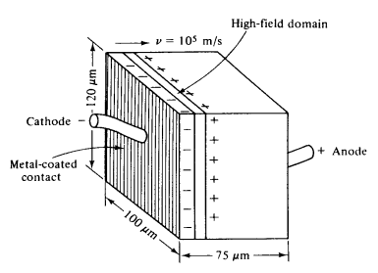
Presentation:
- Gunn effect
- Above some critical voltage of electric field of 2000 to 4000 volts/cm, current in every specimen become a fluctuating function of time
- In GaAs, it is in the form of periodic oscillation
- Frequency of oscillation is determined mainly by specimen and not by external circuit
- Period of oscillation was inversely proportional to specimen length and closely equal to transit time of electron b/w electrodes
- Carrier drift velocity is linearly increased from 0 to maximum, When electric field is varied from 0 to threshold value
- When electric field is beyond threshold value of 3000 V/cm, for n-type GaAs, the drift velocity is decreased and diode exhibit negative resistance
- RWH theory:

- Voltage controlled:
- Current density can be multi-valued
- High field domain separated by two low domain

Current controlled:
- Voltage density can be multi-valued
- Splits the samples with high current filament running along the field directly
- 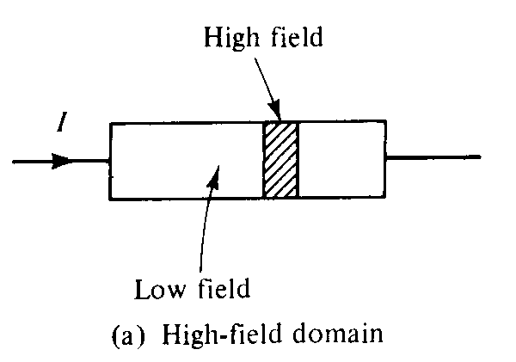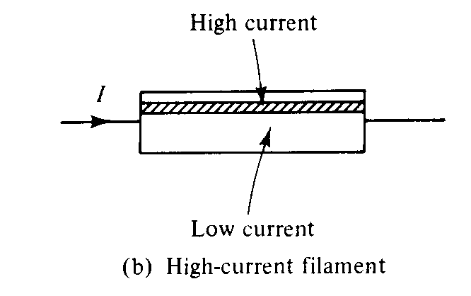
- 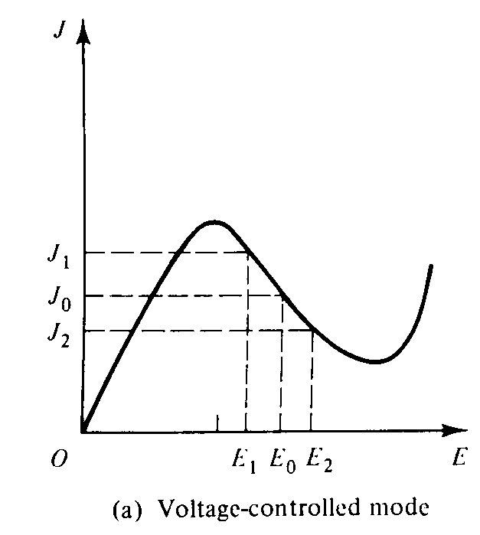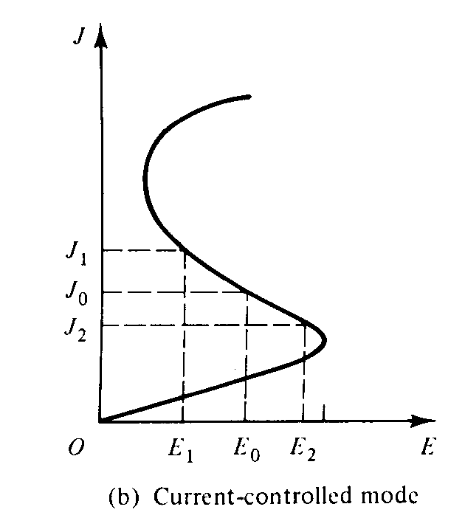
- Two valley model
- 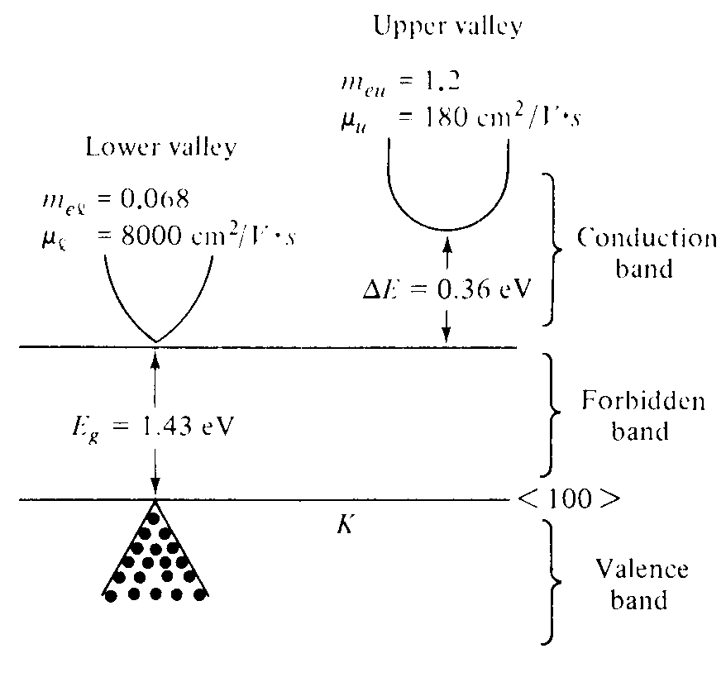
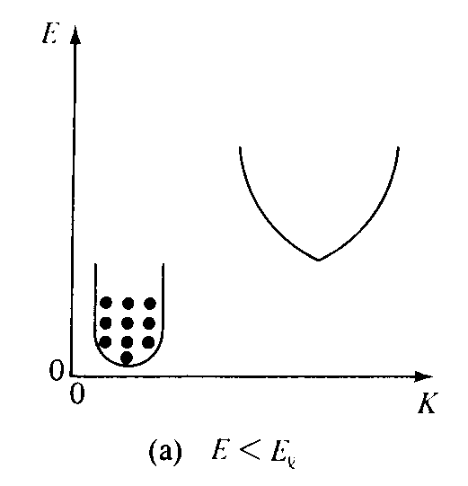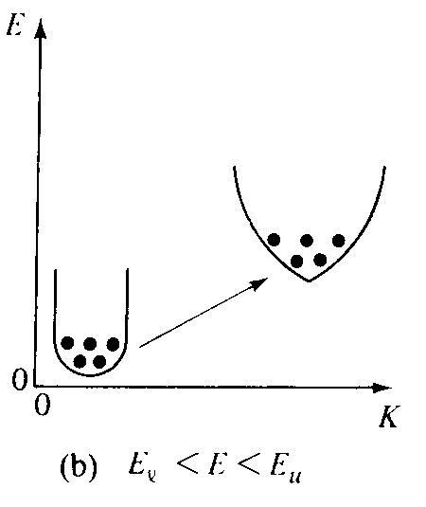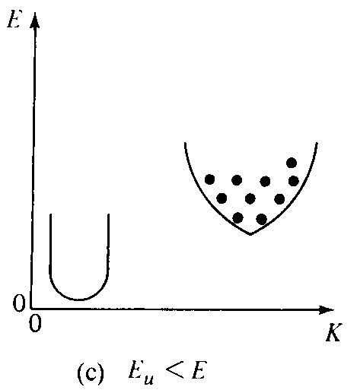
Slide Presentation:
- Domain formation
- Applied voltage across n⁺ n n⁺GaAs, crystal exceeds a threshold level
- Electrons are transferred from lower energy to upper high energy
- Heavier electrons bunch together to form a electric field dipole domain near cathode
- Electric field remains below the threshold level across the rest of the crystal as applied voltage remains constant, thus formation of further domains prevented
- High field domain travels and reaches the end contact, again a high domain formed
- Each domain results in a pulse of current at the output
- These current fluctuations occurs at microwave frequencies to produce output signal at the low impedance RF circuit with a period equal to the transit-time
- Modes of operation
- (i) Gunn oscillation mode
- (ii) Stable amplification mode
- (iii) Limited space charge accumulation mode
- (iv) Bias circuit oscillation mode
- 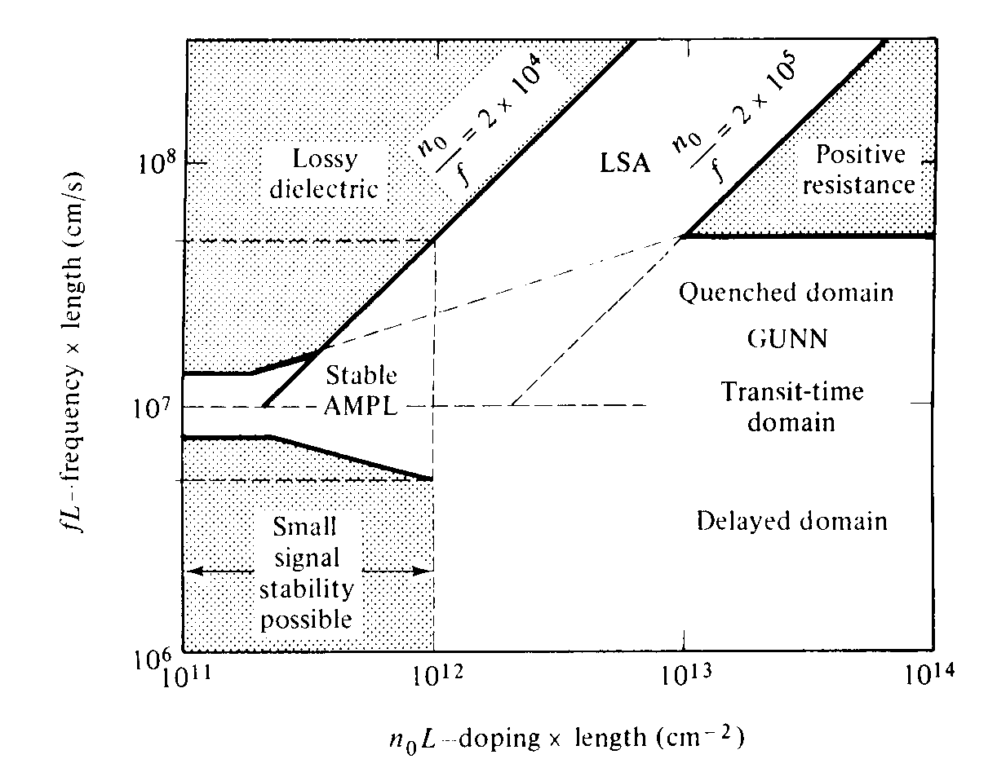
- 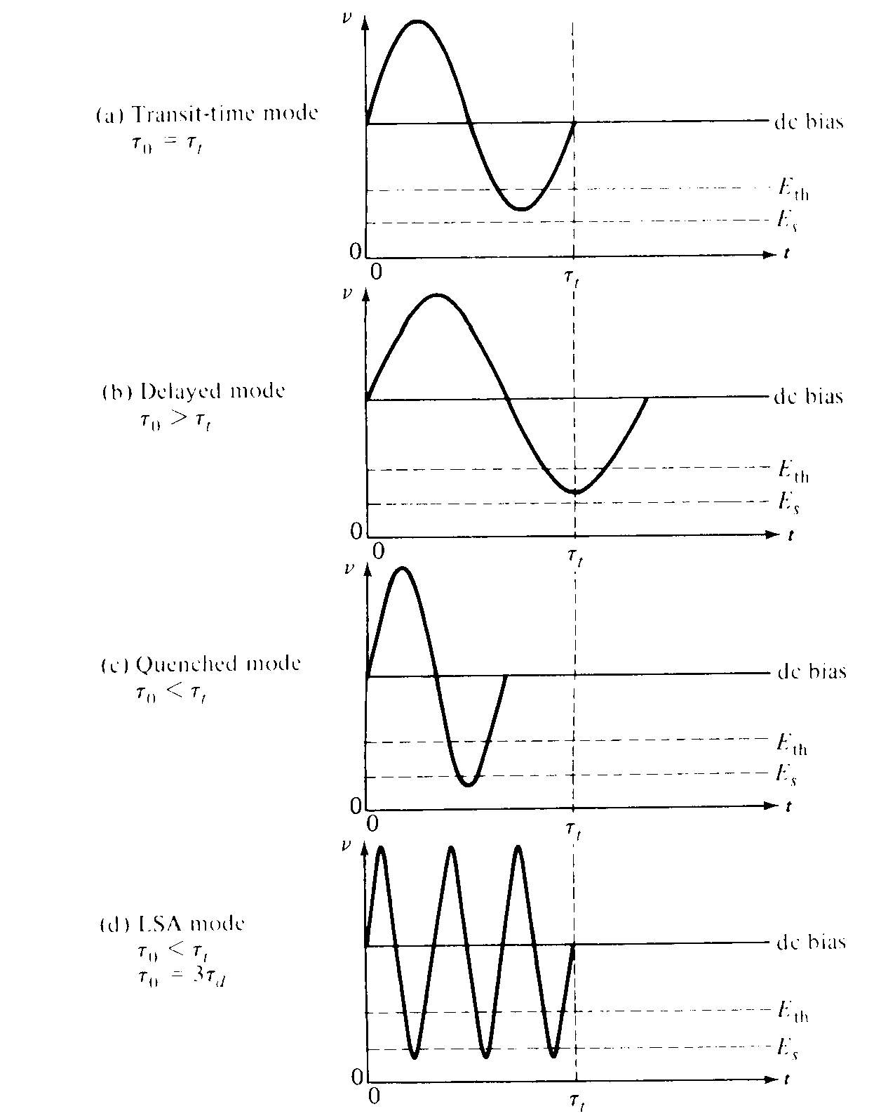
Video Presentation:
http://www.youtube.com/watch?v=MmRaRh-oUHY
http://www.youtube.com/watch?v=P9Tr4Q6oFig
http://www.youtube.com/watch?v=svuJ42v6RPI
Conclusion & summary: List by key words: Quiz
- Difference b/w TED & BJT
- Transferred electron effect
- Materials used
- Transit time
- LSA
- High domain
- Quenched domain
Session –V
Introduction:
- Avalanche transit time diodes – IMPATT & TRAPATT
- It rely on effect of voltage breakdown across a reverse biased PN junction to produce a supply of holes (or) electrons
- It depends on 2 mechanism
- (i) generation of charge carrier
- (ii) movement of these charge carrier through a drift space within the semiconductor
Presentation:
- IMPATT – physical structure - principle - operation
- Impact ionization avalanche transit time diode
- Employs impact ionization and transit time properties to produce negative resistance at microwaves.
- Negative resistance arise due to two delays (i) avalanche delay
- (ii) transit time delay
- Avalanche delay is caused by finite build up time of avalanche current
- Transit time delay is due to the finite time taken by the carriers to cross the drift region
- These two delays add upto 180°, the diode electronic resistance becomes negative and corresponding to that frequency, ionization occurs which results in large multiplication of current (or) avalanche breakdown occurs
- By proper thickness, doping level, a desired RF frequency can be generated
- Construction:
- many forms such as
- n⁺ p i p⁺ (or) p⁺ n i p⁺
- p⁺ n p⁺ abrupt junction
- p⁺ i n⁺ diode
- 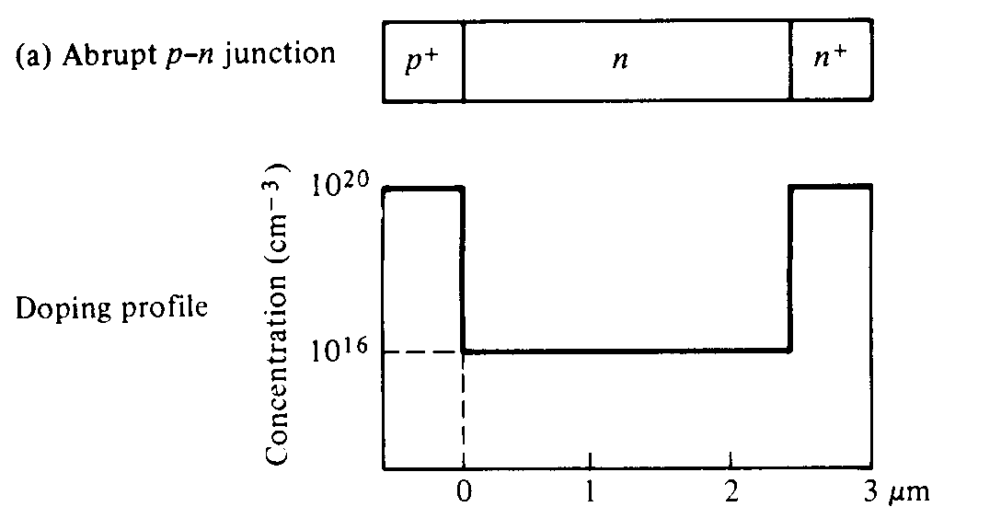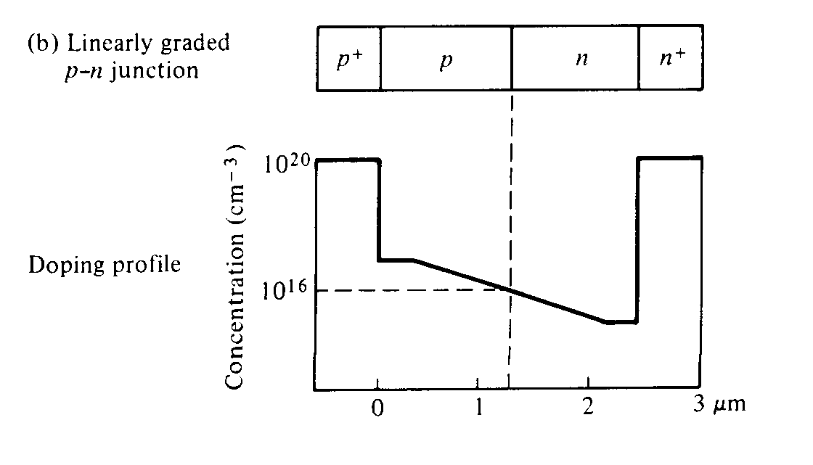
- 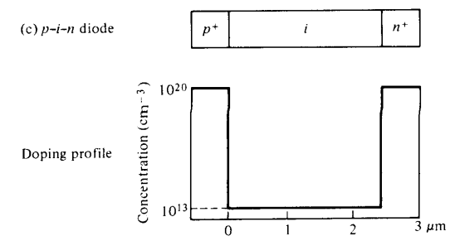

Presentation & Derivation:
- Negative resistance
- Manufactured from Ge, Si, GaAs, InP
- But GaAs provide highest efficiency, highest operating frequency and least noise figure but fabrication is difficult and expensive than Si.
- When large reverse bias voltage is applied, some electrons & holes in region of peak field gain enough energy and thus ionize the atoms in the crystal
- Thus an impact ionization mechanism creates an electron & hole pair
- The electrons and holes thus created are accelerated by the field in the opposite direction and can cause additional impact
- Power output
- 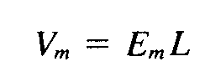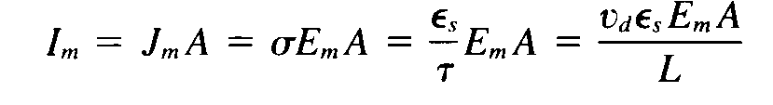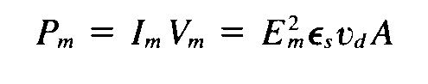
- Performance, Advantages, Applications, Equivalent circuits

Conclusion & summary: recall by key words:
- Avalanche breakdown
- Avalanche transit time
- Delayed transit time
- Doping level
- Noise figure
- Disadvantage

Session –VI
Introduction:
- TRAPATT
- Trapped plasma avalanche triggered transit time diode
- 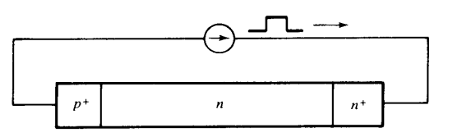
Presentation:
- Principle –physical structure-operation of TRAPATT
- High efficiency oscillation of several hundred MHz to several GHz
- Dense plasma of electrons and holes are formed and fills in depletion layer and trapped in low field region
- 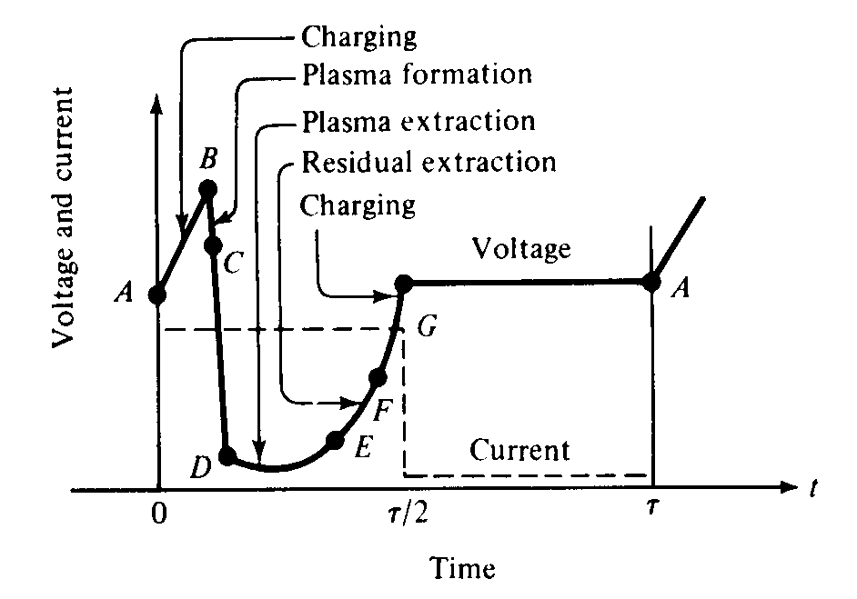

- Performance:
- CW power = 1-3W
- Pulse power = 1-3W
- Operating voltage = 60-150V
- Efficiency = 15 -40%
- Noise figure = >30dB
- Frequency = 3 – 50GHz
- Disadvantages:
- High noise figure
- Generates strong harmonics due to short duration of current pulse
- Application:
- Used in low power Doppler radar
- Used as local oscillator for radar, microwave beacon landing system, radio altimeter, phased array radar
Conclusion & summary: list by key words:
- Configurations
- Carrier transit time
- Plasma formation
- Plasma extraction
- Comparison b/w IMPATT & TRAPATT
Session –VII
Introduction:
Parametric devices – its use:
- Uses nonlinear reactance (or) time varying reactance
- Used to produce capacitance or inductive excitation
- Varactor diode is most used as parametric amplifier for its low noise amplification
- Uses ac voltage rather than dc voltage

Presentation& derivation:
Principle:
- Negative resistance analysis:
- Reactance – circuit element that stores and releases electromagnetic energy
- capacitance c = Q / V
- For nonlinear C(v) = ∂Q / ∂ V
- For inductance L(i) = ∂Q / ∂ i
- Small signal method:
- Signal voltage(Vs) smaller than pumping voltage(Vp)
- Total voltage across nonlinear capacitor C(t) is
- 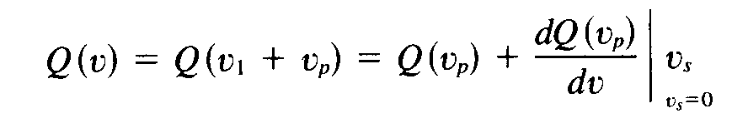
- 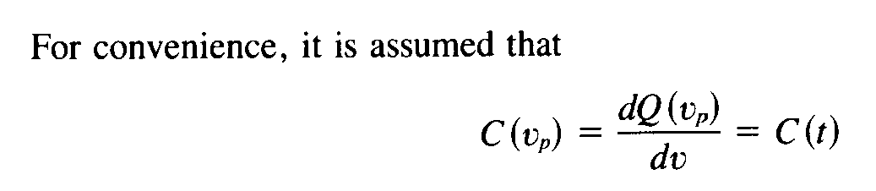
- 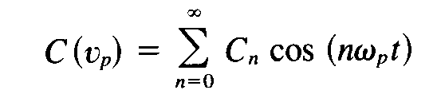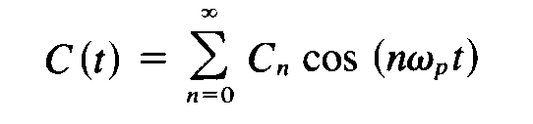
- 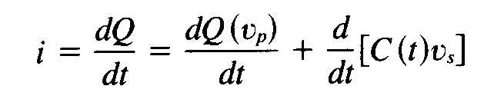
- ii)Large signal method:
- Signal voltage not small compared to pumping voltage
- Capacitance C is proportional to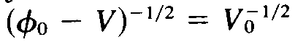
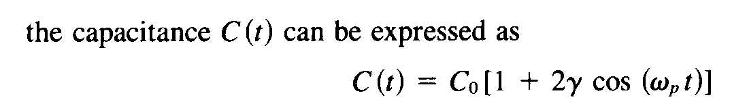
Manley Rowe power relation:
- Derived a set of general energy relations regarding power flowing into and out of an ideal nonlinear reactance
- 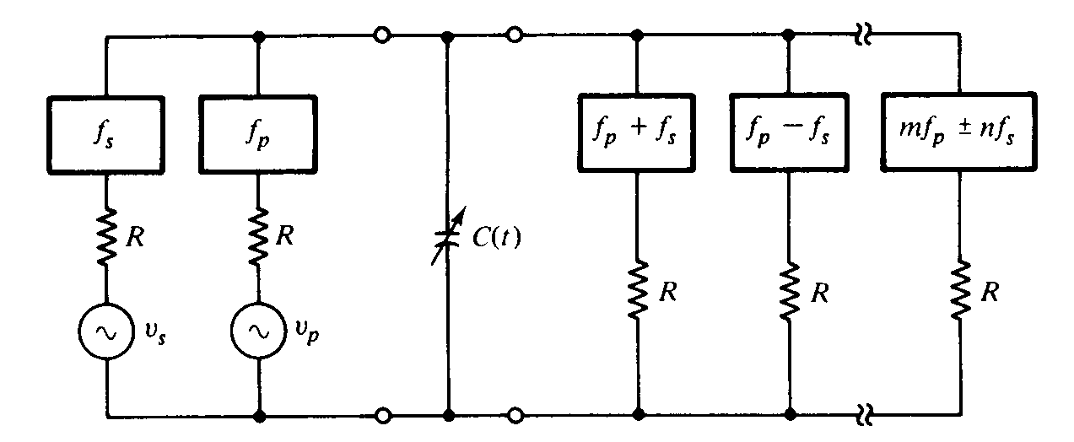
- 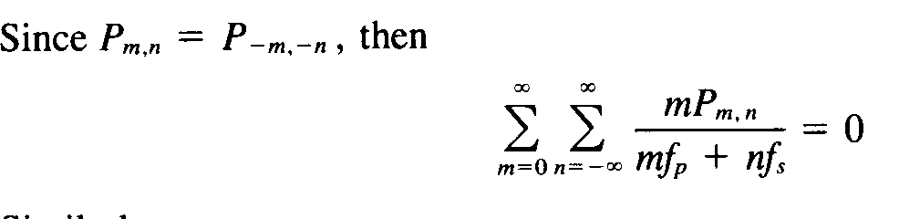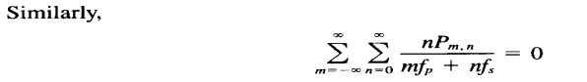
Presentation & derivation & Video:
- Operation – up & down converter – application
- Video presentation
- http://www.youtube.com/watch?v=zVlWCz9vTL4
- http://www.youtube.com/watch?v=KrEGji7zzSA&feature=related
- http://www.youtube.com/watch?feature=endscreen&NR=1&v=yiJPfuKYXWA

Conclusion & summary: recall by key words:
- Manley Rowe relation
- Idler frequency
- Signal frequency
- Pumping frequency
- Degenerate mode
- Regenerate mode
- Up converter
- Down converter

Session –VIII
Discussion & introduction:
- Integrated circuits
- Microwave monolithic integrated circuits(MMIC)
Presentation:
- Microwave monolithic integrated circuit
- Materials used– substrate – conductive
Presentation:
- MMIC -dielectric materials - resistive materials
Conclusion & summary: list by key words: Quiz
- Substrate material & conductive materials
- Dielectric & resistive materials
- Properties of materials
- Etchability
- Solderability

Session – IX
Discussion & introduction:
- Microwave monolithic integrated circuits(MMIC)
Video Presentation:
- Fabrication techniques – oxidation – deposition – etching – examples
- Video presentation
- http://www.youtube.com/watch?v=6T8axj-hMxc&feature=fvwrel
- http://www.youtube.com/watch?v=gBAKXvsaEiw
- http://www.youtube.com/watch?v=Q5paWn7bFg4&feature=related
- http://www.youtube.com/watch?v=i8kxymmjdoM&feature=related
- http://www.youtube.com/watch?v=aoDgulny31M&feature=related
Conclusion & summary: recall by key words
- Ion implantation
- Diffusion
- Lithography
- Epitaxial growth
- Etching process
- Photo resist
- Dc sputtering
- Vacuum evaporation

