UNIT-V
MICROWAVE TUBES & MEASUREMENTS
Session - I
Introduction:
- Microwave tubes - Linear beam- ‘O’type
Presentation & discussion:
- Need for microwave tubes
For amplification, oscillation
- Types
Cavity structure – two cavity klystron, four and multiple cavity, reflex klystron
Slow wave structure – TWT amplifier
- Significances
Oscillator and amplifier for high frequency
Presentation & discussion:-
High frequency limitations:
- Circuit reactance
  - Inter electrode capacitance
  - Lead inductance
- Transit time effects
- Cathode emission & plate heat dissipation area
- Power loss due to skin effect, radiation & dielectric loss
- Gain bandwidth product

Conclusion & Summary: recall by key words
- Cavity tube
- Slow wave structure
- Inter electrode capacitance
- Cathode emission
- Transit time effect
- Skin effect
- Plate heat dissipation area

Session – II
Introduction:
- Multi-cavity Klystron
Two cavity, four cavity and multiple cavity structures
Presentation & video:-
Principle :
- Electrons drift with velocity along the field free space b/w two cavities
- Effect of velocity modulation produces bunching of electron beam (or) current modulation
- Electrons passing at Vs=0, have unchanged velocity
- Electron passing at positive half cycle have travels faster than at Vs=0
- Electron passing at negative half cycle travels slower than at Vs=0
- At distance ΔL, along the beam from the buncher cavity, the beam electrons have drifted into dense clusters

Structure –Operation:
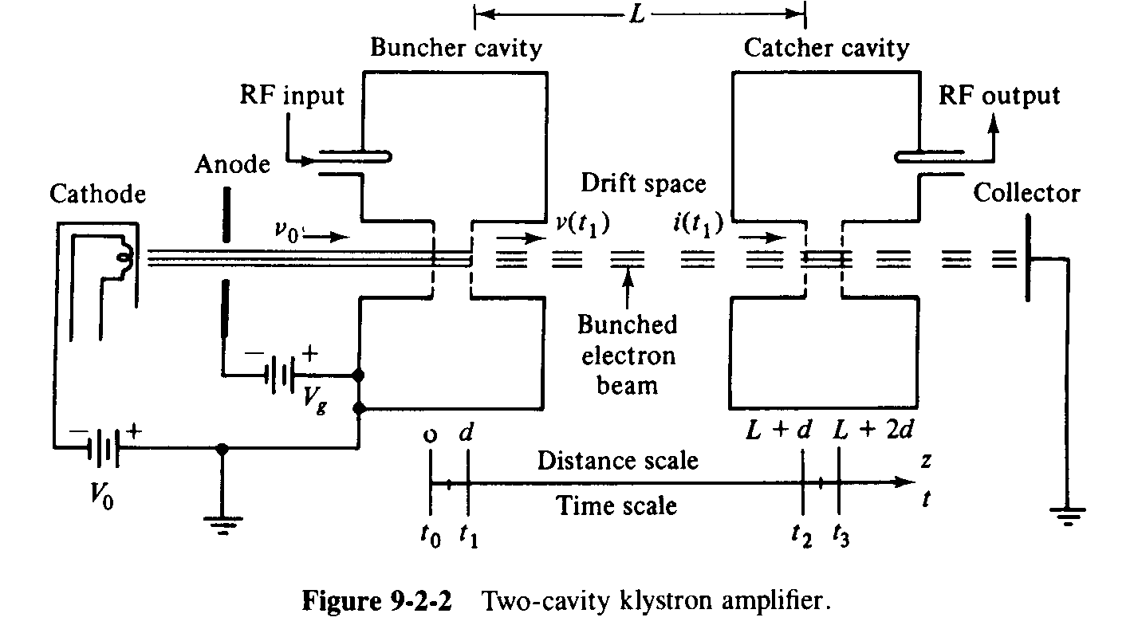
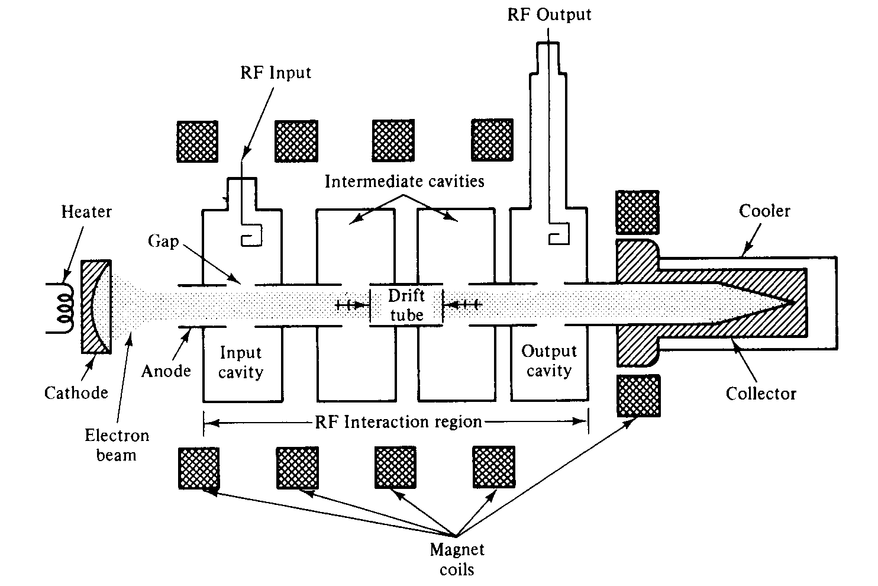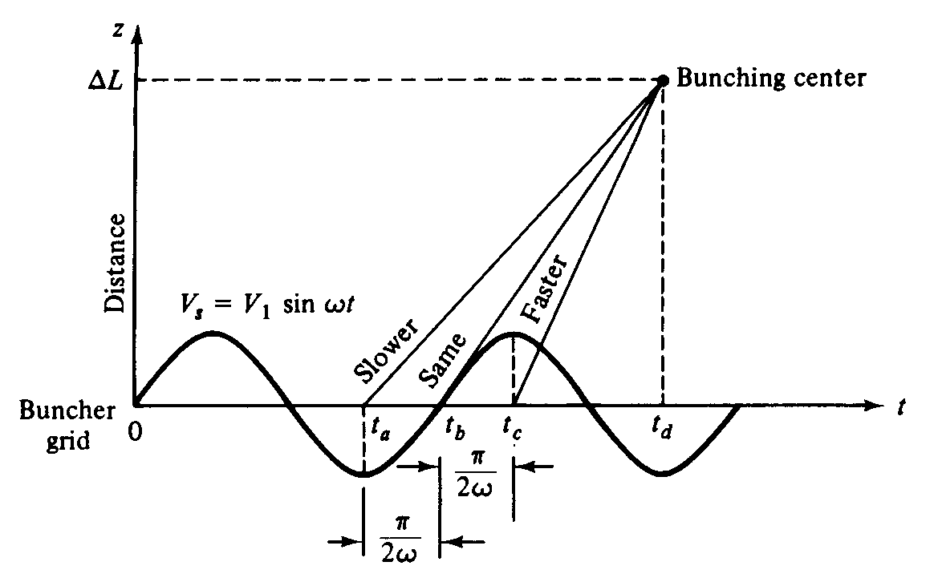
- Video presentation of working concept
- http://www.youtube.com/watch?NR=1&feature=endscreen&v=tXfdv37gTU8
- http://www.youtube.com/watch?v=TsBTI3tO5-8&feature=related
Derivation:
- Beam current density – output current – power
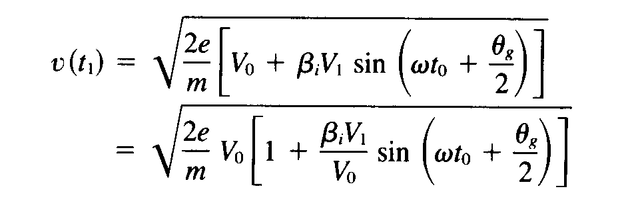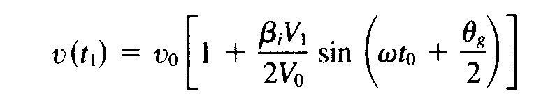
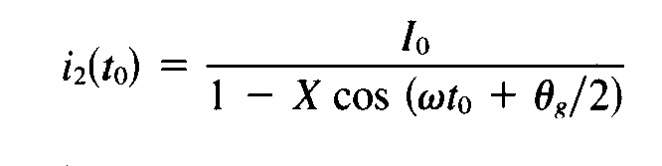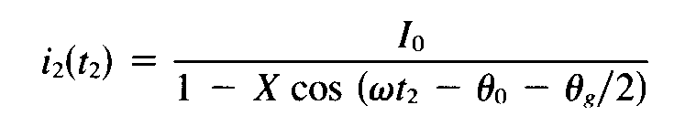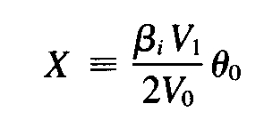
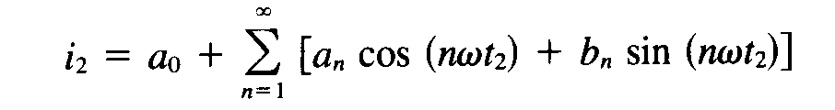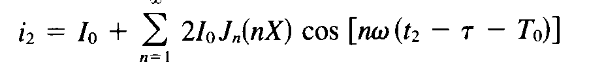
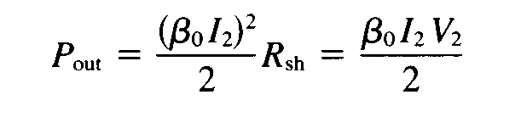
Conclusion & summary: list by key words
- Velocity modulation
- Buncher cavity
- Catcher cavity
- Current modulation
- Power output
- Oscillator & amplifier

Session – III
Introduction:
- Reflex Klystron
If a fraction of output power is fed back to input cavity,
loop gain is maintained as unity
phase shift of multiple of 2π
Then klystron will oscillate.
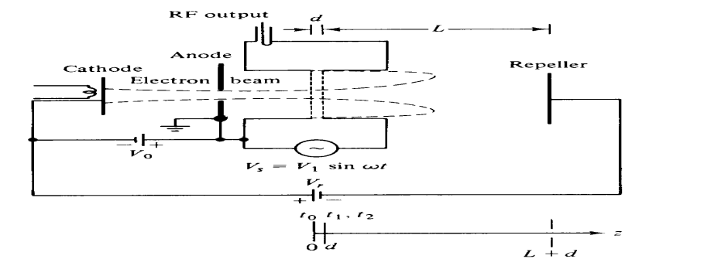
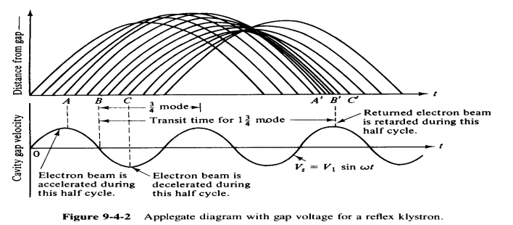

Video Presentation:
- Animated video of Principle & operation & velocity modulation of Reflex Klystron oscillator
Derivation:
- Output power – efficiency – electronic admittance
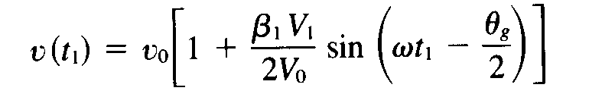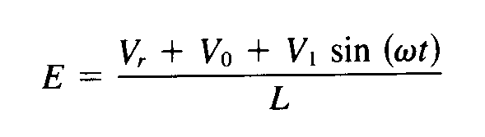
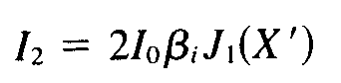
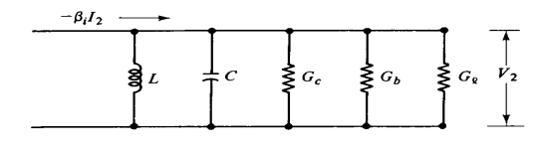
Conclusion & summary: recall by key words
- Electronic admittance
- Velocity modulation
- Cavity gap
- Bunching parameter
- Round trip dc transit time, applications

Session – IV
Introduction:
- Travelling wave tube (TWT)
- Uses slow wave structure of non-resonant
- Helix TWT is widely used for broadband applications
- For high average power purpose like radar transmitter, coupled cavity TWT is widely used
Video Presentation:
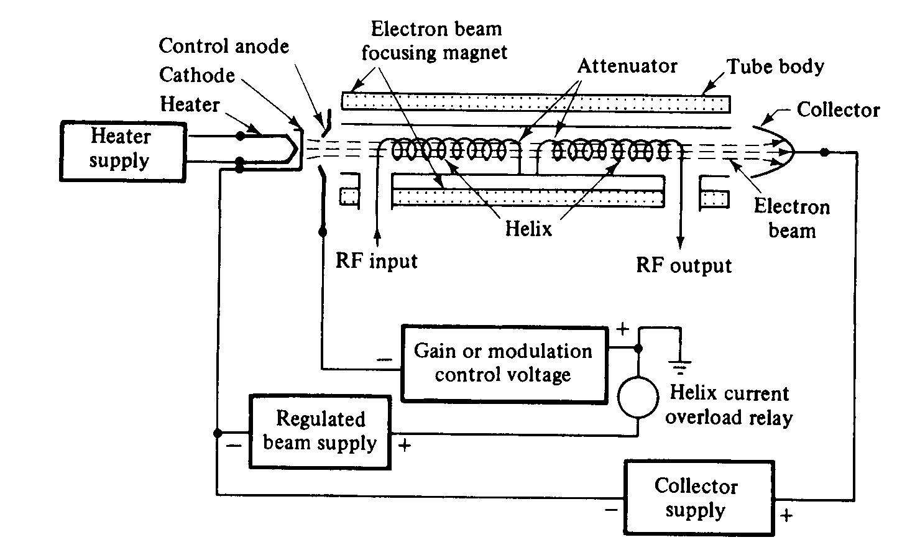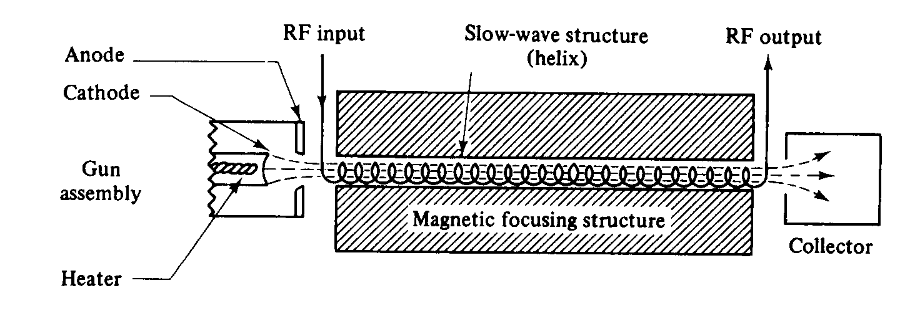
- Animated video of Amplification process & convention current
http://www.youtube.com/watch?v=BLa9e2sz5L8
http://www.youtube.com/watch?v=0m7r2J4jj6o
Derivation:
- Axial electric field – wave modes – gain
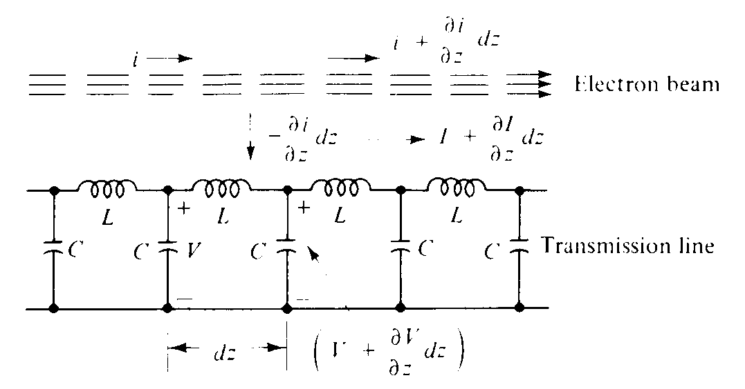
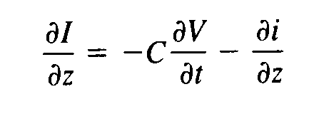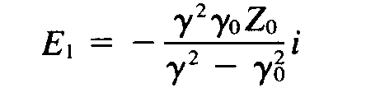
Conclusion & summary: List by key words
- Slow wave structure
- Comparison b/w klystron & TWT
- Frequency pulling & pushing
- FWO, BWO
- Difference b/w TWT & klystron
- Applications
Session –V
Introduction:
Cylindrical magnetron oscillator:-
- Crossed field tube devices(M-type)
- DC electric field & DC magnetic field are perpendicular to each other
- It is high power microwave oscillator

Presentation:
- Principle - operation
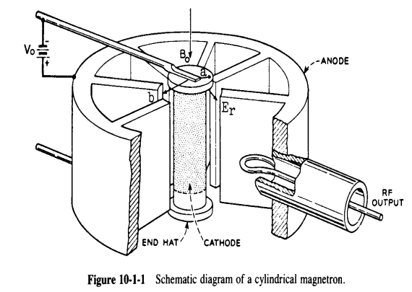
- Cylindrical cathode of finite length of radius “a” at centre
- Cylindrical anode of radius “b”
- Anode is a slow wave structure
- Anode consisting of several reentrant cavities equi-spaced around the circumstance and coupled together through anode cathode space by means of slots
- Dc voltage Vo b/w cathode & anode establishes radial electric field
- Dc magnetic flux(Bo) is maintained by means of permanent magnet(or) an electromagnet
- Electron from cathode try to travel to anode but due to crossed field of E & H, it experience a force F=-eE-e(vxB) & takes curved path
- Due to excitation b/w anodes, electron are accelerated during it motion & transfer energy into cavity to grow output oscillation
- Featured animated video presentation from Simtel.
Derivation:
- Equation of electron motion – cyclotron angular frequency
- At zero magnetic field, electron take straight path from cathode to anode
- If Vo increased, electron take curved path
- At critical value of magnetic field Bc, electron take curved path (teach the anode)& return back to cathode
- If magnetic field greater than critical value, then electron return to cathode without reaching of anode
- Value of Bc is called as cut-off magnetic flux density
Conclusion & summary: recall by key words:
- Phase focus effect
- Strapping
- Cyclotron angular frequency
- Cross field tubes, Resonant cavities

Session –VI
Recap:
- Magnetron
Resonant modes:
- Each anode acts as resonant cavity
Phase shift b/w two adjacent cavity is
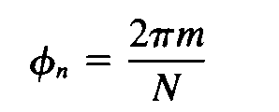
- It has opposite phase in successive cavities, excitation is maximum at 0, called as π mode

Mode separation:
- Each mode corresponds to different frequencies
- Separation of π mode from other mode is done by strapping method in which one ring is connected to even numbered anode & other connected to odd numbered anode
- Magnetron usually designed to operate in π mode

Derivation:
- Power output – efficiency
- Hull cut off magnetic equation is
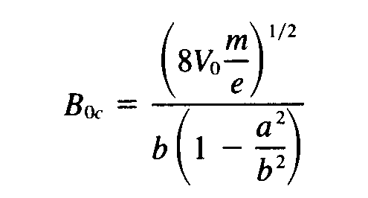
Hull cut off voltage is
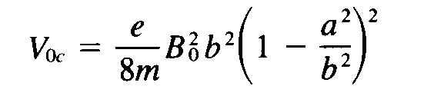
- For oscillation in π mode Beam voltage is Voh = {2 πf (b²-a²)Bo}/ N
called as Hartree Voltage
- A plot b/w Hull cut off voltage (or) Hartree voltage Vs Bo gives region of oscillation
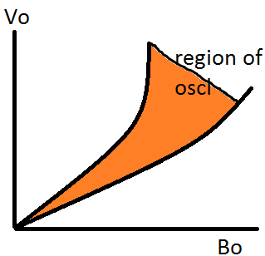
Presentation:
Types :-
- (i) Coaxial magnetron
- (ii) Voltage –tunable magnetron
- (iii) Inverted coaxial magnetron
- (iv) Frequency – agile tunable magnetron

- Magnetron can deliver a peak power output of 40MW with dc voltage of 50KV at 10GHz
- Average power is 800KW
- Efficiency is 40-70%
- Application:
- Radar transmitter
- industrial heating
- microwave ovens

Conclusion & summary: list by key words
- Hull cutoff voltage
- Hartee voltage
- Hull cutoff magnetic equations
- Π mode
- Average drift velocity
- Applications

Session –VII
Brainstorming & introduction:
- Impedance – Standing Wave Ratio(SWR)
Presentation:Measurement of impedance
- Slotted line method
- Reflectometer method
Presentation: Measurement of SWR
- VSWR is important as it determine the degree of impedance matching
- When ZLǂZo, standing waves arise
- VSWR is measured by detecting Vmax&Vmin
Low VSWR:-
- Probe moved from the load until peak voltage is obtained, adjust gain control meter to read at 1.0 or 0 dB – gives Vmax
- Move probe toward sending end until minimum voltage is obtained, thus VSWR meter gives direct reading of VSWR=Vmax/Vmin
- Repeated with other set of frequencies for average
High VSWR:-
- Probe moved to voltage minimum point and probe depth & gain control is adjusted to read 3 dB in VSWR.
- Probe is moved to either sides of minimum to read 0 dB in meter. Position x1 & x2 are noted
- Succesive voltage minimum point is noted = (λg/2)
S = λg / π(x1-x2)
Possible errors
- Probe thickness & depth of penetration produce reflection
- Mechanical slope may cause different values of VSWR
- Reduction in sharpness for 1KHZ signal
Conclusion & summary: list by key words
- VSWR
- ISWR
- Vmax&Vmin
- Tunable detector
- SWR & reflection coefficient
- Possible errors

