Unit-II TRANSMISSION LINE PARAMETERS
Session 1- Parameters of resistance
Quiz
- What is resistance of materials?
- What are the parameters of a line?
- What are the parameters affecting resistance?
- Classify the materials
Ref: http://www.skm-eleksys.com/2011/03/transmission-line-parameters-resistance.html
Presentation
Giving detailed explanation on parameters of line
Resistance
Inductance
Resistance
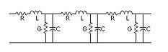
Board activity
Drawing the different conductor configuration
Ref: http://www.skm-eleksys.com/2011/03/transmission-line-parameters-resistance.html
Ref; http://www.cvel.clemson.edu/Emc/calculators/TL_Calculator/index.html

Session 2- Single and three phase transmission lines
Quiz
- What is inductance?
- What are the advantages of three systems?
- What are the parameters affecting inductance?
- Classify the transmission line arrangements
Ref: http://www.skm-eleksys.com/2011/03/transmission-line-parameters-resistance.html
Presentation
Derivation for magnetic flux intensity
External intensity hx =I/$2πx$
Internal intensity hx=Ix/2$πr^{2}$
Where
Ix=current enclosed by the path
r = radius of the conductor
Hx= flux density

Board activity
Drawing the different conductor configuration
Ref: http://www.skm-eleksys.com/2011/03/transmission-line-parameters-resistance.html
Ref; http://www.cvel.clemson.edu/Emc/calculators/TL_Calculator/index.html

Session 3- inductance on single phase transmission lines
Quiz
- What is inductance?
- List the components of flux linkages in a conductor
Ref: http://www.skm-eleksys.com/2011/03/transmission-line-parameters-resistance.html
Presentation
Expression for inductance of a conductor
Total inductance of the input system
L_{T}=4*10⁻⁷*ln(D/R) H/meter
Where
D=distance between the two conductor
R=radius of the conductor

Board activity
Deriving the expresiion
Ref: http://www.skm-eleksys.com/2011/03/transmission-line-parameters-resistance.html
Ref; http://www.cvel.clemson.edu/Emc/calculators/TL_Calculator/index.html

Session 4- Types of conductors
Quiz
- What are stranded conductors?
- Advantages of bundled conductors
- Name the materials used for conductors
Ref: http://www.skm-eleksys.com/2011/03/transmission-line-parameters-resistance.html
Presentation
Giving detailed explanation on types of conductor
Solid conductor
Stranded conductor
Bundled conductor
ACSR conductor 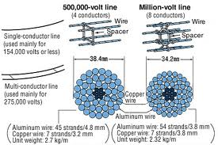

Board activity
Drawing the different conductor configuration
Ref: http://www.skm-eleksys.com/2011/03/transmission-line-parameters-resistance.html

Session 5- Symmetrical and unsymmetrical spacing
Quiz
- What are GMD and GMR?
- Factors affecting L
- Name the materials used for conductors
Ref: http://www.skm-eleksys.com/2011/03/transmission-line-parameters-resistance.html
Presentation
Giving detailed explanation on GMD and GMR
For symmetrical spacing
L=u_{o} /2$π[ln⁡(\frac{D}{r})]$
For unsymmetrical spacing
L=(L_{A}+L_{B}+L_{C} )/3
Where
L=Average inductance

Board activity
Drawing the different conductor configuration
Ref: http://www.skm-eleksys.com/2011/03/transmission-line-parameters-resistance.html

Session 6- Inductance Difference-Causes
Quiz
- What causes differences in inductance of three conductors?
- Symmetrical spacing.
- Transposition of conductors.
Ref: http://www.technoend.com/what-is-transposition-of-electrical-transmission-line/
Presentation
Giving detailed explanation on transposition
TRANSPOSITION:
To avoid unbalancing effect due to unsymmetrical spacing the position of the conductors are changed at regular interval at equal intervals

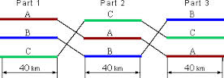

Board activity
Solving a problem on inductance of conductors with unsymmetrical spacing.
Ref: http://www.skm-eleksys.com/2011/03/transmission-line-parameters-resistance.html

Session 7- Concept of GMR and GMD
Quiz
- What is GMD ?
- Factors affecting L
- GMD and GMR of different conductor arrangment
Ref: http://www.skm-eleksys.com/2011/03/transmission-line-parameters-resistance.html
Presentation
Explaining the concept of GMD
GMD | GMR
It is also called as mutual GMD | It is also called as self GMD
Geometrical mean of the distance from one end to other | Geometrical mean of distance between all pair of element
It is depend upon spacing | Independent of spacing
Independent on size and shape | Depend on size and shape

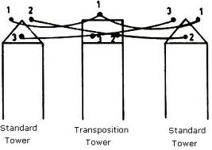
Board activity
Deriving expressions for inductance in terms of GMD and GMR
Ref: http://www.skm-eleksys.com/2011/03/transmission-line-parameters-resistance.html

Session 8-Types of conductor on Power Transmission
Quiz
- What is GMR?
- Factors affecting L
- Name the materials used for conductors
Ref: http://www.skm-eleksys.com/2011/03/transmission-line-parameters-resistance.html
Presentation
Giving detailed explanation on types of conductor on power transmission
Advantages of conductors
Advantages of bundled conductors

Reduced skin effect
Reduced corona loss
Advantages of ACSR conductors
High metallic strength
Inductace is less

Board activity
Deriving inductance expression in terms of GMD and GMR
Ref: www.egr.unlv.edu/~eebag/TRANSMISSION%20LINES.pdf‎

Session 9- Capacitance of Transmission System
Quiz
- What causes capacitance?
- Factors affecting C
- Modeling of transmission lines
Ref: http://www.skm-eleksys.com/2011/03/transmission-line-parameters-resistance.html
Presentation
Giving detailed explanation on parameters of line
Capacitance
less 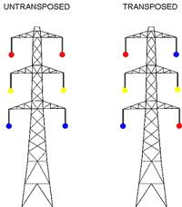

Board activity
Deriving capacitance expression in terms of GMD and GMR
Ref: http://nptel.iitm.ac.in/courses/Webcourse-contents/IIT-KANPUR/power-system/chapter_1/1_13.h

Session 10- Capacitance of Three Phase Transmission System
Quiz
- What are the different conductor arrangements?
- Factors affecting C
- List out the advantages double circuit lines.
Ref: http://nptel.iitm.ac.in/courses/Webcourse-contents/IIT-KANPUR/power-system/chapter_1/1_13.html
Presetation
Giving detailed explanation on parameters of line
Capacitance
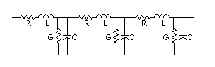
Board activity
Deriving capacitance expression in terms of GMD and GMR
Ref: http://nptel.iitm.ac.in/courses/Webcourse-contents/IIT-KANPUR/power-system/chapter_1/1_13.html

Session 11- interference from communication lines
Quiz
- What are the different sources of interference?
- Factors affecting interference
- Effects of radio interference .
Ref: http://nptel.iitm.ac.in/courses/Webcourse-contents/IIT-KANPUR/power-system/chapter_1/1_13.html
Presentation
Giving detailed explanation on interference on line transmission
e 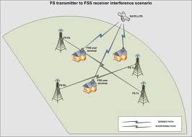

Board activity
Deriving capacitance expression in terms of GMD and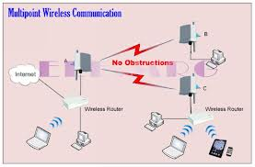 GMR
Ref: http://nptel.iitm.ac.in/courses/Webcourse-contents/IIT-KANPUR/power-system/chapter_1/1_13.html
Session 12- Corona-its origin and effects on power systems
Quiz
- What are the causes of corona?
- Factors affecting corona
- Mention the effects of corona on power systems.
Ref: http://nptel.iitm.ac.in/courses/Webcourse-contents/IIT-KANPUR/power-system/chapter_1/1_13.html
Presetation
Giving detailed explanation on corona loss

What is corona effect in power system and why it occurs?
For corona effect to occur effectively, two factors here are of prime importance as mentioned below:-
1) Alternating potential difference must be supplied across the line.
2) The spacing of the conductors, must be large enough compared to the line diameter.
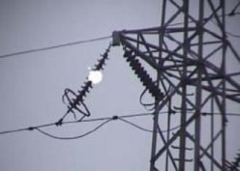
Corona Effect in Transmission Line
in terms of GMD and GMR
Ref: http://nptel.iitm.ac.in/courses/Webcourse-contents/IIT-KANPUR/power-system/chapter_1/1_13.html

