Unit-III PERFORMANCE OF TRANSMISSION LINES
Session 1- Transmission line performance
Quiz
- What are the types of transmission lines?
- What are the performance parameters of a line?
- What is voltage regulation?
- Define transmission efficiency
Ref: http://www.skm-eleksys.com/2011/03/transmission-line-parameters-resistance.html
Presentation
Giving detailed explanation on performance of a line
П-model
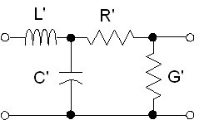
T-model
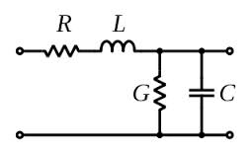
Board activity
Drawing the different conductor configuration for performance analysis
Ref; http://www.cvel.clemson.edu/Emc/calculators/TL_Calculator/index.html

Session 2- Equivalent circuit
Quiz
- What is inductance?
- What are the advantages of three systems?
- What are the parameters affecting inductance?
- Classify the transmission line arrangements
Ref: http://www.skm-eleksys.com/2011/03/transmission-line-parameters-resistance.html
Presentation
Derivation for magnetic flux intensity
External intensity
Internal intensity
Derivation for magnetic flux intensity
External intensity hx =I/$2πx$
Internal intensity hx=Ix/2$πr^{2}$
Where
Ix=current enclosed by the path
r = radius of the conductor
Hx= flux density

Board activity
Drawing the different conductor configuration
Ref: http://www.skm-eleksys.com/2011/03/transmission-line-parameters-resistance.html

Session 3- Regulation and efficiency
Quiz
- What is regulation?
- List the components of flux linkages in a conductor
Ref: http://www.skm-eleksys.com/2011/03/transmission-line-parameters-resistance.html
Presentation
Calculation of efficiency
Performance of transmission lines is meant the determination of efficiency and regulation of lines .The efficiency of transmission lines is defined as
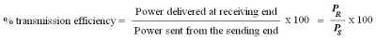
Board activity
Deriving the expression
Ref: http://www.skm-eleksys.com/2011/03/transmission-line-parameters-resistance.html
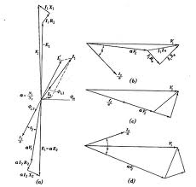

Session 4- Voltage regulation
Quiz
- What is voltage regulation?
- Effects of voltage regulation
- Ways to reduce voltage drop.
Ref: http://www.skm-eleksys.com/2011/03/transmission-line-parameters-resistance.html

Presentation

Giving detailed explanation on calculation of voltage regulation
Voltage regulation

Voltage Regulation
voltage regulation of a line is defined as the change in voltage at the receiving end when full load at a given power factor is removed, the voltage at the sending end being kept constant. it is expressed as a fraction or a percentage of the receiving end voltage at full load. it can be written as,
Per unit regulation = Vrnl - Vrfl / Vrfl
Percent regulation = (Vrnl - Vrfl / Vrfl) * 100

Board activity
Solving a problem
Ref: http://www.skm-eleksys.com/2011/03/transmission-line-parameters-resistance.html

Session 5- Symmetrical and unsymmetrical spacing
Quiz
- What are GMD and GMR?
- Factors affecting L
- Name the materials used for conductors
Ref: http://www.skm-eleksys.com/2011/03/transmission-line-parameters-resistance.html
Presentation
Giving detailed explanation on parameters of line
Inductance
Board activity
Drawing the different conductor configuration
Ref: http://www.skm-eleksys.com/2011/03/transmission-line-parameters-resistance.html

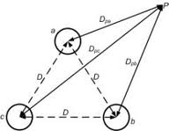

Session 6- Inductance Difference-Causes
Quiz
- What causes differences in inductance of three conductors?
- Symmetrical spacing.
- Transposition of conductors.
Ref: http://www.technoend.com/what-is-transposition-of-electrical-transmission-line/
Presentation
Giving detailed explanation on parameters of line
Inductance
Board activity
Solving a problem on inductance of conductors with unsymmetrical spacing.
Ref: http://www.skm-eleksys.com/2011/03/transmission-line-parameters-resistance.html

Session 7- T model of a line
Quiz
- What are the models of of a line?
- Define regulation
- Factors affecting regulation
Ref: http://www.electrical4u.com/abcd-parameters-of-transmission-line/Presentation
Phasor diagram of T model
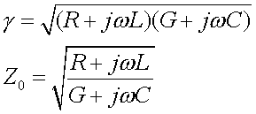
Regulation
Voltage
Board activity
Solving a problem
Ref: https://www.google.co.in/url?sa=t&rct=j&q=&esrc=s&source=web&cd=4&cad=rja&ved=0CDoQFjAD&url=http%3A%2F%2Fwww.ee.lamar.edu%2Fgleb%2Fpower%2FLecture%252009%2520-%2520Transmission%2520lines.ppt&ei=Bu8yUt6tD8SPrgeGyYBA&usg=AFQjCNEio_CEVpfccS3Bd6rFmVfTO94DMQ

Session 8- calculation of sending end power
Quiz
- What is Ferranti effect?
- Factors affecting sending end voltage
- ABCD constants
Ref: http://www.researchgate.net/post/What_is_the_real_interpretation_of_ABCD_parameters_for_transmission_line
Presentation
Giving detailed explanation on ABCD constants 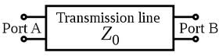

Board activity
Deriving expression for ABCD constants
Ref: www.egr.unlv.edu/~eebag/TRANSMISSION%20LINES.pdf‎

Session 9- Need for compensation in lines
Quiz
- What are the components of reactive power?
- Effects of non optimized reactive power flow
- Definition for reactive power
Ref: http://electrical-engineering-portal.com/the-need-for-reactive-power-compensation
Presentation
Giving detailed explanation on types of compensation
Board activity
Deriving expression for ABCD constants
Ref: http://www.alstom.com/grid/products-and-services/high-voltage-power-products/power-compensation/
‎

Session 10- Rotor angle stability
Quiz
- What is stability of a power system?
- Factors affecting stability
- Rotor angle stability
Ref: http://electricalquestionsguide.blogspot.in/2011/12/rotor-angle-stability-synchronous.html
Presentation
Giving detailed explanation on power angle stability
Board activity
Deriving expression for power angle equation
Ref: http://www.slideshare.net/Shahabkhan/definition-classification-of-power-system-stability

Session 11- Surge Impedance Loading
Quiz
- What is surge impedance?
- Factors affecting amount of loading
- Significance of SIL
Ref: http://electricalquestionsguide.blogspot.in/2012/05/surge-impedance-loading-sil.html
Presentation
Giving detailed explanation on surge impedance loading
Board activity
Deriving expression for surge impedance loading
Ref: http://www.transtutors.com/homework-help/electrical-engineering/power-system/surge-impedance-loading.aspx

Session 12- Angle and voltage stability considerations
Quiz
- What is rotor angle stability?
- Factors affecting angle stability
- Importance of rotor angle stability
Ref: http://electricalquestionsguide.blogspot.in/2012/05/surge-impedance-loading-sil.html
Presentation
Giving detailed explanation on rotor angle stability
Board activity
Deriving expression for rotor angle stability surge impedance loading
Ref: http://www.transtutors.com/homework-help/electrical-engineering/power-system/surge-impedance-loading.aspx

