Unit-4 INSULATORS AND CABLES

Session 1- Introduction: Role of insulators in power systems
Quiz
- What is the role of insulators?
- What are the types of insulators?
- What is voltage regulation?
- Define transmission efficiency
Ref: http://www.skm-eleksys.com/2011/03/transmission-line-parameters-resistance.html
Presentation
Giving detailed explanation of insulators on a transmission line
Insulators are used in electrical equipment to support and separate electrical conductors without allowing current through themselves. An insulating material used in bulk to wrap electrical cables or other equipment is called insulation. The term insulator is also used more specifically to refer to insulating supports used to attach electric power distribution or transmission lines to utility poles and transmission towers.

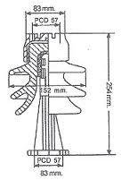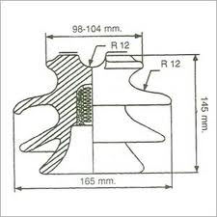
Board activity
Drawing the different conductor configuration for performance analysis
Ref; http://www.cvel.clemson.edu/Emc/calculators/TL_Calculator/index.html

session 2- types of insulators
Quiz
- Write the expression for voltage distribution in insulator string.
- What are the types of insulators?
- What are the parameters affecting inductance?
- Classify the transmission line arrangements
Ref: http://www.skm-eleksys.com/2011/03/transmission-line-parameters-resistance.html
Presentation
Detailed description on types of insulators
Draw and explain the types of insulators
Types of insulator:
1.pin type insulator
2.suspension type insulator
3.shackle type insulator
4.strain insulators
Board activity
Drawing the different types of insulators.
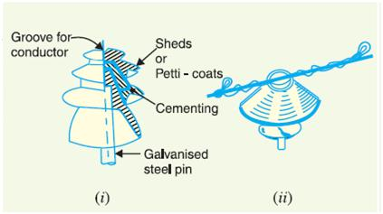
Ref: http://www.skm-eleksys.com/2011/03/transmission-line-parameters-resistance.html

Session 3- Effect of uniform voltage distribution along the string
Quiz
- What is voltage distribution?
- List the components of flux linkages in a conductor
Ref: http://www.skm-eleksys.com/2011/03/transmission-line-parameters-resistance.html
Presentation
Give detailed explanation about voltage distribution on insulators
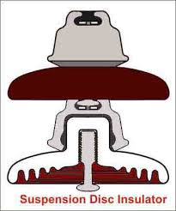

Board activity
Deriving the expression
V2 = (1+m) V1
V3 = (1+3m+m2) V1
V4 = (1+6m+5m2+m3) V1
Vph = V1+V2+V3+V4

Ref: http://www.skm-eleksys.com/2011/03/transmission-line-parameters-resistance.html

Session 4- Tutorial on voltage distribution
Quiz
- What is voltage distribution?
- Effects of voltage distribution
- Ways to reduce voltage drop.
Ref: http://www.skm-eleksys.com/2011/03/transmission-line-parameters-resistance.html
Presentation
Giving detailed explanation on calculation of voltage distribution
Voltage distribution
Vph = V1+V2+V3+V4
Where v1,v2,v3 are the voltages across the conductors
Board activity
Solving a problem
Ref: http://www.skm-eleksys.com/2011/03/transmission-line-parameters-resistance.html

Session 5- Tutorial on improvement of string efficiency
Quiz
- What is string efficiency?
- Factors affecting string efficiency
Ref: http://www.skm-eleksys.com/2011/03/transmission-line-parameters-resistance.html
Presentation
Discuss detailed explanation about string efficiency
STRING EFFICIENCY:
string efficiency refers to the efiiciency of the string which is an assembly of two or more number of insulation disc used between the tower and conductor .
it is given by the formula ,
string efficiency = voltage across the string / number of disc in the string * voltage
across the disc nearest the string
Board activity
Problems are solved on board by the students
Ref: http://www.skm-eleksys.com/2011/03/transmission-line-parameters-resistance.html

Session 6- Underground cables - constructional features of LT cable
Quiz
- What are underground cables?
- What are the types of underground cable?
Ref: http://www.technoend.com/what-is-transposition-of-electrical-transmission-line/
Presentation

GENERAL CONSTRUCTION OF A CABLE
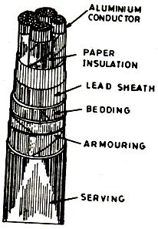

Board activity
Draw the diagram of the underground cable.Ref: http://www.skm-eleksys.com/2011/03/transmission-line-parameters-resistance.html

session 7- Underground cables - constructional features of HT cables
Quiz
- What are the parts in the underground cable?
- Define cable.
Ref: http://www.electrical4u.com/abcd-parameters-of-transmission-line/Presentation
Presentation
Discuss about constructional features of underground cable
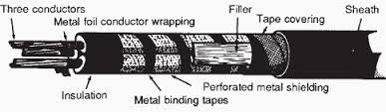
Board activity
Diagram are drawn by the student
Ref: https://www.google.co.in/url?sa=t&rct=j&q=&esrc=s&source=web&cd=4&cad=rja&ved=0CDoQFjAD&url=http%3A%2F%2Fwww.ee.lamar.edu%2Fgleb%2Fpower%2FLecture%252009%2520-%2520Transmission%2520lines.ppt&ei=Bu8yUt6tD8SPrgeGyYBA&usg=AFQjCNEio_CEVpfccS3Bd6rFmVfTO94DMQ

Session 8- Insulation resistance
Quiz
- What is insulation resistance?
- Factors affecting sending end voltage
- ABCD constants
Ref: http://www.researchgate.net/post/What_is_the_real_interpretation_of_ABCD_parameters_for_transmission_line
Presentation
Insulation resistance of a small length dx due to leakage current

where, R_{i} is the resistance of the insulation
R is the radius of the cable
r is the radius of the core
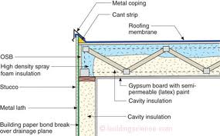

Board activity
Deriving expression for insulation resistance
Ref: www.egr.unlv.edu/~eebag/TRANSMISSION%20LINES.pdf

Session 9- Capacitance of an underground cable
Quiz
- What are the components of reactive power?
- Effects of non optimized reactive power flow
- Definition for reactive power
Ref: http://electrical-engineering-portal.com/the-need-for-reactive-power-compensation Presentation
Giving detailed explanation on capacitance on underground cable

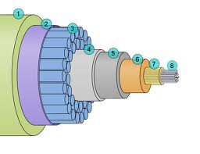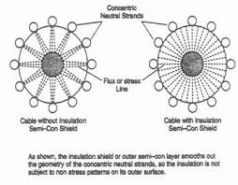
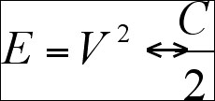
Board activity
Deriving expression for capacitance on cables
Ref: http://www.alstom.com/grid/products-and-services/high-voltage-power-products/power-compensation/

Session 10- Dielectric stress and grading
Quiz
- What is grading?
- Factors affecting grading
Ref: http://electricalquestionsguide.blogspot.in/2011/12/rotor-angle-stability-synchronous.html
Presentation
Giving detailed explanation on grading of cables
GRADING:
It has been observed that the voltage gradient is maximum at the surface of the conductor and minimum at the inner surface of the sheath (i.e., the stress decreases from conductor surface to sheath). This causes breakdown in the insulation. For avoiding this breakdown, it is advisable to have more uniform stress distribution throughout the dielectric. The process of achieving uniform distribution in dielectric stress is called the grading of cables. There are two methods to achieve it, they are:
- The application of layers of different dielectric materials called “Capacitance grading”.
- Providing metallic intersheath between successive layers of the same dielectric materials and maintaining appropriate potential level at the intersheath is called “Intersheath grading”.
TYPES OF GRADING:
There are two methods of grading viz.
  - capacitance grading and
  - intersheath grading.
Board activity
Deriving expression for power angle equation
Ref: http://www.slideshare.net/Shahabkhan/definition-classification-of-power-system-stability

Session 11- Tan δ and power loss
Quiz
- What is surge impedance?
- Factors affecting amount of loading
- Significance of SIL
Ref: http://electricalquestionsguide.blogspot.in/2012/05/surge-impedance-loading-sil.html
PRESENTATION
Giving detailed explanation on surge impedance loading
The surge impedance loading (SIL) of a transmission line is the power (MW) loading of a transmission line when the line is lossless.
A transmission line produces reactive power (MVAr) due to their natural capacitance. The amount of MVAr produced is dependent on the transmission line's capacitive reactance (X_{c}) and the voltage (kV) at which the line is energized.

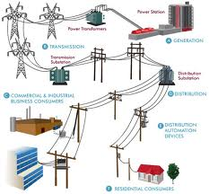
Board activity
Deriving expression for surge impedance loading
Ref: http://www.transtutors.com/homework-help/electrical-engineering/power-system/surge-impedance-loading.aspx

Session 12- Thermal characteristics
Quiz
- What is rotor angle stability?
- Factors affecting angle stability
- Importance of rotor angle stability
Ref: http://electricalquestionsguide.blogspot.in/2012/05/surge-impedance-loading-sil.html
Presentation
Giving detailed explanation on thermal charecteristics

Cables should not be operated at high temperatures because of the following reasons:
- At high temperatures, expansion of oil may cause the sheath to burst.
- The viscosity of the oil may decrease at a higher temperature.
- Dielectric losses increase with increased temperature, so it may cause breakdown of insulation.
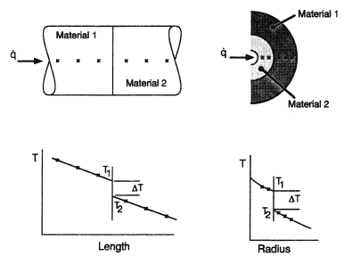

Board activity
Expression for thermal charecteristics was derived by the students

