Unit-V Substations
Session 1- Introduction: Classification, functions and major components of substations
Quiz
- What are the types of substations?
- What are the functions of a substation?
- What is a substation?
- Difference between SS and PS
Ref: http://www.skm-eleksys.com/2011/03/transmission-line-parameters-resistance.html
Presentation
Giving detailed explanation on types of substations
A substation is a part of an electrical generation, transmission, and distribution system. Substations transform voltage from high to low, or the reverse, or perform any of several other important functions. Between the generating station and consumer, electric power may flow through several substations at different voltage levels.
Types of substation:
Based on service
Based on constructional feature

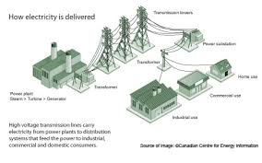
Board activity
Drawing the different types of substations and explaning
Ref; http://www.cvel.clemson.edu/Emc/calculators/TL_Calculator/index.

Session 2- Bus-bar arrangements
Quiz
- What is a bus bar?
- What are the advantages of bus bar?
- What are the materials used for bus bar?
Ref: http://www.skm-eleksys.com/2011/03/transmission-line-parameters-resistance.html
Presentation
Discussing the merits and demerits of different types of bus bar arrangements
Bus bar:
The different types of bus bar arrangements are:
- Single bus bar
- Single bus bar system with sectionalization
- Double bus bar with single breaker
- Double bus bar with two circuit breakers
- Breakers and a half with two main buses
- Main and transfer bus bar
- Double bus bar with bypass isolator
- Ring bus
Board activity
Drawing the different bus bar arrangements and explaning
Ref: http://www.skm-eleksys.com/2011/03/transmission-line-parameters-resistance.html

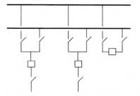

Session 3- Substation bus schemes - Single bus
Quiz
- What are the advantages of single bus bar arrangement?
- List the components of flux linkages in a conductor
Ref: http://www.skm-eleksys.com/2011/03/transmission-line-parameters-resistance.html
Presentation
Merits and demerits of single bus bar arrangement
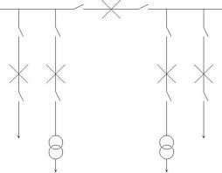

Board activity
Drawing the single bus arrangement on the board and explaining it
Ref: http://www.skm-eleksys.com/2011/03/transmission-line-parameters-resistance.html

Session 4- Substation bus schemes – Double busbar
Quiz
- What are the advantages of double bus bar arrangement?
- List the components of flux linkages in a conductor
Ref: http://www.skm-eleksys.com/2011/03/transmission-line-parameters-resistance.html
Presentation
Merits and demerits of double bus bar arrangement
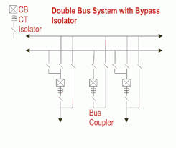
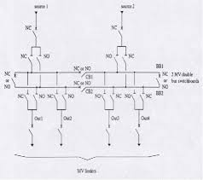
Board activity
Drawing the bouble bus arrangement on the board and explaining it
Ref: http://www.skm-eleksys.com/2011/03/transmission-line-parameters-resistance.html

Session 5- Substation bus schemes – Double bus with single breaker
Quiz
- What are the advantages of double bus bar arrangement?
- List the components of flux linkages in a conductor
Ref: http://www.skm-eleksys.com/2011/03/transmission-line-parameters-resistance.html
Presentation
Merits and demerits of double bus bar arrangement

Board activity
Drawing the bouble bus arrangement on the board and explaining it
Ref: http://www.skm-eleksys.com/2011/03/transmission-line-parameters-resistance.html

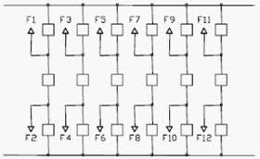

Session 6- Substation bus schemes – Ring bus
Quiz
- What are the advantages of ring bus bar arrangement?
- List the components of flux linkages in a conductor
Ref: http://www.skm-eleksys.com/2011/03/transmission-line-parameters-resistance.html
Presentation
Merits and demerits of ring bus bar arrangement

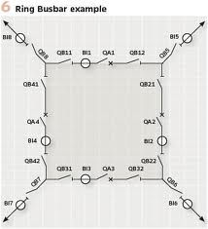

Board activity
Drawing the ring bus arrangement on the board and explaining it
Ref: http://www.skm-eleksys.com/2011/03/transmission-line-parameters-resistance.html

Session 7- Substation earthing
Quiz
- What are the difference between earthing and grounding?
- List the components of flux linkages in a conductor
Ref: http://kiran111.hubpages.com/hub/Substation-Grounding-Earthing
Presentation
REQUIREMENT OF GOOD EARTHING
a) Good earth should have lowresistance
b) It should stabilize circuit potentialwith respect to ground and limitoverall potential rise

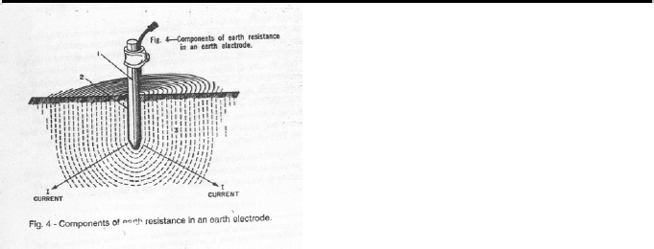

Board activity
Drawing the earthing scheme on the board and explaining it
Ref: http://kiran111.hubpages.com/hub/Substation-Grounding-Earthing

Session 8- Substation neutral grounding
Quiz
- What are the advantages of double bus bar arrangement?
- List the components of flux linkages in a conductor
Ref: http://kiran111.hubpages.com/hub/Substation-Grounding-Earthing
Presentation
Different methods of grounding
-solid grounding
-resistance grounding
-reactance grounding
-resonant grounding
Neutral grounding:
Connecting the neutral or star point of any electrical equipment(generator ,transformer
etc) to earth
Board activity
Drawing the grounding bus arrangement on the board and explaining it
Ref: http://kiran111.hubpages.com/hub/Substation-Grounding-Earthing

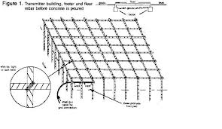

Session 9- Substation earthing practices
Quiz
- What are the need for earthing?
- List the components of flux linkages in a conductor
Ref: http://www.skm-eleksys.com/2011/03/transmission-line-parameters-resistance.html
Presentation
Merits and demerits of earthing practices
Board activity
Drawing the earthing for substation
Ref: http://www.skm-eleksys.com/2011/03/transmission-line-parameters-resistance.html

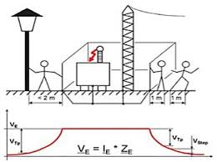

Session 10- Feeders distributor and service mains
Quiz
- What are feeders and distributors?
- List the components of flux linkages in a conductor
Ref: http://eeemcq.blogspot.in/2012/09/what-is-distribution-system-define.htmlPresentation
Functions of feeders and distributors
Board activity
Differentiating feeder from distributor
Ref: http://eeemcq.blogspot.in/2012/09/what-is-distribution-system-define.html
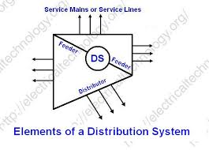

Session 11- DC distributor - 2-wire and 3-wire, radial and ring main distribution
Quiz
- What are feeders and distributors?
- List the components of flux linkages in a conductor
Ref: http://eeemcq.blogspot.in/2012/09/what-is-distribution-system-define.htmlPresentation
Functions of feeders and distributors
Board activity
Differentiating feeder from distributor
Ref: http://eeemcq.blogspot.in/2012/09/what-is-distribution-system-define.html

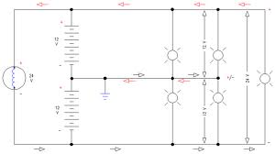

Session 11- AC distribution – single phase and three phase 4-wire distribution.
Quiz
- What are feeders and distributors?
- List the components of flux linkages in a conductor
Ref: http://eeemcq.blogspot.in/2012/09/what-is-distribution-system-define.htmlPresentation
Functions of feeders and distributors
Board activity
Differentiating feeder from distributor
Ref: http://eeemcq.blogspot.in/2012/09/what-is-distribution-system-define.html
