Unit I- Linear Data Structures
Session 1:
Time :20 minutes
Topic: Abstract Datatypes
Activity: Board activity
Description: Abstract datatype concept was highlighted on the board
The points were
- Mathematical abstractions
- Set of operations
Time: 20 minutes
Topic: List ADT
Activity: Presentation and Board activity
Description:
List concept was explained through PPT slides.
The concepts was highlighted on the board
- Definition of List
- List operations- Insert,delete, find,
Time: 10 minutes
Topic: Conclusion
Activity: Question and Answer
- What is datastructure?
- What is abstract data type?
- What is data?
- What are types of datastructures?
- What is meant by list?
- What are types of list?
- What is difference between linear and non linear datastructures?
- Give examples of linear datastructures?
- Give examples of non linear datastructures?
- What are list operations?

Website Links:
1.en.wikipedia.org/wiki/Abstract_data_type
2.www.youtube.com/watch?v=HcxqzYsiJ3k
3.cse.iitkgp.ac.in/pds/notes/ADT.html‎
4.https://en.wikipedia.org/wiki/List_(abstract_data_type)‎
5. lcm.csa.iisc.ernet.in/dsa/node15.html‎

Session 2:
Time :10 minutes
Topic: Array implementation of List
Activity: Quiz
Description: We can conduct quiz to recap what is thought in previous class such as raising questions to two groups of students marked as A and B and questions asked are
- What is List?
- What is Array?
- What are the types of List?
- What are advantages of Arrays?
- What are the disadvantages of Arrays?
- What is List ADT?
Time: 35minutes
Topic: Linked list implementation of List.
Activity: Presentation Videos.
Description: Videos were presented.The weblink was
http://www.youtube.com/watch?v=LOHBGyK3Hbs
Time: 05 minutes
Topic: conclusion
Description: Show and tell
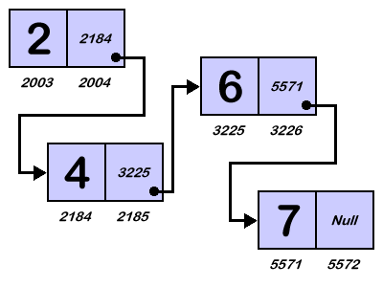
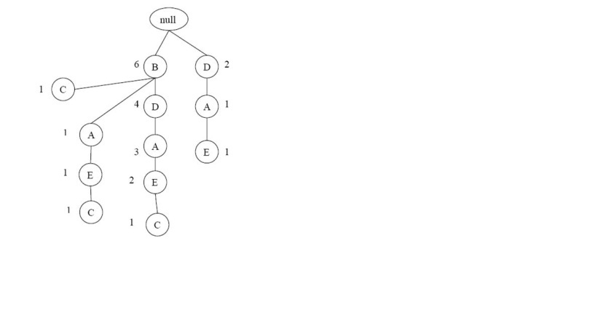
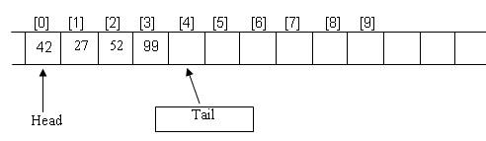
Website Links:
- lcm.csa.iisc.ernet.in/dsa/node18.html‎
- www.cs.sfu.ca/CC/225/jmanuch/lec/2-3.ppt‎
Applications
The main Applications of Linked Lists are
* For representing Polynomials.
* In Dynamic Memory Management.
* In Symbol Tables.
* Representing Sparse Matrix.

Session 3:
Time :10 minutes
Topic: Recap: List and linked list
Activity: Question and answer
Description: We can conduct quiz to recap what is thought in previous class such as raising questions to two groups of students marked as A and B and questions asked are
- What is List?
- What is Array?
- What are the types of List?
- What are advantages of Arrays?
- What are the disadvantages of Arrays?
- What is Linked List?
- What is node?
- What are the two fields in a node in single Linked list?
- What are applications of Linked List?
Time: 30minutes
Topic: Cursor based implementation of list
Activity: Presentation Unspoken words
Description: PPT was presented.
The points are
1. new structure by a call to cursorspace array.
2. Implementation without using pointers
3. Data stored in collection of structures.
Time: 10 minutes
Topic: conclusion
Description: Show and tell

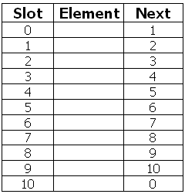

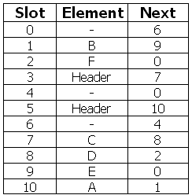

Website Links:
- lcm.csa.iisc.ernet.in/dsa/node18.html‎
- www.cs.sfu.ca/CC/225/jmanuch/lec/2-3.ppt‎

Session 4:
Time :20 minutes
Topic: Doubly linked lists
Activity: Board activity
Description: The concept was explained on the board. The points were highlighted.
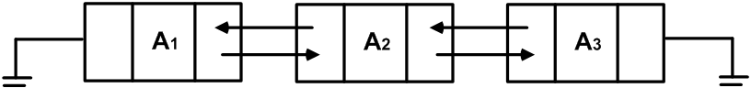
Time: 10minutes
Topic: Application of list
Activity: Presentation and Discussion
Description: PPT was presented.
The points are
The main Applications of Linked Lists are
* For representing Polynomials.
* In Dynamic Memory Management.
* In Symbol Tables.
* Representing Sparse Matrix and sorting numbers.

Time: 10 Minutes
Topic: Merge sort(content beyond the syllabus)
Description: Presentation videos
http://www.youtube.com/watch?v=XaqR3G_NVoo

Website Links:
en.wikipedia.org/wiki/Doubly_linked_list‎
www.cse.unr.edu/~bebis/CS308/PowerPoint/LinkedDoublyLists.ppt‎
www.thelearningpoint.net/.../data-structures-doubly-linked-list-with-c-prog...
staff.science.uva.nl/~heck/JAVAcourse/ch4/sss1_2_3.html‎
en.wikipedia.org/wiki/Merge_sort
www.cse.iitk.ac.in/users/dsrkg/cs210/.../sortingII/mergeSort/merge.htm

Session 5:
Time :5 minutes
Topic: Stack ADT
Activity: Board activity
Description: The concept was explained on the board. The points were highlighted.
Time: 20minutes
Topic: Stack Model
Activity: Demonstration by learners
Description: The learners were trained to put bangles. And explained the concept of stack.
Time: 20 Minutes
Topic: Implementation of stack
Description: Presentation videos
http://www.youtube.com/results?search_query=video+tutorial+on+stack+and+queue&oq=video+tutorial+on+stack+and+queue&gs_l=youtube.3...10790.20526.0.20812.39.32.3.4.5.1.268.4227.5j24j3.32.0...0.0...1ac.1.11.youtube.8aCbFEbWcFg
Time: 5 Minutes
Topic: Conclusion
Description: Recall by Keywords
- Stack
- LIFO
- Push
- Pop
- Top pointer
- Overflow
- Underflow
- Full
- Empty

Website Links:
www.youtube.com/watch?v=9ch1mor0NvY
see.stanford.edu/materials/icsppcs107/stack-implementation.pdf
www.cs.ualberta.ca/~holte/T26/linked-impl-stacks.html‎
www.cs.bu.edu/teaching/c/stack/array/‎
en.wikipedia.org/wiki/Stack_(abstract_data_type)‎

Session 6:
Time :10 minutes
Topic: Application of Stack
Activity: Board activity
Description: The concept was explained on the board. The points were highlighted.
Time: 15minutes
Topic: Balancing Expressions
Activity: Board Activity
Description: The problems was solved on the board.
Time: 15Minutes
Topic: Polynomial operations
Description: Board Activity
Time: 10 Minutes
Topic: Infix to postfix
Description: Learner led activity
http://www.youtube.com/watch?v=rA0x7b4YiMI
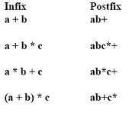
Website Links:
www.youtube.com/watch?v=rA0x7b4YiMI
www.csd.uwo.ca/courses/CS1037a/notes/topic06_Stacks.pdf‎
www.cse.yorku.ca/course_archive/2003-04/F/.../DatStr_03_Stacks.pdf‎
scriptasylum.com/tutorials/infix_postfix/algorithms/infix-postfix/
en.wikipedia.org/wiki/Stack_(abstract_data_type)‎

Session 7:
Time :20 minutes
Topic: Application of Stack
Activity: Board activity
Description: The concept was explained on the board. The points were highlighted.
Evaluating postfix
Infix to postfix
Tower of Hanoi
Time: 20minutes
Topic: Postfix Expressions
Activity: Presentation videos
Description: The Video was shown to the learners.
http://www.youtube.com/watch?v=uh7fD8WiT28
Time: 10 Minutes
Topic: Conclusion
Description: Learner led activity
Sample problems were given to learners to solve on the board.
10 2 8 * + 3 - Answer: 23
6 2 3 + - 3 8 2 / + * 2 ^ 3 + Answer: 52
Website Links:
http://www.youtube.com/watch?v=uh7fD8WiT28
www.cs.nthu.edu.tw/~wkhon/ds/ds10/tutorial/tutorial2.pdf
faculty.cs.niu.edu/~hutchins/csci241/eval.htm‎

Session 8:
Time :20 minutes
Topic: Queue ADT
Activity: Presentation Unspoken words
Description: The concept was explained on the board. The points were highlighted.
Time: 10minutes
Topic: Array Implementation of Queue ADT
Activity: Presentation and Board Activity
Description: The problems was solved on the board.
Time: 10Minutes
Topic: Linked list implementation of Queue ADT
Activity: Board Activity
Description:
Time: 10 Minutes
Topic: Conclusion
Activity: Show and tell
Description:

Website Links:

Session 9:
Time :20 minutes
Topic: Application of Queues
Activity: Board activity
Description: The concept was explained on the board. The points were highlighted.
Time: 15minutes
Topic: Implemenation of Circular Queue
Activity: Presentation analogy
Description: The problems was solved on the board.
Time: 10 Minutes
Topic: Conclusion
Activity: Recall by Keywords
Description:
Website Links:

