UNIT-II Design of Shafts and Couplings

Session -1

**Objective:** To introduce the shaft, types of shaft material selection.

www.ignou.ac.in/upload/Unit-7-60‎ itll.colorado.edu/.../ch14the_basics_of_engineering_mechanics.pdf‎

**Recap:** Recall the Fundamentals of shafts from Strength of Material

Recalling the fundamentals by asking

What is shaft?

Circular in cross section used to transmit power.

What are methods to find diameter?

Strength basis and Rigidity basis

**Introduction to the Shaft: PPT and Board Explanation**

A shaft is a rotating machine element which is used to transmit power from one place to other place. Carbon steels of grade 40C8, 45C8, 50C4, 50C12 are normally used as shaft materials.

**Material properties**

* It should have high strength
* It should have good machinability.
* It should have low notch sensitivity factor.
* It should have good heat treatment properties.
* It should have high wear resistance.

**TYPES OF SHAFT**

**Transmission shaft:**

These shafts transmit power between the source and machines absorbing power. The counter shafts, line shafts, overhead shafts all shafts are transmission shafts.

**Machine shafts:**

These shafts from an integral part of the machine itself.

**Conclusion &Summary:** Conclude the session by recalling what is shaft? What is the use and factors that affecting the design process.

Session -2

**Objective:** To know the types of shaft and Know about the strength basis

www.ignou.ac.in/upload/Unit-7-60‎

vjit.ac.in/wp-content/uploads/2012/01/Design-of-Shafts.doc‎

**Recap:** Recall what is shaft, what are all the types.

**DESIGN OF SHAFTS PPT and Board Explanation**

The shaft may be designed on the basis of

1. Strength

2. Rigidity and stiffness

In designing shaft on the basis of strength the following cases may be consider

1. Shafts subjected to twisting moment only
2. Shaft subjected to bending moment only
3. Shaft subjected to combined twisting moment and bending moment
4. Shaft subjected to fluctuating loads

**Strength Basis**

*T*  

*J r*

*T*  

16

  *d* 3

For hollow section

*T*  

16

  *d o*

3  1  *k* 4 

Twisting moment may be obtained by using the following relation

*T*   *P*  60

2    *N*

In case of belt drives

T= (T1-T2) R

T1- Tension in the tight side

T2- Tension in the slack side

R- Radius of the pulley

**Conclusion &Summary:** Conclude the session by recalling the design formula for strength basis.

Session -3

**Objective:**  To know the basic concepts of Hollow shafts based on strength basis.

harshparmar.files.wordpress.com/2013/04/shaft.ppt‎

www.engineeringtoolbox.com/torsion-shafts-d_947.html‎

**Recap:** Recalling the design formula for strength basis and its terminology.

**DESIGN OF HOLLOW SHAFTS PPT and Board Explanation**

The shaft may be designed on the basis of

1. Strength
2. Rigidity and stiffness

In designing shaft on the basis of strength the following cases may be consider

1. Shafts subjected to twisting moment only
2. Shaft subjected to bending moment only
3. Shaft subjected to combined twisting moment and bending moment
4. Shaft subjected to fluctuating loads

Strength Basis

*T*  

*J r*

For hollow section

*T*  

16

  *d o*

3  1  *k* 4 

Twisting moment may be obtained by using the following relation

*T*   *P*  60

2    *N*

In case of belt drives

T= (T1-T2) R

T1- Tension in the tight side

T2- Tension in the slack side

R- Radius of the pulley

**Conclusion &Summary:**  Conclude the session by recalling the design formula for strength basis.

Session -4

**Objective:** To improve the problem solving skill in strength basis.

Recap: Recall simple torque equation for solid and hollow

Tutorial Problem: Board Presentation

From university question bank solve simple problems on solid and hollow shafts

**Conclusion &Summary:** Recall the session by summarizing the formula for solid and hollow shafts

Session Plan-5

**Objective:** To improve the problem solving skill in strength basis.

www.freestudy.co.uk/dynamics/gears.pdf‎

Recap: Recall formula for solid and hollow shafts based on strength basis

**Solid and Hollow shaft Board Presentation**

When the shaft is subjected to combined twisting moment ad bending moment then the shaft must be designed on the basic of two moments simultaneously



**DESIGN OF SHAFT FOR RIGIDITY:**

In many cases the shaft is to be designed from rigidity point of view. We should consider

torsional rigidity as well as lateral rigidity. (‘ I) Tensional rigidity:

The angle of twist in radians for a solid circular shaft of uniform diameter chi and length L is given by



Where, T — Torque on the shaft

**Conclusion &Summary:** Recall formula for solid and hollow shafts based on rigidity basis.

Session -6

**Objective:**  To introduce the shaft under rigidity basis

www.asabe.org/media/124595/asabe_pe_2012.ppt‎

**Recap**: Recall the Fundamentals of shafts design under rigidity basis

Recalling the fundamentals by asking

What is Strength basis?

From the given power and torque calculate the dia of shaft with help of shear stress only

**Torsional rigidity: PPT and Board Explanation**

**DESIGN OF SHAFT FOR RIGIDITY:**

In many cases the shaft is to be designed from rigidity point of view. We should consider

Torsional rigidity as well as lateral rigidity. (‘I) Tensional rigidity:

The angle of twist in radians for a solid circular shaft of uniform diameter chi and length L is given by



Where, T — Torque on the shaft

**Conclusion &Summary:** Recall formula for solid and hollow shafts based on rigidity basis.

Session -7

**Objective:** To know the types of shaft and Know about the strength basis

www.ignou.ac.in/upload/Unit-6-60.pdf‎

depts.washington.edu/matseed/.../**Material**%20**Selection**%20Process.htm‎

**Recap:** Recall what is shaft, what are all the types, design procedure and methods.

**KEY**

A key is a piece of mild steel inserted between the shaft and hub or boss of the pulley to connect these together in order to prevent relative motion between them.

**TYPES OF KEYS**

1. Sunk key, 2.Saddle key, 3.Tangent key, 4. Round key 5.Splines

**SUNK KEYS**

The sunk keys are provided half in the keyway of the shaft and half in the keyway of the hub or boss of the pulley.

**TYPES OF SUNK KEYS**

**1. Rectangular sunk key**

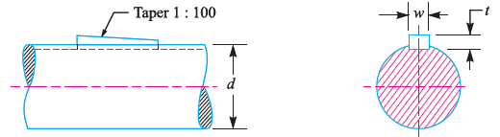

**2. Square sunk key**

The only difference from the rectangular sunk key is the width and thickness is equal

**3. Parallel sunk key**

The parallel sunk key may be of rectangular or square cross section. The cross section is uniform in width and thickness throughout length.

**4. Gib head key**

A gib head key is similar to a square or rectangular key but it has a head at one end, generally at the larger end of the taper sunk key. The gib head is used for driving the key while assembling or disassembling.

**5. Feather key**

Feather key is used where it is necessary to slide a keyed gear, pulley assembly along the shaft. Keys are tight fitted or screwed on the shaft.

**6. Woodruff key**

A woodruff key is used to transmit small amount of torque in automotive and machine tool industries. The keyway in the shaft is milled in a curved shape whereas the ke yway in the hub is usually straight. The main advantage of this key is that it will align itself in the keyway.

**Conclusion &Summary:** Conclude the session by recalling the various types of key and its functions.

Session -8

**Objective:** To improve the problem solving skill in strength basis and rigidity basis.

Tutorial Problem: **Board Presentation**

From university question bank solve simple problems on solid and hollow shafts

**Conclusion &Summary**: Recall the session by summarizing the formula for solid and hollow shafts

Session -9

**Objective:** To know about the couplings and its functions

Recap:Recallsimple torque equation for solid and hollowand its terminology

**DESIGN OF COUPLING** PPT & **Board Presentation**

Shaft couplings are used in machinery for several purposes

1. To provide for connection of shaft of units those are manufactured separately.
2. To provide for misalignment of the shaft or to introduce mechanical flexibility.
3. To reduce the transmission of shock loads from one shaft to another.
4. To introduce protection against over loads.

**REQUIREMENT OF A GOOD SHAFT COUPLING**

1. It should be easy to connect or disconnect.
2. It should transmit the full power from one shaft to the other shaft without losses.
3. It should hold the shaft in perfect alignment.
4. It should have no projecting parts.

**TYPES OF SHAFT COUPLINGS**

**1. Rigid coupling**

* It is used to connect two shafts which are perfectly aligned. The types are
* Sleeve (or) muff coupling
* Clamp (or) split muff (or) compression coupling
* Flange coupling

**2. Flexible coupling**

It is used to connect two shafts having lateral and angular misalignments. The types are

* Bushed pin type coupling
* Universal coupling
* Oldham coupling

**Conclusion &Summary**: Recall the session by summarizing the concepts of coupling and its function with types

Session -10

**Objective:** To derive the design procedure for solid muff coupling.

www.stat.columbia.edu/~regina/research/slides5.pdf‎

Recap:Recall the coupling and its function.

**Board Presentation**

**SLEEVE (or) MUFF COUPLING**

It is made of cast iron. It consists of a hollow cylinder whose inner diameter is that same as that of the shaft. It is fitted over the ends of two shafts by means of a gib head key. The power transmitted from one shaft two other shafts by means of a key and a sleeve.

Outer diameter of sleeve D=2d+13mm

Length of sleeve L=3.5d

d- diameter of shaft

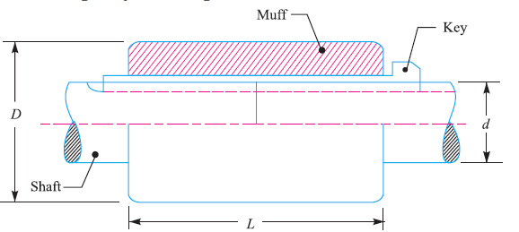

**DESIGN OF MUFF COUPILNG**

**1. Design for sleeve**

The sleeve is designed by considering it as a hollow shaft

❐  *D* 4  *d* 4 

*T*        

16   *D* 

**2. Design for key**

The length of coupling key is at least equal to the length of the sleeve. The coupling key is usually made into two parts so that the length of key in each shaft

*l*  *L*

2

after that the induced shearing and crushing stresses may be checked.

*T*  *l*  *w*    *d*

2

*T*  *l*  *t*    *d*

2 *c* 2

**Conclusion &Summary:** Recall procedure for designing muff coupling.

Session -11

**Objective:** To derive the design procedure for solid flange coupling.

www.engineering108.com/Data/Engineering/...**Design**/MD.../CHP-12.pdf

Recap:Recall muff coupling and its design procedure.

**Board Presentation**

**FLANGE COUPLING**

A flange coupling usually applied to a coupling having two separate cast iron flanges. Each flange is mounted on the shaft and keyed to it. The faces are turned up at right angle to the axis of the shaft. One of the flange has a projected portion and the other flange has a corresponding recess. This helps to bring the shaft into line and to maintain alignment. The two flanges are coupled together by means of bolt and nuts.

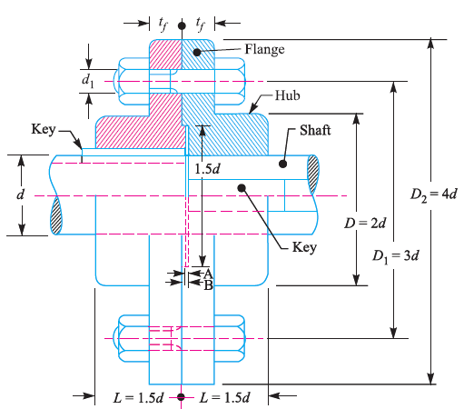

**1. Design for hub**

The hub is designed by considering it as a hollow shaft

❐  *D* 4  *d* 4 

*T*    *c*    

16   *D* 

D=2*d

Length of hub L=1.5d

**2. Design for key**

The key is designed with equal properties and then checked for shearing and crushing stress. The length of key is taken equal to the length of hub

**3. Design for flange**

*D* 2

*T* 

2

 *c*  *t f*

tf- thickness of flange(d/2)

**4. Design for bolt**

The bolts are subjected to shear stress due to torque transmitted. The number of bolts (n)

depends upon the diameter of shaft and pitch circle diameter is taken

D1=3d

Torque transmitted

*T*    *d* 2 

 *n*  *D*1

4 1 *b* 2

d1- diameter of bolt

for crushing

*T*  *n*  *d*

1

 *t f*

  *cb*

 *D*1

2

**Conclusion &Summary:** Recall design procedure for Flange coupling.

Session -12

**Objective:** To improve the problem solving skill on design of flange coupling.

Tutorial Problem: **Board Presentation**

From university question bank solve simple problems design of flange coupling

**Conclusion &Summary**: Recall the session by summarizing the design procedure for flange coupling