**Unit V-Graphs**

**Session 1:**

**Time :10 minutes**

**Topic:** Definition-Graphs

**Activity:** Brainstorming

**Description:** Teacher introduces the concept of graphs by giving clues and make them to learn the definition and examples.

G=(V,E)

**Time: 10 minutes**

**Topic:** Representation of Graphs

**Activity:** Presentation Unspoken words

**Description : Slides were presented for representation of Graphs.**

**1.Adjacency Lists**

**2. Adjacency Matrix**

**Time: 20 minutes**

**Topic:** Topological Sorting

**Activity:** Presentation Unspoken words

* Visiting vertex with no incoming edges
* Deleting the vertex and its outgoing edges.

**Time: 10 minutes**

**Topic:** Conclusion

**Activity:** Question and answers

1. **What is meant by Graph?**
2. **What is node?**
3. **What is edge?**
4. **What is complete graph?**
5. **What is directed graph?**
6. **What is undirected graph?**
7. **What is weighted and unweighted graph?**
8. **Website Links:**

1.en.wikipedia.org/wiki/**Graph**_(abstract_data_type)‎

2. www.dcs.gla.ac.uk/~pat/52233/slides/**Graphs**1x1.pdf‎

3. crypto.cs.mcgill.ca/~crepeau/CS250/2004/25.**Graphs**DS.pdf‎

**Session 2:**

**Time :10 minutes**

**Topic:** Recap:Graphs

**Activity:** Discussion

**Description:** The previous session concept was discussed among students. The points were listed on the board.

Graphs

Lists

Adjacency Matrix

Adjacency lists

Directed and undirected graph

**Time: 30 minutes**

**Topic:** Breadth first traversal

**Activity:** Presentation

**Description: PPt slides were presented.**

**Time: 10 minutes**

**Topic:** Conclusion& Summary

**Activity:** Learner Led activity

**The graphs were given to the students and learners were allowed to practice the breadth first search.**

**Website Links:**

1. en.wikipedia.org/wiki/**Breadth**-**first**_**search**‎
2. www.cs.princeton.edu/courses/archive/spr10/cos226/.../51demo-bfs.ppt‎
3. [www.youtube.com/watch?v=QRq6p9s8NVg](http://www.youtube.com/watch?v=QRq6p9s8NVg)
4. www.cs.bu.edu/teaching/c/tree/**breadth**-**first**/‎

**Session 3:**

**Time :20 minutes**

**Topic:** Shortest Path algorithms

**Activity:** Board activity

**Description:** The concept was introduced by writing the concept on board

1. **Shortest path**
2. **Weighted graph**
3. **Unweighted graph**

**Time: 20 minutes**

**Topic:** Unweighted shortest paths

**Activity:** Presentation and Discussion

**Description: Powerpoint slides were presented.**

**Time: 10 minutes**

**Topic:** Conclusion

**Activity:** Writing Board

1. **Shortest path**
2. **Unweighted shortest path**
3. **Weighted shortest path**
4. **Greedy technique**
5. **Dijkstra algorithm**

**Website Links:**

1. www.cs.princeton.edu/~rs/AlgsDS07/15**ShortestPaths**.pdf‎
2. en.wikipedia.org/wiki/**Dijkstra's**_**algorithm**‎
3. www.cs.cornell.edu/courses/cs312/2002sp/lectures/lec20/lec20.htm‎
4. www.youtube.com/watch?v=qJ5Ozb2ZSxM

**Session 4:**

**Time :10 minutes**

**Topic:** Introduction: graph Algorithms

**Activity:** Brainstorming

**Description:** Graph was given and learners were made to find the shortest path. The concept was introduced to the learners from previous concepts

1. **What is Graph?**
2. **Why shortest path?**
3. **What is source and destination?**
4. **What are shortest path algorithm?**
5. **What is greedy technique?**

**Time: 20 minutes**

**Topic:** Dijkstra’s Algorithm

**Activity:** Board Activity

**Description: the concept was explained on the board.**



**Time: 15 minutes**

**Topic:** Dijkstra’s Algorithm

**Activity:** Board Activity

**Description: Learners were made to solve the problems.**

**Time: 10 minutes**

**Topic:** Conclusion

**Activity:** Writing Board

Example problems were solved by the learners.

**Website Links:**

1. www.cs.princeton.edu/~rs/AlgsDS07/15**ShortestPaths**.pdf‎
2. en.wikipedia.org/wiki/**Dijkstra's**_**algorithm**‎
3. www.cs.cornell.edu/courses/cs312/2002sp/lectures/lec20/lec20.htm‎
4. www.youtube.com/watch?v=qJ5Ozb2ZSxM

**Session 5:**

**Time :10 minutes**

**Topic:** Graphs with negative edge costs

**Activity:** Board activity

**Description:** Problems were solved on the boards and concept was introduced

**Time: 15 minutes**

**Topic:** Acyclic graphs

**Activity:** Board activity

**Description:** The concept was introduced to the learners on board and activity was given to the learners to solve the problem.

**Time: 15 minutes**

**Topic:** All pairs shortest path

**Activity:** Board activity

**Description: Problems were solved.**

**Time: 10 minutes**

**Topic:** Conclusion

**Activity:** Group Discussion

**Description:**

**The students were divided into 3 teams and they were made discuss about shortest path and all pair shortest path algorithms and points were listed out.**

**Website Links:**

1. www.cs.princeton.edu/~rs/AlgsDS07/15**ShortestPaths**.pdf‎
2. en.wikipedia.org/wiki/**Dijkstra's**_**algorithm**‎
3. www.cs.cornell.edu/courses/cs312/2002sp/lectures/lec20/lec20.htm‎
4. www.youtube.com/watch?v=qJ5Ozb2ZSxM

**Session 6:**

**Time :10 minutes**

**Topic:** Introduction to minimum spanning tree

**Activity:** Presentation and Board activity

**Description:** ppt slides were presented.

**Time: 20 minutes**

**Topic:** Prim’s Algorithm

**Activity:** Presentation and Board activity

**Description: ppt slides were presented.**

**Time: 10 minutes**

**Topic:** Conclusion

**Activity:** Learner led activity

Students were given problem to solve on the board.

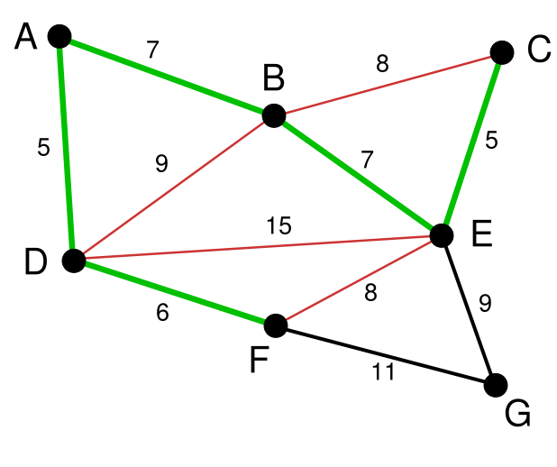

**Website Links:**

1. people.cs.clemson.edu/~pargas/courses/cs212/.../**ppt**/19**PrimKruskal**.**ppt**‎
2. www.mrbartonmaths.com/resources/.../d1/**Prim's**%20and%20**Kruskal**.**ppt**‎
3. faculty.kfupm.edu.sa/ics/jauhar/.../Unit27_MinimumSpanningTree.**ppt**‎

**Session 7:**

**Time :10 minutes**

**Topic:** Recap : Minimum spanning tree algorithm

**Activity:** Presentation and unspoken words

**Description:** slides were presented.

**Time: 30 minutes**

**Topic:** Kruskal Algorithm

**Activity:** Board activity

**Description: Problems were solved on the board.**

**Time: 10 minutes**

**Topic:** Problem solving

**Activity:** Learner led activity

Students were given problem to solve on the board.



**Website Links:**

1. people.cs.clemson.edu/~pargas/courses/cs212/.../**ppt**/19**PrimKruskal**.**ppt**‎
2. www.mrbartonmaths.com/resources/.../d1/**Prim's**%20and%20**Kruskal**.**ppt**‎
3. faculty.kfupm.edu.sa/ics/jauhar/.../Unit27_MinimumSpanningTree.**ppt**‎

**Session 8:**

**Time :10 minutes**

**Topic:** Introduction

**Activity:** Writing Board

**Description:**

**Time: 20 minutes**

**Topic:** Depth first Search

**Activity:** Presentation Videos

**Description: the concept was explained on the board.**

**Time: 10 minutes**

**Topic:** Depth first number (content beyond the syllabus)

**Activity:** Presentation

**Description:**

**Time: 10 minutes**

**Topic:** Conclusion

**Activity:** Recall by keywords

**Website Links:**

1. www.cs.princeton.edu/~rs/AlgsDS07/15**ShortestPaths**.pdf‎
2. en.wikipedia.org/wiki/**Dijkstra's**_**algorithm**‎
3. www.cs.cornell.edu/courses/cs312/2002sp/lectures/lec20/lec20.htm‎
4. www.youtube.com/watch?v=qJ5Ozb2ZSxM

**Session 9:**

**Time: 5 minutes**

**Topic:** Application of Depth first search

**Activity:** Short Seminar

**Description:**

**Time: 20 minutes**

**Topic:** Biconnectivity

**Activity:** writing Board

**Description:**

**Time: 10 minutes**

**Topic:** Euler circuits

**Activity:** Presentation and Unspoken words

**Description:**

**Time: 10 minutes**

**Topic:** Application of Graphs

**Activity:** Presentation and unspoken words

**Description:**

**Time: 5 minutes**

**Topic:** Conclusion

**Activity:** Recall by keywords

**Description:**

**Website Links:**

1. www.cs.princeton.edu/~rs/AlgsDS07/15**ShortestPaths**.pdf‎
2. en.wikipedia.org/wiki/**Dijkstra's**_**algorithm**‎
3. www.cs.cornell.edu/courses/cs312/2002sp/lectures/lec20/lec20.htm‎
4. www.youtube.com/watch?v=qJ5Ozb2ZSxM