Unit-I: SERVICES AND TECHNICAL CHALLENGES

**Session -1 Introduction to wireless communication 10.07.2013, 5th period**

Activity:

1. Recap: Asking questions

* How to transmit the information over air medium?
* How electromagnetic waves carry information bits?

1. Presentation slides

* Examples of wireless transmission
* History of wireless communication

1. Recall by key words

* Digital standards
* Analog standards

**Session -2 wireless services 12.07.2013, 1st period**

Activity:

1. Recap: Asking questions

Activity Description:

- What are the present wireless services?

- How service providers share the spectrum?

2. Content: Presentation slides

Activity: Relay network in trunking radio

Ask the learners about 400 meter relay game. Compare the concept of game with data transformation and extract the idea for developing relay network in trunking radio system.

Video : <http://www.youtube.com/watch?v=uT6b5AAq6co>

Satellite cellular service:

Video : <http://www.youtube.com/watch?v=vFypCugyFoM>

3. Conclusion: Recall by keywords

Activity Description**:** Instructed to learners write the list of keywords.

Types of services

* **Broad casting**
* **Paging**
* **Cellular telephony**
* **Trunking** radio
* Cordless telephone
* WLAN,PAN, FWA,UWB
* **Satellite phones**

**Session -3 Requirements for wireless services 13.07.2013, 6th period**

Activity:

1. Recap: Asking
   1. List out the types of wireless services?
   2. What is relay networks?
   3. How WLAN differ from PAN?
   4. What is the difference between cordless and cellular ?
   5. How satellite phone cover large distance?

.

2. Content: Presentation slides

1. Conclusion: Recall by keywords

Activity Description**:** Instructed to learners to listout the keywords related to requirements of services.

* **1.Data Rate**
* **2.Range and Number of User**
* *3.Mobility*
* *4.Energy Consumption*
* *5.Use of Spectrum*
* *6.Direction of Transmission*

*7.Service Quality*

**Session – 4 Multipath fading 15.07.2013, 4th period**

Activity:

1. Recap: Group Quiz

Activity Description:Ask the learners to identify the services and find the requirements for that services.

1. Presentation slides & Board activity

<http://www.radio-electronics.com/info/propagation/multipath/multipath-fading.php>

<http://www.radio-electronics.com/info/wireless/>

<http://www.youtube.com/watch?v=-apeihWhSKs>

**3.** Conclusion: Recall by keywords

Activity Description**:** Instructed to learners write the list of keywords.

* ISI
* Fading
* Small scale fading
* Large scale fading
* Causes & remedies

**Session – 5 Spectrum Limitation 16.07.2013, 4th period**

Activity:

1. Presentation slides (Content)

<http://electronicdesign.com/4g/technology-solution-spectrum-limitations>

1. Recap: Questions and answers

**a)What is the difference between a regulated and unregulated spectrum?**

1. **regulated spectrum usage,** where a single network operator has control over the usage of the spectrum.
2. **unregulated spectrum**, where each user can transmit without additional control, as long as (s)he complies with certain restrictions on the emission power and bandwidth.

**b.List the frequency range for few applications ?**

• Below 100MHz: at these frequencies, we ﬁnd Citizens’ Band (CB) radio, pagers, and analog cordless phones.

• 100–800MHz: these frequencies are mainly used for broadcast (radio and TV) applications.

• 400–500MHz: a number of cellular and trunking radio systems make use of this band. It is mostly systems that need good coverage, but show low user density.

• 800–1000MHz: several cellular systems use this band

**3.Conclude the practical difficulties of Frequency Reuse in Unregulated Spectrum?**

* + - (i) limit the emission power to a prescribed value,

(ii) follow certain rules for the signal shape and bandwidth, and

(iii) use the band according to the (rather broadly deﬁned) purposes stipulated by the frequency regulators.

**Session -6 Noise- and Interference-Limited Systems 17.07.2013, 5th period**

<http://www.wirelesscommunication.nl/reference/chaptr05/digimod/noise.htm>

Activity:

Asking questions

1.List the data rate used for different services , for Frequency range (below 100Mhz to 16 Ghz)

Conclusion by Questions and answers:

**a.Compare ISI and Fading?**

* Overlapping of one symbol duration with others is called ISI
* Reduction in signal strength is fading.

**b. Differentiate constructive and destructive fading.**

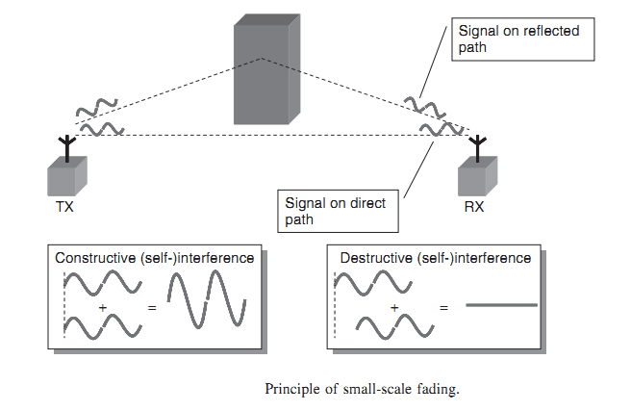.

**Session – 7 : Principles of Cellular Networks 18.07.2013, 2nd period**

<http://www.infotech.su.edu.eg/course/Download_Files/down_1086Chapter%20Three-%20Cellular.pdf>

<http://itechsolutionprovider.blogspot.in/2010/11/principles-of-cellular.html>

* **Recap**

**ISI, Fading**

* **Principles of cellular networks**

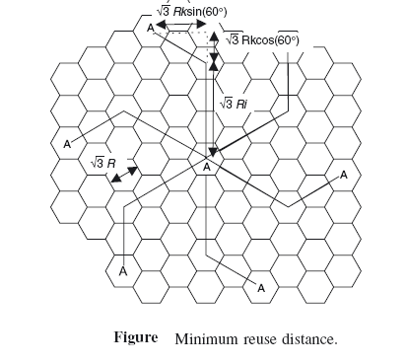

**Recall by words (Conclusion):**

1. Write the cellular concept.

.2. What is cell cluster?

3. Define cell.

4.Write the frequency reuse concept.

**Session – 8: Multiple Access schemes 19.07.2013, 1st period**

Recap by rising questions:

* Cellular concept
* Frequency reuse
* Capacity
* ACI,CCI

Activity:

1. Four set of Four students are formed a group and perform role play for TDMA, FDMA, CSMA-CD, CSMA-CA Concept. They perform an activity to share the resource and use to make a connection between peoples. From their activity the learners learn the different methods of resource allocation. These methods are related to the concepts multiple access in wireless communication.

<http://www.ee.iitb.ac.in/uma/~bhagwan/AntennaHandbook/handbook1.pdf>

<http://latestemergingtechnology.blogspot.in/2009/10/multiple-access-techniques-in-cellular.html>

Recall by words (Conclusion)

1. What is multiple access?

Multiple access is a signal transmission situation in which two or more users wish

to simultaneously communicate with each other using the same propagation channel.

2. Write the applications of multiple access methods

(i) Satellite networks

(ii) Cellular and mobile communication networks

(iii) Military communication and

(iv) Underwater acoustic networks

3. Mention the types of multiple access techniques.

(i) Frequency division multiple access(FDMA) (ii) Time division multiple access (TDMA)

(iii) Code division multiple access(CDMA) (iv) Space division multiple access (SDMA)

4.Define FDMA.

In FDMA, the total bandwidth is divided into non-overlapping frequency subbands. Each user is allocated a unique frequency sub band (channels) for the duration of the connection, whether the connection is in an active or idle state.

5. What is the need of guard bands in FDMA?

The adjustment frequency bands in the FDMA spectrum are likely to interference with each other. Therefore it is necessary to include the guard bands between the adjacent frequency bands.

**Session – 9: Multiple Access schemes 20.07.2013, 5th period**

Recall by words (Conclusion)





Conclusion: Questions and answers

1.Differentiate FDMA with TDMA ,CDMA, SDMA

**Conclusion: Questions and Answers**

**Differentiate FDMA,TDMA,CDMA and SDMA**

<http://www.tapr.org/packetradio.html>

<http://dl.acm.org/citation.cfm?id=1499984>