**Unit-II: PROPAGATION MECHANISM**

**Session -1: Free space propagation 22.07.2013, 4th period**

* **Introduction -presentation**
* **Remember by keywords**
* Reflection
* Diffraction
* Scattering

Activity:

1. **Reflection**

**Smoke box experiment**

<http://www.youtube.com/watch?v=8q-oXhqIuIU>

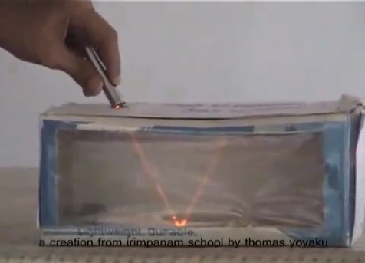

The **experiment** shows the **reflection of light** on a plane mirror. Smoke from a mosquito coil is used in the box. Mirror placed in the bottom side and send a light source towards mirror, mirror reflect the light. Reflected light will be seen in the smoke box.

1. **Refraction**

<http://www.youtube.com/watch?v=cY34qYoQCXg>

This lets students see how waves change direction as they travel from one material into another. Refraction of Earthquake waves has given scientists insights about the structure of Earth's interior.



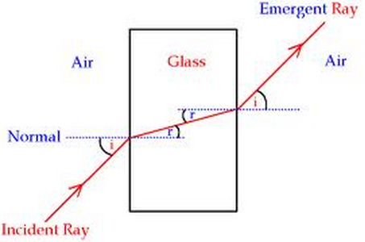

**Session -2: Diffraction 23.07.2013, 3rd period**

**Activity:**

**Diffraction:**

* **Using ligt source and CD, other cot boards we demonstrate the diffraction of waves.**

<http://www.youtube.com/watch?v=AMBcgVlamoU>

<http://www.youtube.com/watch?v=veBOHaWXS9k>

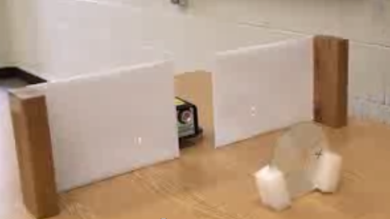

Recall by keywords:

1. Diffraction
2. Reflection
3. Refraction

**Session -3:Statistical model of propagation 24.07.2013, 5th period**

**Activity:**

**Recap: Questioning**

1. **What s Propagation?**
2. **How signal reflects in the medium?**
3. **What are the sources of signal scattering in the air medium?**

**Presentation: slides**

<http://www.ubicc.org/files/pdf/Highway_249.pdf>

www.cwins.wpi.edu/workshop11/ppt/ban.../BANTA_11_final.ppt‎

**Session -4: Local propagation Effects with mobile radio 25.07.13, 2nd period**

**Presentation (content)**

**Board Activity**

**Rayleigh fading**

**Rician fading**

* **Video clipping :** [**http://www.youtube.com/watch?v=40i9ujVJ040**](http://www.youtube.com/watch?v=40i9ujVJ040)

**:** [**http://www.youtube.com/watch?v=3QnD2c4Xovk**](http://www.youtube.com/watch?v=3QnD2c4Xovk)

**Session -5: Doppler shift, Fast fading 27.7.13, 6th period**

Recap: Question and answer

1. Explain the concept behind fading

Reduction in signal strength

2.Compare slow and fast fading.

Small objects causes slow fading

Large objects causes fast fading

**Board Activity**

**Doppler shift**

Fast fading

Conclusion: Questions and answers

1. Define Doppler shift.

If the receiver is moving towards the source, then the zero crossing of the signal appear faster and the received frequency is higher.

**Session -6 Channel models 29.07.2013, 4th period**

Recap: Group quiz

Activity Description: We can divide the learners into two teams and instruct each team to prepare 5 questions on the Feedback and its types. After 5 minutes of preparation, each team will ask the other

**Content: Presentation slides**

Board activity: Narrow band and wide band models

**Session -7 Channel classification 30.07.2013, 5th period**

Presentation (content): slides

Conclusion: Questions and answers

1..Define ultrawideband channel

Any transmission where the RF bandwidth exceeds 1Ghz.Any transmission where the RF bandwidth at the -10dB points of the spectrum exceeds 25% of the center frequency.Ultra-wideband transmission is considered best for low power indoor application where there is high clutter, that is the surrounding environment causes significant amount of multipath.

2. Define time selective signal

The gain and signal strength of received signal are time varying means then the channel is time selective channel. The frequency response of the time selective channel Is constant so called frequency flat channel.

3. Define coherence bandwidth

The coherence bandwidth is related to the specific multipath structure of the channel.

The coherence bandwidth is a measure of the maximum frequency difference for which signals are still strongly correlated in amplitude. This bandwidth is inversely proportional to the rms value of time delay spread 

4. what are the types of dispersion occur in time selective & frequency selective channels?

1. time dispersion – received signal duration > transmitted signal duration

2. frequency dispersion - received signal bandwidth > transmitted signal bandwidth

**Session -8** Free Space Link Budget And Satellite Link Budget 01.08.2013, 2nd period

Recap: Group quiz

* Activity Description: We can divide the learners into two teams and instruct each team to prepare 5 questions on the Feedback and its types. After 5 minutes of preparation, each team will ask the other team the questions prepared.

Unspoken activity:

Conclusion: Recall by words

**Terrestial link budjet**

**Necessity**

**Satellite link budjet**

**Session -9** propagation performance model for ad-hoc 802.11

Recap :

Link budget -free space

Link budget- satellite link

Presentation: slides

<http://ieeexplore.ieee.org/xpl/login.jsp?tp=&arnumber=997466&url=http%3A%2F%2Fieeexplore.ieee.org%2Fxpls%2Fabs_all.jsp%3Farnumber%3D997466>

<http://www.ee.oulu.fi/~juma/opnet/01606014.pdf>