Unit-V: Advanced Transceiver Schemes

Session -1 Orthogonal Frequency Division Multiplexing 19.09.2013, 5th period
- Recall by keyword
- Spread spectrum
- CDMA
- Presentation
- Quiz
- State the principle of OFDM system?
- Draw transceiver implementation?
- Compare analog and digital implementation?

Session -2 Code Division Multiple Accessu 24.09.13, 4th period
Recap by key words
- Spread spectrum
- Direct sequence
- Frequency hopping
- Slow,fast hopping
- Pn sequence
- Presentation by slides
- Chart preparation
http://www.youtube.com/watch?v=LD5zjFkeyiM(cdma)
conclusion by questions
1.compare cdma/tdma/fdma

Session -3 Spread Spectrum 24.09.13, 5th period

- Unspoken words
- Jamming
- interference
- PN sequence
- Walsh code
- Presentation
- http://www.youtube.com/watch?v=2oa7pyQchT8&feature=related
- http://www.youtube.com/watch?v=55Ig4wHfWIA&feature=related
- Recall by keywords
- DS-SS
- FH-SS
- Recall by keywords
- Spread spectrum
- Bandwidth
- principle
- security
- anti jamming capability
- spectrum utilization
- DS-SS
- operation
- Tx-RX
- FH-SS/ FHMA
- Principle
- Types
- Quiz
- List and briefly define two classes of FH-SS.
- Write two common techniques used to protect a data?
- List out three benefits that can be provided by spread spectrum system?
- Difference between slow and fast hopping?
- Compute merits of SS?
- Compare DS-SS and FH-SS?
- Few points about PN sequence?

Session -4 Code Division Multiple Access 03.10.13, 2nd period
- Recap by key words
- Fdma
- Tdma
- cdma
Presentation by slides
- Video: http://www.youtube.com/watch?v=SCmKGsEWImg
- Conclusion by Quiz
- Enumerate the role of CDMA in 2G?
- Discuss on effects of Multipath Propagation on Code Division Multiple Access
- In general terms, power control means?
- Draw RAKE receiver.
- State the principle behind RAKE receiver?

Session -5 Cellular Code-Division-Multiple-Access Systems 04.10.13, 8th period

Video: http://www.youtube.com/watch?v=qy0-X7CTqss
- Presentation
- Recall by keyword
- Principle Behind Code Division Multiple Access
- Methods to increase capacity
- Quiz
- Enumerate on power control?
- List out the Methods to increase capacity.
- Briefly describe the cellular CDMA.

Session -6 Orthogonal Frequency Division Multiplexing 05.10.2013, 7th period 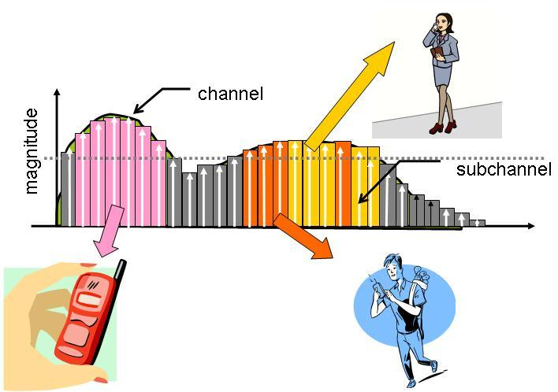
Show and tell
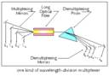
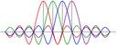

Presentation by slides
Remember by keyword
- multiple carrier
- MIMO
- FDM/OFDM
- Remember by keyword
- Quiz
- List the design goals of OFDM.
- List the techniques used by OFDM.
- Role of cyclic prefix?
- Applications of OFDM?

Session -7 GSM 10.10.2013, 8th period
Recall by words:
1G standards
2G
3G
Presentation: 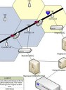
Recall by keywords

- Bandwidth
- Uplink, downlink frequency
- Multiple access scheme
- BSS,NSS and OSS
- Logical channels
- Power control
- Super Frame structure
- Services of GSM

Session -8 Interim Standards (IS-95) 17.10.2013, 2nd period
- Presentation
- Quiz
- What are the differences among the two standards.
- In the context of power control, what is the difference between open loop and closed loop?
- Differentiate dedicated and common channels?
- State the significance of SIM card

Session -9 3 G Standards 26.10.2013, 6th period
- Presentation
- Quiz
- What are the differences among the 2 G and 3G standards.
- In the context of standards, what is the UMTS?
- Few words about 3GPP?
- State the significance of 4G

