Unit-I: SERVICES AND TECHNICAL CHALLENGES

**Session -1 Introduction to wireless communication**

Introduction:2G,3G standards

Presentation slides:broadcast,paging,cellular, trunking radio

[www.fotosearch.com](http://www.fotosearch.com) for wireless communication relevant photos

* <http://classes.soe.ucsc.edu/cmpe257/Winter11/lectures/lecture2.pdf> challenges
* <https://sites.google.com/site/gurudatha/engg.notes>ppt

1. Recall by words (Conclusion)

1G standards-AMPS

2G standards-GSM

3G standards-WCDMA,**Types of Services**

**Session -2 wireless services**

Activity:

* Recap: Asking questions Group Quiz

Activity Description: We can divide the learners into two teams and instruct each team to prepare 5 questions on the types of services. After 5 minutes of preparation, each team will ask the other team the questions prepared.

2.Content: Presentation slides

<http://wysterdesir.com/2008/08/27/how-can-wireless-communications-technologies-be-used-to-expand-internet-connectivity-in-developing-countries/>

[www.bluetooth.com](http://www.bluetooth.com/)

3. Conclusion: Recall by keywords

Activity Description**:**Instructed to learners write the list of keywords.

Types of services

* **Broad casting**
* **Paging**
* **Cellular telephony**
* **Trunking** radio
* Cordless telephone
* WLAN,PAN,FWA,UWB
* **Satellite phones**

**Session -3Requirements for wireless services**

* Recap: Asking questions Group Quiz

Activity Description: We can divide the learners into four teams and instruct each team to prepare 5 questions on the types of services. After 5 minutes of preparation, each team will ask the other team the questions prepared.

Content: Presentation slides:<http://ppt2000.com/view?url=http://www.uobkupartnership.talktalk.net/KU%20Wireless.ppt>

<http://www.stanford.edu/class/ee359/lectures12/lecture1_6pp.pdf>andreabook slides

**Data Rate**

* **2.Range and Number of User**
* *3.Mobility*
* *4.Energy Consumption*
* *5.Use of Spectrum*
* *6.Direction of Transmission*

*7.Service Quality*

Conclusion: Recall by keywords

Activity Description**:**Instructed to learners write the list of keywords and each one have to draw the diagram and show it.

**Session – 4 Multipath fading**

Activity:

1. Recap: Group Quiz

Activity Description:We can divide the learners into three teams and instruct each team to prepare 10 questions on the data rate to service quality . After 5 minutes of preparation, each team will ask the other team the questions prepared.

Explanation: through analogy multipath fading is explained.

1. Call one of the student to pronounce a word. It will reach the first bench of students clearly and for the last bench it will not be clear due to reduction in signal strength- fading.
2. Call upon a group of students .let them talk with each other. It means after a minute a confusion among them will arise -ISI

Presentation slides & Board activity:<http://lecturesppt.blogspot.in/2011/09/wireless-and-mobile-networking-ppt-pdf.html> lecture notes

**3.**Conclusion: Recall by keywords

Activity Description**:**Instructed to learners write the list of keywords.

* ISI
* Fading
* Small scale fading
* Large scale fading
* Causes & remedies

**Session – 5 Spectrum Limitation**

Activity:

**Recap**: Questions and answers about multipath effects

**Presentation**: through analogy spectrum allocation is explained

Analogy:Students sitting in a bench for throughout the semester is compared for **regulated spectrum.**

Students sitting in a bench randomly is an un**regulated spectrum.**

slides (Content)<http://ebookbrowse.com/lecture-notes-on-mobile-communication-pdf-d336896137> book

**3.Conclude:** Recall by keywords- regulated, unregulated and ISM band.

**1)What is the difference between a regulated and unregulated spectrum?**

1. **regulated spectrum usage,** where a single network operator has control over the usage of the spectrum.
2. **unregulated spectrum**, where each user can transmit without additionalcontrol, as long as (s)he complies with certain restrictions on the emission power and bandwidth.

**2..List the frequency range for few applications ?**

**Session -6Noise- and Interference-Limited Systems**

**Recap :**Asking questions

**Compare ISI and Fading?**

* Overlapping of one symbol duration with others is called ISI
* Reduction in signal strength is fading.

**b. Differentiate constructive and destructive fading.**

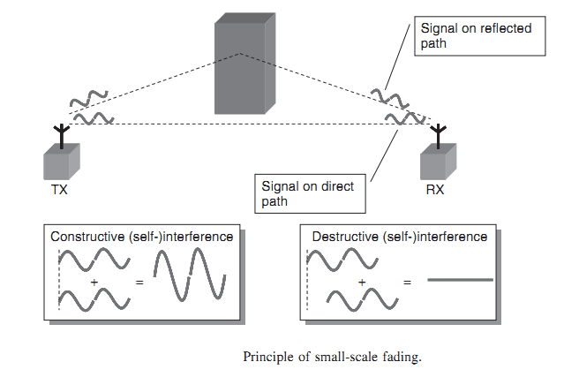.

Presentation: slides

* <http://www.stanford.edu/class/ee359/lectures12/lecture1_6pp.pdf>andrea

Conclusionby :Recall by keywords

1. Thermal noise
2. Man-made noise
3. Receiver noise
4. ISI
5. Link budget

**Session – 7 :Principles of Cellular Networks**

**Recap-**Asking questions

**ISI, Fading**

**Presentation: through roll play frequency reuse concept is explained**

**Call a group of 8 students. Assign different notes to them. In that group assign same notes for two of them.**

**These two students are kept at far away distance .so copying of notes is difficult for these two students.**

**So same frequency is used by two BS kept at far away distance will not cause interference.**

**Slides: Principles of cellular networks.**

<http://ppt2000.com/view?url=http://www.uobkupartnership.talktalk.net/KU%20Wireless.ppt>

**Recall by words (Conclusion):**

1. Write the cellular concept.

If a given set of frequencies or radio channels can be reused without increasing the interference, then the large geographical area covered by a single high power transmitter can be divided into a number of small areas, each allocated a subset of frequencies.

2.What is cell cluster?- A group of cells that use a different set of frequencies in each cell isCalled a cell cluster: The N cells which collectively use the complete set of availableFrequencies is called a cluster.

3. Define cell.-Each cellular base station is allocated a group of radio channels to be used with smallgeographic area called a cell

4.Write the frequency reuse concept.

Physical separation of two cells is sufficiently wide; the same subset of frequencies can be used in both cells. This is the concept of frequency reuse.

**Session – 8: Multiple Access schemes**

Recap by rising questions:

* Cellular concept
* Frequency reuse
* Capacity
* Interference -ACI,CCI

Presentation: roll play – call 6 number of students . Divide them into 2 equal groups.One group act as transmitter of

differentfrequencies. Another group as receiver.Instruct Tx group to give message to receiver at the same time.- FDMA

similarly for TDMA and CDMA also.

* <http://www.scribd.com/doc/131408414/Multiple-Access-Techniques-in-Wireless-Communication-Ppt-Ayaz> multiple access

Recall by words (Conclusion)

1. What is multiple access?Multiple access is a signal transmission situation in which two or more users wish

to simultaneously communicate with each other using the same propagation channel.

2. Write the applications of multiple access methods.

(i) Satellite networks(ii) Cellular and mobile communication networks

(iii) Military communication and(iv) Underwater acoustic networks.

3.Mention.the.types.of.multiple.access.techniques.

**Session – 9: Multiple Access schemes**

Recall by words :

FDMA,TDMA,CDMA and SDMA

**Presentation**: Analogy explanation-Before eating food we are sensing the smell. From it the quality is inferred. Same way before sending the data the status of receiver is observed.

* <http://www.stanford.edu/class/ee359/lectures12/lecture1_6pp.pdf>andrea

Conclusion: Questions and answers

* Carrier Sense Multiple Access

Packet Reservation Multiple Access