**UNIT-1**

**Introduction**

**Session input 1**

**SubTopic:** Introduction to Optical communication

**Suggested Activity:chalk and talk**

The communication system is explained within analogy such that The communication between the human beings are done through voice, action etc.Like this the communication in optical transmission is done with optical rays.The advantages are also discussed.

**SubTopic: Need for communication**

**Suggested Activity: Brainstorming**

The students were asked to give the reason for communication. They told various reasons such that to convey the information in every moment.The evolution of fiber optic also explained.

**SubTopic: Windows of operation**

**Suggested Activity: Slide Representation**

The three windows of operation are explained with its advantage and disadvantages

**SubTopic: Elements of fiber optic system**

**Suggested Activity: Slide representation**

The complete optical communication system within its elements is explained in detail.

**Sub Topic:Conclusion**

**Suggested Activity: Recall by keywords**

Thus the introduction to optical communication is once again recalled by asking explanation words such as splices, connectors, couplers, and concluded.

<http://en.wikipedia.org/wiki/Fiber-optic_communication>

<http://books.google.co.in/books/about/Optical_Fiber_Communications.html?id=5IlhzNqpL3gC>

**Session input 2**

**SubTopic: Recap :Introduction to fiber optic system**

**Suggested Activity: Questioning**

The Questions were asked to the students whose name started with the Alphabet ‘A’.The questions asked are

1.What are the elements of fiber optic system?

2.What are the advantages of Fiber optic communication?

3.What is the difference between Splices and couplers?

**Sub Topic:Total internal reflection**

**Suggested Activity: Chalk and talk.**

The way the ray propagates along the fiber concept is explained with total internal reflection. The formula was derived for critical angle

**Subtopic: Acceptance angle.**

**Suggested Activity: Slide representation**

The derivation for acceptance angle and numerical aperture is derived and explained.

**Sub Topic: Conclusion**

**Suggested Activity: Problem solving**

Thus the section is concluded with the solving the problem to find critical angle ,NA and acceptance angle.

books.google.co.in/books?isbn=0080455069

books.google.co.in/books?isbn=0486414582

<http://books.google.co.in/books/about/Optical_Fiber_Communications.html?id=5IlhzNqpL3gC>

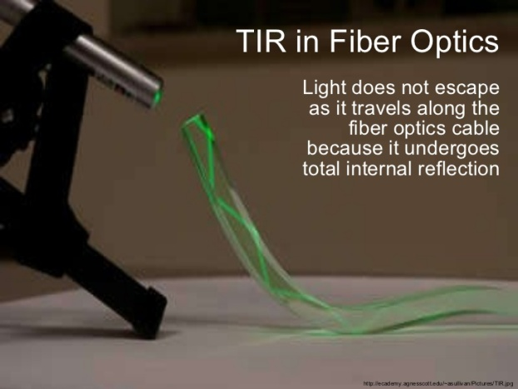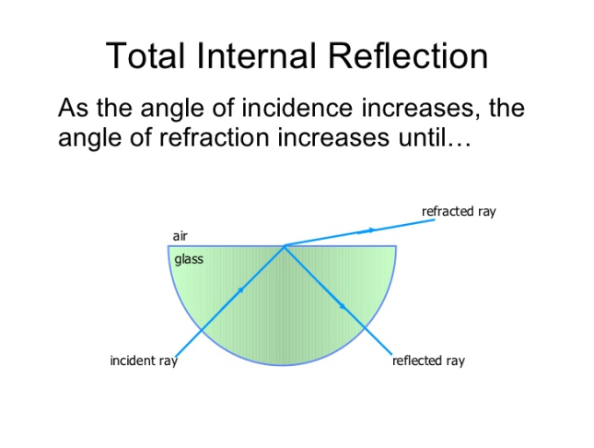

**Session input 3**

**SubTopic: Recap :Ray optics theory**

**Suggested Activity: Questioning**

The Questions were asked to the students whose name started with the Alphabet ‘A’.The questions asked are

1. What is the condition for total internal reflection?

2. What is meant by critical angle?

3. Give the formula for acceptance angle.

4. what information we got from NA?

5.Relate NA with acceptance angle

**Sub Topic:Introduction to optical fiber**

**Suggested Activity: Slide representation.**

The optical fiber with its parts were clearly explained with its uses.

**Subtopic: Types of fiber.**

**Suggested Activity: Slide representation**

The step and graded index fiber is explained with its concepts.

**Sub Topic: Conclusion**

**Suggested Activity: Problem solving**

Thus the section is concluded with the solving the problem to find V no and Number of guided modes.

books.google.co.in/books?isbn=0080455069

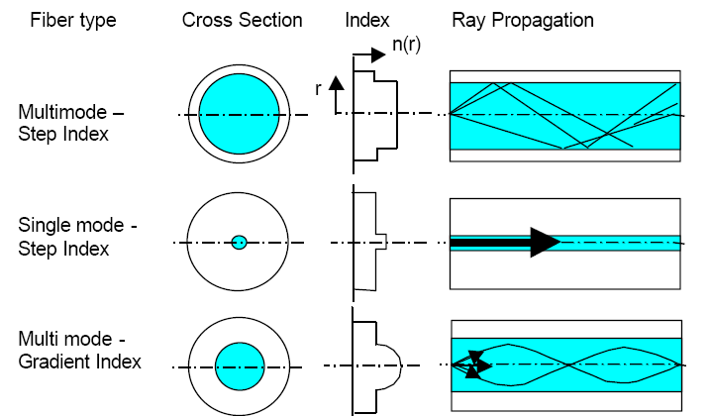

**Session input 4**

**SubTopic: Recap :Types of fiber**

**Suggested Activity: recall by keywords**

The Keywords used are

* V no=2.405
* More BW and longer distance
* More dispersion fiber
* Less dispersion fiber

**Sub Topic: fiber optics structure**

**Suggested Activity: Slide representation.**

The various optical fiber such as step ,graded and single mode fiber is explained with its dimensions.

**Subtopic: Comparison of fibers.**

**Suggested Activity: chalk and talk**

The step and graded index fiber comparison single and multimode fiber comparison is explained

**Topic: Conclusion**

**Suggested Activity: Problem solving**

Thus the section is concluded with the solving the problem to find cut off wavelength,normalized frequency.

books.google.co.in/books?isbn=0080455069

<http://etd.lib.fsu.edu/theses/available/etd-11202003-060632/unrestricted/09_psm_Chapter2.pdf>

<http://search.babylon.com/?q=single+mode+fiber+ppt&babsrc=SP_ss_sps&mntrId=620B180373761B71&affID=119357&tsp=4937>

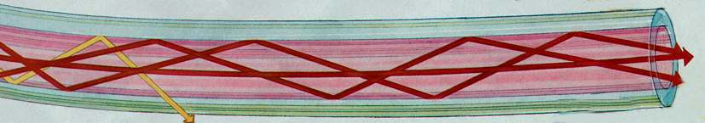

Multimode step index fiber

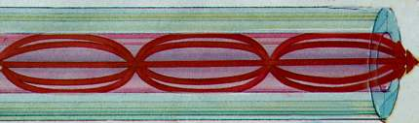

Multimode graded index fiber

**Session input 5**

**SubTopic: Recap :comparison of fiber**

**Suggested Activity: tit for tat**

The students were asked to form two groups. Five questions from each side is asked .The answer given by the oppssite side is assigned with 1 mark.if they are not answered the turn goes to opposite side.The questions asked were

* What is meant by cutoff wavelength?
* What are the advantages of graded index fiber over step index fiber?
* Give the expression for step and graded index fiber.
* What are the advantages of single mode fiber?

**Sub Topic: types of rays**

**Suggested Activity: Slide representation.**

The types of rays –meridional and skew rays are explained.

**Subtopic: Acceptance angle of graded index fiber.**

**Suggested Activity: chalk and talk**

The acceptance for skew ray was derived.

**Topic: Conclusion**

**Suggested Activity: Problem solving**

Thus the section is concluded with the solving the problem to find core diameter, normalized frequency, acceptance angle of skew rays and meridional rays.

[http://course.ee.ust.hk/elec342/notes/Lecture%205_waveguiding%20in%20optical%20fibers.pdf- skew](http://course.ee.ust.hk/elec342/notes/Lecture%205_waveguiding%20in%20optical%20fibers.pdf-%20%20%20skew)

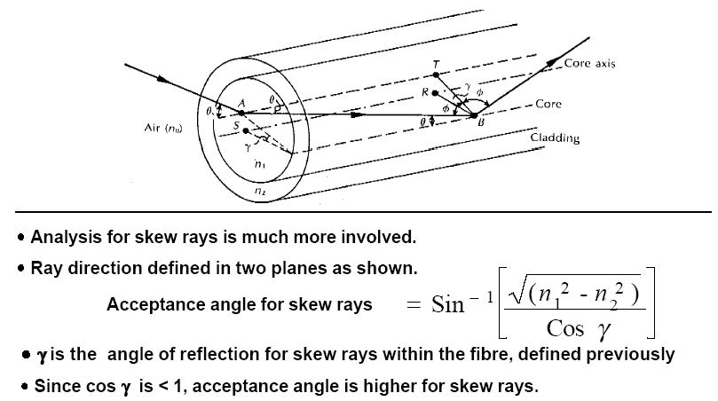

**Session input 6**

**SubTopic: Recap :types of rays**

**Suggested Activity: question and answer**

The questions were asked to the students from the rays such that

* Distinguish between skew rays and meridional rays
* Give the acceptance angle for skew rays and meridional rays
* What is the formula for v no for the cutoff condition in graded index fiber?

**Sub Topic: Electromagnetic mode theory**

**Suggested Activity: chalk and talk.**

The mode theory was explained with the derivation steps

**Subtopic: overview of modes**

**Suggested Activity: slide representation**

The order of modes is explained and the types - guided modes ,refracted mode and radiation mode was explained.

**Topic: Conclusion**

**Suggested Activity: summarize**

Thus the section is concluded with the summarize of the modes.

<http://www.google.co.in/search?client=firefox-a&hs=9r&rls=org.mozilla:en-US:official&q=mode+theory+for+circular+waveguides&revid=149016416&sa=X&ei=9r3mUaS3BonJrAeGhIFg&ved=0CHsQ1QIoAg>

[www.docstoc.com/docs/.../24-**Mode**-**theory-for-circular**-**waveguide**](http://www.docstoc.com/docs/.../24-Mode-theory-for-circular-waveguide)

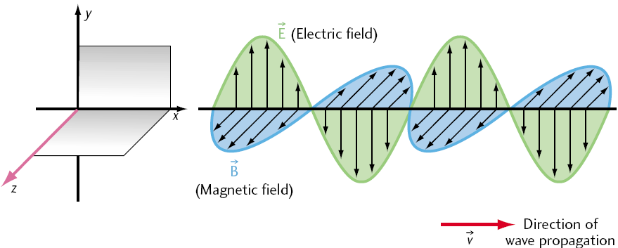

**Session input 7**

**SubTopic: Recap : mode theory**

**Suggested Activity: question and answer**

The questions were asked to the students from the rays such that

* What are the different types of modes occur with reference to cut off condition
* What is the condition to be satisfied for guided modes?
* What is the order of mode indicates in TE,TM modes.

**Sub Topic: Modes in planar guide**

**Suggested Activity: chalk and talk.**

The modes in planar guide concept is explained

**Subtopic: phase and group velocity**

**Suggested Activity: slide representation**

The concept of phase and group velocity is explained.

**Topic: Conclusion**

**Suggested Activity: summarize**

Thus the section is concluded with the summarize of the modes.

<http://galileo.phys.virginia.edu/classes/109N/more_stuff/Applets/sines/GroupVelocity.html>

<http://www.mathpages.com/home/kmath210/kmath210.htm>

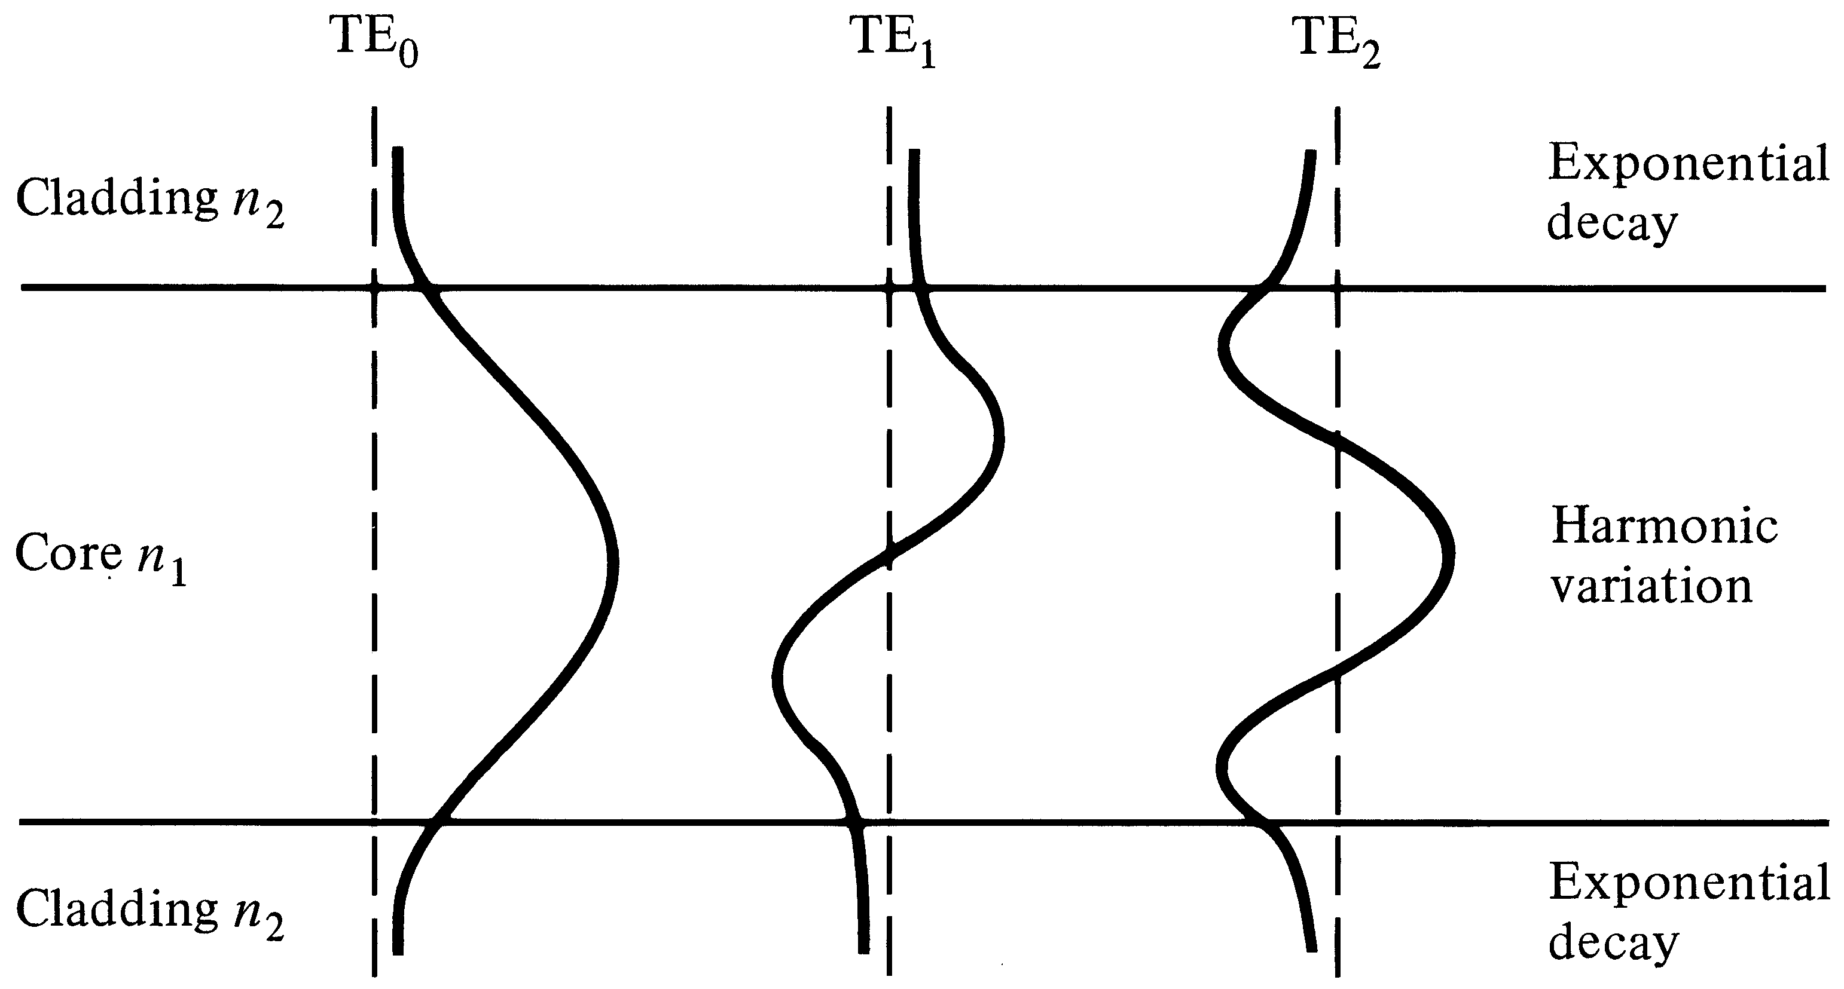

**Session input 8**

**SubTopic: Recap : fiber and ray optics**

**Suggested Activity: 2 marks test**

The questions were asked to the write the answers for the given 5 questions .The questions asked were such that

* What are the advantage of multimode graded index fiber than the step index fiber
* What are the conditions for total internal reflection
* Differentiate single mode and multimode fibers?
* Give the possible expressions for numerical aperture
* given wavelength,n1,n2, for single mode operation find the core dia

**Sub Topic: Linearly polarized modes**

**Suggested Activity: Brainstorming**

The standard forms of LP modes are given .then asked the student to form the combination for various LP modes.They apply the form and tell the answer.

**Subtopic: Goos-Haenchen shift**

**Suggested Activity: slide representation**

The concept of gooshaenchen shift and mode coupling is explained with slides.

**Topic: Conclusion**

**Suggested Activity: summarize**

Thus the section is concluded with the summarize of the modes.

<http://en.wikipedia.org/wiki/Mode_coupling>

[http://www.xpowerpoint.com/EE-230-Optical-Fiber-Communication-Lecture-3-WaveguideFiber------PPT.html#](http://www.xpowerpoint.com/EE-230-Optical-Fiber-Communication-Lecture-3-WaveguideFiber------PPT.html)

  

**Session input 9**

**SubTopic: Recap : linearly polarized modes**

**Suggested Activity: question and answer**

The questions were asked to the students.The questions asked were such that

* Whar are the advantage of LP modes?
* What is meant by mode coupling?
* Give the combination of modes for LP21 and LP13 modes.
* Define goos haenchen shift.

**Sub Topic:single mode fibers**

**Suggested Activity: slide representation.**

The concepts used in single mode fibers are explained with cut off wavelength, Effective refractive index,

**Subtopic: Group delay and Mode delay.**

**Suggested Activity: slide representation**

The group delay and mode delay is explained with formulas .The optical communication used in the space also explained

**Topic: Conclusion**

**Suggested Activity:Match the following**

1.V=2.405 - multimode graded index fiber

2.Larger bandwidth - multimode step index fiber

3.High dispersion and high attenuation -single mode fiber

4.β>n2 k - single mode graded index fiber

5.Low dispersion - guided modes

<http://en.wikipedia.org/wiki/Group_delay_and_phase_delay>.

books.google.co.in/books?isbn=0080455069

<http://www.esa.int/esapub/bulletin/bullet91/b91lutz.htm>

<http://en.wikipedia.org/wiki/Free-space_optical_communication>