Unit V- PRODUCTION COST ESTIMATION
Session 1
Recap:
Addressing the concept of various allowances in cost estimation.
Session objective:
After studding this session the learner will be able to understand the concept of material cost and material cost estimation procedure.
Suggested activity:
PPT
ESTIMATION OF MATERIAL COST
Determination of Material Cost
To calculate the material cost of the product the first step is to study drawing of the product and split it into simple standard geometrical shapes and to find the volume of the material in the product and then to find the weight. The volume is multiplied by density of the metal used in the product.
The exact procedure to find the material cost is like this:
1. Study the drawing carefully and break up the component into simple geometrical shapes.
(Cubes, prisms, cylinders, etc.)
2. Add the necessary machining allowances on all sides which are to be machined.
3. Determine the volume of each part by applying the formulae of mensuration.
4. Add the volumes of all the simple components to get total volume of the product.
5. Multiply the total volume of the product by the density of the material to get the weight of
the material.
6. Find out the cost of the material by multiplying the cost per unit weight to the total weight
of the material
Conclusion:
At the end of this session the learners should understand the concept of material cost and procedure for material cost calculation.
Website URL
http://www.newagepublishers.com/samplechapter/001490.pdf

Session 2
Recap:
Addressing the concept of material cost estimation procedure.
Session objective:
After studying this session the learner will be able to understand the concept of calculation of material cost.
Suggested activity:
Board Presentation
Example 5.1
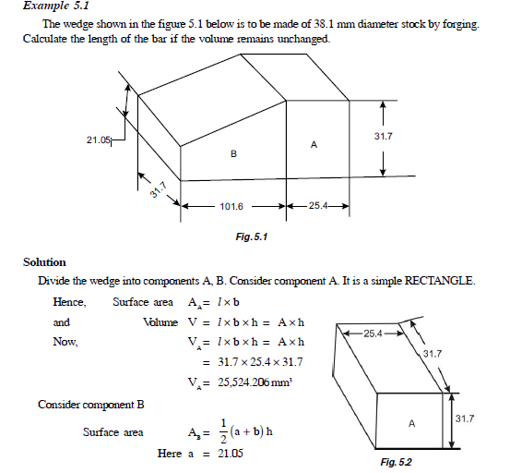

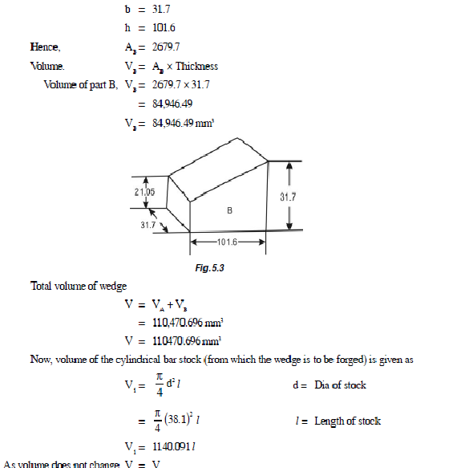

Conclusion:
At the end of this session the learners should understand the concept of material cost and procedure for material cost calculation.
Website URL
http://www.newagepublishers.com/samplechapter/001490.pdf

Session 3
Recap:
Addressing the concept of material cost estimation procedure.
Session objective:
After studying this session the learner will be able to understand the concept of calculation of material cost.
Suggested activity:
Board Presentation
Example 5.2
An iron wedge has been made by forging a 3 cm diameter bar stock. The length and breadth
of the base being 4.5 cm and 2.5 cm. Length 4 cm and height 12 cm. If the density remains
unchanged after forging. What length of bar is required to make the wedge?
All diamensions are in cms.

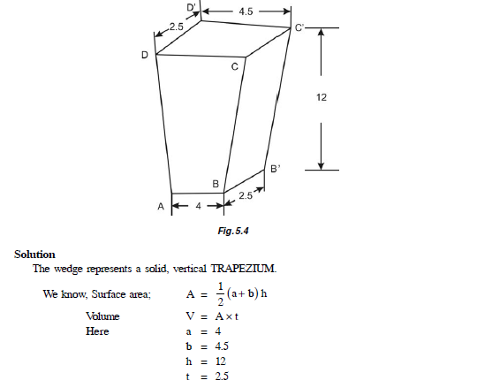
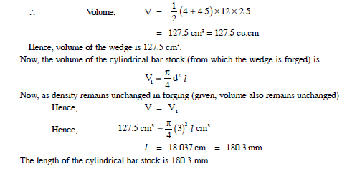
Conclusion:
At the end of this session the learners should understand the concept of material cost and procedure for material cost calculation.
Website URL
http://www.newagepublishers.com/samplechapter/001490.pdf

Session 4
Recap:
Addressing the concept of material cost estimation procedure.
Session objective:
After studying this session the learner will be able to understand the concept of calculation of material cost.
Suggested activity:
Board Presentation
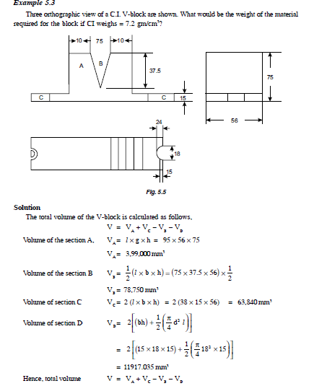
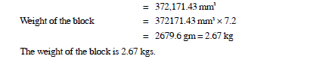
Conclusion:
At the end of this session the learners should understand the concept of material cost and procedure for material cost calculation.
Website URL
http://www.newagepublishers.com/samplechapter/001490.pdf

Session 5
Recap:
Addressing the concept of material cost estimation procedure.
Session objective:
After studying this session the learner will be able to understand the concept of calculation of material cost.
Suggested activity:
Board Presentation

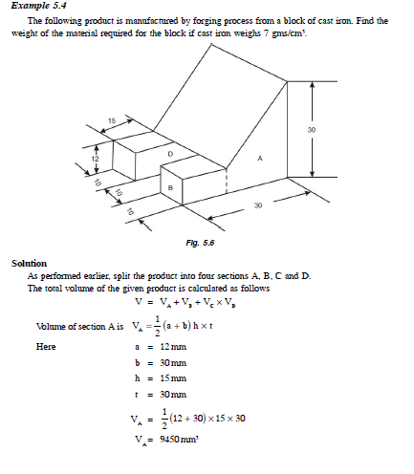
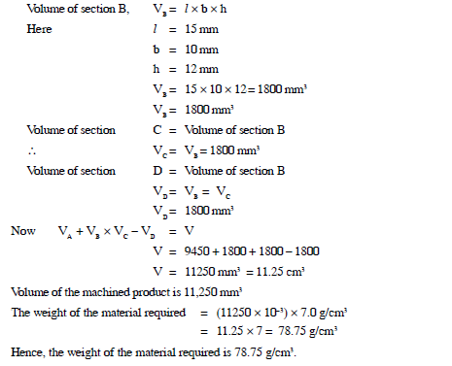
Conclusion:
At the end of this session the learners should understand the concept of material cost and procedure for material cost calculation.
Website URL
http://www.newagepublishers.com/samplechapter/001490.pdf

Session 6
Recap:
Addressing the concept of material cost estimation procedure.
Session objective:
After studying this session the learner will be able to understand the concept of calculation of material cost.
Suggested activity:
Board Presentation

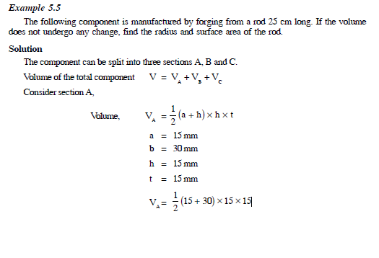
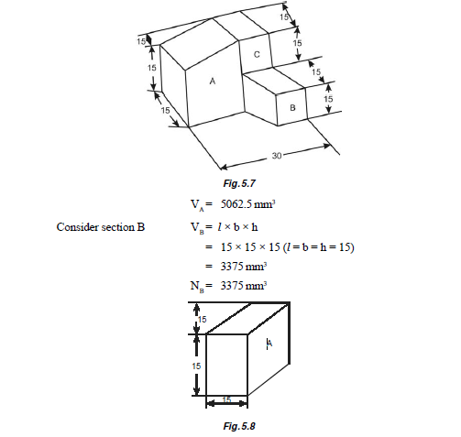

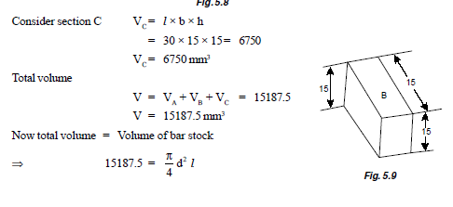
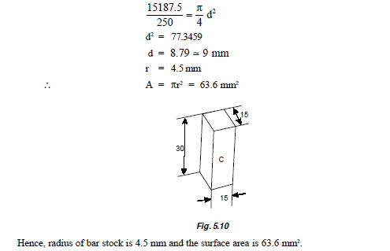
Conclusion:
At the end of this session the learners should understand the concept of material cost and procedure for material cost calculation.

Session 7
Recap:
Addressing the concept of material cost estimation procedure.
Session objective:
After studying this session the learner will be able to understand the concept of calculation of material cost.
Suggested activity:
Board Presentation
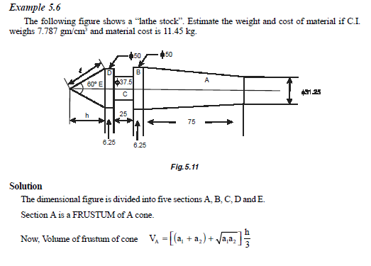
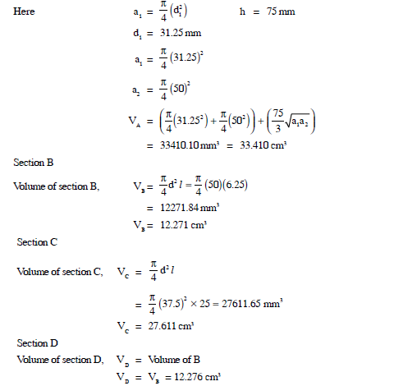
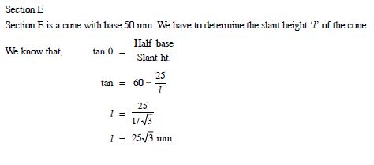
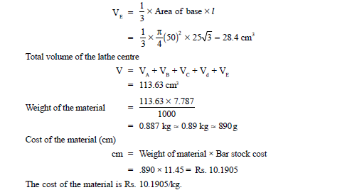
Conclusion:
At the end of this session the learners should understand the concept of material cost and procedure for material cost calculation.
Website URL
http://www.newagepublishers.com/samplechapter/001490.pdf

Session 8
Recap:
Addressing the concept of material cost estimation procedure.
Session objective:
After studying this session the learner will be able to understand the concept of calculation of material cost.
Suggested activity:
Board Presentation
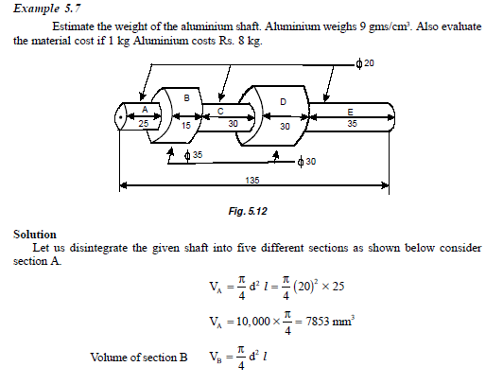
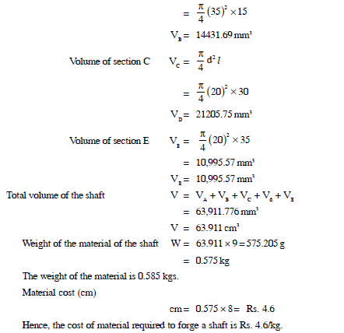
Conclusion:
At the end of this session the learners should understand the concept of material cost and procedure for material cost calculation.
Website URL
http://www.newagepublishers.com/samplechapter/001490.pdf

Session 9
Recap:
Addressing the concept of material cost estimation procedure.
Session objective:
After studying this session the learner will be able to understand the concept of calculation of material cost.
Suggested activity:
Board Presentation
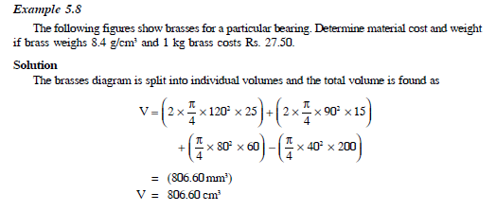
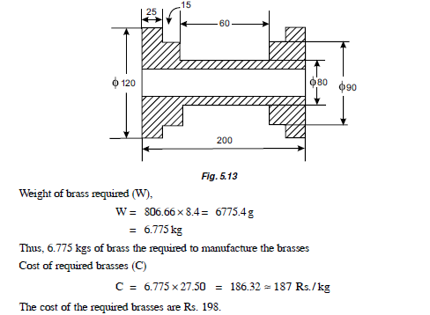

Conclusion:
At the end of this session the learners should understand the concept of material cost and procedure for material cost calculation.
Website URL
http://www.newagepublishers.com/samplechapter/001490.pdf

Session 10
Recap:
Addressing the concept of material cost estimation procedure.
Session objective:
After studying this session the learner will be able to understand the concept of calculation of material cost.
Suggested activity:
Board Presentation
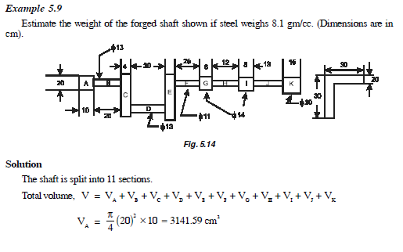
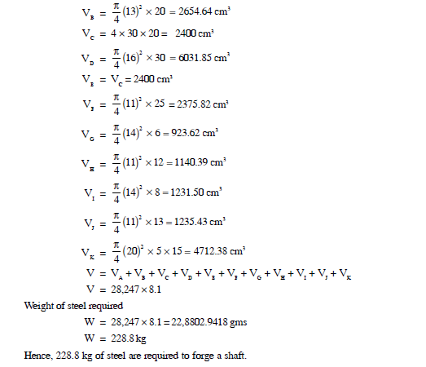
Conclusion:
At the end of this session the learners should understand the concept of material cost and procedure for material cost calculation.
Website URL
http://www.newagepublishers.com/samplechapter/001490.pdf

Session 11
Recap:
Addressing the concept of material cost estimation.
Session objective:
After studding this session the learner will be able to understand the concept of laboue cost and labourl cost estimation procedure.
Suggested activity: Board presentation 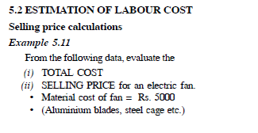
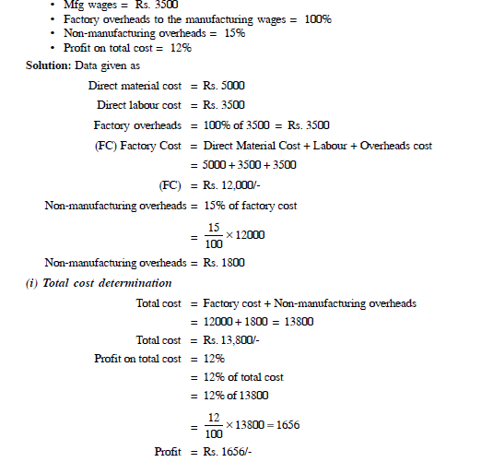
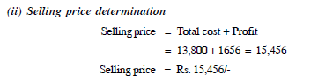
Conclusion:
At the end of this session the learners should understand the concept of labour cost and procedure for labor cost calculation.

Session 12
Recap:
Addressing the concept of labour cost estimation procedure.
Session objective:
After studding this session the learner will be able to understand the concept of overhead cost and allocation of over head cost estimation procedure.
Suggested activity: Board presentation
ESTIMATION OF OVERHEAD COST
5.3.1 Introduction
Overhead expenses are those costs which are incurred by the manufacturer but cannot beindentified and charged directly to any order product. Overhead expenses include all expenditure incurred by the manufacturer on the product except the direct material cost, direct labour cost anddirect chargeable expenses.
In most of the manufacturing organisation the overhead expenses are more than the direct
labour costs. In some cases it may be 100 per cent of direct labour costs. In some other cases
there may range from 200 per cent to 300 per cent of direct labour cost.
(a) Indirect material expenses.
(b) Indirect labour expenses.
(c) Other indirect.
(a) Indirect material expenses
Indirect materials are those materials which are consumed in the operations and processes in the factory but cannot be indentified as a part of a product. The expenditure incurred on such materials, which do not form a part of the final product but are consumed in the process conversion of raw materials into the finished products, are called indirect material expenses. The direct material expenses include the cost of oil, grease, lubricants, coolants, emery papers, cotton waste, etc. The indirect materials are weighed, counter or measured and then issued to the shop against requisition slip. The cost of such materials may then be worked out to assess the total cost of indirect materials used in manufacture and allocated to the product/products.
(b) Indirect labour expenses
Indirect labour is one who is not actually employed in the manufacturing of the product but his services are used in some indirect manner. The indirect labour includes supervisors, inspectors, foremen, store-keeper, gatekeepers, repair and maintenance staff, crane drivers, sweepers, administrative office staff and sales and distribution staff, etc. Salaries and wages paid to indirect labour in the entire year may be calculated from the records and distributed on the product/products.
(c) Other indirect expenses
All other expenses except direct and indirect materials, direct and indirect labour and direct expenses, incurred on a product are called “other indirect expenses”. The other indirect expenses include depreciation of plant and machinery, water and electricity charges, rent of factory building, licence fee, insurance premia stationery, legal expenses, audit fee etc. The cost of all the above may be calculated on yearly basis and charged to the product/products
ALLOCATION OR DISTRIBUTION OF OVERHEAD
After estimating the total on-cost, next step is the allocation of this on-cost over the production.
To run the business in economical way, it is necessary to know, the variation of on-cost with the
variation of production. Several methods are available for the allocation of on-cost. The choice of a particular method depends upon the nature of work, type of organisation and types of machine used, etc.
Following are the different methods of on-cost allocation:
1. Percentage on direct material cost.
2. Percentage on direct labour cost.
3. Percentage on prime cost.
4. Manhour method.
5. Machine hour method.
6. Combination of man hour and machine hour method.
7. Unit of production method.
8. Space rate method.
Conclusion:
At the end of this session the learners should understand the concept of overhead cost and procedure forl allocation of overhead cost.

Session 13
Recap:
Addressing the concept of overhead cost estimation procedure.
Session objective:
After studding this session the learner will be able to understand the concept of forging cost estimation procedure.
Suggested activity: Board presentation
ESTIMATION OF DIFFERENT TYPES OF JOBS
Estimation of Forging Shop
Losses in Forging
It is well known that some metal is always lost in the different operations of forging and this lost
metal must be added to the net weight before calculating the material cost. The different losses to
be considered are:
(i) Scale loss. (ii) Flash loss.
(iii) Tonghold loss. (iv) Sprue loss.
(v) Shear loss.
(i) Scale loss
This is the material lost because of the surface oxidaton in heating and forging the piece. When
iron is heated at a high temperature in atmospheric conditions a thin of iron oxide is formed all round the surface of the heated metal which goes as a waste. The iron oxide film is known as scale and it falls from the surface of the metal on being beaten up by the hammer. Scale loss depends upon the surface area, heating time and the type of material. For forgings under 5 kg loss is 7.5 per cent of the net weight, and for forgings from 5 to 12.5 kg and over an addition of 6 per cent and 5 per cent of the
net weight is necessary for scale loss.
(ii) Flash loss
There is a certain quantity of metal which comes between the flat surfaces of the two dies after the die cavity has been filled in. This material equal to the area of the flat surface is a wastage. For finding the flash loss, the circumference is determined which multiplied by cross-sectional area of flash will give the volume of the flash. The volume multiplied by material density gives the flash loss. Generally, it is taken as 3 mm thick and 2 mm wide all round the circumference.
(iii) Tonghold loss
This is the loss of material due to a projection at one end of the forging to be used for holding it with a pair of tongs and turning it round and round to give the required cross section in drop forging. About 1.25 cm and 2.5 cm of the size of the bar is used for tonghold. The tonghold loss is equal to the volume of the protections.⋅
(iv) Sprue loss
The connection between the forging and tonghold is called the sprue or runner. The material loss due to this portion of the metal used as a contact is called sprue loss. The sprue must be heavy enough to permit lifting the workpiece out of the impression die without bending. The sprue loss is generally 7.5 per cent of the net weight.
(v) Shear loss
In forging, the long bars or billets are cut into required length by means of a sawing machine. The material consumed in the form of saw-dust or pieces of smaller dimensions left as defective pieces is called shear loss. This is usually taken as 5% of the net weight.
The cost of a forged component consists of following elements:
(i) Cost of direct materials.
(ii) Cost of direct labour.
(iii) Direct expenses such as due to cost of die and cost of press.
(iv) Overheads.
(I) Direct material cost
Cost of direct materials used in the manufacture of a forged component are calculated as
follows:
(i) The net weight of forging
Net weight of the forged component is calculated from the drawings by first calculating the volume and then multiplying it by the density of the metal used.
Net weight = Volume of forging × Density of metal.

(ii) Gross weight
Gross weight is the weight of forging stone required to make the forged component. Gross weight is calculated by adding material cost due to various factors discussed above, to the net weight. Gross weight = Net weight + Material loss in the process.
In case of smith or hand forging, only scale loss and shear loss are to be added to net weight but
in case of die forging all the losses are taken into account and added to net weight.
Conclusion:
At the end of this session the learners should understand the concept of forging cost and procedure for forging cost estimation..

Session 14
Recap:
Addressing the concept of forging cost estimation procedure.
Session objective:
After studying this session the learner will be able to understand the concept of welding cost estimation procedure.
Suggested activity: Board presentation
Estimation of Welding Shop
5.5.2.1 Welding Cost
Cost procedure
In estimation welding cost of a job, the different items which are to the taken into account are material, labour and tooling cost.
Material cost
In this, costs of all materials are included used in fabrication progress like metallic sheet or plate stock costing stampings, forging etc. Another major item is the consumable electrode or weld wire used to provide for the additional metal in the weld groove. This quantity is determined by the crosssectional area, length and the particular welding process. In case of gas welding cost of gases like oxygen and acetylene consumed are taken into con
Labour cost
Under this category, costs of all persons are directly related to the making of weldment. First of all welding times are calculated and from that the labour cost is calculated. The labour cost is subdivided into following groups:
Material deposition
This is determined by the rate of weld deposit, weld joint preparation, number of passes required for the weld.
(iv) Post welding operation
This includes the cost for the removal of excess of weld metal, slag, rough or finish machining to weldment dimensions.
Cost of heat treatment operations after welding such as annealing, normalising, hardening etc.,
are also including under this.

(v) Finishing
Cost of cleaning welded portion for surface finish is considered under finishing cost.
Tooling cost
Under this item would be the costs of welding fixtures, machining fixtures and machining template.
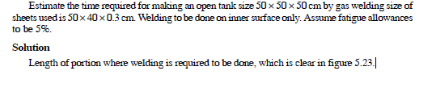
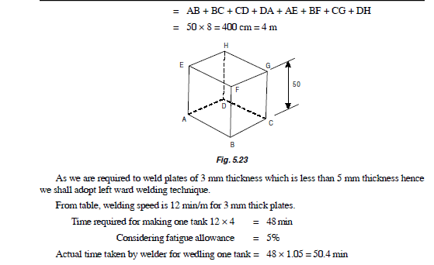
Conclusion:
At the end of this session the learners should understand the concept of welding cost and procedure for welding cost estimation.

Session 15
Recap:
Addressing the concept of welding cost estimation procedure.
Session objective:
After studying this session the learner will be able to understand the concept of foundry cost and foundry cost estimation procedure.
Suggested activity: Board presentation
Estimation of Foundry Shop
Estimation of Pattern Cost
After finding the volume of rough wood by the process described in the previous article, it is multiplied by the existing price per unit volume to obtain the cost of wood required for the pattern of furniture. The labour cost for the work is more difficult to determine, since the process in values a lot of manual work. Similar works undertaken previously are taken as guides in this respect. Experience tells us that a good pattern-maker, working entirely manually, can finish the work on 0.025 m3 of wood in 8 hours. Other charges are usually taken in proportion to either the material cost or the labour cost.
Foundry Losses
• Losses influence strongly the economies of production of castings.
• Losses occur mainly during melting because of oxidation or volatilization of alloying elements
and the entrapment of molten metal in the dross or slag removed from the furnace or
crucible.
• Melting losses are most serious when they occur in costly alloys.
• Melting losses vary with the type of foundary and its conditions such as raw material, melting
practice, composition of alloy etc.
• Highest melting losses occur when the surface area to volume ratio of the charge is more
i.e., in a scrap charge containing large proportion of turnings, swarf and fines (and that too
heavily contaminated).
• Furnace type and design also affect melting losses.
• Rotary and reverberatory furnaces, owing to more pronounced contact of melt with furnace
atmosphere and constant renewal of metal surface are susceptible to higher losses than a
crucible furnace with a small bath area.
• Losses in the melting of cast iron in cupola are lesser than obtained in air furnace.
• In the melting of steel, cupola converter practice produces highest losses of the order of
12.5% whereas they are only 3 to 5% in electric are furnace an
Steps for Finding Costing Cost
1. Calculate the volume of the casting from the past drawing, as explained earlier.
2. Multiply the volume by the density of the part material in order to arrive at net weight of
the casting.
3. Calculate the weight of metal lost in oxidation in the furnace and as sprues, gates, risers
etc. This metal loss is roughly 10% of the net weight of the casting.
4. Calculate the weight of foundry process scrap.
5. Add (2), (3) and (4) above to get total weight.
6. Calculate cost of metal by multiplying the total weight with the cost per unit weight of the
metal.
7. Calculate process scrap return value and deduct it from the cost of metal in order to arrive at Net direct material cost.
8. Calculate indirect material cost by estimating the amount of coke, flux, etc., required to
melt and cleanse the molten metal for casting.
9. Calculate direct and indirect labour costs.
(a) Cost of making moulds.
(b) Cost of making and baking cores.
(c) Cost of firing the furnace
(d) Cost of melting metal.
(e) Cost of pouring molten metal into the moulds.
(f) Cost of removing solidified castings from the moulds.
(g) Cost of fettling and finishing of castings.
(h) Cost of heat-treatment, if any.
10. Cost of inspection.
Conclusion:
At the end of this session the learners should understand the concept of foundry cost and procedure for foundry cost estimation

Session 16
Recap:
Addressing the concept of foundry cost estimation procedure.
Session objective:
After studying this session the learner will be able to understand the concept of foundry cost and foundry cost estimation problem.
Suggested activity: Board presentation
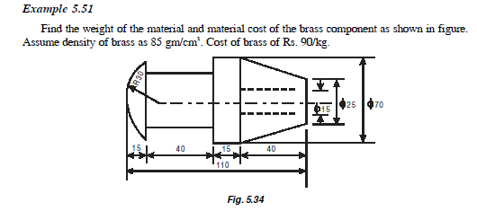
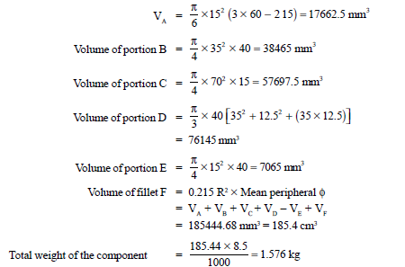
Hence, the cost of material = 1.576 × 90 = Rs. 141.84
Conclusion:
At the end of this session the learners should understand the concept of foundry cost and procedure for foundry cost estimation.

